Stage 2 Musical Styles
Assessment Type 2: Investigation
Task 5
To analyse the soundtrack of the movie "Slum dog Millionaire" composed by A. R. Rahman, with specific reference to the influence of both traditional and modern musical elements and the technologies employed in the music.
The soundtrack of “Slumdog Millionaire”

A. R. Rahman is an Indian film composer, who composed the soundtrack for Danny Boyle’s 2008 film “Slumdog Millionaire,” using software on an computer. Rahman uses technology to free himself from the expense and rehearsal associated with hiring other musicians, and for easy collaboration.¹
Analysis
Perceptive analysis and understanding of music in its historical and cultural context.

The vast range of influences in the score come from Rahman's diverse background and personal experiences – he studied both Western and Indian classical music, toured with professional tabla players, and wrote music for advertising. He reflects on his upbringing as “very multiculti. [I was] watching Hollywood movies [and] listening to Chinese and African music.” ²

Rahman has composed for film, television, and stage, and been called “Bollywood’s most important modern composer.”³

Music is used extensively in Indian film; “virtually all Bollywood films are musicals.”⁴ As a result, the Indian film and music industries overlap, as movies provide the country with hit songs and "immense production numbers.”⁵ Danny Boyle stated "in India it is song and dance in the movies and in life.”⁶

Indian film music usually has an Indian-sounding timbre and melody, but incorporates the simpler rhythms and shorter forms found in Western popular music.
Analysis
Perceptive analysis of stylistic features.

Indian melody is usually based on ragas, a type of melodic mode. Many ragas exist, and each features specific “ethical and emotional properties.”⁷ Indian music does not use the Western major and minor tonal systems, or emphasise harmony. Instead, melodies incorporate seven-note thats. Unlike Western scales, the interval pattern varies for each that. Two of the most common thats, Asavari and Bilawal, closely approximate the Aeolian mode (natural minor scale) and Ionian mode (major scale), respectively.

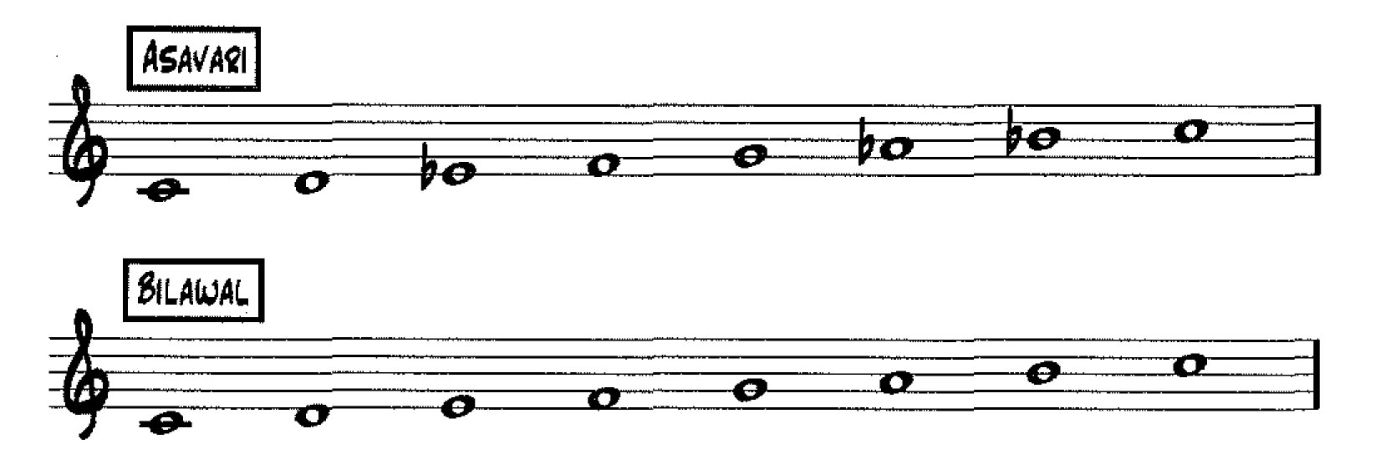
Practical Application
Confident and comprehensive presentation, displaying highly effective use of musical examples, technologies, and processes.

¹ Jackson, Stephanie Lou. Beyond Kitsch: A.R. Rahman and the Global Routes of Indian Popular Music. Ohio: Graduate College of Bowling Green State University, 2010.
² Hermes, W. “ ‘Slum dog Millionaire' Brings Bollywood to the Oscars’.” Rolling Stone, 2009: 16.
³ Ibid.
⁴ Corlis, Richard, and Thottam, Jyoti. "Going Bollywood." TIME, 2002 22, July: 51-52.
⁵ Ibid.
⁶ Beaufoy, Simon. Slumdog Millionaire: The Shooting Script. london: Nick Hern Books, 2008
⁷ Columbia University. "Hindu Music." in Columbia Electronic Encyclopedia, 6th Edition. Ipswich: Columbia University, 2010.

Traditional Indian music is monodic, with most compositions having a single melodic line, with percussion and drone accompaniment. Most Indian classical music is not contrapuntal - instead, “the interest and complexity of this music lies in its melodies and rhythms.”⁸

Talas, rhythmic patterns, are the basis for the complex rhythms of accompanied song.⁹ Talas are
Analysis
Perceptive analysis of stylistic features.
long rhythmic cycles, unlike the Western practice of organizing rhythm into short measures.

Vocal music is part of Indian tradition, and “vocal techniques are... the basis of good instrumental technique.”¹⁰ In general, Indian vocalists do not use vibrato, giving a tonal quality that may sound nasal, flat, or lifeless to the Western listener. However, in Indian music, this can be described as a "clean, clear sound" that does not mask or overpower the subtleties of ragas, or the production of
intricate vocal embellishments, such as swoops and bends.¹¹
Analysis
Perceptive analysis and understanding of music in its historical and cultural context.
Rahman's soundtrack uses both traditional Indian elements, influences from other cultures, as well
as modern Western technologies. Rahman's instrumentation and technological effects makes the
soundtrack unique.

“Ringa Ringa” is a composition inspired stylistically by Laxmikant-Pyarelal's “Choli ke Peech.” Laxmikant-Pyarelal are an Indian duo who have composed extensively for Hindi film. Therefore, “Ringa Ringa” exploits many Indian elements, but also uses modern technology and Western musical features. The entire piece is underpinned by a constant ostinato, first introduced by voices on a single syllable, and used as a recurring rhythmic motif throughout.¹² This motif is also played continually by percussion, and solid tambourine crotchet beats create further rhythmic stability and reinforce the song's pulse and simple duple meter. In addition, percussion use faster semiquaver patterns at the end of sections for a transitional effect.
Analysis
Discerning skills in aural analysis of music.
Knowledge and Communication
Comprehensive knowledge and understanding of the topic, with excellent use of musical terminology.

As is typical of Indian vocal music, the song is sung with a distinct nasal tonal quality, and with many
swoops and bends. The voice is often doubled in unison by melodic instruments - such as a
synthesised instrument. This is a typical element of Hindustani classical music.¹³

Stereotypically for an Indian song, the piece begins without harmony - it is made up of solo, or
unison, melodic lines, and no chords are used. However, Rahman eventually uses string backings in
a fuller homophonic character to contrast the thinner opening texture, and introduces a chord
progression, as the song seems to indicate the key of C Major.¹⁴

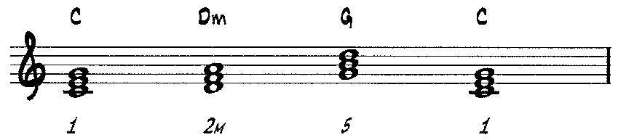

Fig 3. Basis of Chord Progression

⁸ 0p cit. 7
Analysis
Discerning skills in aural analysis of music.
⁹ Schmidt-Jones, Catherine. Indian Classical Music: Tuning and Ragas. July 21, 2011. http://cnx.org/content/m12459/latest/ (accessed September 11, 2011)
¹⁰ Ibid.
¹¹ Ibid.
¹² Refer Track 1
¹³ Refer Track 2
¹⁴ Refer Track 3

The melody of the chorus - using the title lyric - is not based on a Western melodic pattern, but on the Indian Bhairav that.

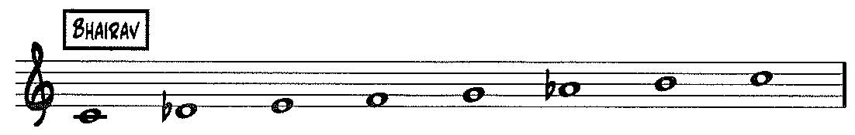

For the Western listener, the use of the, 2 and, 7 creates an exotic dissonance. In what appears to be
Analysis
Discerning skills in aural analysis of music.

a tonal centre of G, the notes of G, A, B, and C are emphasised in a bamboo flute line, and the notes

of D, F, G, and A♭, in the chorus melody.¹⁵

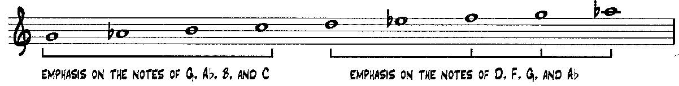

However, contemporary technologies are also used; this is particularly evident in instrumentation. Rahman writes for synthesisers, and uses overdrive and distortion effects to produce a particularly 'dirty' synthesised sound.¹⁶
Analysis
Perceptive analysis and understanding of music in its historical and cultural context.

"Jai Ho" is the film's final song, that sees characters dancing in "an unbound celebration of hope al humanity." ¹⁷ It too uses Indian elements, but also uses many different musical features from other cultures and extensive technology, which results in the unity of "lavish orchestration" and "digital beats," ¹⁸
Analysis
Discerning skills in aural analysis of music.
The piece opens with a highly syncopated, acoustic Spanish guitar riff, which is then doubled up an octave, for a heterophonic effect. The piece also uses crotchet hand claps - perhaps reflecting the celebratory nature of the work.¹⁹
Knowledge and Communication
Comprehensive knowledge and understanding of the topic, with excellent use of musical terminology.
The accented introduction oftaiko drum - triggered in – on beat one, emphasises the beginning of the bar, and a fragment ofthe main theme, "Jai Ho," introduced by voices, brings
abrupt textural and dynamic change that contrasts the opening Spanish guitar riff.²⁰ A female voice sings in the light Western bel canto style, before synthesised drums introduce a feel with an
accented backbeat on beat three of the bar.²¹ This feel recurs in the verses, acting as two-bar “breakdowns,” that contrast the accents on beats two and four of the chorus.

Analysis
Perceptive analysis of stylistic features.

¹⁵ Refer Track 4
¹⁶ Refer Track 5
¹⁷ Beaufoy, Simon. Slumdog Millionaire: The Shooting Script. London: Nick Hem Books, 2008.
¹⁸ Walters, B. "Slumdog Millionaire: Music From the Motion Picture." Rolling Stone, 2009: 70.
¹⁹ Refer Track 6
²⁰ Apple Inc. Logic Studio. 2011. http://www.apple.com/logicstudio/plug-ins/ (accessed September 30, 2011).
²¹ Refer Track 7

For an Indian song, this appears to have a greater use of key and harmony, creating a feeling of a tonal centre. The first verse's male vocal line is based on the Bhairavi that. This pattern is identical to the Western Phrygian mode. This tonal centre is reinforced by an ostinato bass drone on E.²²
Knowledge and Communication
Comprehensive knowledge and understanding of the topic, with excellent use of musical terminology.

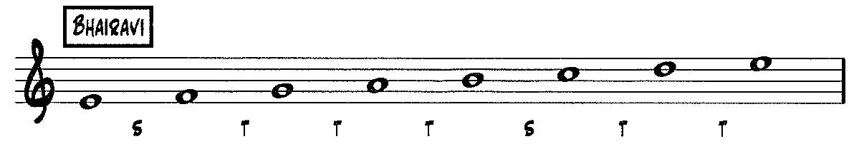
Analysis
Discerning skills in aural analysis of music.

Fig 5 - Bhairavi that, at pitch of "Jai Ho." Letters indicate the pattern of tones and semitones.

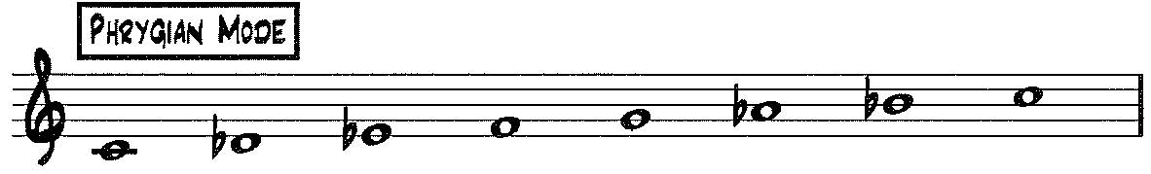

Strings are introduced in the first verse, playing highly syncopated ostinati that increase intensity towards the chorus.²³
Analysis
Discerning skills in aural analysis of music.

Fuller harmony is used in the bridge, using Western chords, and following the progression of C – Gm - Dm - Gm. The melody uses the notes of C, D, E, and G, all of which are part of a C Major scale.²⁴
Analysis
Perceptive analysis of stylistic features.

In characteristic Indian fashion, the second verse sees the vocal melody line duplicated. In this instance, this is achieved by synthesisers that play in multiple octaves.²⁵ Strings also introduce short riffs that reinforce the ends of vocal phrases, before a short descending scalic passage on violin, for a transitional effect into the second half of the verse. Electronic instruments such as electric guitar are also used - this plays a muted comping rhythm reminiscent of funk music in the verse, and Rahman applies Pitch Correcting Software on his voice to create an "exaggerated tuning effect.” ²⁶ ²⁷ The use of this software gives a highly refined, synthesised quality.
Knowledge and Communication
Comprehensive knowledge and understanding of the topic, with excellent use of musical terminology.

The piece ends with slow, unaccompanied synthesised string pads.²⁸ This stark contrast is perhaps used for contrasting emotive effect; at this point of the film, two characters walk hand in hand in Boyle's final shot.

In contrast, "O... Saya" uses technological influences extensively, with a range of cultural influences. The composer stated that "Danny [Boyle, director] suggested M.I.A. [a musician of Sri Lankan and Tamil descent who co-composed and performed in the song], so it was like two cultures meeting." ²⁹
Analysis
Perceptive analysis and understanding of music in its historical and cultural context.

²² Refer Track 8
²³ Refer Track 9
²⁴ Refer Track 10
²⁵ Refer Track 11
²⁶ Op cit, 1
²⁷ Refer Track 12
²⁸ Refer Track 13

The song opens with low frequency oscillations, with Rahman's voice introducing the title lyric, with heavy echo, in a minimalist, ambient feel.³⁰ This sound, not necessarily individual musical elements, inform the listener that this is not a typical traditional Indian work.³¹ lnterestingly, "O Saya" are not words from any language, but rather, nonsense syllables that are used for particular emotive effect. Drums introduce an ostinato pattern at a slow tempo, before a long accelerando.³² This provides rhythmic drive with constant accents, and is based on that of the Indian alap, a "slow" section in "free rhythm," before the jor-alap section "introduces a rhythmic pulse," and the jhala section, in which percussion enters and "becomes faster." ³³
Analysis
Discerning skills in aural analysis of music.
Knowledge and Communication
Comprehensive knowledge and understanding of the topic, with excellent use of musical terminology.
Analysis
Perceptive analysis of stylistic features.

Rahman uses audio from the film for technological effect throughout the song. A boy's voice is electronically manipulated by the composer to create a rhythmic effect, and used to build towards the accents at the end of this phrase.³⁴ Rahman also edits fragments of his vocal line and plays it in an interjecting, call-and-response fashion, with M.I.A.'s, creating a layered electronical soundscape.³⁵
Distortion is also used for timbral effect.³⁶
Analysis
Perceptive analysis of stylistic features.
The work has a clearly defined tonal centre, and features a drone on B for much of the song – bass plays two ascending quavers, using the notes of Band D, to highlight this tonal centre. The combination of drone and percussion is one element of classical Indian music present, although accompanying drone and bass figures usually use pure perfect fifths, not that of a minor third.³⁷
Analysis
Perceptive analysis and understanding of music in its historical and cultural context.

A recurring melodic motif, the main refrain, uses the notes of a B natural minor scale, but interestingly, not the supertonic or submediant notes.
Analysis
Perceptive analysis of stylistic features.


Analysis
Discerning skills in aural analysis of music.

Interestingly, these notes can also be re-arranged, starting on D, to indicate a pentatonic scale.
Knowledge and Communication
Comprehensive knowledge and understanding of the topic, with excellent use of musical terminology.



²⁹ TIME Magazine. 10 Questions for AR. Rahman. April 6, 2009.
http://www.time.com/time/magazine/article/0,9171,1887759,00.html#lxzz1Nvx9PneR (accessed August 14, 2011).
³⁰ Refer Track 14
³¹ Op cit. 1
³² Refer Track 15
³³ Op cit. 9
³⁴ Refer Track 16
³⁵ Refer Track 17
³⁶ Refer Track 18
³⁷ Ibid.

Although the vocalisation in the second verse has been described as a "rap," M.I.A. sings at definite pitch, using repetitive rhythms on the tonic and mediant notes (1 and ♭3).³⁸ This is therefore unlike Western rap, which generally uses spoken word and rhythm as its basis.
Analysis
Perceptive analysis of stylistic features.
Analysis
Discerning skills in aural analysis of music.
Although there is virtually no harmony in the first three minutes of the work, harmony emerges as female voices introduce a B Minor chord as a backing for the last chorus.³⁹

Interestingly, the three songs use four languages – English, Hindi, Spanish, and nonsense syllables. It is perhaps because of the vast array of cultural and stylistic influences, as well as the influence of contemporary technologies, that have resulted in Rahman's work being so accessible to such a wide audience. The soundtrack to Slumdog Millionaire exemplifies the composer's unique blend of both Western music and Indian film music, blurring “the line between genre-bound stylistics, thereby reaching a wider global popular music audience.”⁴⁰
Analysis
Perceptive analysis and understanding of music in its historical and cultural context.
Knowledge and Communication
Highly creative exploration and insightful discussion of aspects of music.

Additional Comments

This investigation is an A+ grade.

Response used aural analysis significantly throughout.

Response demonstrates highly effective planning and management, extensive research resources and comprehensive musical examples in the audio tracks.

Response demonstrated a comprehensive understanding of the topic and use of musical terminology. Investigation was clearly communicated and showed perceptive analysis and context.

Practical Application
Extensive and highly effective management of the investigation, with insightful use of a range of resources and relevant documentation.

Knowledge and Communication
Incisive discussion and clear communication demonstrated throughout.

³⁸ Refer Track 19
³⁹ Refer Track 20
⁴⁰ Op cit. 1

Practical Application
Extensive and highly effective management of the investigation, with insightful use of a range of resources and relevant documentation.
Bibliography

Audio

- Rahman, A.R. Slumdog Millionaire: Musicfrom the Motion Picture. 2008.

Books

- Beaufoy, Simon. Slumdog Millionaire: The Shooting Script. London: Nick Hern Books, 2008.

- Bram, Leon L., ed. "Indian Music" in Funk & Wagnolls New Encyclopedia, Volume 13,226-227. Chicago: Funk & Wagnalls, Inc., 1971.

- Columbia University. "Hindu Music." in Columbia Electronic Encyclopedia, 6th Edition. Ipswich:
Columbia University, 2010.

- Shankar, Ravi. My Music, My Life. Simon & Schuster, 1968.

- Wierzbicki, James. Film Music: A History. New York: Routledge, 2009.

Interview

- Rahman, A.R., interview by James S. Snyder. A.R. Rahman, Slumdog Millionaire Maestro
(February 5, 2009).

Magazines and Periodicals

- Corlis, Richard, and Thottam, Jyoti. "Going Bollywood." TIME, 2002 22, July: 51-52.

- Graff, Gary. "Music from the Motion Picture Slumdog Millionaire." Billboard, 2009: 34.

- Hermes, W. "'Slumdog Millionaire' Brings Bollywood to the Oscars'." Rolling Stone, 2009: 16.

- Walters, B. "Slumdog Millionaire: Music From the Motion Picture." Rolling Stone, 2009: 70.

Score

- A.R. Rahman et aI., arr. Jay Bocook. "Music from Siumdog Millionaire." Milwaukee: Hal
Leonard Corporation, 2009.

Thesis

- Jackson, Stephanie Lou. Beyond Kitsch: A.R. Rahman and the Global Routes of Indian Popular Music. Ohio: Graduate College of Bowling Green State University, 2010.

World Wide Web

- Apple Inc. Logic Studio. 2011. http://www.apple.com/logicstudio/plug-ins/(accessed September 30, 2011).

- Kumar, Suresh. Slumdog Millionaire Score. December 4,2008.
http://www.backgroundscore.com/2008/12/slumdog-millionaire-score.html (accessed August 8, 2011).

- Public Radio International. "Slumdog Millionaire" soundtrack composer. February 21, 2009.
http://www.pri.org/stories/arts-entertainment/music/slumdog-millionaire-composer.htmI
(accessed August 14, 2011).

- Schmidt-Jones, Catherine. Indian Classical Music: Tuning on Ragas. July 21, 2011.
http://cnx.org/content/m12459/latest/ (accessed September 11, 2011)

- Southbank Centre. Slumdog Millionaire composer A R Rahman Interview - Alchemy Festival, Southbank Centre. March 26, 2010. http://www.youtube.com/watch?v=rh9kWYq-R4k
- (accessed August 14, 2011).

- Spectrasonics Virtual Instruments. Spectrasonics in Slumdog Millionaire score. 201l.
http://www.spectrasonics.net/news/news-content.php?id=24 (accessed August 8, 2011).

- TIME Magazine. 10 Questions for A.R. Rahman. April 6, 2009.
http://www.time.com/time/magazine/articie/0.9171.1887759.00.html#ixzz 1 Nvx9PneR
(accessed August 14, 2011).

- TIME 10 Questions: TIME Magazine Interviews: A.R. Rahman. April 22, 2009.
http://www.youtube.com/watch?v=TqUbiOgEbOw& (accessed August 14, 2011).

Appendix One - Overview of Audio Tracks

- The following is an overview of the musical element(s) discussed in the essay that is evident in each audio example, for easy reference.

- The audio CD should be stopped after each track, and referred to as per footnotes in the body of the essay.

Song Name | Track Number | Note – Musical Element Discussed
Ringa Ringa | 1 | Introduction of ostinato (rhythmic motif) on voice.
Ringa Ringa | 2 | Indian tonal quality (in voice), doubling of voice with melodic instrument.
Ringa Ringa | 3 | Introduction of chord progression.
Ringa Ringa | 4 | Use of Bhairav that in flute line / chorus melody.
Ringa Ringa | 5 | Synthesised instrument.
Jai Ho | 6 | Heterophony / hand claps.
Jai Ho | 7 | Introduction of taiko drum and bel-canto style vocals.
Jai Ho | 8 | Bass drone on E.
Jai Ho | 9 | String backings, increasing in intensity.
Jai Ho | 10 | Melody - use of notes from C Major scale.
Jai Ho | 11 | Vocal line doubled by melodic instrument (synthesisers).
Jai Ho | 12 | Use of software on vocals for an exaggerated tuning effect, and synthesised quality.
Jai Ho | 13 | String pads.
O… Saya | 14 | Oscillations, and introduction of title lyric (with echo).
O… Saya | 15 | Accelerando.
O… Saya | 16 | Manipulation of boy's voice.
O… Saya | 17 | Vocal lines in interjecting fashion.
O… Saya | 18 | Use of distortion.
O… Saya | 19 | M.I.A.'s "rap," using tonic and median notes.
O… Saya | 20 | Introduction of harmony – B Minor chord.

Practical Application

Use of musical examples is comprehensive and effective.

Response demonstrates highly effective, independent research skills with outstanding planning processes.
Performance Standards for Stage 2 Musical Styles
 | Practical Application | Knowledge and Communication | Analysis
A | Highly effective demonstration of independent work, and planning and investigation processes.  Extensive and highly effective management of the investigation, with insightful use of a range of resources and relevant documentation.  Confident and comprehensive presentation, displaying highly effective use of musical examples, technologies, and processes. | Comprehensive knowledge and understanding of the topic, with excellent use of musical terminology.  Highly creative exploration and insightful discussion of aspects of music.  Incisive and clear communication of investigation findings.  Highly developed aural recognition skills. | Perceptive analysis and understanding of music in its historical and cultural context.  Perceptive analysis of stylistic features.  Discerning skills in aural analysis of music.
B | Effective demonstration of independent work, and planning and investigation processes.  Very capable management of the investigation, with well-considered use of resources and relevant documentation.  Very capable presentation displaying effective use of musical examples, technologies, and processes. | Detailed knowledge and informed understanding of the topic, with clear and consistent use of musical terminology.  Creative exploration and well-considered discussion of aspects of music.  Well-considered and mostly clear communication of investigation findings.  Very good aural recognition skills. | Well-considered analysis and understanding of music in its historical and cultural context.  Well-considered analysis of stylistic features.  Very capable skills in aural analysis of music.
C | Appropriate demonstration of independent work, planning, and investigation processes.  Organised management of the investigation, with considered use of resources, and mostly relevant documentation.  Considered presentation displaying appropriate use of musical examples, technologies, and processes. | Knowledge and informed understanding of the topic, with mostly accurate use of musical terminology.  Some creativity in exploration and considered discussion of aspects of music.  Considered and generally clear communication of investigation findings.  Generally competent aural recognition skills. | Considered analysis and understanding of music in its historical and cultural context.  Considered analysis of stylistic features.  Generally competent skills in aural analysis of music.
D | Demonstration of some independent work, planning, and basic investigation processes.  Attempted investigation, with inconsistent use of resources and documentation.  Presentation that displays inconsistent use of musical examples, technologies, or processes. | Some knowledge and understanding of aspects of the topic, with attempted use of appropriate musical terminology.  Some basic exploration and description of aspects of music.  Communication of elements of an investigation.  Emerging aural recognition skills. | Description of some aspects of music in its historical and cultural context.  Description of some stylistic features.  Some skill in aural analysis of music.
E | Limited demonstration of independent work, effective planning, or investigation processes.  Limited investigation attempted with use of one or more resources, which may have limited relevance, and very little documentation.  Limited presentation with some identification of a musical example, technology, or process. | Some awareness of the topic, with limited use of musical terminology.  Attempted exploration and description of aspects of music.  Attempted communication of limited elements of an investigation.  Limited aural recognition skills. | Identification of one or more aspects of music in its historical or cultural context.  Identification of one or more stylistic features.  Limited skill in aural analysis of music.

