
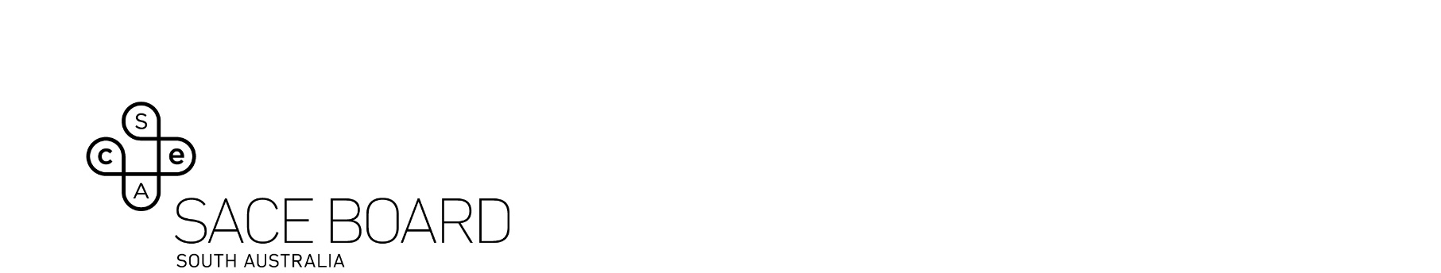
2024 ABORIGINAL SACE COMPLETERS
Consent Form
I give permission for the SACE Board of South Australia to (please tick boxes):
☐ use my name and photograph on the 2024 Aboriginal SACE Completers poster
☐ contact me by email occasionally to learn about my pathway after SACE
Name of Student: |  | Date of Birth:
School attended: |  | SACE ID:
Address: |  | Postcode
2025 Email:
Contact phone no.:

Evidence of consent
Signature of student: |  | Date:
OR
Parent/Guardian to sign if student is under 18 years old: |  | Date:
OR
Attach correspondence that demonstrates student/parent/guardian consent.

Form submission
Please return completed form, along with a high-resolution photo to the SACE Board of South Australia by 28 March 2025 to: SACE.aboriginalstudents@sa.gov.au
Please contact Hassan Mekawy via SACE.aboriginalstudents@sa.gov.au if you have any queries in relation to this form.

