**Stage 2 Agricultural Production**

**Assessment Type 1: Agricultural Reports**

|  |  |
| --- | --- |
| Student Name: | SACE Number: |

|  |  |  |
| --- | --- | --- |
| ASSESSMENT TYPE | Agricultural Report | |
| TASK | **Soils Investigation** | |
| DESCRIPTION | The class will design and conduct an investigation comparing soil from two different agricultural sites. Students will then individually design an extension investigation where the outcome is uncertain, exploring a soil management issue. | |
| TOPICS | Topic 1: Animal Production   * *Animal nutrition* * *Reproduction* * *Breeding systems* * *Animal welfare* * *Disease & pest management*   Topic 2: Plant Production   * *Nutrition* * *Reproduction* * *Production* * *Disease, pest & weed management* | Topic 3: Resource Management   * *Soils* * *Water* * *Waste management* * *Biodiversity* * *Climate*   Topic 4: Agribusiness   * *Enterprise management* * *Enterprise analysis* * *Farm systems* * *Marketing* * *Work health and safety* |
| ASSESSMENT | Investigation, Analysis, and Evaluation  IAE1 Deconstruction of a problem and design of an agricultural investigation.  IAE2 Obtaining, recording, and representation of data, using appropriate conventions and formats.  IAE3 Analysis and interpretation of data and other evidence to formulate and justify conclusions.  IAE4 Evaluation of procedures and their effect on data.  Knowledge and Application  KA1 Demonstration of knowledge and understanding of agricultural concepts and practices.  KA2 Application of agricultural concepts, skills, and practices in new and familiar contexts.  KA3 Exploration and understanding of the interaction between agricultural science and society.  KA4 Communication of knowledge and understanding of agriculture, using appropriate terms, conventions, and representations | |
| CAPABILITIES | literacy  numeracy  information and communication technology (ICT) capability  critical and creative thinking  personal and social capability  ethical understanding  intercultural understanding | |
| **Draft due date** |  | |
| **Final due date** |  | |

Teacher note

Prior to this task, students learn how to conduct a range of chemical and physical tests on soils from different sites. The properties tested include pH, nitrogen, phosphorus, texture, colour, composition, water repellence, bulk density and porosity. Students also examine the results of tests conducted on their soil samples by a commercial laboratory. The properties tested may include, salinity, organic matter, macronutrients such as nitrogen and phosphorus, and micronutrients such as zinc and magnesium. These results can provide extra information about the suitability of the soils for use in paddocks.

PART A: As a group, the class will discuss possible questions about soil management that could be investigated. One of these questions is selected and the class designs and conducts an investigation to address this question. Students will collect soil samples from two different sites, carry out the relevant tests and record their observations. Individually they will present and analyse the data and evaluate the procedure and results.

The report on Part A of this practical investigation should include:

* a brief section with the investigable question, materials and method (for context but not for assessment)
* results* (IAE2)
* analysis of results, identifying trends, and linking results to concepts (IAE3)
* evaluation of procedures and data, and identifying sources of uncertainty (IAE4)
* conclusion and/or recommendations, with justification (IAE3)

Practical skills will be assessed via a rubric (KA2).

PART B: Students then individually design an “extension” investigation on a different aspect of soil management. Aspects that could be investigated include soil compaction, erosion, tillage methods, paddock management, waterlogging and topography.

Each student develops a question to be investigated for which the outcome is uncertain.

Students submit a design proposal for Part B that includes:

* introduction with relevant agricultural concepts, a hypothesis and variables, or investigable question and/or rationale for the design (IAE1)
* materials/apparatus*(IAE1)
* method/procedure that uses appropriate testing techniques and includes justification of the steps to be taken* (IAE1)
* identification and management of safety and/or ethical risks*(IAE1)

Students do not carry out the investigation in Part B.

The total report for Parts A and B should be a maximum of 1500 words if written, a maximum of 9 minutes for an oral presentation, or the equivalent in multimodal form.

*The four asterisked sections (materials/apparatus, method/procedures, risks, and results) are excluded from the word count.

**RISK ASSESSMENT**

Use the matrix below to rate the overall risk of the activity

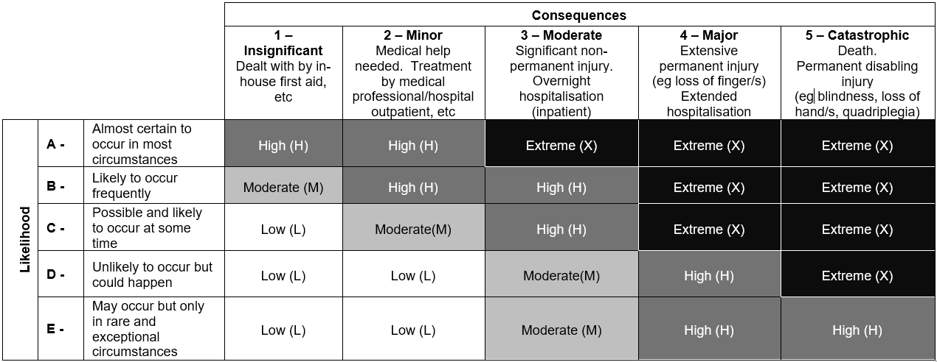

RATING (include Number and Letter code): _____________________

Write a brief statement explaining why you selected this risk rating.

|  |
| --- |
|  |

Complete the chart below to identify safety hazards associated with this activity and ways to minimise the risk involved.

|  |  |  |
| --- | --- | --- |
| **Possible hazard** | **Safe Operating Procedure** | **PPE and other safety**  **equipment required** |
|  |  |  |
|  |  |  |
|  |  |  |
|  |  |  |

Soils Investigation Practical Skills Rubric

|  |  |  |  |  |  |  |
| --- | --- | --- | --- | --- | --- | --- |
|  | A | B | C | D | E | I |
| **KA2 Development and application of agricultural concepts, skills, and practices in new and familiar contexts.** | Develops and applies agricultural concepts, skills, and practices highly effectively in new and familiar contexts. | Develops and applies agricultural concepts, skills, and practices mostly effectively in new and familiar contexts. | Develops and applies agricultural concepts, skills, and practices generally effectively in new or familiar contexts. | Develops and applies basic agricultural concepts, skills, and practices in familiar contexts. | Attempts to develop and apply one or more basic agricultural concepts, skills, and/or practices in familiar contexts.  . | Not attempted |
| Field Skills |  |  |  |  |  |  |
| Lab Skills |  |  |  |  |  |  |
| Collaboration |  |  |  |  |  |  |
| WHS |  |  |  |  |  |  |
| OVERALL GRADE | | | | | | |

FIELD SKILLS

* Soil sample sites selected appropriately
* Probe used efficiently
* Minimum 10 samples taken
* Samples mixed thoroughly
* Equipment cleaned and packed away

LAB SKILLS

* Tests conducted efficiently
* Methods followed effectively
* Samples identified accurately
* Equipment used competently
* Lab cleaned and equipment packed away

COLLABORATION

* Working as a team to collect samples & conduct tests
* show initiative & planning
* discuss strategies
* communication
* fair sharing of workload

WHS

* Follow SOPS & safe behaviour
* Risk Assessment completed
* Listen to and follow instructions
* Present fit and ready for work
* Appropriate PPE in use

Assessment Type 2: Applications: *Soils Investigation*

Performance Standards for Stage 2 Agricultural Production

| - | Investigation, Analysis and Evaluation | Knowledge and Application |
| --- | --- | --- |
| A | Critically deconstructs a problem and designs a logical and coherent agricultural investigation with detailed justification.  Obtains, records, and represents data, using appropriate conventions and formats accurately and highly effectively.  Systematically analyses and interprets data and evidence to formulate logical conclusions with detailed justification.  Critically and logically evaluates procedures and their effect on data. | Demonstrates deep and broad knowledge and understanding of a range of agricultural concepts and practices.  Applies agricultural concepts, skills, and practices highly effectively in new and familiar contexts.  Critically explores and understands in depth the interaction between agricultural science and society.  Communicates knowledge and understanding of agriculture coherently, with highly effective use of appropriate terms, conventions, and representations. |
| B | Logically deconstructs a problem and designs a well-considered and clear agricultural investigation with reasonable justification.  Obtains, records, and represents data, using appropriate conventions and formats mostly accurately and effectively.  Logically analyses and interprets data and evidence to formulate suitable conclusions with reasonable justification.  Logically evaluates procedures and their effect on data. | Demonstrates some depth and breadth of knowledge and understanding of a range of agricultural concepts and practices.  Applies agricultural concepts, skills, and practices mostly effectively in new and familiar contexts.  Logically explores and understands in some depth the interaction between agricultural science and society.  Communicates knowledge and understanding of agriculture mostly coherently, with effective use of appropriate terms, conventions, and representations. |
| C | Deconstructs a problem and designs a considered and generally clear agricultural investigation with some justification.  Obtains, records, and represents data, using generally appropriate conventions and formats, with some errors but generally accurately and effectively.  Undertakes some analysis and interpretation of data and evidence to formulate generally appropriate conclusions with some justification.  Evaluates procedures and some of their effect on data. | Demonstrates knowledge and understanding of a general range of agricultural concepts and practices.  Applies agricultural concepts, skills, and practices generally effectively in new or familiar contexts.  Explores and understands aspects of the interaction between agricultural science and society.  Communicates knowledge and understanding of agriculture generally effectively, using some appropriate terms, conventions, and representations. |
| D | Prepares a basic deconstruction of a problem and an outline of an agricultural investigation.  Obtains, records, and represents data, using conventions and formats inconsistently with occasional accuracy and effectiveness.  Describes data and undertakes some basic interpretation to formulate a basic conclusion.  Attempts to evaluate procedures or suggest an effect on data. | Demonstrates some basic knowledge and partial understanding of agricultural concepts and practices.  Applies basic agricultural concepts, skills, and practices in familiar contexts.  Partially explores and recognises aspects of the interaction between agricultural science and society.  Communicates basic information about agriculture, using some appropriate terms, conventions, and/or representations. |
| E | Attempts a simple deconstruction of a problem and a procedure for an agricultural investigation.  Attempts to record and represent some data with limited accuracy or effectiveness.  Attempts to describe results and/or interpret data to formulate a basic conclusion.  Acknowledges that procedures affect data. | Demonstrates some limited recognition and awareness of agricultural concepts and practices.  Attempts to apply one or more basic agricultural concepts, skills, and/or practices in familiar contexts.  Attempts to explore and identify an aspect of the interaction between agricultural science and society.  Attempts to communicate information about agriculture. |
| **OVERALL GRADE:** | | |