***How have Ancient Greek Beauty Standards and Art* Culture *Been Influenced by Mythology, Respectively?***

The Ancient Greeks were a North-Eastern Mediterranean civilisation, that flourished between their emergence in the 8th century BCE, to the 6th century CE (fall of classical antiquity) (*Ancient Greece*, n.d.). They were an established people, known for their timeless inventions and great minds. They were pioneers in mathematics and astronomy; marking themselves as a fundamental source of modern knowledge and discoveries. Amongst their extraordinary scientific and philosophical culture, the Greeks were also a staple of art, literature and theatre (*Classical Greek Culture (Article)*, n.d.). Their remarkable application of such captured the very essence of beauty.

Beauty is defined as the subjective aesthetic appeal of a person, object, or thing. Beauty has been a globally perceived concept since the dawn of humanity. It has shaped how people interpret the world around them and the individuals they choose to form relationships. Evidence of such is found in the artistry of all periods, including the age of human primitivity. From cave paintings to modern-day makeup influencers, beauty has encapsulated humanity (Sudarshan, 2021). Mythology/religion has held supremacy in the encapsulation and perception of beauty amongst Ancient civilisations. Evidence of such is shown through artwork, architecture, literature and many other forms of expression. Regarding the Ancient Greeks, artists expressed their appreciation of beauty through stone sculptures, literacy, pottery, clothing and sport. Most of which were directly in affinity to the Gods and Goddesses they believed in.

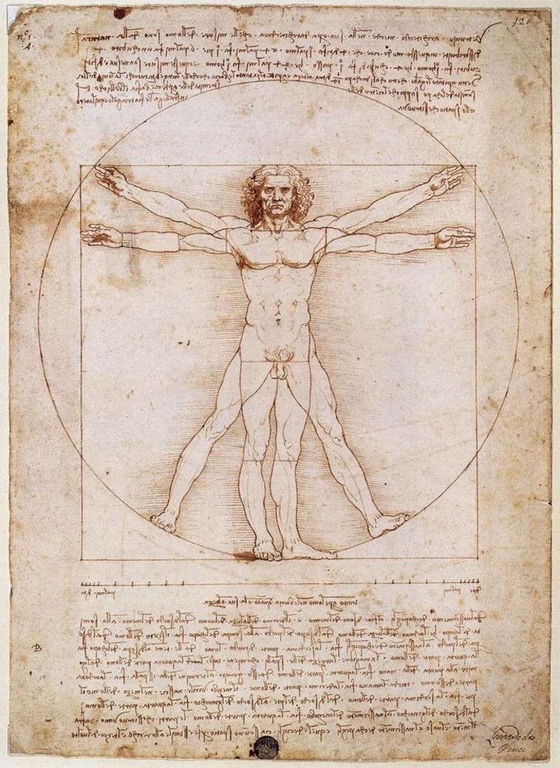The Gods were considered to be the most abundant in beauty; the Vitruvian Man is a map created by Leonardo Da Vinci (1487), depicting the perfectly proportionate human in alignment with mathematics and geometry (fig. 1) (Study.com, 2022). Such perfection, mostly unattainable by humans, was what the Greeks saw for the Gods. To compare a person to a God was seen as the greatest compliment, insinuating that the individual transcends mortal beauty into the divine realm. While beauty is often attributed to the physical nature of things, the Greeks had additional values in intelligence, wisdom, spirituality, and metaphysicality. If a person were to have astounding displays of any listed qualities, they too could be

considered ‘god-like’ and become an ascended individual. Praises such as

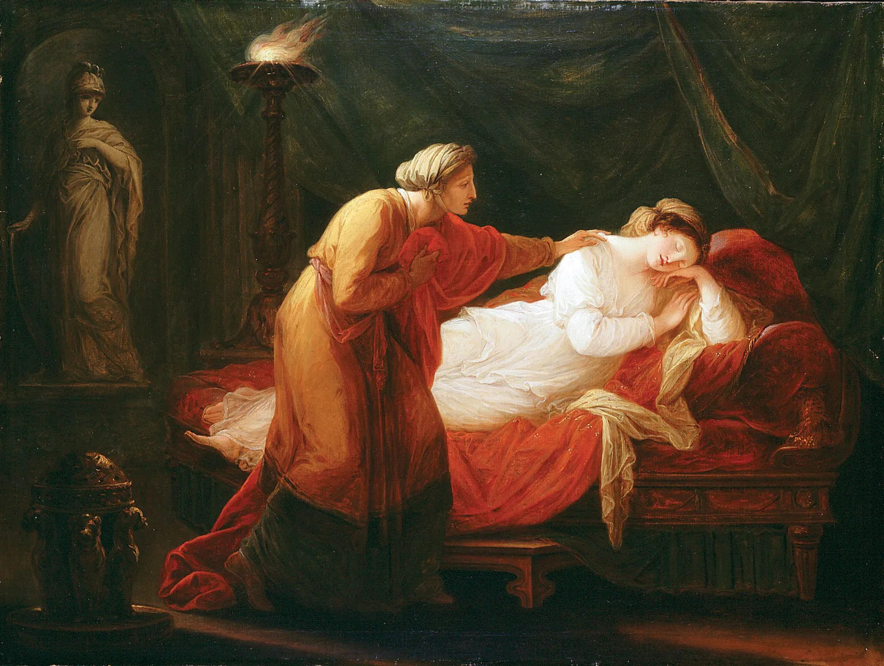this were mainly spoken for champions and leaders, where considering them ‘godlike’ highlighted an elevated, significant status (Ivanova, 2023). However, there have been some exceptions to this trait. In the 24th

installation of Homer’s Odyssey, Penelope (mortal wife of Odysseus) (fig. 2) was heavily praised by the ghost of Agamemnon for her loyalty, wisdom, and empathy towards her husband. Such qualities, as generous as Penelope’s, are directly aligned with those attributed to great Gods of their pantheon. For this reason, Agamemnon cried joyously, “Odysseus, son of Laertes… What depth of

wisdom there is in flawless Penelope… How faithfully she kept her husband’s image in her mind… The gods will create a song of delight for

mortal ears, in honour of loyal Penelope…” (Homer, BkXXIV: 98-204, 8-7th Century BCE)(Kline, n.d.). This epithetical, god-like, honour demonstrates Penelope’s promoted status over the other mortals in the narrative, specifically enforcing her significance of character.

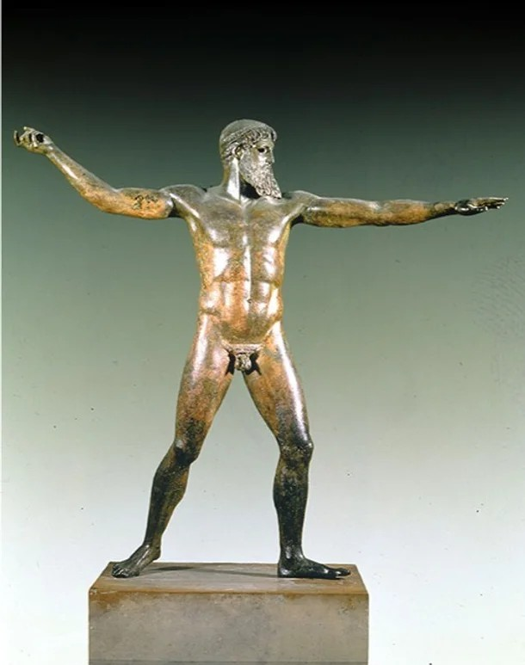Symmetry, strength, masculinity, and physical definition were considered the features of a beautiful Grecian man. This coincides with the (realistically) unaccomplishable perfection of male Gods depicted in their respective sculptures and paintings (Ivanova, 2023).

An example of this is the *Artemision Bronze* (c. 46 BCE) (fig. 3); a slightly larger-than-life-size bronze statue, sculptured to represent the physical nature of a significant Greek God. Mostly, it is believed to be a depiction of Zeus, the God of thunder, but debates have spread claiming that it could, in theory, be Poseidon, the God of the sea. This debate is based on the missing weapon in the

figure's right hand. All the same, the statue portrays the God with broad  shoulders, perfectly structured abdominal muscles, strong limbs, and a

defined face (Agnew, 2023). Mortal men that existed in the age of the Ancient Greeks are no exception to the artistic portrayal. A bronze statue from 300-100 BCE,

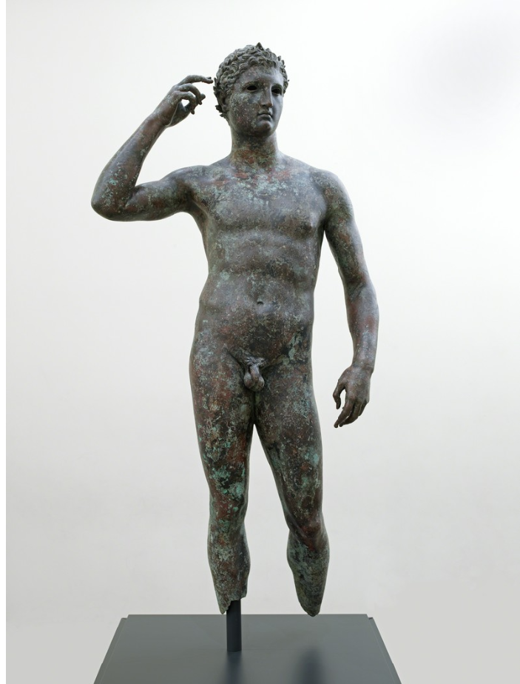displays a victorious youth, plausibly a champion of sorts (fig. 4). He is modelled with a fit physique, unquestionably impressive, however not identically perfect as the Artemision Bronze. Notably, though, this artistic depiction may not necessarily be accurate in its image, as it is plausible the artist exaggerated the youth’s aesthetics to preserve the Grecian beauty standard. Similar to how modern-day influencers edit their photographs to adhere to public likeness.

Men were visually valued for their physical strength, with aesthetics

that coincided with that of a great warrior or hero - a nod to the desire

to be god-like. Women however were valued for their likeness to (specifically) 

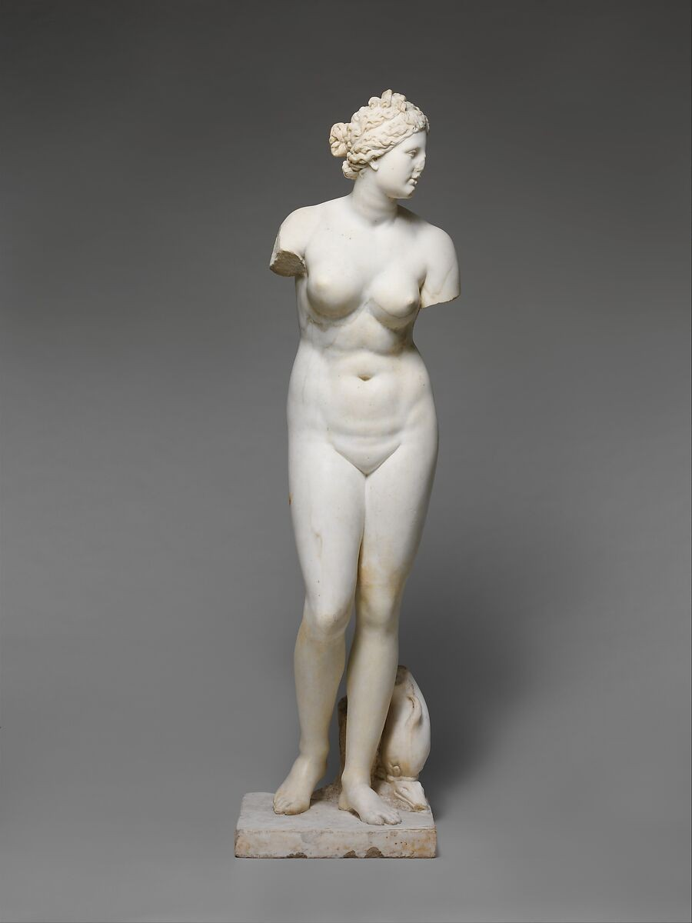Aphrodite, the Goddess of love. Aphrodite was additionally a Goddess of fertility, which meant that her stature reflected a physique perfectly developed for child-bearing (Agnew, 2023) (Ivanova, 2023). Artworks and sculptures depict her with wide hips, large breasts and a

pear-shaped body (see fig. 5). Contrasting modern-day standards, Aphrodite was pale and held noticeable weight, creating natural skin folds and curves; this being a Grecian standard attests to the poverty/slavery issue in their culture. Bodily fullness in a woman suggests she is wealthy enough to eat largely, while paleness suggests a lack of activity in the sun (i.e. outside slave labour) which

demonstrates her higher status (Ivanova, 2023). The closer a woman is to

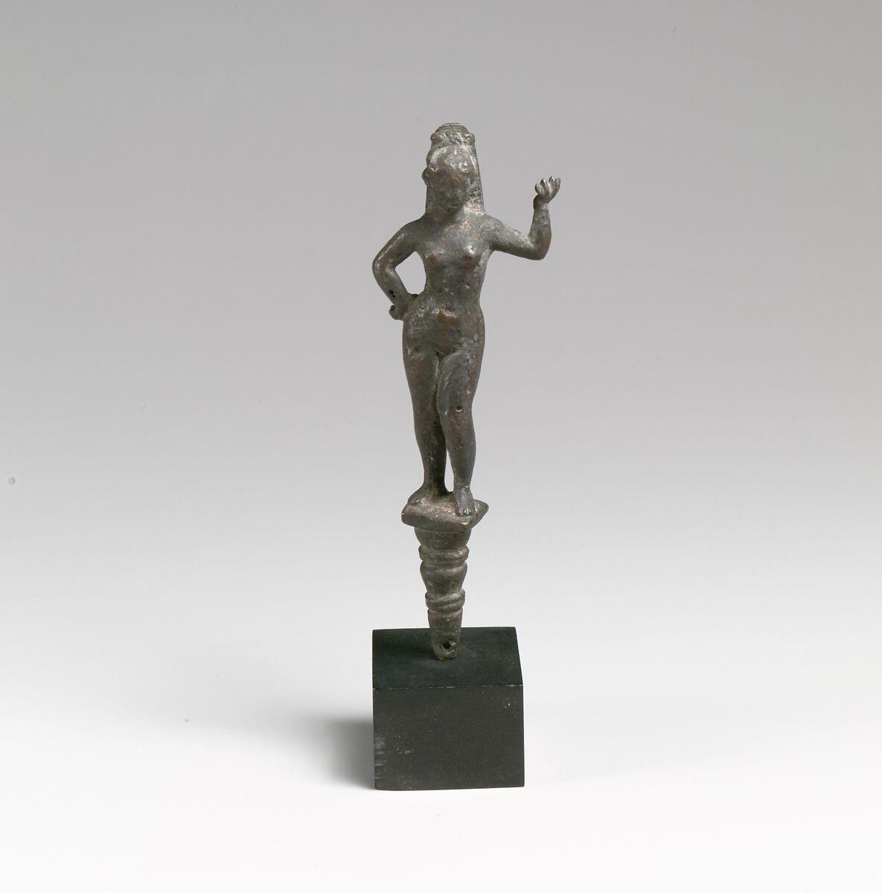the beauty of Aphrodite, the closer she appears

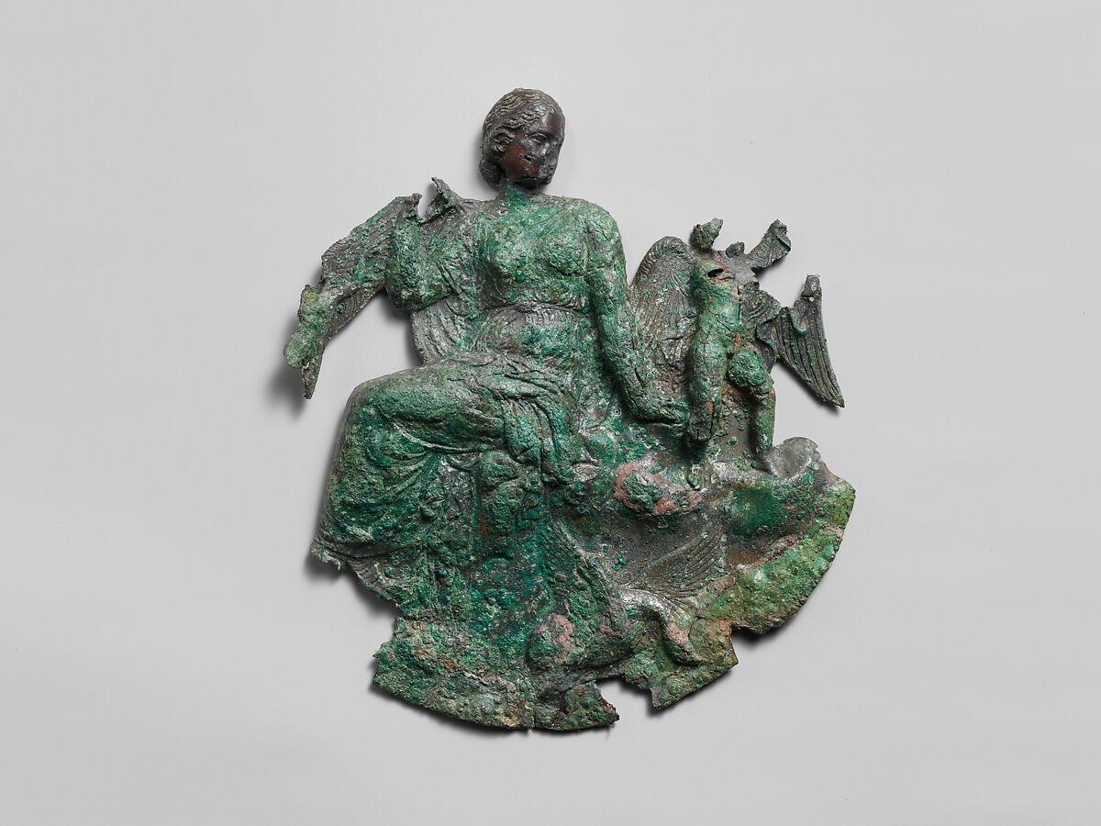to god-like perfection in the eyes of the Greeks. Her impact on beauty extends further than physical aesthetics; reliefs of Aphrodite are seen on many household objects related to beauty. A mirror handle from the 1st-2nd century CE

displays a full-body bronze statuette of the Goddess (fig. 6). She stands confidently, likely acting as a spiritual tool to manifest

beauty to the bearer of the mirror. Similarly, there  exists a bronze relief of Aphrodite that likely

came from the back of another mirror (fig. 7); made

in the 4th century CE, the carving of the Goddess appositely served the

same purpose as the handle.

The Ancient Greeks additionally used their hair to honour the Gods. Men were seen as highly masculine for wearing their hair long and healthy. It was seen as a form of honourship to the divine realm and an extension of their strength and vitality (Martin, 2023). Women were known to express divine worship through hair accessories and length. Long hair in women was considered objectively seducing; this was inspired by the story of Hera’s seduction of Zeus.

Hera, Goddess of marriage, harnessed the length of her beautiful hair to help her seduce Zeus, God of thunder. This lead Greek women to believe that maintaining long, healthy hair would make them appear more beautiful. As well as honouring Hera, the intention of lengthy hair growth also brings honour to Aphrodite, as she is a Goddess of sexuality. Women would decorate their hair with flowers and wreaths to mimic the decorations placed upon Pandora, the first woman created by the Gods. It’s a possibility that women used these honouring systems to feel closer to their Gods, similarly to how modern Christians use their crosses (Ivanova, 2023), (The Delphi Guide, n.d.).

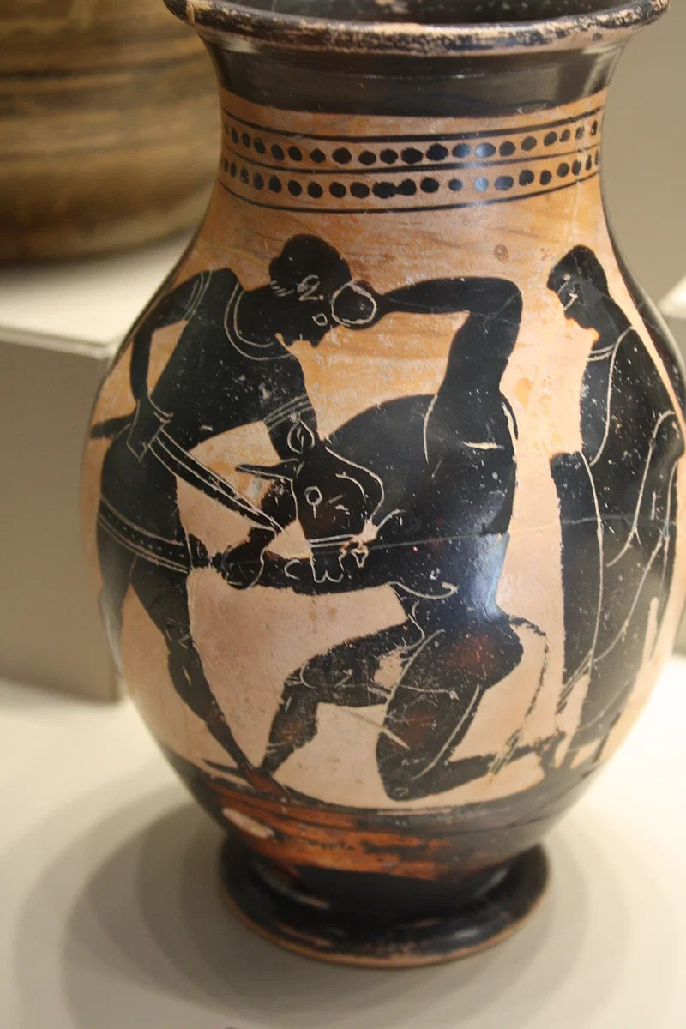Aside from organic beauty, man-made wonders of the Ancient Greek world are widely considered for their divine intentions. As previously observed (fig. 3,4,5, 6), sculptures are a favoured method of displaying the gods. However other evidence demonstrates the domestic and literate aspects of mythologicsl artwork (as supported by Homer’s epics). Many artworks depict legends of Godly success, such as Theseus and the Minotaur (fig. 8). The pot is made using the ‘black figure’ technique, where depicted characters are

blacked out to preserve simplicity. This pot was likely made from clay, and used as a water vessel or storage vase (Cartwright, n.d.). Artworks devoted to mythology have framed many divine figures as a tool to

demonstrate deeper meaning. Greek mythology, being intricate and captivating in essence, provides a large amount of subject matter that artists have harnessed centuries later. While not genuine Greek creations, such paintings are evidence of Greek mythology’s large influence on art - past and present. The first ever plays, written/invented by Greeks, were mostly tragic retellings of mythological legend; this prompted later development in literature and theatre (LSA Classics, 2022). Figures of mythology have been made summed into symbolism; Aphrodite has been used in imagery to represent the feminine nature of the artwork, or to populate the idea of love/seduction to the audience (Meyer, 2022). She is depicted in many paintings of the

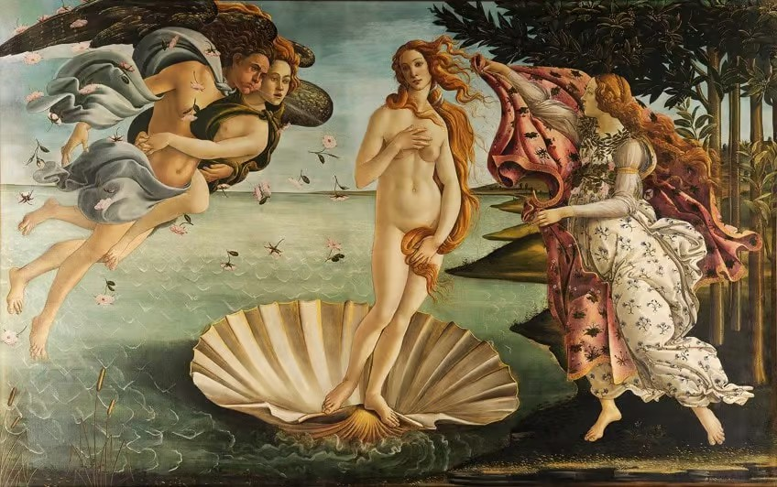renaissance era, most famourly in The Birth of Venus (Sandro Botticelli, 1486) (fig. 9). This painting has since become an item of modern

popular culture, where there exists film cameos and crude recreations. While a distant extension, the responsibility of influence still begins from Greek mythology (Meyer, 2022).

To conclude, Greek mythology *has* influenced the way people have viewed beauty and art - past and

present. The value of strength and heroism was developed from the expectations and idolatry of Ancient Greek Gods. Women took inspiration

from Goddesses such as Hera and Aphrodite; with necessity for pleasantry in personality to appease the divine attributes. Art, a subjective culture, has been a gem of the demonstration of beauty in Grecian society. The Gods have been honoured through intricate sculptures, pottery designs, murals, and theare (etc.). Sculptures provided universal understanding of the physical nature of the Gods, which, in turn, influenced the way Greeks percieved beauty in one another. The influence of Grecian beauty standards, stemmed from the divine, has impacted the way modern people perceive beauty. The desire for symmetry, masculinity has travelled from the Greek Gods to the wants of current-day men. Women, however, are less open to Ancient Grecian beauty standards, as they’re are far too attainable for most women. However, extreme femininity and porcelain-perfection has remained important for women’s visual value. Pottery and murals told the stories behind the divine, spreading their history to greater lands and ages. Theatre allowed pagans to preach their Gods to the world. Such representation from Ancient times, allowed for global recognition of the Greek pantheon and their figures/events. The exploration of Greek mythology brought their Ancient beliefs into the modern world. Greek tragedies have come so far as to have modern artforms (i.e. film) create adaptations from their storytelling. Greek mythology, with evidence provided from primary sources, has heavily influenced beauty and artistry in ways that expand further than their existed era.

**References**

*Ancient Greece*. (n.d.). Wikipedia. Retrieved August 18, 2023, from https://en.wikipedia.org/wiki/Ancient_Greece

Cartwright, M. (n.d.). *Ancient Greek Pottery*. World History Encyclopedia. Retrieved August 24,

2023, from https://[www.worldhistory.org/Greek_Pottery/](http://www.worldhistory.org/Greek_Pottery/)

*Classical Greek culture (article)*. (n.d.). Khan Academy. Retrieved August 18, 2023, from https://[www.khanacademy.org/humanities/world-history/ancient-medieval/classical-greec](http://www.khanacademy.org/humanities/world-history/ancient-medieval/classical-greec) e/a/greek-culture

*The Gods in Greek Tragedy – Lytham St Annes CA*. (2022, March 24). Lytham St Annes Classical Association. Retrieved August 24, 2023, from https://lsaclassics.com/2022/03/24/the-gods-in-greek-tragedy/

*the intriguing hair care and hair styles in Ancient Greece*. (n.d.). theDelphiGuide.com. Retrieved August 24, 2023, from

https://thedelphiguide.com/hair-care-and-hair-styles-in-ancient-greece/

Ivanova, E. (2023, May 8). *Beauty as an Idea in Ancient Greece 101: Ideals of Physical Beauty*.

By Arcadia. Retrieved August 20, 2023, from

https://[www.byarcadia.org/post/beauty-as-an-idea-in-ancient-greece-101-ideals-of-physic](http://www.byarcadia.org/post/beauty-as-an-idea-in-ancient-greece-101-ideals-of-physic) al-beauty

Ivanova, E. (2023, July 19). *Beauty as an Idea in Ancient Greece 101: Beauty and Mythology*.

By Arcadia. Retrieved August 18, 2023, from

https://[www.byarcadia.org/post/beauty-as-an-idea-in-ancient-greece-101-beauty-and-myt](http://www.byarcadia.org/post/beauty-as-an-idea-in-ancient-greece-101-beauty-and-myt) hology

Kline, A. (n.d.). *Homer - The Odyssey: Book XXIV*. Poetry In Translation. Retrieved August 20, 2023, from https://[www.poetryintranslation.com/PITBR/Greek/Odyssey24.php#BkXXIV98](http://www.poetryintranslation.com/PITBR/Greek/Odyssey24.php#BkXXIV98)

Martin, N. (2023, June 16). *Untangling the Legacy: The Untold Story of Men's Long Hair in Greek History*. Greek City Times. Retrieved August 20, 2023, from https://greekcitytimes.com/2023/06/16/untangling-the-legacy-the-untold-story-of-mens-lo ng-hair-in-greek-history/

Meyer, I. (2022, June 9). *Famous Greek Paintings of Gods - The Best Greek Mythology*

*Paintings*. Art in Context. Retrieved August 24, 2023, from https://artincontext.org/famous-greek-paintings-of-gods/

Sudarshan, A. (2021, September 14). *A Brief History of Beauty. We humans have been alive for a long… | by Anvita Sudarshan | Medium*. Anvita Sudarshan. Retrieved August 18, 2023, from https://anvitasudarshan.medium.com/a-brief-history-of-beauty-96e513e2217

*The Vitruvian Man History & Proportions | What Is the Vitruvian Man? - Video & Lesson Transcript*. (2022, April 16). Study.com. Retrieved August 20, 2023, from <https://study.com/learn/lesson/vitruvian-man-history-proportions.html>

|  |  |  |
| --- | --- | --- |
| Performance standard | Grade | Comment |
| KU1 Knowledge and understanding of texts, artefacts, ideas, events, and/or people. | B | Student has demonstrated some depth in their knowledge and understanding of Greek mythology and its representation in art and beauty standards. |
| KU2 Recognition of, and reflection on, political, social, cultural, and/or economic diversity within the ancient world. | B | Some thoughtful reflection on the cultural diversity of ancient Greece, particular around the differences in beauty standards between men and women. |
| KU3 Knowledge and understanding of literary, historical and/or archaeological concepts. | B | Some depth of knowledge and understanding of art styles, pottery techniques, and representation through material items. |
| RA1 Research into and analysis of primary and secondary sources and perspectives. | B | Well-considered research into artwork/sculptures from ancient Greece with the different primary sources analysed to support the student’s ideas and argument. Evidence of well-considered research into secondary sources and perspectives. |
| RA2 Research into and understanding of ideas or innovations that emerged from the ancient world, and consideration of their influence. | B | Student has demonstrated thoughtful research into the influence of Greek mythology on artwork and beauty standards. Consideration of this influence is implied throughout the student’s argument, and summarised in the conclusion. Some depth has been given to this consideration, with some references made to the modern world, albeit not as strong as the connections made to the ancient world. |
| A1 Synthesis of evidence and appropriate acknowledgment of sources. | B | Well-considered synthesis of primary and secondary source evidence to support ideas and arguments. Sources have been acknowledged appropriately throughout via in-text referencing and a reference list. |
| A2 Communication of ideas and arguments, using subject-specific language. | C | Communication of ideas is informed with some persuasiveness. Some subject-specific language has been used. |
| A3 Evaluation of the nature of sources and evidence. | B | Accurate evaluation of the nature of sources, interwoven with the student’s consideration of the influence of mythology on the artwork/beauty standard. |
| Overall grade: | B | 22/30 |