
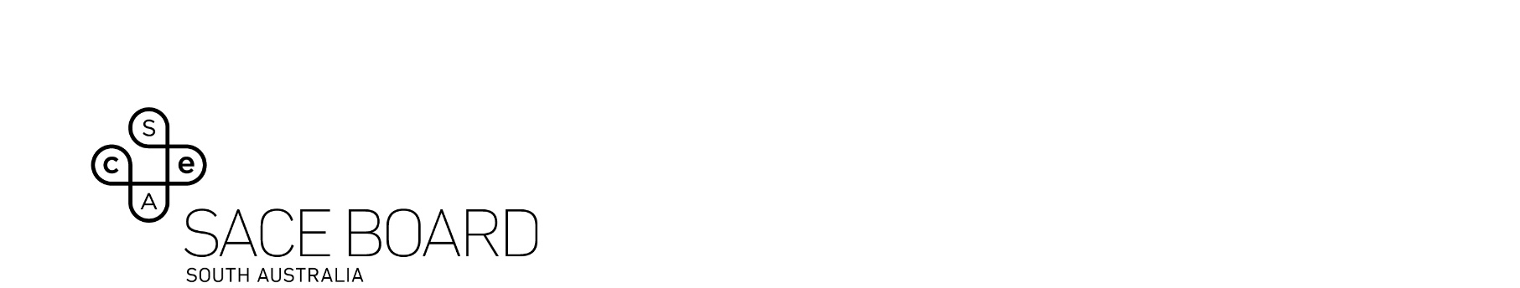
2024 Politics, Power and People Subject Assessment Advice

Overview
Subject assessment advice, based on the 2024 assessment cycle, gives an overview of how students performed in their school and external assessments in relation to the learning requirements, assessment design criteria, and performance standards set out in the relevant subject outline. They provide information and advice regarding the assessment types, the application of the performance standards in school and external assessments, and the quality of student performance.
Teachers should refer to the subject outline for specifications on content and learning requirements, and to the subject operational information for operational matters and key dates.

School Assessment
Teachers can improve the moderation process and the online process by:
- thoroughly checking that all grades ae entered in schools online are correct
- ensuring that uploaded tasks are clear and removing blank pages and student notes.

Assessment Type 1: Folio (50%)
As in previous years, students were to undertake at least three folio assessments. This assessment type provides the opportunity to work in the following assessment design criteria areas: Critical and Creative Thinking, Communication and Collaboration, Understanding and Ethical Reasoning, and Research and Analysis as defined in the subject outline.
Teachers can elicit more successful responses by:
- including a mixture of tasks with different levels of complexity
- providing or encouraging opportunities to show an argumentative style
- ensuring that a range of interpretations are promoted.
The more successful responses commonly:
- explored and analysed political issues in-depth, UER1
- had a wide range of perspectives
- were highly organised, critical analysis of research, CCT1
- were impressive and innovative, UER2
- had impressive coverage of the contemporary Australian political scene, UER 1
- offered balanced thoughtful evaluations of political actions in response to the issue, RA2clearly demonstrated where and to what extent collaboration was used, CC2
- used a wide range of appropriate political sources beyond only web sites, RA1
The less successful responses commonly:
- were too general overall and overused dot points
- did not construct challenging questions
- were too descriptive rather than critical
- had discussions that rarely offered balanced judgments
- had discussions that lacked organisational structure
- listed impacts of events which were not explored
- provided statistics without any criticism of the source.

Assessment Type 2: Source Analysis (20%)
As in previous years, students were to undertake at least two source analysis. This assessment type provides the opportunity to work in the following assessment design criteria areas: Critical and Creative Thinking, Communication and Collaboration, Understanding and Ethical Reasoning as defined in the subject outline.
Teachers can elicit more successful responses by:
- encouraging students to use more recent source material
- looking to use a diversity of source material
- making it clear how much is required in each sub part of the question/s.
The more successful responses commonly:
- used comparatively ‘recent’ source material
- used clearly worded questions
- used multi-media components to advantage
- did not attempt too many source analysis skills in the one question
- checked that a ‘clash’ of ideas/ideals were present in the materials to be analysed
- used a range of social media platforms to advantage
- critically considered the usefulness and evaluation of sources
- on occasions, worked collaboratively to advantage
- had questions that clearly stated how many words were expected in each short answer response.
The less successful responses commonly:
- had minimal use of ‘external’ knowledge
- showed a limited or superficial analysis
- recounted information from the source
- assumed the editorials were without bias
- responses were not explained
- did not define the issue clearly
- did not discuss who is involved, their power and their impact on the outcomes.

External Assessment

Assessment Type 3: Investigation (30%)
As in previous years, students were to investigate a contemporary local, national, or international political issue that is of personal interest from one of the option themes. This assessment type provides the opportunity to work in the following assessment design criteria areas: Critical and Creative Thinking, Communication and Collaboration, Understanding and Ethical Reasoning as defined in the subject outline.
The more successful responses commonly:
- proposed some ‘insightful solutions’ so as to satisfy the Performance Standards as in CCT1
- had focused clear and contemporary political issues
- ensured, as in the past, that the guiding question was clearly addressed throughout the paper and in the final paragraph
- demonstrated extensive and wide-ranging research using primary and secondary sources
- had primary interviews/opinions throughout, RA2
- covered a topic with a contemporary political focus with fluent communication, CC1
- had charts and/or graphs and/or statistics, which were clearly annotated; RA1
- there was comprehensive use of email responses, RA1
- arguments were clear and cohesive
- seamless integration of political terminology and concepts
- made critical use of social media, UER2
- proposed some ‘insightful solutions’, CCT1
- convincingly linked the final paragraph to the key initial question
- demonstrated fluent expression with a well organised structure.
The less successful responses commonly:
- used overly broad or unfocused questions’
- sometimes omitted recommendations
- had argument and sentence structure that lacked fluidity
- showed limited inquiry skills
- spent too much too on the ‘history’ of the Investigation topic
- provided a vague task question or hypothesis
- formatting and communication of ideas was inconsistent
- lacked one or more of in-depth coverage, nuance, or fluidity.

