Stage 2 Physical Education
Assessment Type 2: Folio
Response 1: Application of Concepts covered in Exercise Physiology to the Sport of Team Handball

QUESTION 1:
Team Handball is dominated by intermittent activity– essentially alternating periods of high and low effort (Players perform 190 rhythm changes - changes in tempo of footwork ) – this change in the dominance of the energy systems during changes in game related efforts is essential to prolonged and effective performance.
At the 9 minute mark of the first half, the player's heart rate is nearly 100% of maximum. Hypothetically he takes the ball and sprints 10 meters to jump and throw a goal – requiring a maximal 8-10 second effort. In this case ATP-CP system is the dominant energy system because of the inability of the aerobic system to supply enough oxygen to the muscles to be dominant. An effort requiring a longer maximal effort of up to 2 minutes would see the lactic acid system become the dominant pathway.
Knowledge and Understanding In-depth knowledge and understanding of exercise physiology.
Following this the player jogs back to his defensive 6 meter goal line to defend the oppositions re-start. 60% of maximal heart rate in the 11 minute mark of the first half highlights this. This sub-maximal effort sees the aerobic system become the dominant contributor of the energy accessed because the energy demands of the effort’s are met based on the provision and delivery of oxygen to the muscles by the cardiac and respiratory systems. (diagram below summarises this)
Critical Analysis and Evaluation Highly discerning evaluation of the relevance of principles and concepts to a given situation.
The mutual dependence of the different body's energy systems is the key to this concept of "interplay" During anaerobic efforts seen above creatine phosphate and glycogen are utilised to re-build ATP. In doing so they produce lactic acid (9 mmols as seen in the data) and deplete creatine phosphate. When the player jogs back to his defensive area ( a sub-maximal effort) it not only allows him to use aerobic pathways for energy – but they also enable fundamental breakdown of lactic acid produced during previous anaerobic efforts and the re-building of creatine phosphate used. This alternation between the systems is essential to sustained performance during the overall game because it is the key to delaying the onset of fatigue and maintaining consistent performance.
Knowledge and Understanding In-depth knowledge and informed understanding of physical education concepts relevant to specific physical activities.

QUESTION 2:
Many changes in the tempo occur in Handball requiring the player to exhibit different levels of effort. Such changes cause immediate adaptations (in seconds and minutes) to key body systems ensuring the working muscles are supplied with ample amounts of blood and oxygen needed to function properly - the so called "acute responses".
The following table highlights these changes in effort (intensity):
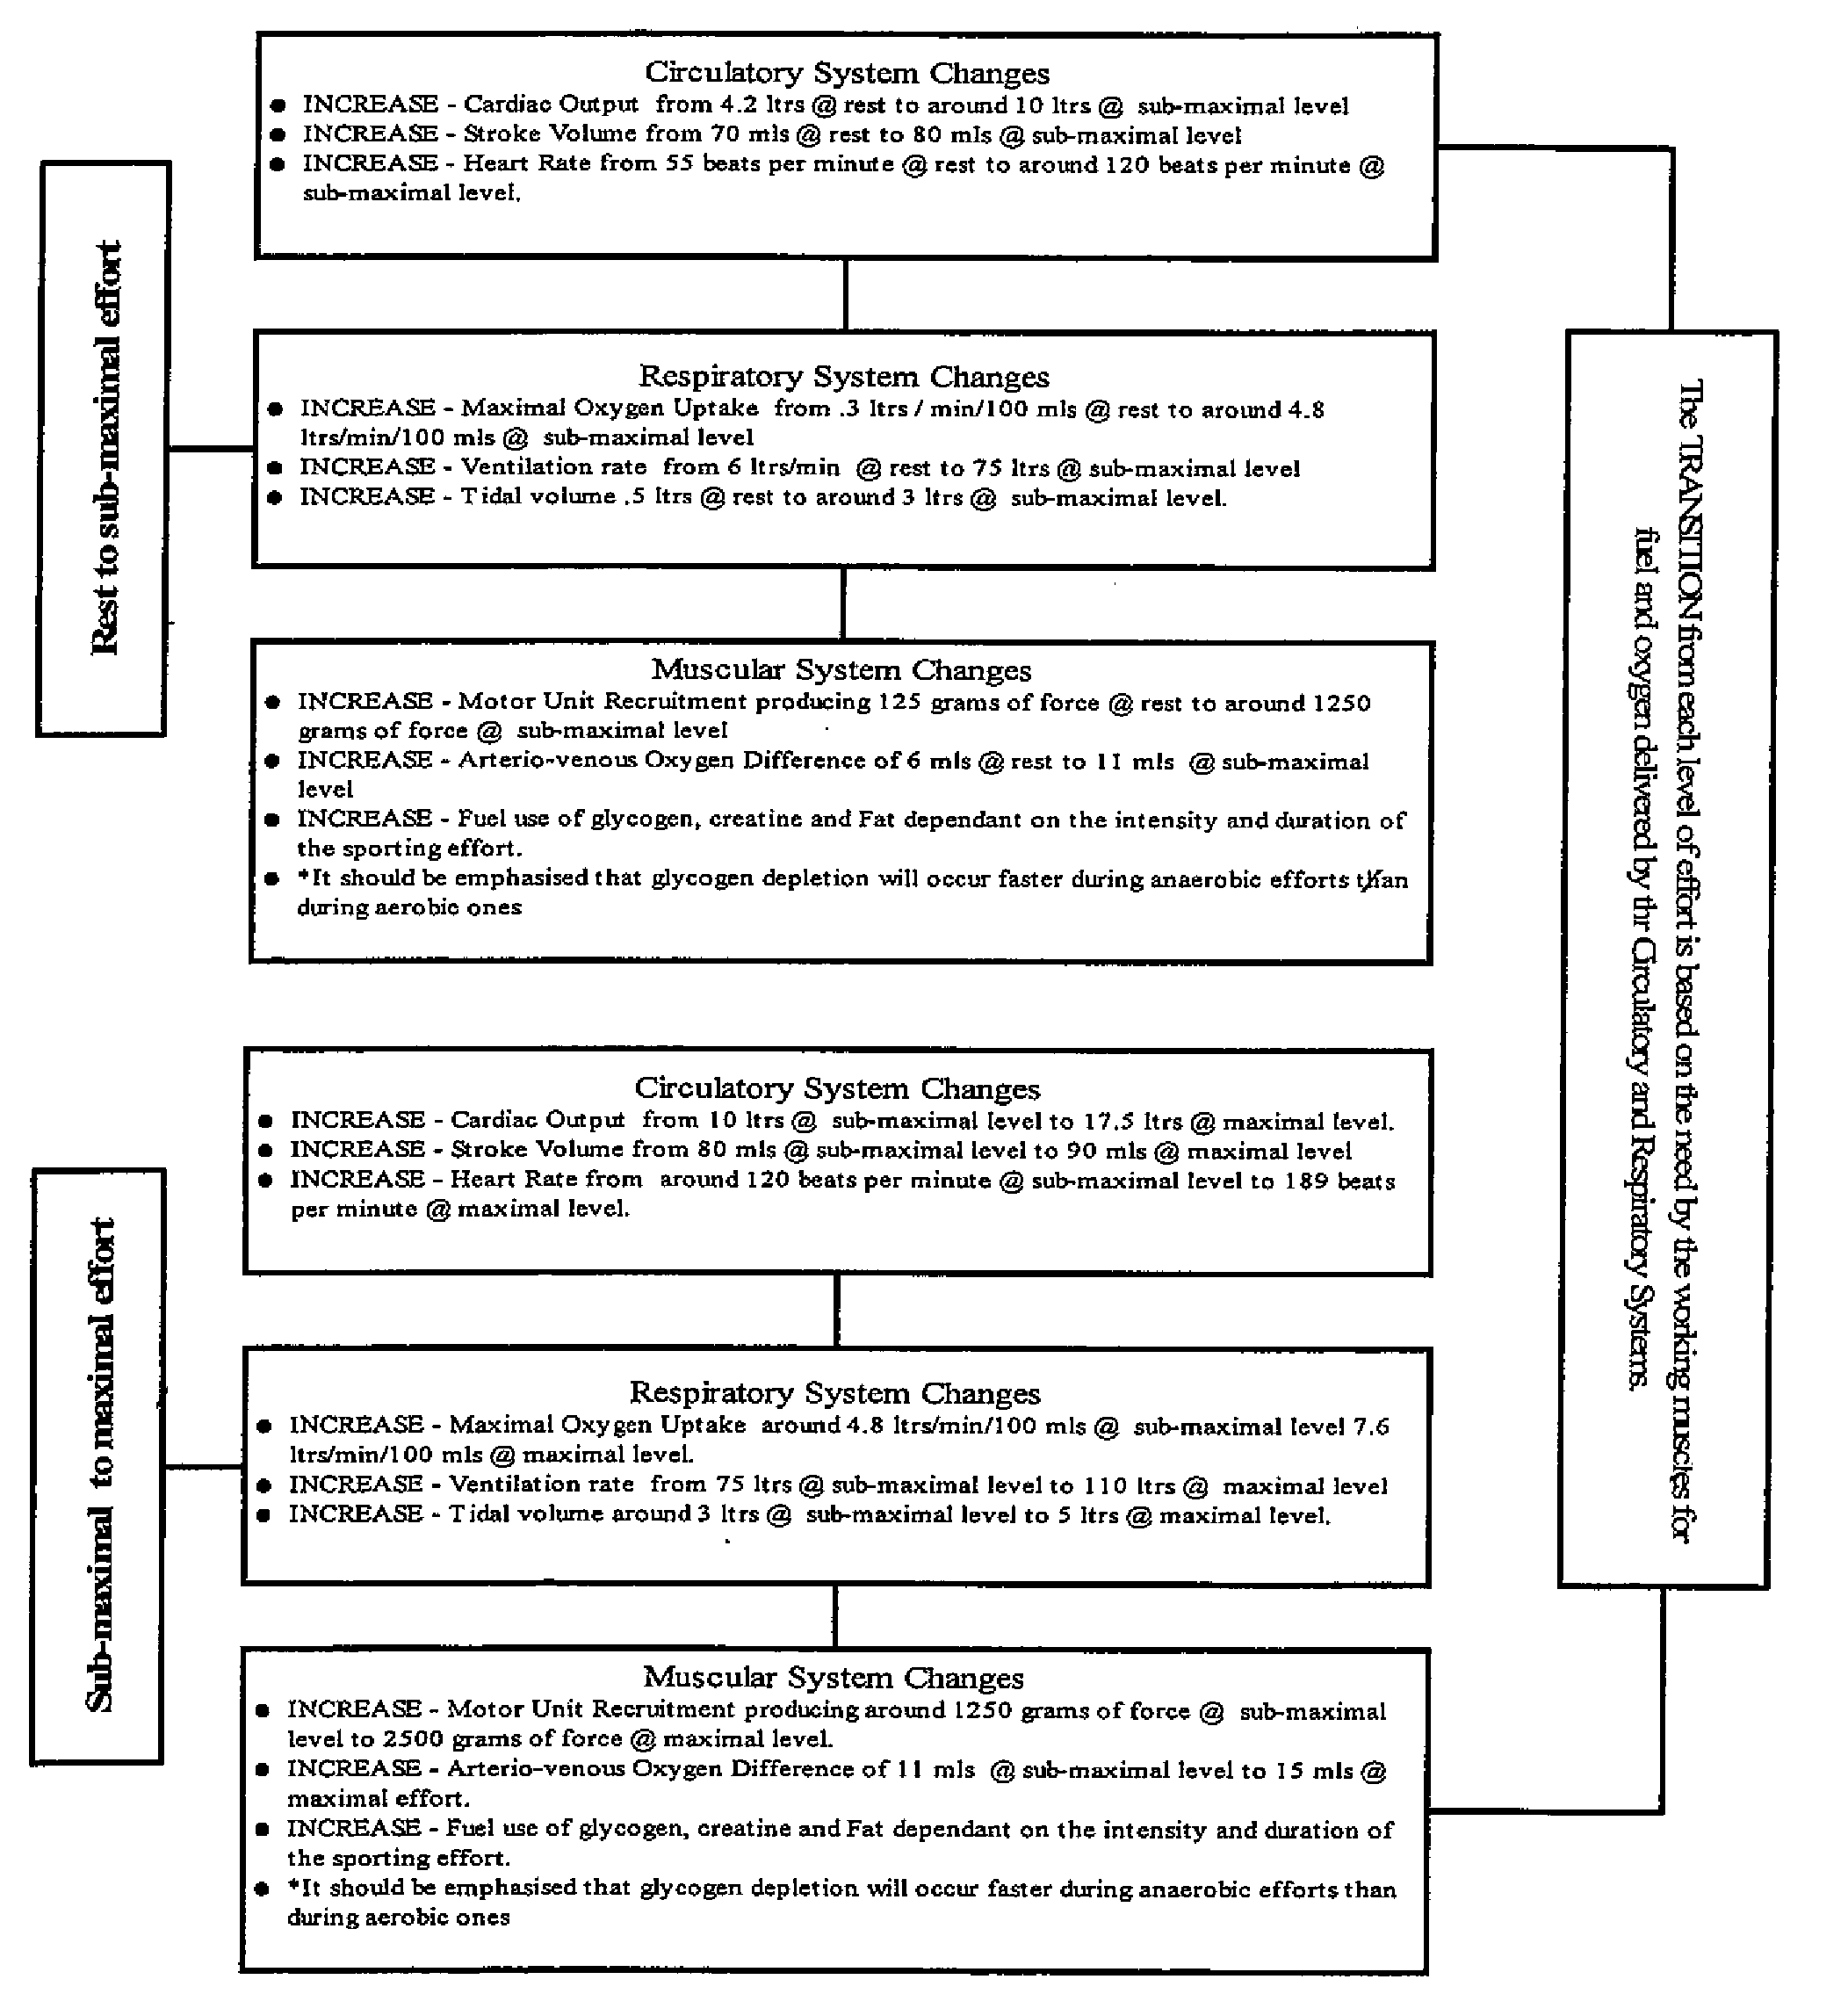
Knowledge and Understanding In-depth knowledge and understanding of exercise physiology.
Knowledge and Understanding Clear and accurate knowledge and understanding of appropriate terminology.
What we see above is that body systems ability to deliver ample oxygen to the muscles during activity is the premise behind the "acute responses".
Critical Analysis and Evaluation Highly discerning evaluation of the relevance of principles and concepts to a given situation.
For example the game required a sub-maximal at the 8-10 minute mark, but a maximal one at the 15 minute mark. Using the circulatory system as an example of these responses, such maximal efforts required a 43% increase in blood output compared to those at rest or sub-maximal efforts. Similar changes would occur in the respiratory and muscular systems.
QUESTION 3:
Post first half player's heart rate drops from a high to a low percentage of maximal heart rate. This indicates heart rate does not simply drop to resting levels immediately after high level activity. This is referred to as Excess Post-Exercise Oxygen Consumption. Key processes that enable recovery to occur at this time include: (i) the restoration of ATP and CP stores (referred to as alactacid debt , where creatine phosphate is re-built – taking between 2-5 minutes depending on the recovery strategy employed) (ii) the removal of Lactic Acid (referred to as lactacid debt , where ATP is rebuilt and lactic acid removed – taking up to 1 hour depending on recovery strategy employed) (iii) the dispersal of heat produced during muscular activity (iv) the removal of adrenaline – the hormone secreted by the body at the onset of activity causing heart and breathing rates to increase and (iv) the replenishment of oxygen to pre-exercise levels in the myoglobin, surrounding tissues and blood.
Knowledge and Understanding Clear and accurate knowledge and understanding of appropriate terminology.

QUESTION 4:
Data indicates both players start the game with equal amounts of muscle glycogen.
Knowledge and Understanding Well-considered knowledge and informed understanding of physical education concepts relevant to specific physical activities.
Player B is the right winger because his position requires him to move large distances (between 10-30 meters per effort) forward and back at high intensity, e.g. – 485 high intensity efforts in 60 minutes at an average of 8 per minute. During these he is required to provide bursts of power and speed in order to create options, and ultimately score goals during game play. To do this he requires fuels that provide energy quickly and effectively. Data indicates B has reduced pre-match glycogen levels to just above 1 gm/100 gm post match (a 45% reduction) reflecting the demands of this position.
Player A who exhibits a lower level of glycogen depletion post game is the goalkeeper. He performs many game efforts in the six meter circle - jumping, diving and occasionally running towards the ball. A large portion of these efforts are at a low level of effort. Data indicates A has reduced pre- game glycogen levels to just above 1.6 to 1.7 gm /100 gm post match (a 25% reduction) indicative of the demands related to a goalkeeper.
Critical Analysis and Evaluation Logical evaluation of the relevance of principles and concepts to a given situation.
QUESTION 5:
The two dominant fitness components clearly evident in data required in Handball are:
Knowledge and Understanding In-depth knowledge and informed understanding of physical education concepts relevant to specific physical activities.
- Speed – the ability to put body parts into motion quickly and to sustain high intensity efforts. Data indicated players sprinted 451 meters during a match (maximal/high intensity efforts). These efforts are clearly speed related.
A key test of this is the 40 meter sprint test.
- Cardio-respiratory endurance - the capacity of heart, lungs and blood vessels to deliver oxygen efficiently to sustain aerobic activity. Data indicates in a 1 hour game players execute sub-maximal efforts such as walking (620 meters) and jogging (707). These efforts require cardio-respiratory fitness.
The Beep Test is a good test of this component.

Additional Comments
The response displays:
- very comprehensive use of appropriate exercise physiology terminologies
- relevant use of specific examples during game play to highlight specific concepts
- succinct discussion in responses (within the 1000 word maximum for an integrated task)
- accurate use of data and profile information to highlight and identify concepts
- appropriate terminologies in response to Question 3 however more focus on the specific requirement of the question would have further supported the response
- accurate identification of appropriate players in response to Question 4, including the impact of game movements on glycogen depletion. However, discussion of glycogen utilization in both aerobic and anaerobic circumstances would support the response.
On balance, the response displays evidence of:
- In-depth knowledge and informed understanding of physical education concepts relevant to specific physical activities
- Highly discerning evaluation of the relevance of principles and concepts to a given situation.
Performance Standards for Stage 2 Physical Education
 | Knowledge and Understanding | Practical Skills Application | Initiative and Collaboration | Critical Analysis and Evaluation
A | In-depth knowledge, informed understanding, and accurate application of physical education concepts relevant to specific physical activities.  In-depth knowledge and understanding of exercise physiology, the biomechanics of human movement, and skills acquisition.  Clear and accurate knowledge and understanding of appropriate terminology. | A high level of proficiency in the performance of physical activities, with reference to specific skills criteria.  Accurate interpretation and proactive application of skills, specific concepts, ideas, strategies, and techniques, in a practical context. | A proactive approach to demonstrating initiative, self-reliance, and leadership in practical activities.  Co6nstructive and confident interpersonal and collaborative skills in team situations. | Thorough and insightful critical analysis of practical techniques and performance.  Highly discerning evaluation of the relevance of principles and concepts to a given situation.  Perceptive and critical analysis and evaluation of an issue related to physical activity and clearly relevant to local, regional, national, or global communities.  Thorough and focused use of information from different sources, with appropriate acknowledgment.
B | Well-considered knowledge, informed understanding, and thoughtful application of physical education concepts relevant to specific physical activities.  Some depth of knowledge and understanding of exercise physiology, the biomechanics of human movement, and skills acquisition.  Mostly clear knowledge and understanding of appropriate terminology. | Proficiency in the performance of physical activities, with reference to specific skills criteria.  Capable interpretation and active application of skills, specific concepts, ideas, strategies, and techniques, in a practical context. | An active approach to demonstrating initiative, self-reliance, and leadership in practical activities.  Confident interpersonal and collaborative skills in team situations. | Detailed critical analysis of practical techniques and performance.  Logical evaluation of the relevance of principles and concepts to a given situation.  Critical analysis and evaluation of an issue related to physical activity and relevant to local, regional, national, or global communities.  Mostly focused use of information from different sources, with appropriate acknowledgment.
C | Considered knowledge, informed understanding, and competent application of physical education concepts relevant to specific physical activities.  Considered knowledge and understanding of exercise physiology, the biomechanics of human movement, and skills acquisition.  Competent knowledge and understanding of appropriate terminology. | Competent performance in physical activities, with reference to specific skills criteria.  Competent interpretation and application of skills, specific concepts, ideas, strategies, and techniques, in a practical context. | Generally effective demonstration of initiative and self-reliance, and some contribution to leadership in practical activities.  Appropriate interpersonal and collaborative skills in team situations. | Some critical analysis of practical techniques and performance, with a tendency to rely on description.  Generally clear evaluation of the relevance of principles and concepts to a given situation.  Some critical analysis and evaluation of an issue related to physical activity that has some relevance to local, regional, national, or global communities.  Competent use of information from different sources, with appropriate acknowledgment.
D | Recognition and some understanding of physical education concepts relevant to one or more specific physical activities.  Some recognition and understanding of aspects of exercise physiology, the biomechanics of human movement, and/or skills acquisition.  Some recognition and understanding of basic terminology that may be appropriate. | Some competence in aspects of the performance of physical activities, with reference to specific skills criteria.  Inconsistent interpretation and application of skills, specific concepts, or ideas, in a practical context. | Occasional demonstration of initiative and self-reliance in practical activities, with support.  Occasional demonstration of collaborative skills in team situations, with some use of interpersonal skills. | Some consideration and basic description of a narrow range of practical techniques and performance.  Some consideration of the relevance of principles and concepts to a given situation.  Basic description of some aspects of an issue related to physical activity but with limited relevance to local, regional, national, or global communities.  Some use of information from more than one source, with attempted acknowledgment.
E | Limited awareness and application of one or more physical education concepts.  Limited awareness of aspects of exercise physiology, the biomechanics of human movement, or skills acquisition.  Limited awareness of basic terminology that may be appropriate. | Limited performance in one or more physical activities, with reference to specific skills criteria.  Emerging ability to interpret or apply skills, specific concepts, or ideas, in a practical context. | Some recognition of the need for initiative, self-reliance, or leadership in practical activities.  Emerging collaborative skills in team situations, with limited use of interpersonal skills. | Identification and some limited description of one or more practical techniques or performance.  Recognition of the need to consider the relevance of principles and concepts for a given situation.  Disconnected description of an issue related to physical activity.  Attempted use of information from a source, with limited acknowledgment.

