Student Work
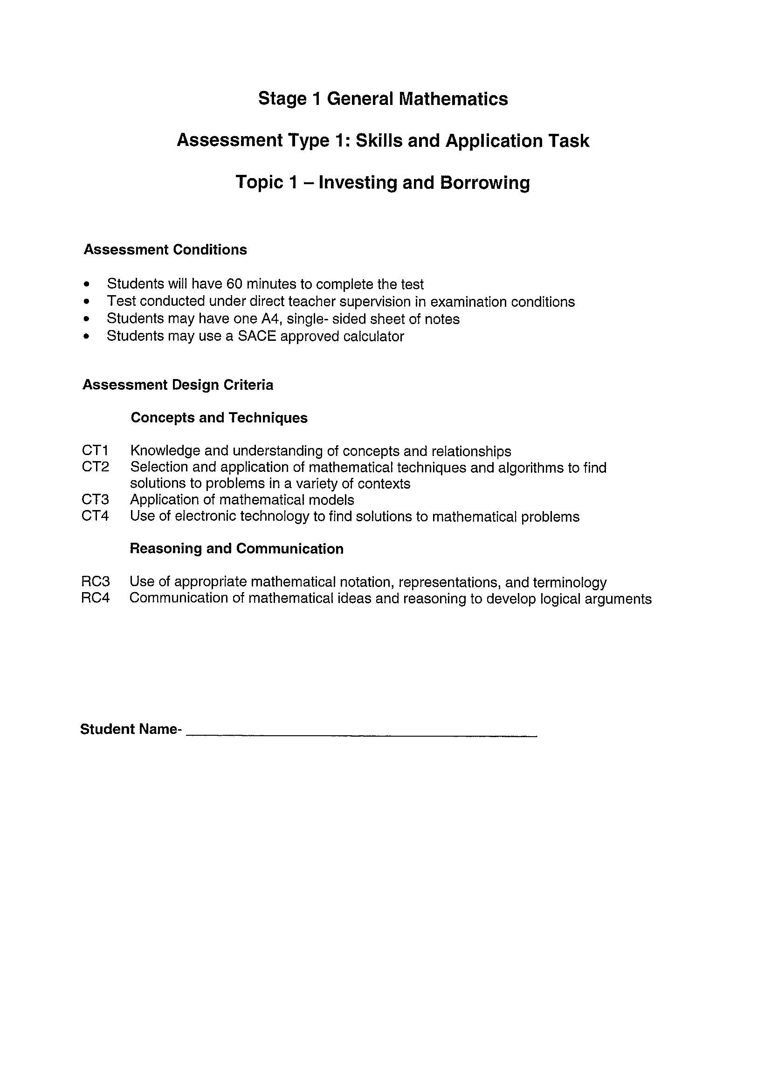
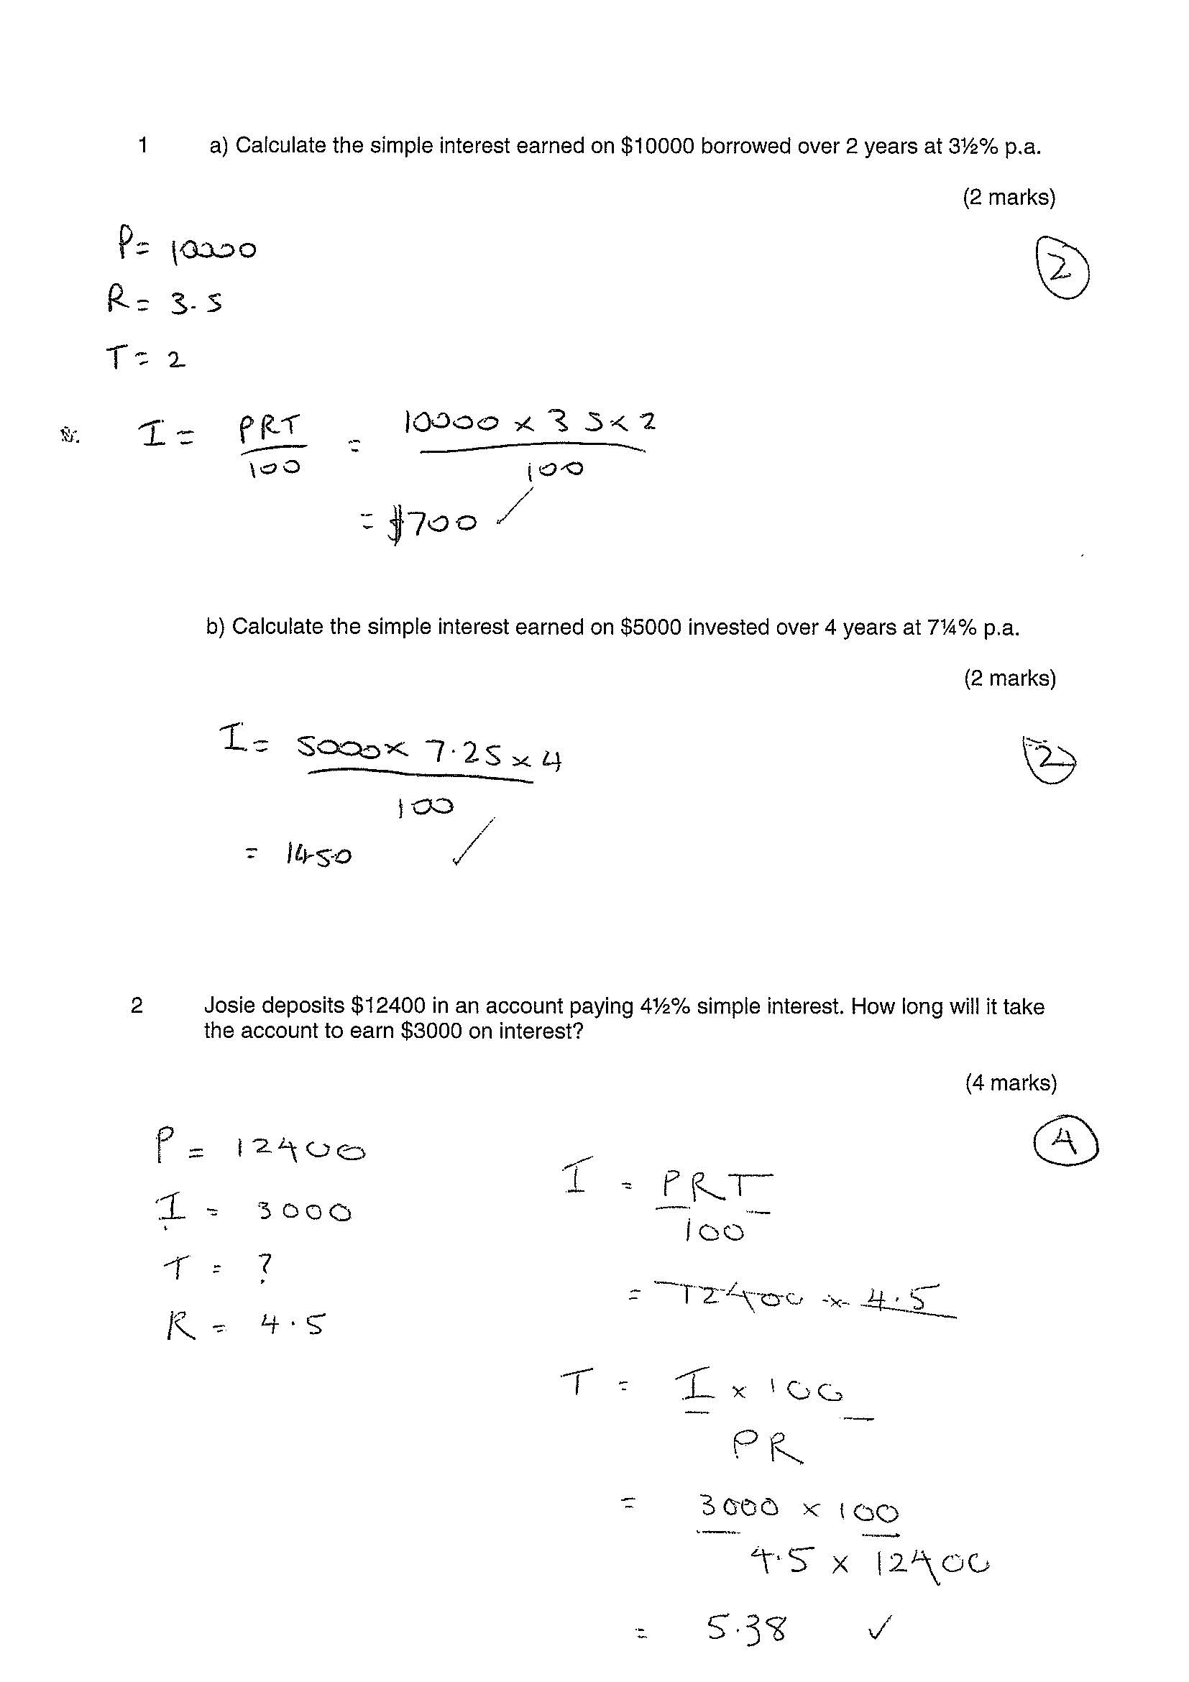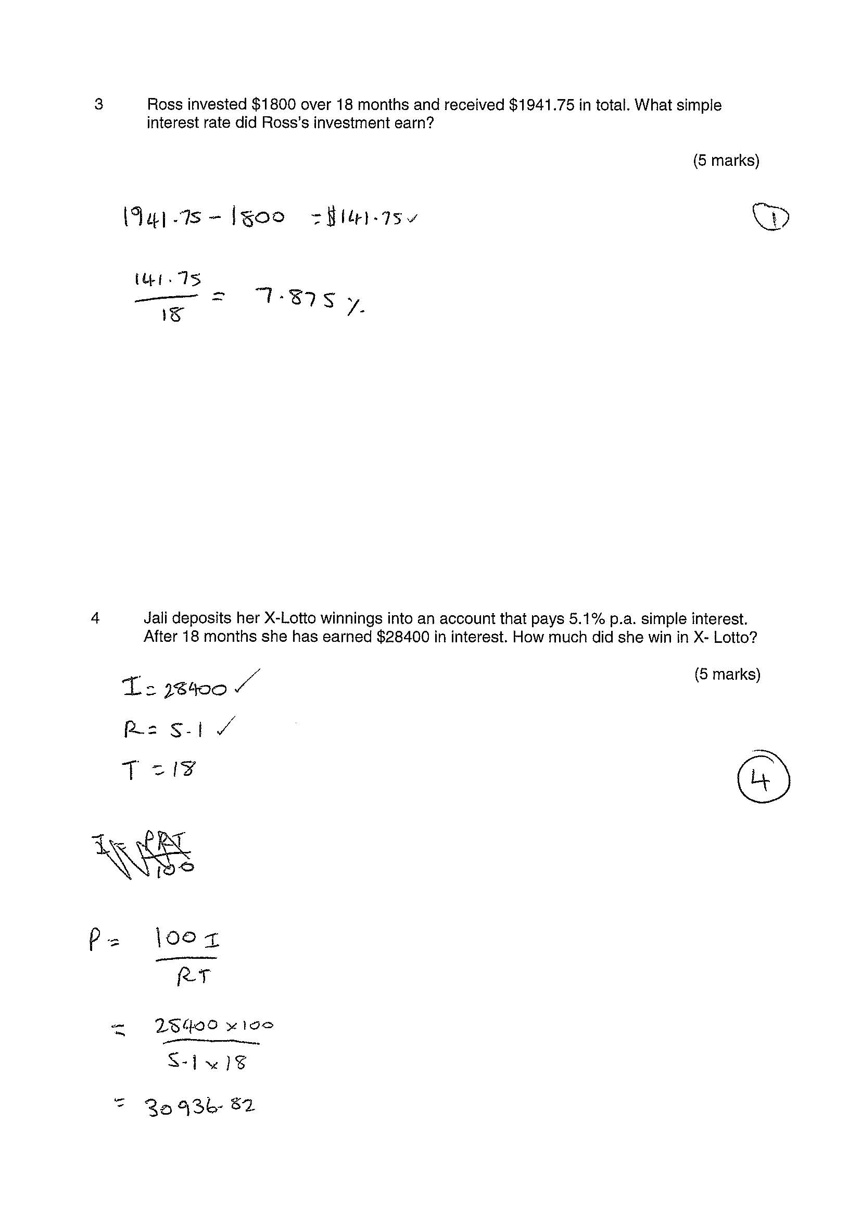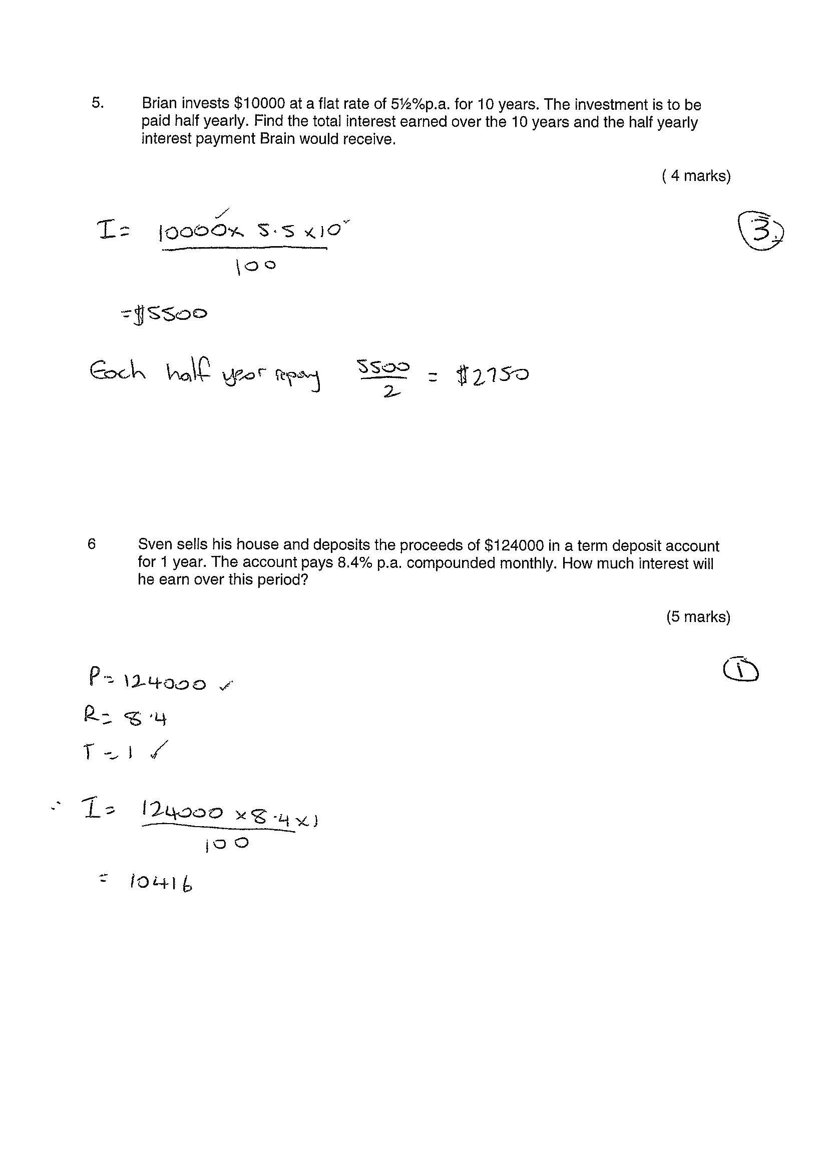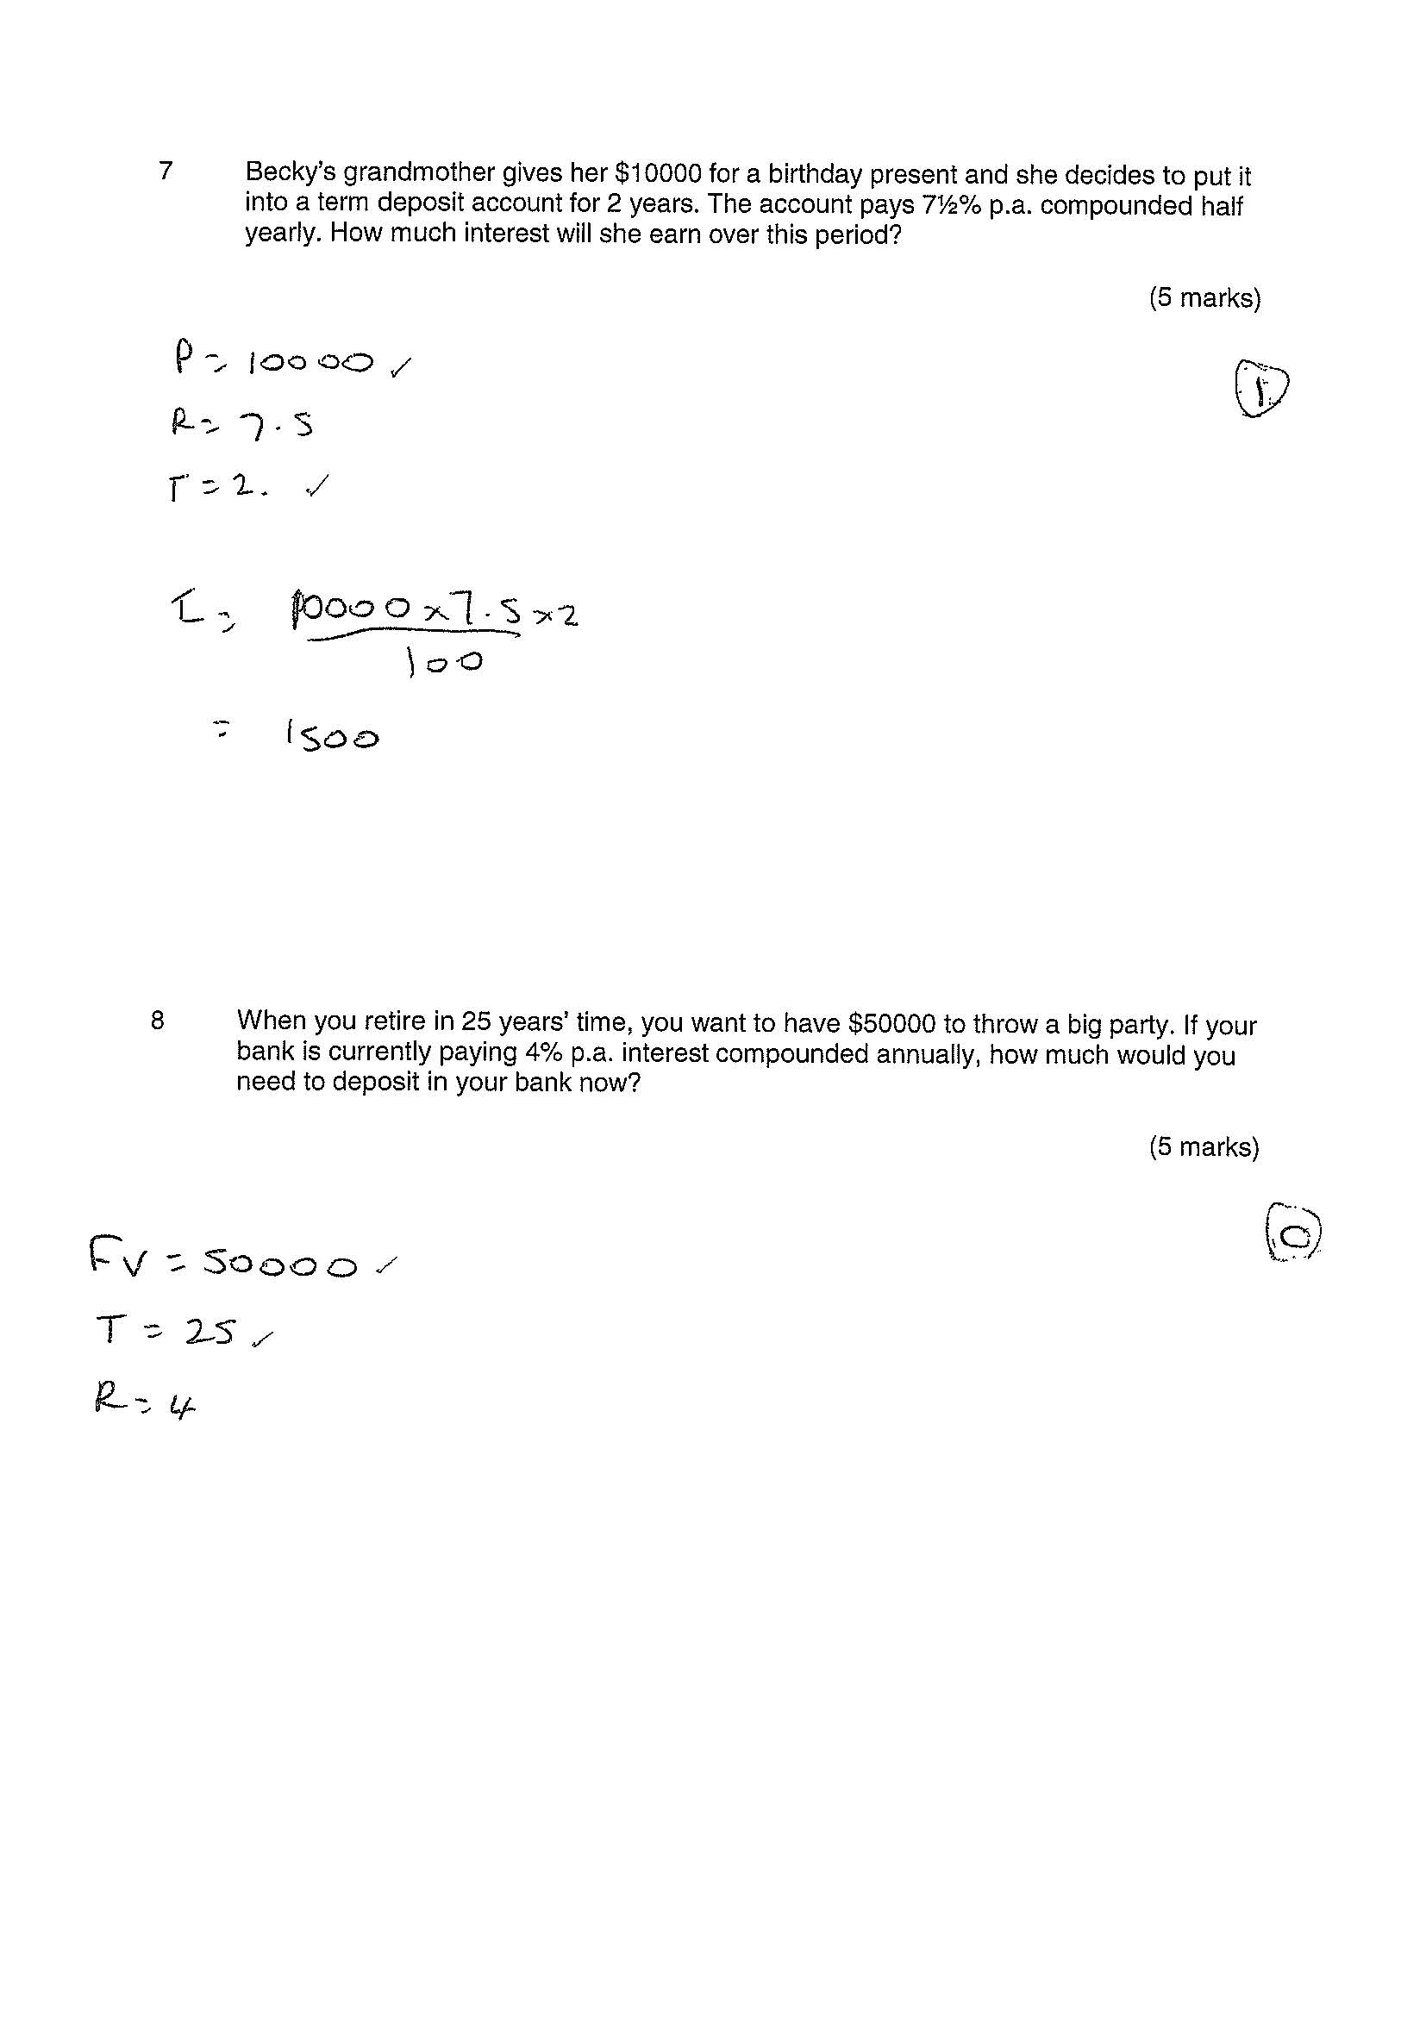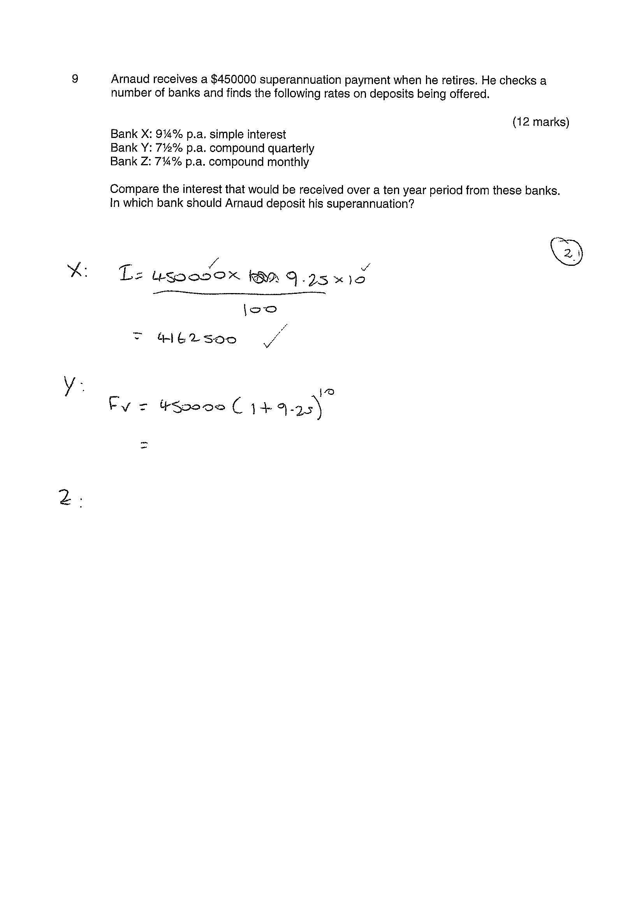
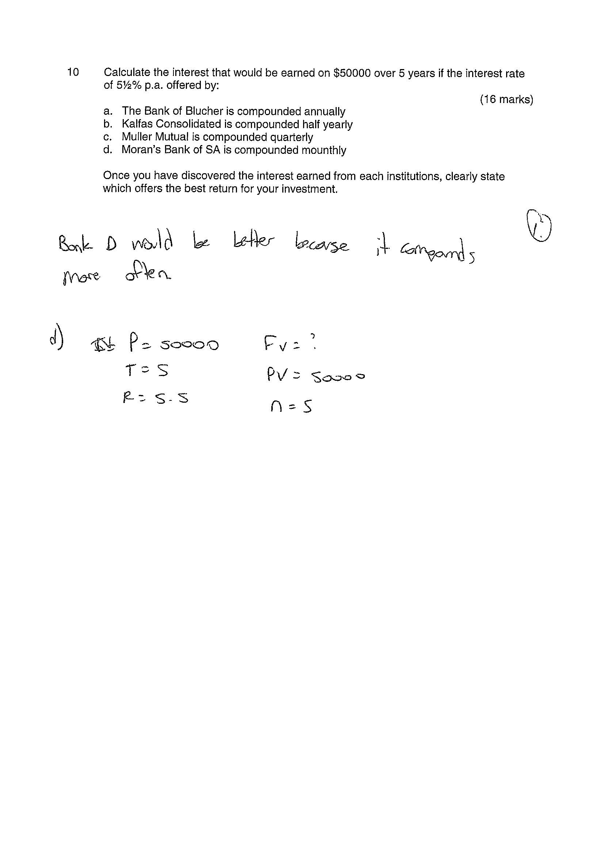

- | Concepts and Techniques | Reasoning and Communication
C | Generally competent knowledge and understanding of concepts and relationships.  Generally effective selection and application of mathematical techniques and algorithms to find mostly accurate solutions to routine problems in different contexts.  Application of mathematical models to find generally accurate solutions.  Generally appropriate and effective use of electronic technology to find mostly accurate solutions to routine problems. | Generally appropriate interpretation of mathematical results in the context of the problem.  Drawing some logical conclusions from mathematical results, with some understanding of their reasonableness and limitations.  Generally appropriate use of mathematical notation, representations, and terminology, with reasonable accuracy.  Generally effective communication of mathematical ideas and reasoning to develop some logical arguments.  Formation of an appropriate prediction and some attempt to test it using mathematical evidence.
D | Basic knowledge and some understanding of concepts and relationships.  Some selection and application of mathematical techniques and algorithms to find some accurate solutions to routine problems in context.  Some application of mathematical models to find some accurate or partially accurate solutions.  Some appropriate use of electronic technology to find some accurate solutions to routine problems. | Some interpretation of mathematical results.  Drawing some conclusions from mathematical results, with some awareness of their reasonableness.  Some appropriate use of mathematical notation, representations, and terminology, with some accuracy.  Some communication of mathematical ideas, with attempted reasoning and/or arguments.  Attempted formation of a prediction with limited attempt to test it using mathematical evidence.
E | Limited knowledge or understanding of concepts and relationships.  Attempted selection and limited application of mathematical techniques or algorithms, with limited accuracy in solving routine problems.  Attempted application of mathematical models, with limited accuracy.  Attempted use of electronic technology, with limited accuracy in solving routine problems. | Limited interpretation of mathematical results.  Limited understanding of the meaning of mathematical results, their reasonableness or limitations.  Limited use of appropriate mathematical notation, representations, or terminology, with limited accuracy.  Attempted communication of mathematical ideas, with limited reasoning.  Limited attempt to form or test a prediction.

Benchmark decision = D

Benchmark notes
Concepts and Techniques
In the Investing and Borrowing task, the student showed basic knowledge and some understanding of concepts and relationships. This was evident in the response to the early questions involving simple interest. The student was able to use the simple interest formula appropriately and calculate correctly at times. This demonstrated some selection and application of mathematical techniques to find some accurate solutions to routine problems. The use of electronic technology to find solutions to routine problems was also identified. The attempted application of mathematical models, with limited accuracy was evident in questions 9 and 10. The student evidence did not demonstrate success with any compound interest problems in the paper.
(CT3 @ E, CT1, 2 & 4 @ D)

Reasoning and Communication
In the Investing and Borrowing task, some appropriate use of mathematical notation, representation, and terminology were evident. Notation was inconsistent especially with the use of $ and % symbols. The student’s ability to communicate mathematical ideas was limited. Evidence included the basic statement of results, as demonstrated in question 5, and the identified values and formula in early questions. Mathematical terminology such as ‘years’, ‘$’ and ‘%’ were inconsistently used in answers.
(RC4 @ E, RC3 @ D)

