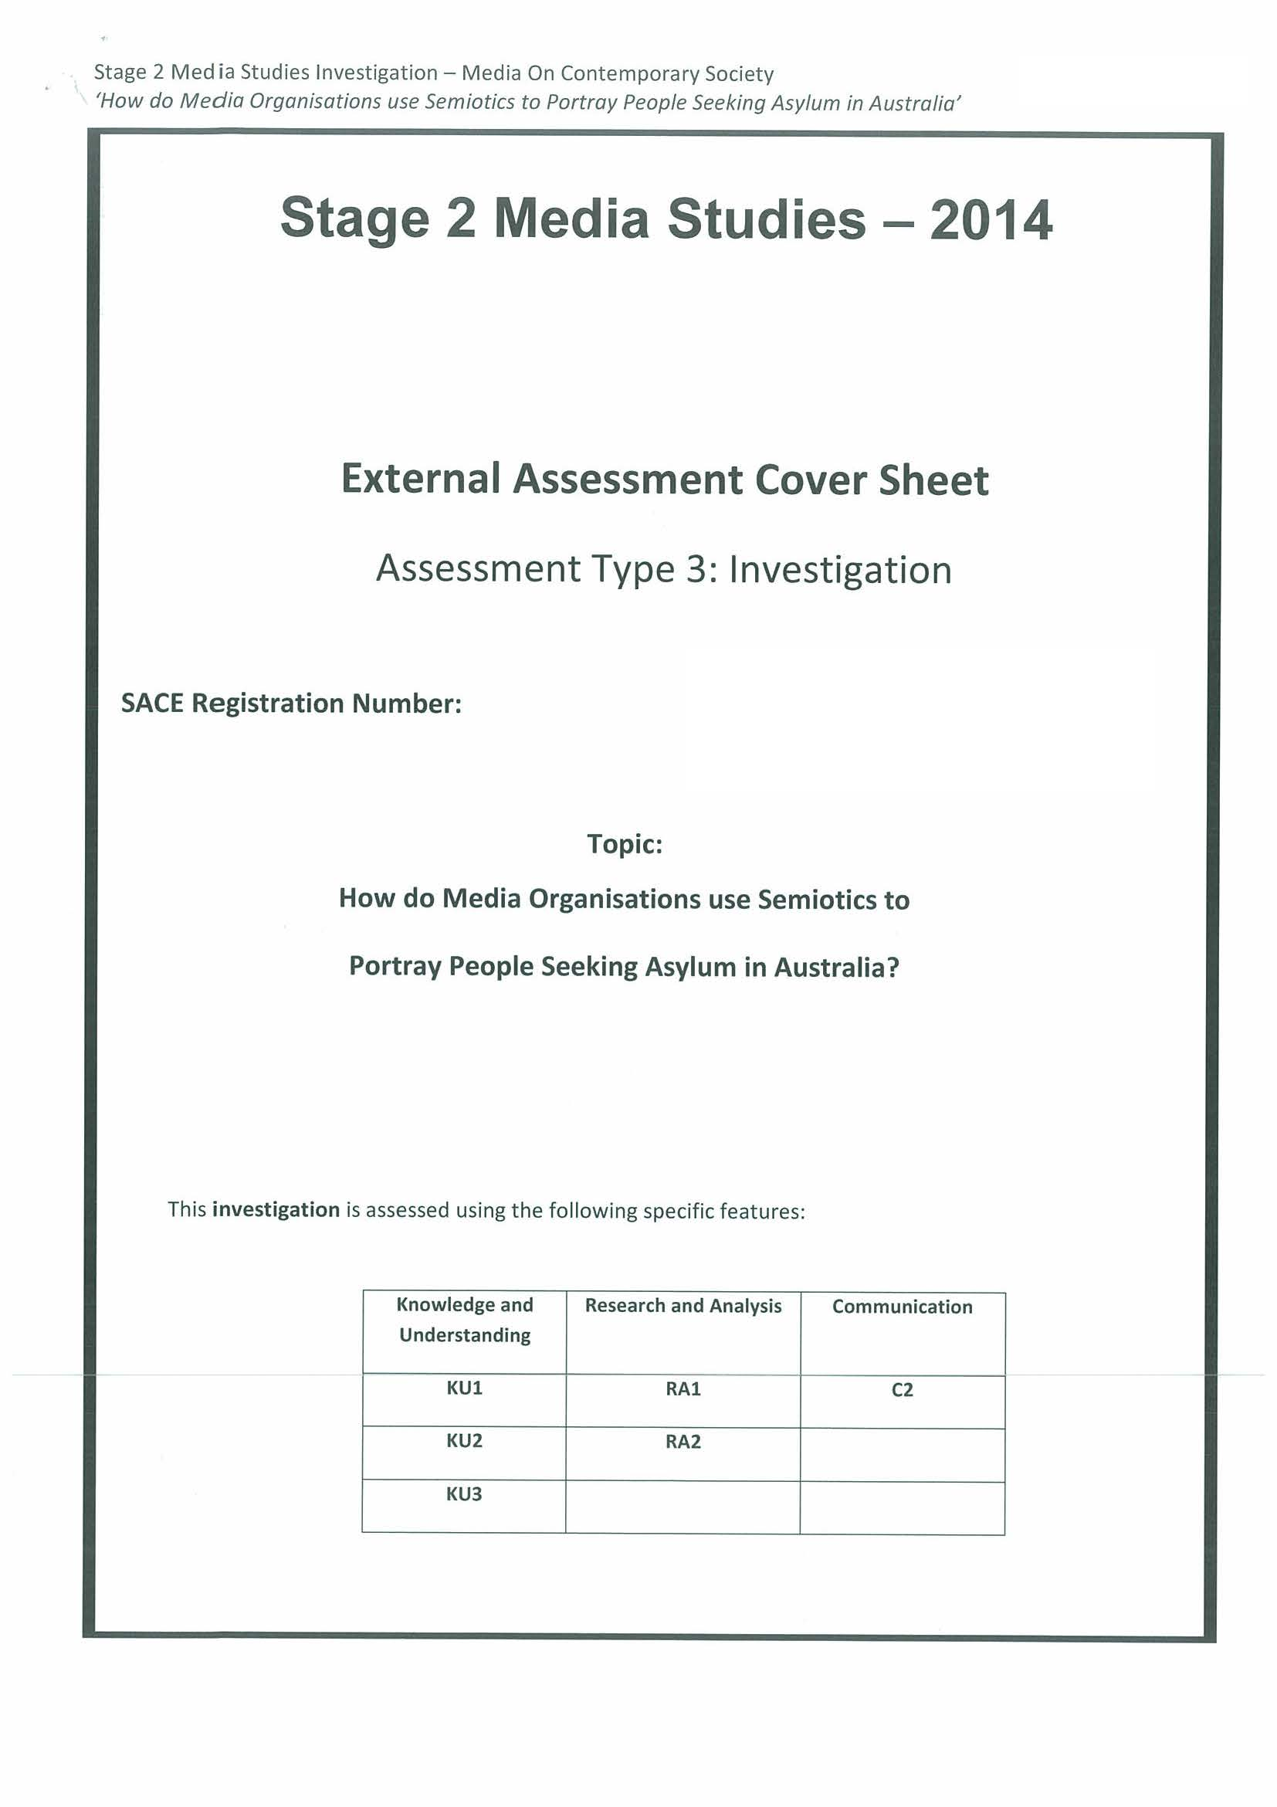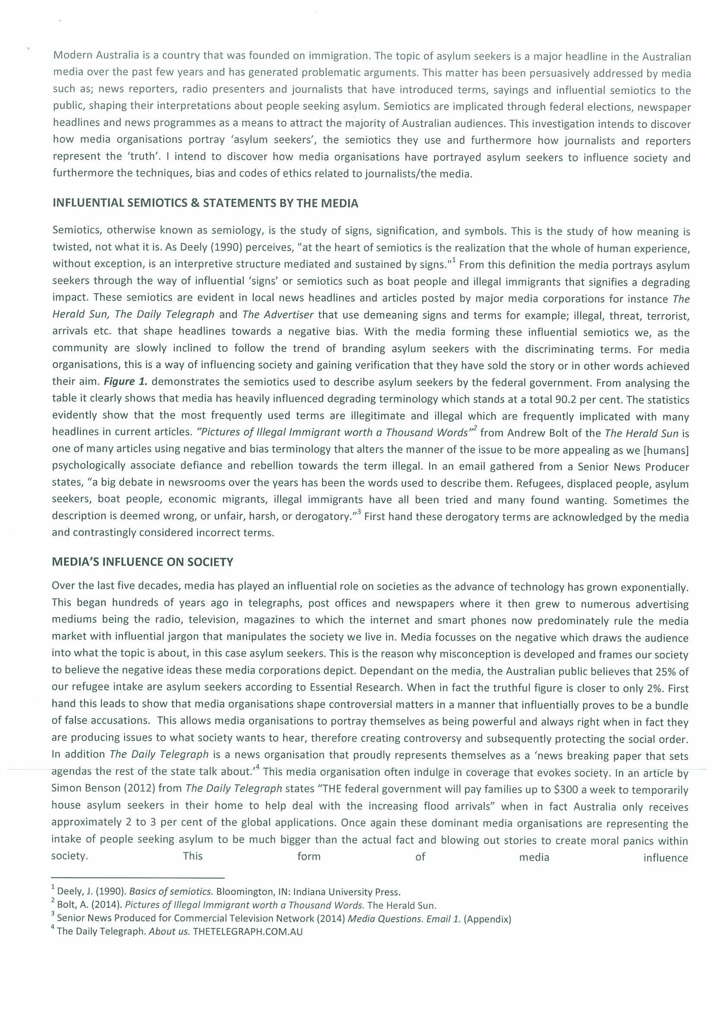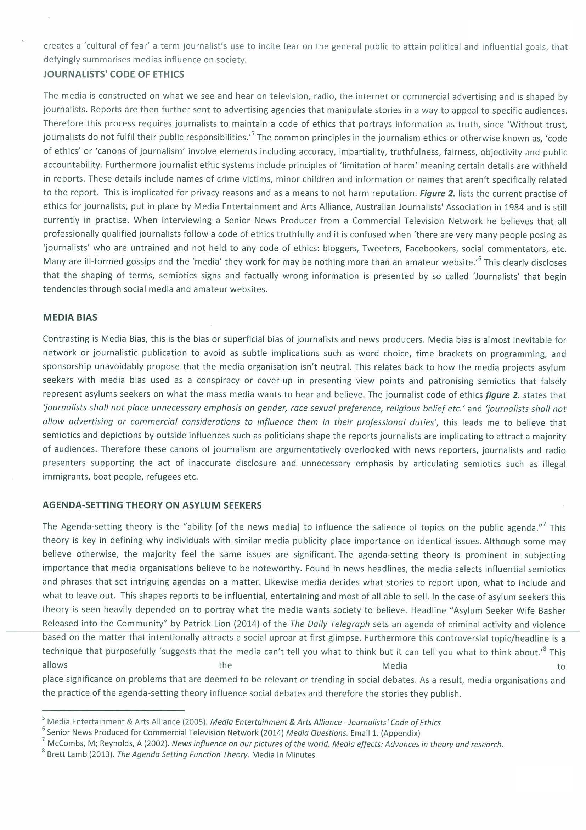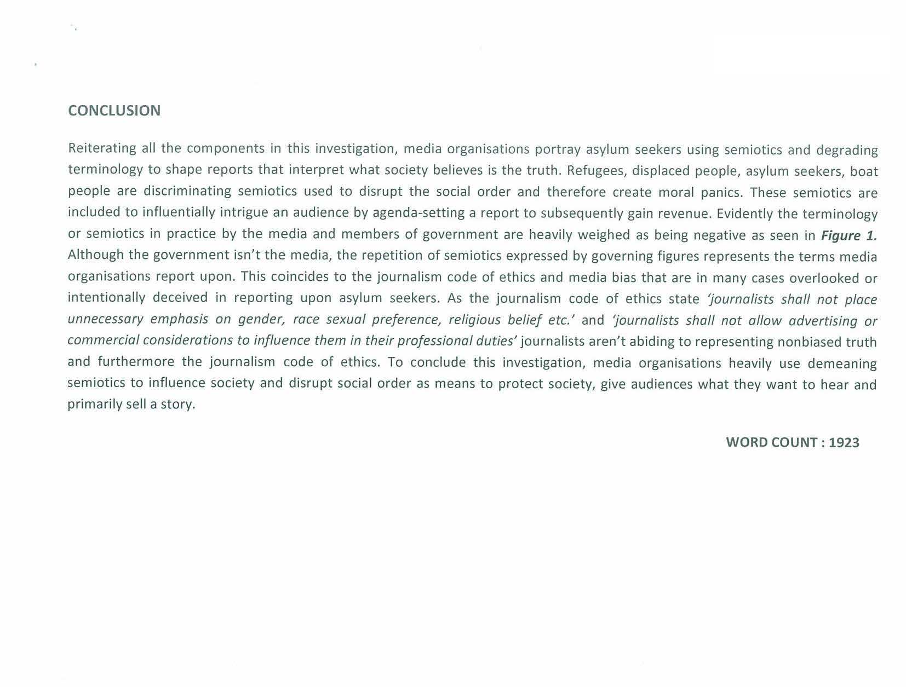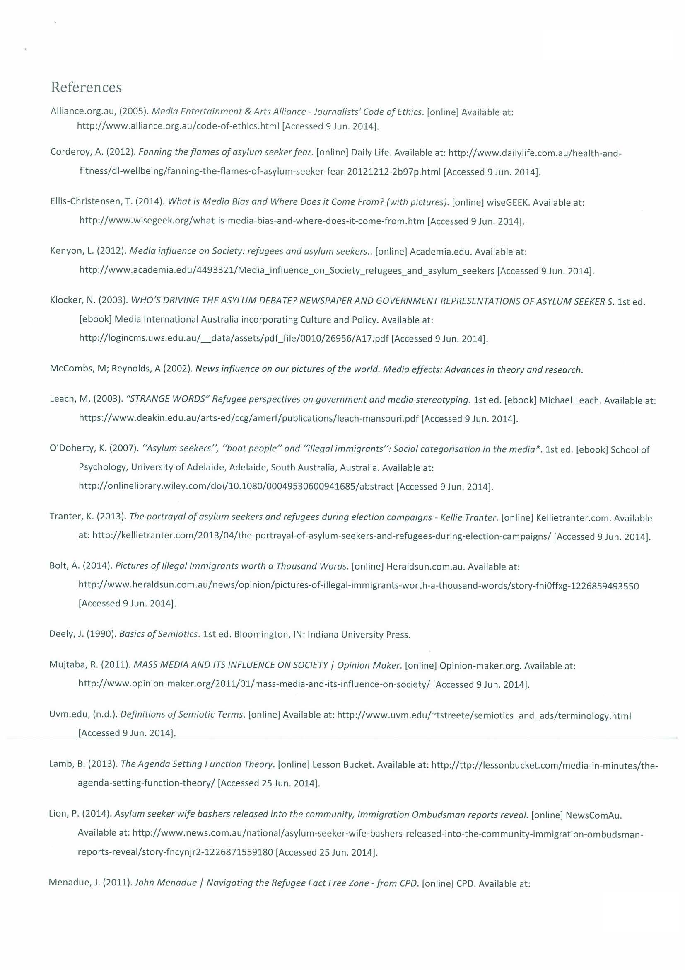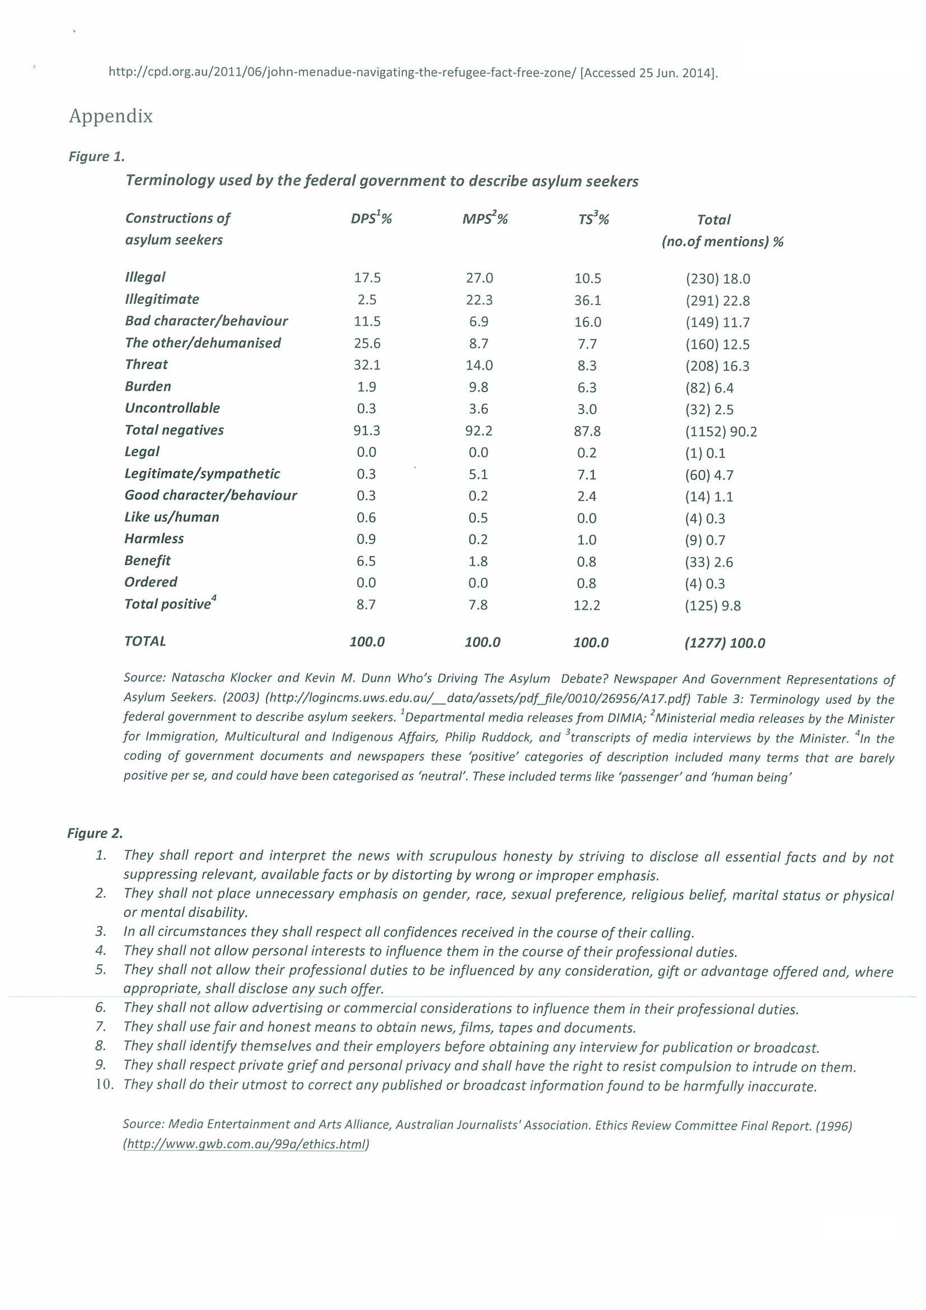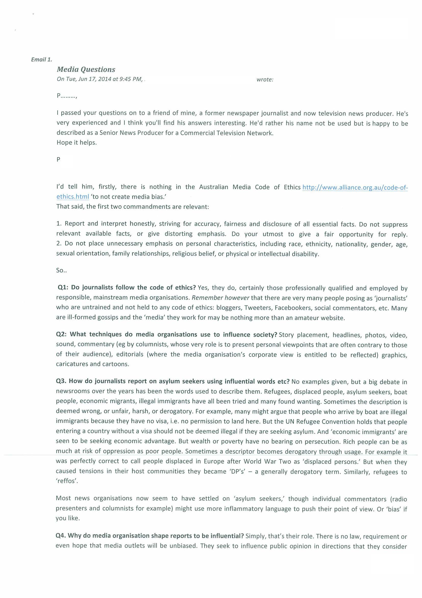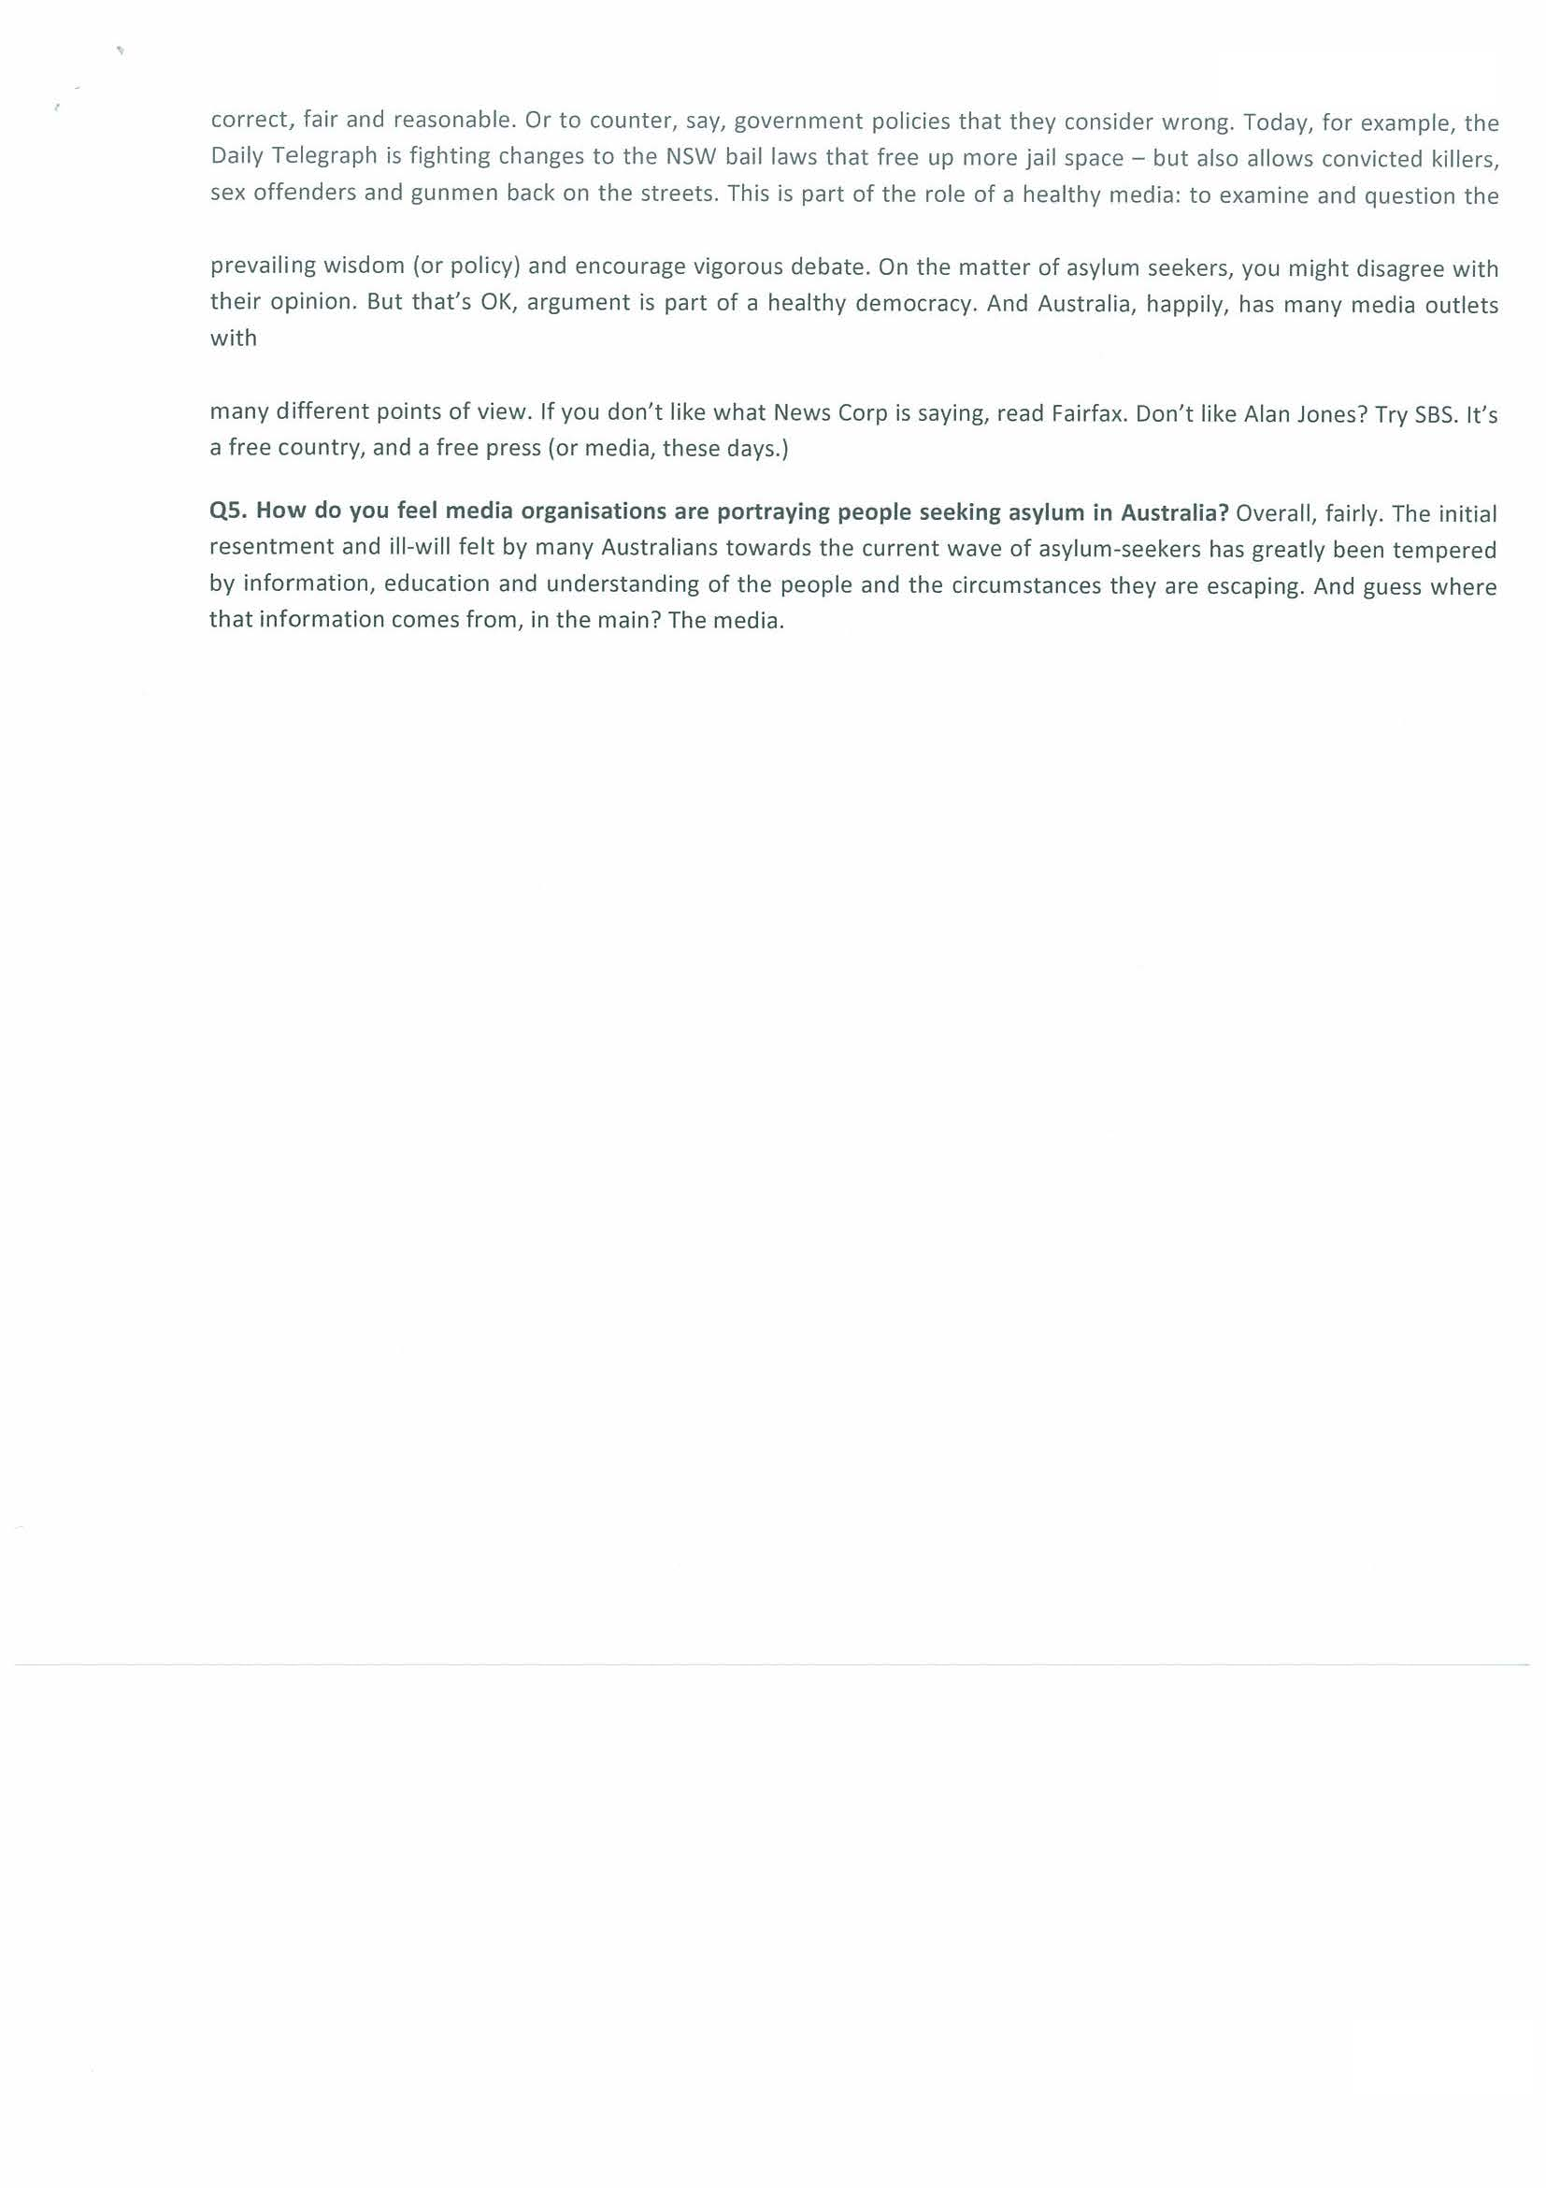
Open ended topic question.
Issue current.
KU1
Media concepts – semiotics, media structure. Comprehensive.
KU3
Understanding bias. Considered and informed.
KU1
Structures.
KU3
Bias well considered and informed.
KU1
Structures and interactions comprehensive.
KU3
Bias and facts insightful.
KU1
Media concepts. Comprehensive.
KU2
Media influence on audience well considered.
KU1
Structure and interaction comprehensive.
KU2
Media influence on audience perceptive.
Additional Comments
C2
Fluent across the investigation with appropriate media terminology used.
RA1
Thorough and well informed. Bias addressed across a range of media texts – see references.

This investigation was graded at A-.
RA2
Well informed research.
RA1
Use of primary source thorough and well informed.
Performance Standards for Stage 2 Media Studies
 | Knowledge and Understanding | Research and Analysis | Producing | Communication
A | Comprehensive and sustained knowledge and understanding of media structures, issues, concepts, and interactions.  Perceptive knowledge and informed understanding of how audiences influence, and are influenced by, forms and content of media texts.  Insightful and informed understanding of facts, opinions, and bias in media texts or products. | Thorough and well-informed research into and analysis of different points of view, bias, values, or intent across a range of media texts and in the media investigation.  Comprehensive research into and analysis of the ways in which groups and individuals are represented in media.  Perceptive analysis of interactions with media. | Comprehensive design and planning of media products for selected audiences.  Highly proficient use of appropriate production techniques and technologies, and media conventions. | Comprehensive reproduction of the structural and conventional features of media texts, to clearly and consistently convey meaning.  Fluent expression, using consistently clear and appropriate media terminology.
B | Well-considered and mostly sustained knowledge and understanding of media structures, issues, concepts, and interactions.  Well-considered knowledge and informed understanding of how audiences influence, and are influenced by, forms and content of media texts.  Well-considered and informed understanding of facts, opinions, and bias in media texts or products. | Well-informed research into and analysis of different points of view, bias, values, or intent across a range of media texts and in the media investigation.  Well-considered research into and informed analysis of the ways in which groups and individuals are represented in media.  Well-considered analysis of interactions with media. | Thorough design and planning of media products for selected audiences.  Proficient use of appropriate production techniques and technologies, and media conventions. | Sound reproduction of the structural and conventional features of media texts, to clearly convey meaning.  Mostly fluent expression, using clear and appropriate media terminology.
C | Considered knowledge and understanding of media structures, issues, concepts, and interactions.  Considered knowledge and informed understanding of how audiences influence, and are influenced by, forms and content of media texts.  Considered and informed understanding of facts, opinions, and bias in media texts or products. | Considered and informed research into and analysis of different points of view, bias, values, or intent across a range of media texts and in the media investigation.  Considered and informed research into and analysis of the ways in which groups and individuals are represented in media.  Considered analysis of interactions with media. | Considered design and planning of media products for selected audiences.  Competent use of appropriate production techniques and technologies, and media conventions. | Competent reproduction of the structural and conventional features of media texts, to convey meaning.  Generally fluent expression, using appropriate media terminology.
D | Partial knowledge and basic awareness of media structures, issues, concepts, and interactions.  Basic awareness and some understanding of how audiences influence, and are influenced by, forms and content of media texts.  Recognition and some understanding of facts, opinions, and bias in media texts or products. | Basic consideration and recognition of different points of view, bias, values, or intent in one or more media texts and in the investigation.  Identification of some of the ways in which groups or individuals are represented in media.  Description of one or more interactions with media. | Partial design and some planning of media products for a selected audience.  Basic use of some simple and appropriate production techniques and technologies, and some basic media conventions. | Some reproduction of the structural and conventional features of one or more media texts, to convey basic meaning.  Occasionally clear expression and use of basic media terminology.
E | Limited awareness of media structures, issues, concepts, or interactions.  Limited awareness of how audiences influence, and are influenced by, forms and content of media texts.  Limited recognition of facts, opinions, or bias in a media text or product. | Attempted description of a point of view, bias, value, or intent in a media text, and/or the investigation.  Attempted recognition of one way in which a group or individual is represented in media.  Attempted description of an interaction with media. | Attempted design or planning of media products.  Attempted use of a production technique or technology, and one or more basic media conventions, which may be appropriate. | Attempted reproduction of the structural and conventional features of one media text.  Limited expression or use of basic media terminology.

