**SKILLS AND APPLICATIONS TASK**

**SUMMATIVE ASSESSMENT TASK**

**TOPIC 3: Multicellular Organisms**

**Purpose and Background Information of the Assessment Task: To have the opportunity to show your in-depth knowledge and understanding of the concepts taught in the Topic 3: Multicellular Organisms.**

**TASK DESCRIPTION:**

**The test will be conducted under supervision.**

**Time: 90 minutes + 10 mins reading time**

**The test will contain the following questions:**

**Part A: Multiple Choice Questions**

**Part B: Short Answer Questions including Science as an Inquiry**

**Part C: Paragraph answers related to one or more key concepts of Science as a Human Endeavour**

**The amount of space is an indicator on how much you should write.**

**Use of appropriate Biological Terminology will be assessed.**

**You may use a calculator.**

**Performance Standard:**

|  |  |  |
| --- | --- | --- |
|  | Investigation, Analysis and Evaluation | Knowledge and Application |
| A | Critically deconstructs a problem and designs a logical, coherent, and detailed biological investigation.  Obtains, records, and represents data, using appropriate conventions and formats accurately and highly effectively.  Systematically analyses and interprets data and evidence to formulate logical conclusions with detailed justification.  Critically and logically evaluates procedures and their effect on data. | Demonstrates deep and broad knowledge and understanding of a range of biological concepts.  Applies biological concepts highly effectively in new and familiar contexts.  Critically explores and understands in depth the interaction between science and society.  Communicates knowledge and understanding of biology coherently, with highly effective use of appropriate terms, conventions, and representations. |
| B | Logically deconstructs a problem and designs a well-considered and clear biological investigation.  Obtains, records, and represents data, using appropriate conventions and formats mostly accurately and effectively.  Logically analyses and interprets data and evidence to formulate suitable conclusions with reasonable justification.  Logically evaluates procedures and their effect on data. | Demonstrates some depth and breadth of knowledge and understanding of a range of biological concepts.  Applies biological concepts mostly effectively in new and familiar contexts.  Logically explores and understands in some depth the interaction between science and society.  Communicates knowledge and understanding of biology mostly coherently, with effective use of appropriate terms, conventions, and representations. |
| C | Deconstructs a problem and designs a considered and generally clear biological investigation.  Obtains, records, and represents data, using generally appropriate conventions and formats with some errors but generally accurately and effectively.  Undertakes some analysis and interpretation of data and evidence to formulate generally appropriate conclusions with some justification.  Evaluates procedures and some of their effect on data. | Demonstrates knowledge and understanding of a general range of biological concepts.  Applies biological concepts generally effectively in new or familiar contexts.  Explores and understands aspects of the interaction between science and society.  Communicates knowledge and understanding of biology generally effectively, using some appropriate terms, conventions, and representations. |
| D | Prepares a basic deconstruction of a problem and an outline of a deconstruction and biological investigation.  Obtains, records, and represents data, using conventions and formats inconsistently, with occasional accuracy and effectiveness.  Describes data and undertakes some basic interpretation to formulate a basic conclusion.  Attempts to evaluate procedures or suggest an effect on data. | Demonstrates some basic knowledge and partial understanding of biological concepts.  Applies some biological concepts in familiar contexts.  Partially explores and recognises aspects of the interaction between science and society.  Communicates basic biological information, using some appropriate terms, conventions, and/or representations. |
| E | Attempts a simple deconstruction of a problem and a procedure for a biological investigation.  Attempts to record and represent some data, with limited accuracy or effectiveness.  Attempts to describe results and/or interpret data to formulate a basic conclusion.  Acknowledges that procedures affect data. | Demonstrates limited recognition and awareness of biological concepts.  Attempts to apply biological concepts in familiar contexts.  Attempts to explore and identify an aspect of the interaction between science and society.  Attempts to communicate information about biology. |

**Part A: Multiple Choice Questions. Put the correct letter corresponding to each question in the answer box provided at the end of the section.**

1. Which one of the following statements correctly defines the concept of gene expression?

Gene expression is the process

J. used to transfer information from RNA to DNA.

K. that controls the M phase of the cell cycle.

L. by which information from a gene is used in the synthesis of a functional gene product.

M. where specific parts of the DNA is changed into protein.

2. A gene codes for

J. complementary base pairs on DNA molecules.

K. an RNA molecule.

L. sequences of polypeptides on DNA molecules.

M. an amino acid molecule.

1. The cells of a single organism are

J. all genetically identical in all the parts of the body.

K. 50% genetically identical and 50% genetically different.

L. not identical except for the gamete cells.

M. all identical except for the gamete cells.

1. Which one of the following combinations of the organisation of cells, tissues and organs is correct?

|  |  |  |  |
| --- | --- | --- | --- |
|  | Cells | Tissue | Organ |
| J | Muscle | Nervous | Eye |
| K | Blood cell | Muscular | Brain |
| L | Tracheid | Vascular | Stem |
| M | Bone | Connective | Heart |

1. In humans, the circulatory system contains a number of different transport vessels including arteries, veins and capillaries. There are two different types of capillaries involved in transporting materials.

Which one of the following statements correctly identifies the type of capillary with its function?

J. Blood capillaries are responsible for absorbing digested fat molecules in the villi of the small intestine.

K. Lymph capillaries transport important molecules including oxygen to the brain.

L. Blood capillaries are involved in the exchange of gases in the alveoli of the lungs.

M. Lymph and Blood capillaries are both responsible for transporting red blood cells to the heart.

1. Refer to the following diagram which shows different stages of embryonic and foetal development in a number of different organisms.

[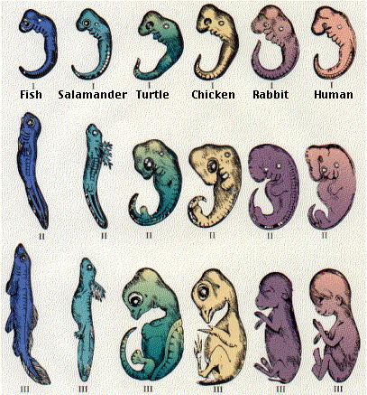](http://www.google.com.au/url?sa=i&rct=j&q=&esrc=s&source=images&cd=&cad=rja&uact=8&ved=0ahUKEwj5oPHE5JHLAhWCkpQKHUPYCcMQjRwIBw&url=http://www.biology-pages.info/R/Recapitulation.html&bvm=bv.115277099,d.dGo&psig=AFQjCNEWXDRo_-YrkbhF7lKekNY-822tlQ&ust=1456450269845933)

In the earlier stages of the embryonic development, the similarities between the organisms are greater than later in the development process.

In the organisms shown, all the organisms develop from a fertilised egg cell.

For these organisms to develop into functional offspring of that species, which one of the following statements must be correct?

J. Specific genes in each organism are turned on and/or off to enable cells to differentiate and express species specific characteristics

K. All the organisms have the same genes and it is differential gene expression that determines the characteristics that will develop.

L. Individuals of different species will turn on and off the same genes and this is why embryonic development looks the same in all animals.

M. Different species have different genes, however, the same messages are sent and this explains why the embryos look the same in the early stages of development.

1. Refer to the following table, which lists the concentrations (in g/100cm3) of various substances in the blood plasma, the glomerular filtrate, and the urine of a hospital patient.

|  |  |  |  |
| --- | --- | --- | --- |
| **Substance** | **Blood Plasma** | **Glomerular Filtrate** | **Urine** |
| Water | 92 | 99 | 96 |
| Urea | 0.03 | 0.03 | 2.00 |
| Glucose | 0.01 | 0.01 | 0.00 |
| Amino acids | 0.05 | 0.05 | 0.00 |
| Proteins | 8.00 | 2.00 | 2.00 |
| Chloride Ions | 0.50 | 0.48 | 0.01 |

Which one of the following statements is ***not*** consistent with the information in the table above?

J. Glucose is filtered from the blood.

K. Proteins are not filtered from the blood.

L. Water is reabsorbed into the blood.

M. Proteins are not reabsorbed into the blood.

1. Which one of the following changes is most likely to occur when the blood pressure in the kidney is decreased?

J. A decrease in the rate of filtration of blood in capillaries.

K. An increase in the reabsorption of protein in the tubules.

L. A decrease in the rate of filtration of water into the blood capillaries.

M. An increase in the reabsorption of urea in the tubules.

1. Which one of the following enzymes is responsible for the breakdown of protein?

J. Amylase

K. Lipase

L. Pepsin

M. Catalase

1. In plants, excess glucose produced in photosynthesis is stored as

J. Lipid

K. Cellulose

L. Starch

M. Glycogen

|  |  |  |  |  |  |  |  |  |  |  |
| --- | --- | --- | --- | --- | --- | --- | --- | --- | --- | --- |
| **Question** | **1** | **2** | **3** | **4** | **5** | **6** | **7** | **8** | **9** | **10** |
| Answer |  |  |  |  |  |  |  |  |  |  |

**Part B: Short Answer Questions.**

**Please answer all questions in the space provided.**

[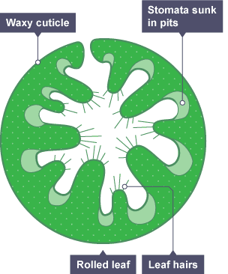](http://www.google.com.au/url?sa=i&rct=j&q=&esrc=s&source=images&cd=&cad=rja&uact=8&ved=0ahUKEwic9KLn-ZHLAhXFHJQKHUXuAWwQjRwIBw&url=http://www.bbc.co.uk/education/guides/zps82hv/revision/5&bvm=bv.115277099,d.dGo&psig=AFQjCNGdqIUwyy-Omas3XTg_5hQ4RmawJA&ust=1456456502391375)

Wind direction

1. Refer to the schematic diagram above of a cross section of the Marram grass (Ammophilia sp.) leaf.

Marram Grass has a rolled leaf that creates a localised environment of water vapour potential within the leaf, and helps to prevent loss of water. The [stomata](https://en.wikipedia.org/wiki/Stomata) sit in small pits within the curls of the structure, which make them less likely to open and to lose water. The folded leaves have hairs on the inside to slow or stop air movement.

1. State the name of the process that results in the loss of water from the surface of leaves.

___________________________________________________________________________

1. Draw a stomatal pore and describe its function in leaves.
2. Describe one feature of the Marram grass leaf that would increase the rate of gas exchange.

___________________________________________________________________________

___________________________________________________________________________

___________________________________________________________________________

1. With reference to the wind direction in the schematic diagram above, explain how the structure of the leave would minimise water loss.

___________________________________________________________________________

___________________________________________________________________________

___________________________________________________________________________

___________________________________________________________________________

1. The drawing below shows the respiratory system of a human:

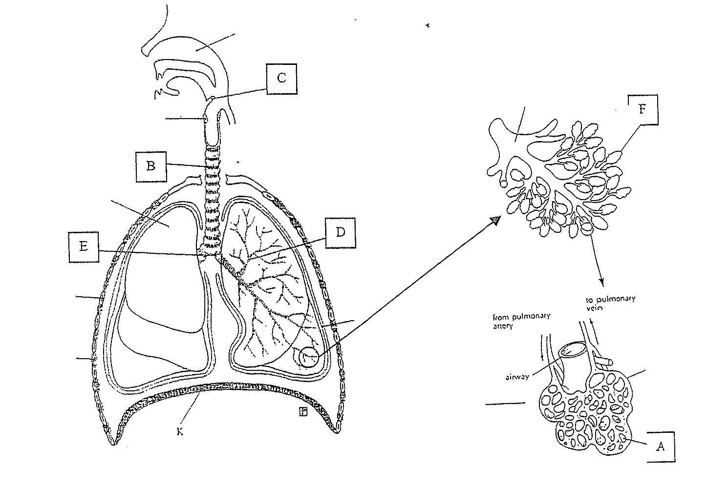

* 1. i) State the name of structure B.

___________________________________________________________________________

ii) State the name of structure K and explain its role in inhalation and exhalation.

___________________________________________________________________________

* 1. iii) Indicate which letter represents the epiglottis and describe its importance.

___________________________________________________________________________

* 1. iv) State the name of the structure where the actual exchange of oxygen and carbon dioxide takes place?

___________________________________________________________________________

* 1. v) Explain how oxygen and carbon dioxide are exchanged in the respiratory system of humans.

___________________________________________________________________________

___________________________________________________________________________

___________________________________________________________________________

___________________________________________________________________________

Refer to the following diagram, which shows the respiratory system of a fish.

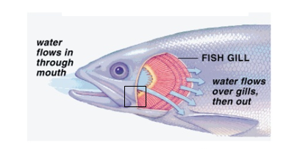

vi) Describe how gas exchange occurs at the gills of the fish.

___________________________________________________________________________

vii) State one feature of the fish respiratory system that is:

1. the same as the human respiratory system

___________________________________________________________________________

1. different to the human respiratory system

___________________________________________________________________________

1. Duckweed is a small freshwater plant; *Lemna gibba* and *Spirodela polyrhiza* are two species of duckweed.

A student placed populations of duckweed in two identical controlled-environment ponds. Only *Lemna* *gibba* was placed in pond A. Equal amounts of *Lemna* *gibba* and *Spirodela* *polyrhiza* were placed in pond B. each pond was provided with suitable nutrients for duckweed growth.

Every week a square metre sample of plants growing on the surface of each pond was removed and the weight of *Lemna* *gibba* plants in each sample was measured. The samples were then returned to the ponds.

The following table shows the change in weight of *Lemna* *gibba* in pond A and in pond B over the eight weeks of the investigation.

|  |  |  |
| --- | --- | --- |
| **Time since experiment began (weeks)** | **Pond A** | **Pond B** |
| **Weight of *Lemna* *gibba* when grown alone (g)** | **Weight of *Lemna* *gibba* when grown with *Spirodela* *polyrhiza* (g)** |
| 0 | 60 | 60 |
| 1 | 110 | 85 |
| 2 | 190 | 105 |
| 3 | 255 | 85 |
| 4 | 285 | 90 |
| 5 | 335 | 80 |
| 6 | 330 | 75 |
| 7 | 340 | 40 |
| 8 | 360 | 35 |

1. State one hypothesis that this investigation may have been designed to test.

___________________________________________________________________________

1. State the dependent variable in this investigation.

___________________________________________________________________________

1. Both ponds contained equal amounts of *Lemna* *gibba* at the start if this investigation. State two quantities that should have been deliberately kept the same for pond A and B.

___________________________________________________________________________

___________________________________________________________________________

___________________________________________________________________________

___________________________________________________________________________

1. Describe the changes in the weight of *Lemna* *gibba* population in pond B over the eight weeks of the investigation.

___________________________________________________________________________

___________________________________________________________________________

___________________________________________________________________________

___________________________________________________________________________

1. State one conclusion that can be reached by comparing the data for pond A and pond B.

___________________________________________________________________________

___________________________________________________________________________

1. The student did not repeat this investigation.
   1. State why the validity of the results is reduced because the student did not repeat this investigation.

___________________________________________________________________________

___________________________________________________________________________

___________________________________________________________________________

___________________________________________________________________________

* 1. The lack of repetition is a weakness in the design of this investigation. State one other weakness in the design of this investigation.

___________________________________________________________________________

___________________________________________________________________________

___________________________________________________________________________

___________________________________________________________________________

The student used a computer to graph the results of the investigation. The student’s graph is shown as follows.



1. State two ways in which the student could improve the representation of the data in the graph above.

___________________________________________________________________________

___________________________________________________________________________

___________________________________________________________________________

___________________________________________________________________________

1. Refer to the diagram which shows the digestive systems of various animals.

[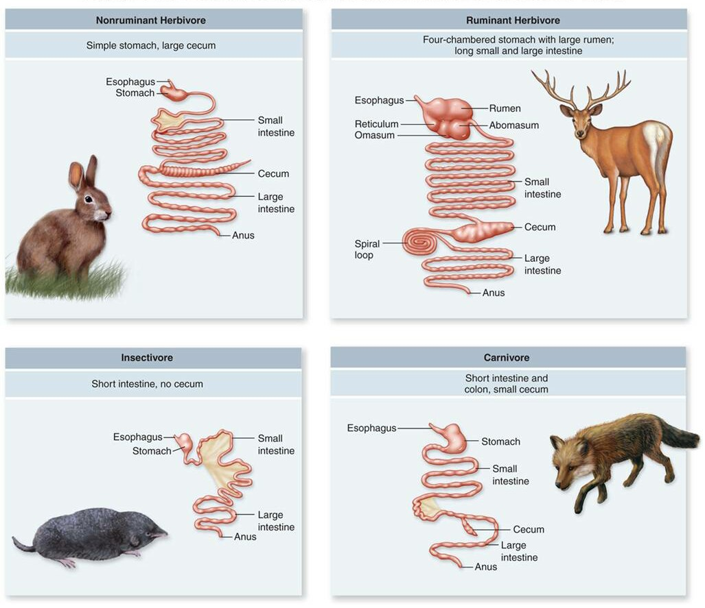](http://www.google.com.au/url?sa=i&rct=j&q=&esrc=s&source=images&cd=&cad=rja&uact=8&ved=0ahUKEwja9M-g4a_LAhVFkpQKHS2kAvAQjRwIBw&url=http://wordpress.as.edu.au/cshannon/2013/05/22/the-digestive-system/&bvm=bv.116274245,d.dGo&psig=AFQjCNG3UAsPxGLhYsHFwVwymExdwBocBQ&ust=1457480547028149)

1. State the function of the digestive system in animals

___________________________________________________________________________

___________________________________________________________________________

1. Describe how plants obtain their nutrients for growth in the absence of a digestive system.

___________________________________________________________________________

___________________________________________________________________________

___________________________________________________________________________

___________________________________________________________________________

1. Using the information in the diagram, describe the relationship between the food consumed by the animal and the length and complexity of the digestive tract.

___________________________________________________________________________

___________________________________________________________________________

___________________________________________________________________________

___________________________________________________________________________

1. State the role of the rumen in the X.

___________________________________________________________________________

___________________________________________________________________________

1. In humans, the villi in the small intestine are responsible for the absorption of required substances, explain how lipids are broken down and absorbed.

___________________________________________________________________________

___________________________________________________________________________

___________________________________________________________________________

___________________________________________________________________________

**Part C: Paragraph Answers**

1. Lifestyle choices can have serious consequences on human health. Alternatively, good choices can help to prevent the likelihood of developing a lifestyle disease.

* Using examples, explain how lifestyle choices could have a detrimental *or* positive effect on an individual’s health.
* Discuss the advantage to *society*, if individuals took more responsibility for their own health and made positive lifestyle choices.

One page of lines

In a world of advancing technologies and innovative health care, some individuals would rather rely on medical interventions that may solve their health issues.

* With reference to gene therapy, discuss the potential disadvantages with this type of treatment of lifestyle induced diseases.

One page of lines