Stage 1 Modern History
Assessment Type 2: Historical Study

Learning Requirements
1. understand and explore historical concepts
2. understand and explore the role of ideas, people, and events in history
3. analyse developments and/or movements in the modern world, and their short- and long-term impacts
4. analyse ways in which societies in the modern world have been shaped by both internal and external forces and challenges
5. apply the skills of historical inquiry to examine and evaluate sources and interpretations, and support arguments
6. draw conclusions and communicate reasoned historical arguments.

ASSESSMENT OBJECTIVE
- To produce a negotiated extension project on the decolonization of Vietnam / Anti-War Movements associated with the Vietnam War
- For students to demonstrate knowledge and understanding of selected movements, events, individuals, groups, institutions, societies and societies
- For students to demonstrate skills which allow them to research, critically analyse, interpret and synthesise primary and secondary sources, draw conclusions, and communicate their knowledge in reasoned historical arguments

TASK

- Complete a multiple intelligences test on-line at http://www.bgfl.org/custom/resources_ftp/client_ftp/ks3/ict/multiple_int/index.htm
- In light of your strengths, choose one of the following tasks to complete.
- You will need to complete individual research referring to information other than the handouts and information given in class.
- You must use both secondary and primary sources in the final product and correctly reference your sources in a format appropriate to your selected project.
- This assessment piece is negotiable, so if there are other ideas you may wish to explore, you can negotiate this with the teacher on an individual basis

ASSESSMENT CONDITIONS

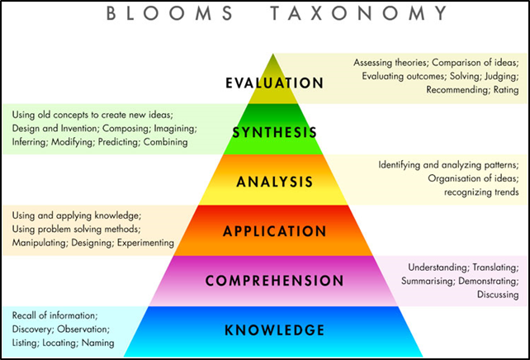
- In order to achieve the best results in your work, carefully read the image below. Understand that the more complex your thinking, the higher your achievement will be against the Performance Standards. What thinking skills does your work show?

- You will have access to IT, library resources and 2 weeks of programmed class time
- All work MUST be referenced in text
- Your work MUST include a bibliography
DRAFT DUE DATE | FINAL SUBMISSION
- You are able to submit one draft to your teacher for formal feedback

Verbal/ Linguistics | Logical/ Mathematical | Visual/ Spatial | Musical/ Rhythmic | Bodily/ Kinaesthetic | Interpersonal | Intrapersonal
If America's soul becomes totally poisoned, part of the autopsy must read "Vietnam." Martin Luther King, Jr., 1967  In an 800-1000 word formal written essay, use historiography to prove or challenge King’s comments.  800-1000 words | Draw a detail map with annotations, and notes analysing the purpose and impact of three conflicts US troops were involved in in the Vietnam War  A3 map annotated with approx. 600 words | Make a 3D model of a symbol relating to anti-war protests, or a diorama of an anti-war protest. Explain your design and relevance in  600 words | Design and record / perform your own anti-war song, which explains impact of the war  Justify choices in regards to lyrics and score, reflect on these in a 600 word report. | Write and perform a speech Martin Luther King or JFK may have delivered if either had not been assassinated, on the role of the US in Vietnam  5min presentation | In pairs, design and run a role play for the class from the point of view as either the US War Council discussing points for and against engaging in the Vietnam war.  4 – 6 min presentation | Produce a persuasive response on your personal opinion of using Napalm and other methods of Chemical Warfare during the Vietnam War  800-1000 word written or 4 – 6 minutes oral
Write an 800-1000-word letter from the point of view of a one of the students involved in University of Washington Anti-War Protests. Reflect on your experiences of the Vietnam War, as wells as those of your generation.  800-1000 words written | Gather, graph and analyse data on troop numbers and war spending involved in the Vietnam War. Consider demographics of each country, Australia, US, North Vietnam, South Vietnam, China & USSR. Reflect on this data in terms of injury, loss of life, and money / resources spent  Graphs and 600 word reflection | Design 2 campaign posters to encourage US troops to enlist in the Vietnam War Consider language, image, design, target audience and historical fact  Justify design choices based on historical interpretation in 600 words | Re-create a film clip to a piece of anti-war protest music. Use images with show synthesis and interpretation of the lyrics and score  Present as a 4 minute video clip with a 600 word written report. | In a pair or group of 3, design and create 3 different and original anti-war t-shirts, present a role play from a firsthand perspective at a protest.  10 minute group presentation and 600 word individual reflection on the protest - 600 words | In pairs, present an interview between Vietnamese villagers about the impact of war on their everyday lives.  4 – 6 min. presentation. | Choose a significant period of either a US President or Australian Prime Minister’s life, and write a journal explaining the significant of this period  (US - JFK, LBJ, Eisenhower, Nixon,  Aus - Menzies, Holt, Gorton, McMahon)  800-1000 words

STAGE 1 MODERN HISTORY PERFORMANCE STANDARDS

 | UNDERSTANDING & EXPLORATION | APPLICATION & EVALUATION | ANALYSIS
A | In-depth understanding and exploration of historical concepts.  Comprehensive understanding and insightful exploration of the role of ideas, people, and events in history. | Perceptive application of the skills of historical inquiry to critically examine and evaluate sources and interpretations.  Discerning use of relevant evidence to support arguments and draw insightful and relevant conclusions.  Communication of well-reasoned, coherent, and insightful historical arguments, with appropriate acknowledgment of sources. | Critical analysis of short- and long-term impacts of developments and/or movements in the modern world.  Insightful and critical analysis of ways in which societies in the modern world have been shaped by both internal and external forces and challenges.
B | Some depth in understanding and exploration of historical concepts.  Some depth of understanding and thoughtful exploration of the role of ideas, people, and events in history. | Thoughtful application of the skills of historical inquiry to examine and evaluate sources and interpretations.  Well-considered use of mostly relevant evidence to support arguments, and draw mostly relevant conclusions.  Communication of reasoned and coherent historical arguments, with some insights, and with appropriate acknowledgment of sources. | Some depth in analysis of short- and long-term impacts developments and/or movements in the modern world.  Well-considered analysis of ways in which societies in the modern world have been shaped by both internal and external forces and challenges.
C | Understanding and exploration of historical concepts.  Understanding and considered exploration of the role of ideas, people, and events in history. | Application of the skills of historical inquiry to examine sources and interpretations, with some evaluation.  Use of generally relevant evidence to support arguments, and draw some relevant conclusions.  Communication of generally reasoned and coherent historical arguments, with acknowledgment of sources. | Description, with some analysis, of short- and long-term impacts of developments and/or movements in the modern world.  Description, with some analysis, of ways in which societies in the modern world have been shaped by both internal and external forces and challenges.
D | Some recognition of historical concepts.  Recognition and basic understanding the role of ideas, people, and events in history. | Basic application of some skills of historical inquiry to select and use sources.  Use of some information with partial relevance to support an argument, and draw basic conclusions.  Partial communication of a historical argument, with attempted acknowledgment of sources. | Description of basic short- and/or long-term impacts of a development and/or movement in the modern world.  Superficial description of one or more ways in which societies in the modern world have been shaped by an internal or external force or challenge.
E | Attempted engagement with one or more historical concepts.  Awareness of one or more ideas, people, or events in history. | Attempted application of the skills of historical inquiry to select and use one or more sources.  Attempted use of information of limited relevance.  Attempted description of a historical event, with limited or no acknowledgment of sources. | Attempted description of a short- or long-term impact of a development or movement in the modern world.  Attempted description of one way in which a society in the modern world has been shaped by an internal or external force.

