Stage 1 Modern History
Assessment Type 1: Historical Skills
Task: Documentary
Learning Requirements
2. understand and explore the role of ideas, people, and events in history
3. analyse developments and/or movements in the modern world, and their short- and long-term impacts
4. analyse ways in which societies in the modern world have been shaped by both internal and external forces and challenges
5. apply the skills of historical inquiry to examine and evaluate sources and interpretations, and support arguments

ASSESSMENT OBJECTIVE

- The methods employed by institutions, people, and groups to promote and resist change. Examples include protest marches, civil disobedience/passive resistance, and violence.
- The short- and long-term influence and legacy of the movement, and changing perspectives of the movement over time.
  - To create a multimodal product which captures the numerous influences of pop culture on the Vietnam War
  - To understand the significant impact Anti-War protests had on the outcome of the war

TASK

- As a pair, you will create a 6-8 documentary (3-4 minutes per student) which explores Anti-War protests in an American context
- Your documentary needs to incorporate the following historically appropriate stimulus;
  - Primary sources – Vision, images, interviews, quotes, statistics
  - Secondary sources – music, TV / Movie footage, poetry, cartoons
- The content of your documentary needs to cover;
  - Outline ONE significant Anti-War protest or role of a significant group or individual. For example, but not limited to;
- Protests - Kent State, Lincoln Memorial, University of Washington, ‘teach-ins’ at Berkley University, etc
- Groups - Vietnam Veterans Against the War, Students for a Democratic Society, Another Mother for Peace, Catholic Worker Movement
- Individuals - Denise Levertov, Joan Baez, Martin Luther King, Mohammed Ali, Rev James L. Bevel
  - Outline the objectives and methods of this protest / group / individual, and make reference to any significant key dates of action in relation to the War
  - Describe / give voice to the individuals involved
  - Evaluate the impact of the protest / group – what impact did it have on the social and political context at the time in the US? How was this influenced by the power of media?
  - Evaluate the impact protest movements had on the outcome of the war. Make reference to Nixon’s policy of ‘Vietnamization’

ASSESSMENT CONDITIONS
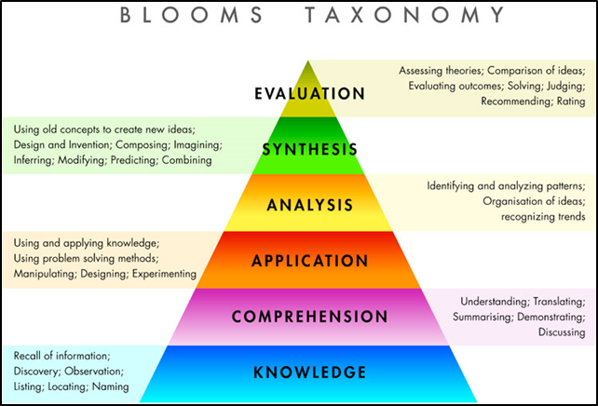
SYNTHESIS: In what ways does the documentary you have produced offer insight and ideas into the topic? Have you used evidence to compose your work?
ANALYSIS: Have you logically organised your documentary to tell the narrative of your individual/group/protest, supported by engaging audio-visual sources?
APPLICATION: Have you applied your research from primary and secondary sources into your documentary to create an engaging visual product?
COMPREHENSION: Have you drawn ideas and arguments from different sources, and summarised them into your own words? Have you demonstrated an argument and progression of events?
KNOWLEDGE: Does your documentary use facts, names of specific individuals, places, ideas, phenomena, and define these clearly?
EVALUATION: Does your documentary evaluate the success of the protest/ group/ individual in the context of the war, and the overall outcome?
- In order to achieve the best results in your work, carefully consider the image above. Understand that the more complex your thinking, the higher your achievement will be against the Performance Standards. What thinking skills does your work show?
- You will have access to IT, library resources and 2 weeks of programmed class time
DRAFT DUE DATE | FINAL SUBMISSION
- Your work MUST include a bibliography
- You are able to submit one draft to your teacher for formal feedback

- | Understanding and Exploration | Application and Evaluation | Analysis
A | In-depth understanding and exploration of historical concepts.  Comprehensive understanding and insightful exploration of the role of ideas, people, and events in history. | Perceptive application of the skills of historical inquiry to critically examine and evaluate sources and interpretations.  Discerning use of relevant evidence to support arguments and draw insightful and relevant conclusions.  Communication of well-reasoned, coherent, and insightful historical arguments, with appropriate acknowledgment of sources. | Critical analysis of short-term and long-term impacts of developments and/or movements in the modern world.  Insightful and critical analysis of ways in which societies in the modern world have been shaped by both internal and external forces and challenges.
B | Some depth in understanding and exploration of historical concepts.  Some depth of understanding and thoughtful exploration of the role of ideas, people, and events in history. | Thoughtful application of the skills of historical inquiry to examine and evaluate sources and interpretations.  Well-considered use of mostly relevant evidence to support arguments, and draw mostly relevant conclusions.  Communication of reasoned and coherent historical arguments, with some insights, and with appropriate acknowledgment of sources. | Some depth in analysis of  short-term and long-term impacts of developments and/or movements in the modern world.  Well-considered analysis of ways in which societies in the modern world have been shaped by both internal and external forces and challenges.
C | Understanding and exploration of historical concepts.  Understanding and considered exploration of the role of ideas, people, and events in history. | Application of the skills of historical inquiry to examine sources and interpretations, with some evaluation.  Use of generally relevant evidence to support arguments, and draw some relevant conclusions.  Communication of generally reasoned and coherent historical arguments, with acknowledgment of sources. | Description, with some analysis, of short-term and long-term impacts of developments and/or movements in the modern world.  Description, with some analysis, of ways in which societies in the modern world have been shaped by both internal and external forces and challenges.
D | Some recognition of historical concepts.  Recognition and basic understanding of the role of ideas, people, and events in history. | Basic application of some skills of historical inquiry to select and use sources.  Use of some information with partial relevance to support an argument, and draw basic conclusions.  Partial communication of a historical argument, with attempted acknowledgment of sources. | Description of basic short-term and/or long-term impacts of a development and/or movement in the modern world.  Superficial description of one or more ways in which societies in the modern world have been shaped by an internal or external force or challenge.
E | Attempted engagement with one or more historical concepts.  Awareness of one or more ideas, people, or events in history. | Attempted application of the skills of historical inquiry to select and use one or more sources.  Attempted use of information of limited relevance.  Attempted description of a historical event, with limited or no acknowledgment of sources. | Attempted description of a  short-term or long-term impact of a development or movement in the modern world.  Attempted description of one way in which a society in the modern world has been shaped by an internal or external force.

