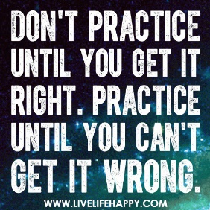

Devise a purpose made study/ etude/ exercise

- Investigate one aspect of technique on your instrument/ voice and devise/ compose a purpose made study/ etude/ exercise that helps you to improve one aspect of your performance.

- It MUST relate to an aspect of the repertoire you are presenting for the Ensemble Performance task.

- The exercise may be notated using music writing software, or hand written with scripted instructions, and / or a combination of both.

- You should be able to clearly explain the overall intention of the exercise you have devised prior to demonstrating it during the part testing assessment.

Use the chart below to organise your thoughts and help to narrow down your choices for an exercise to create.

✓ / X
✓ / X

✓ / X

