STAGE 1 CREATIVE ARTS
ASSESSMENT TYPE 1: PRODUCT (SUPPORT MATERIALS)
This exemplar was developed under the 2014 Subject Outline. Please refer to the current subject outline for word count (or equivalent oral/multi-media) limits

Fantasy Art Exhibition

Introduction: We chatted about us visual art students and what we would contribute to the Arts Extravaganza and the role at the exhibition we are expected to do. We discussed ideas about the theme and I said I think fantasy is similar to Science Fiction but others thought medieval (fighting fantasy) and others said Manga or Anime and others said Lord of the Rings. Ms XXXX said there are other forms of fantasy. She showed us some famous artists and their art. Bosch used very fine details in his fantasy paintings and he was before his time. William Blake the poet used some mythical images in his pen drawings. Some of the Surreal artists like Dali and Magritte were very much like fantasy artists and in fact led on the modern movement in fantasy. I thought William Blake’s pen drawings and Magritte’s optical paintings were the best. Ms XXXX told us that we should go outside of our comfort zone and research artists to help us do one large or a group of smaller pieces of art. We talked about getting different styles of drawing and painting going in the class. Some wanted to do fighting fantasy or Manga and she said that was OK. I wanted to try some science fiction black and white pieces and try to go beyond the idea of illustrations and produce pieces suitable for hanging on your wall. She said that this would be OK. I do draw well and I am creative so I am hoping to do some good work. The class has chosen lots of different styles of fantasy art for the exhibition.
Practical Application
Shows selective and productive collaborative approaches to planning the exhibition.
Next lesson we did some work on “the creative process”. We have to research several artists to help us with ideas, and then try out some ideas and practice techniques. We must keep a record of all of this and then do the final art. When we are finished we will help put up the exhibition and we are expected to go along to both times we are showing the exhibition to the others in the school.
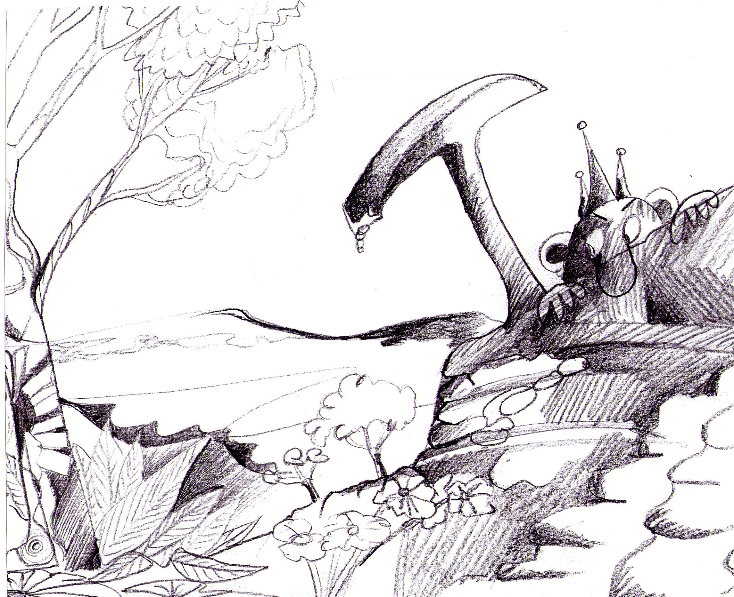

Ms XXXX said something about us talking about our Art work to others but I’m not sure I want to do this.

Here is a fantasy drawing of a landscape and character I tried first. It is done in pencil. It is not good but it is a start. The little being on the right did not get much attention as I did not like the way this drawing was going.

Research
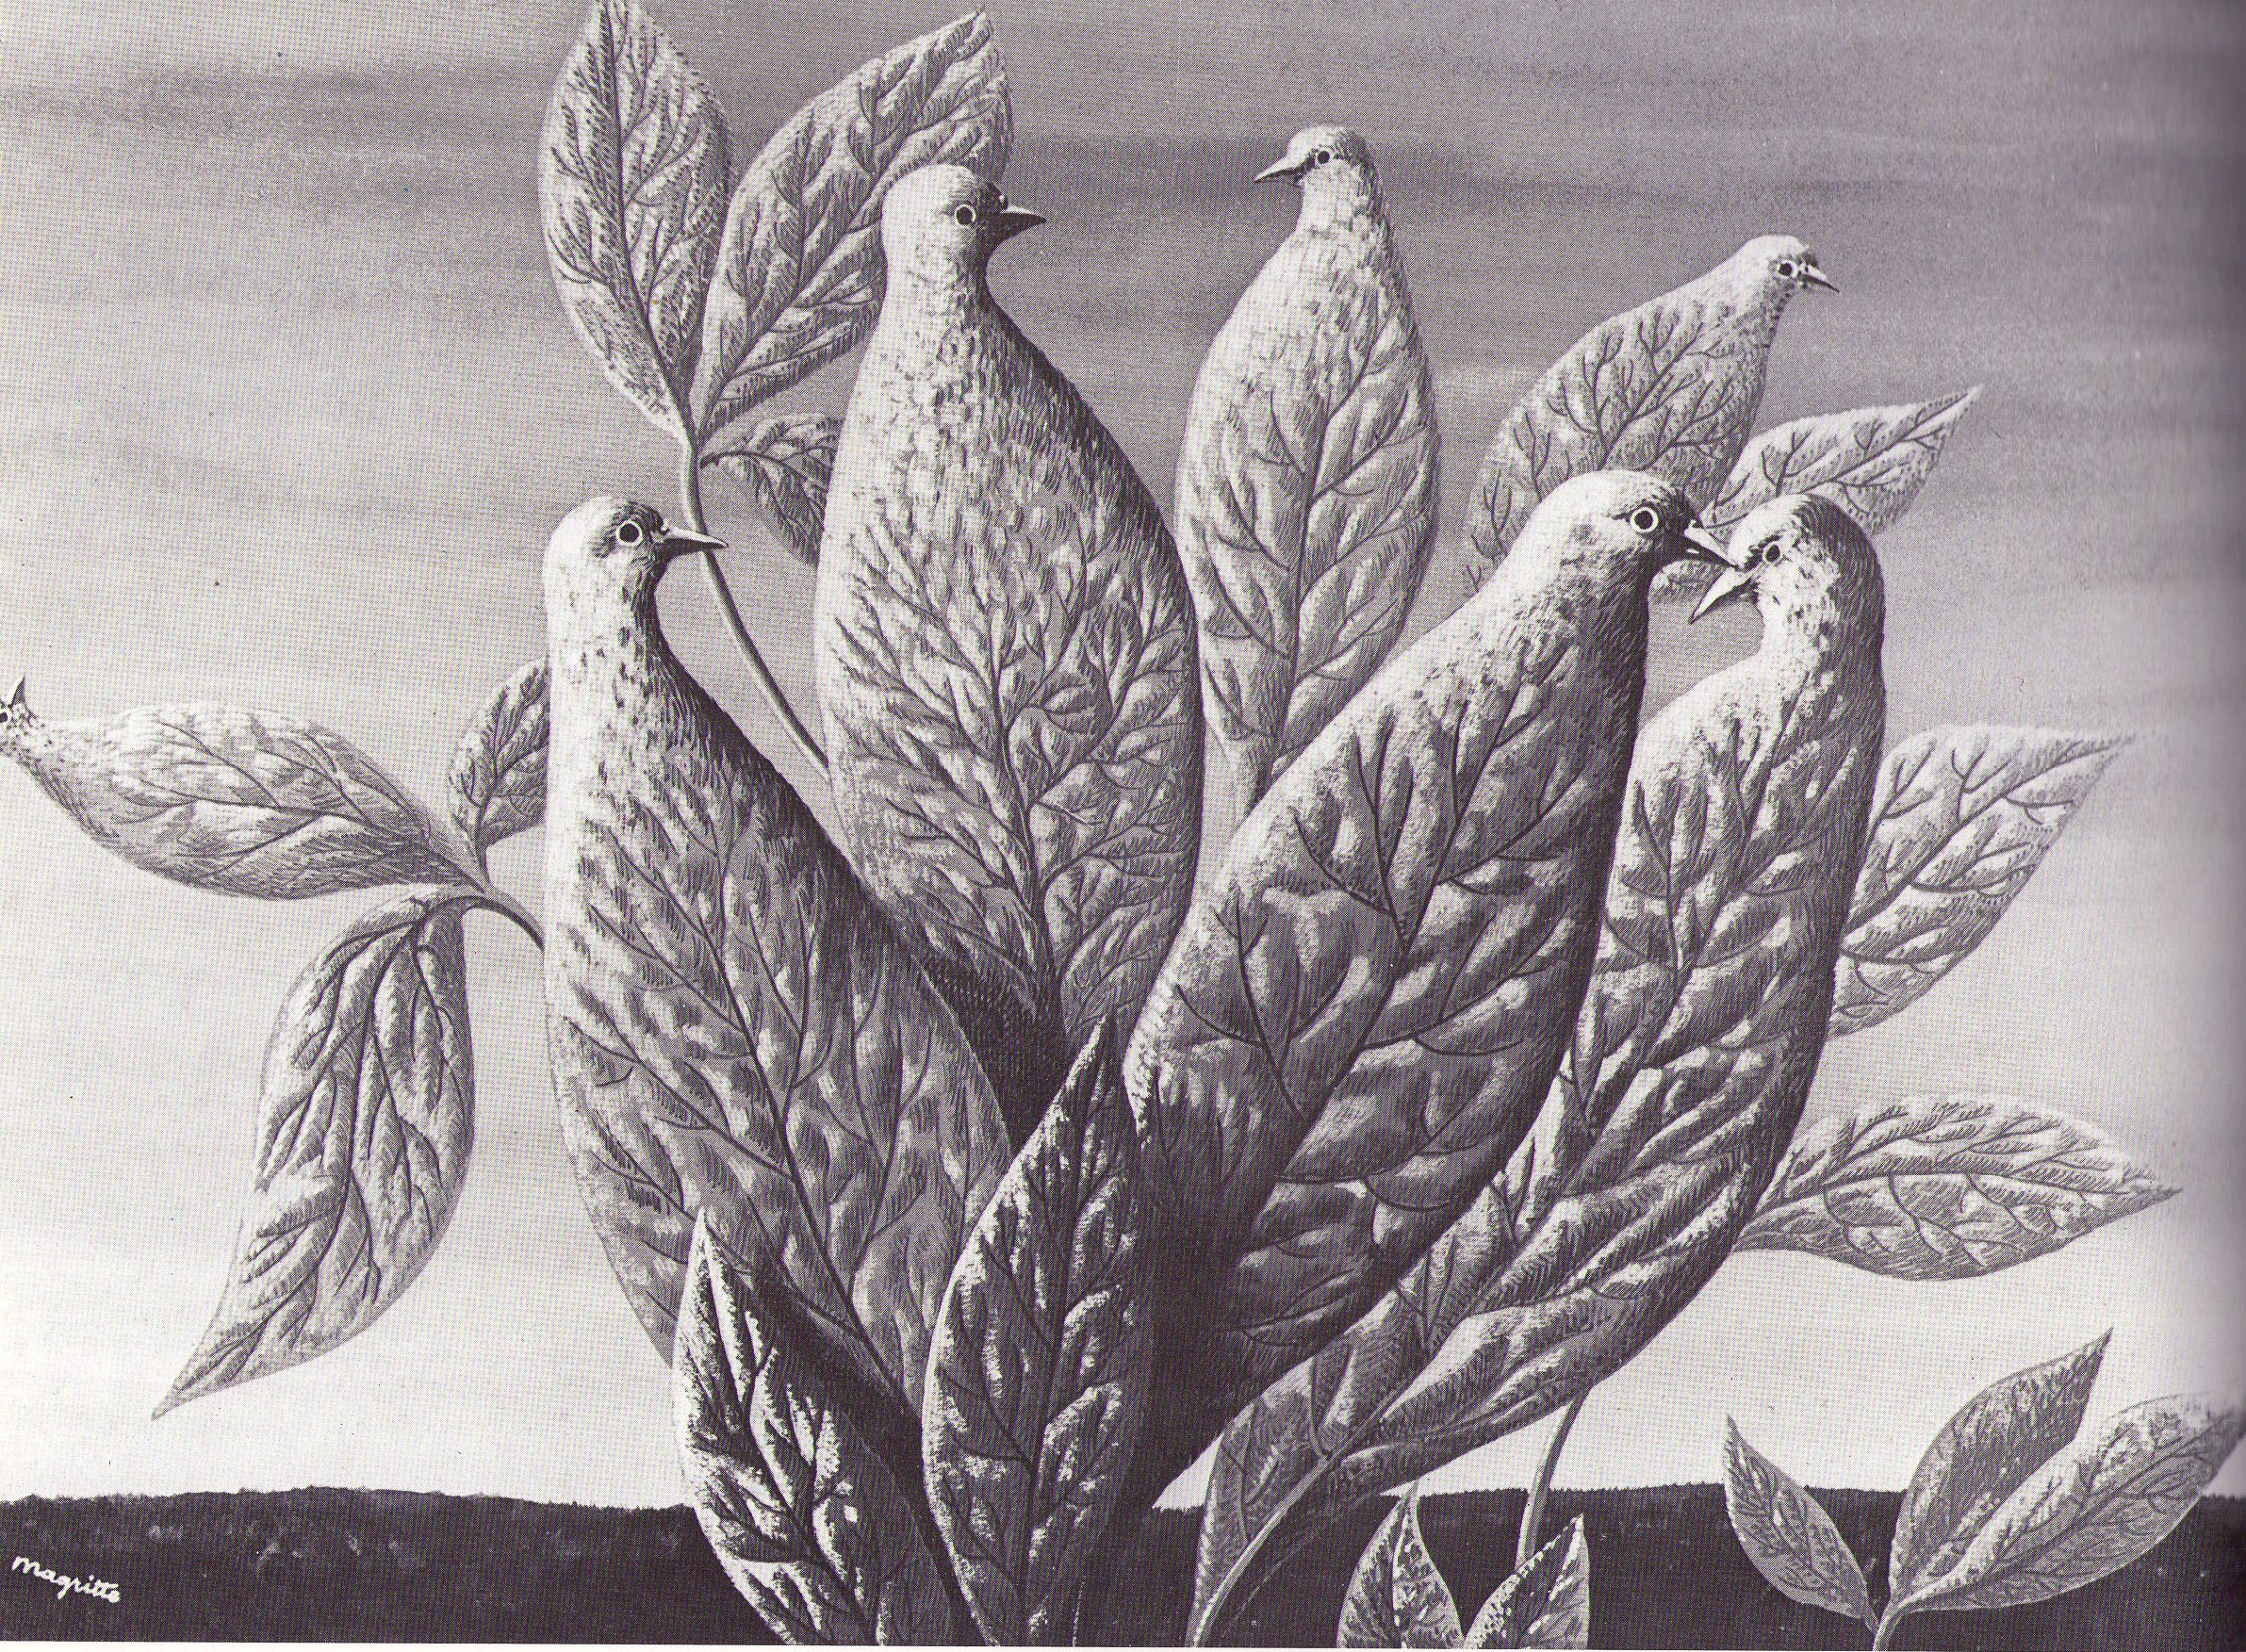
I like Henri Matisse because he plays tricks with your eyes. His painting The Natural Graces done in 1942 is of birds (they look like doves or pigeons) morphing into leaves. I think Matisse is saying that all of nature is the one thing, but I just like the effect of how the veins of the leaves turn into the feathers of the bird. I really like drawing birds and I did a whole project on this topic in year 10 so perhaps I could use these drawing and do a series of fantasy birds.
Investigation and Interpretation
Clearly and perceptively interprets creative ideas of others to inform the creative arts process.
Ms XXXX said I need to look at different lines and shading with pen and different types of pen.
She had a pen and ink book in her collection of books. I photo copied these ones below. Catherine Slade did cartoons and in old fashioned pen and ink and used thin and thick lines to make her cartoons sensitive & interesting. Cross hatching is used for shadows. I think I need to practice this more. The cross hatching on her girl and umbrella is not very dark. I have always been told by my art teachers to make the darkest areas as black as possible when showing shadows.
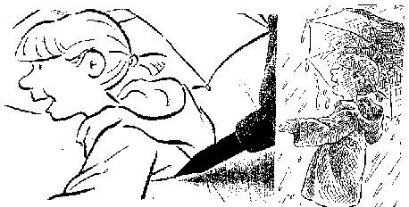
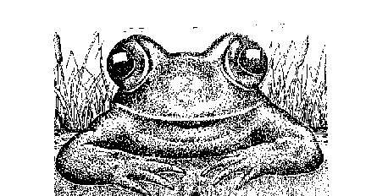
I quite like the frog by Catherine Slade as there are more areas of contrast to create a more defined image . The eyes are almost completely black except for the highlights that bring the frog to life. However, I don’t like the dot technique. I think the dots would be painful to do so I don’t think I will even try. In my opinion this effect looks too false. I like the more natural look. Ms XXXX says it is called stippling. I don’t like it.

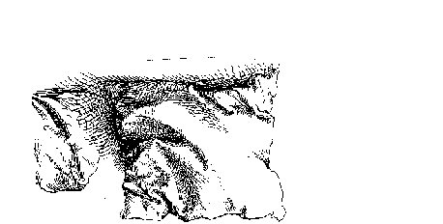
Two examples of using hatching and Cross hatching.

I like Durer’s Six Pillows (a section of it and scanned upside
down) Durer has used darker areas than Slade and
has made the folds in the pillows look very natural. He must have done these as drawings from real life to get the details of the folds looking right. Perhaps I should also do this same sort of drawings
for practice.
Anthony Colbert’ landscape drawing is very good. To get the feeling of a cold winter’s morning, he uses very dark areas with heavy cross hatching very close together. I like how dark the tractor and person are against the plain white cloudy area. It has great
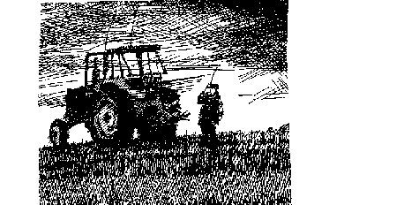
contrast. The levels of cross hatching in the grass show a small amount of perspective in the foreground to give the idea of depth over a small distance.

I like William Blake’s drawing below. It looks like he used a brush to fill in the black areas. I read that he was famous for his control of line work with a pen. The lines around the sun look like they have been done with a compass at first, but when you look closely they are obviously free hand. He was very well known for his poetry and so these drawings are probably pictures for his poems. It looks like some kind of mythical beast with what looks like eyes and other features of faces tattooed on his body. I could do some fantasy drawings of mythical creatures for my contribution to the exhibition. Perhaps a set of three.

The example I found by Edmund Sullivan is on the right. I like the effects with pen that have been used. It is not a fantasy drawing, but it is useful to look at to see what the artist was trying to do. The faces of the people who look like a jury in an old fashioned court room, are interesting characters. I like the idea of creating characters who have distinct features. I like the untidy look of this drawing and using very close together scribbles and dashes and some cross hatching to get the different textures and areas of darkness. I like the artists use of perspective to help the composition. The strong diagonal line of the structure, jury members are leaning on and the deep shadows underneath add a feeling of foreboding about the decision the group are going to make. Ms XXXX says this is an example of expressionism. I like it and I will practice these kinds of techniques in my drawings.
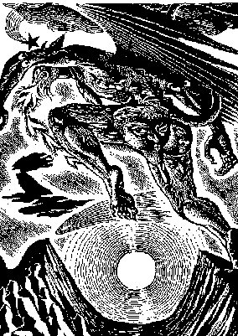
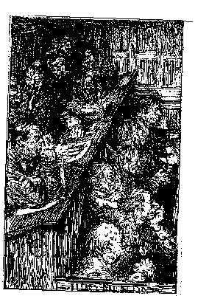

Reflection
Insightfully appraises other artists’ work. Ideas, techniques and decision making are referred to.

Ms XXXX told us that she wants us to be super organized with our work. I will do lots of fantasy drawings with birds as a theme and use ideas from my research. How many I don’t know. It will depend on how well I go with my ideas. I will have a set of 3, A3 drawings for the exhibition. Here are my drawings and some comments.
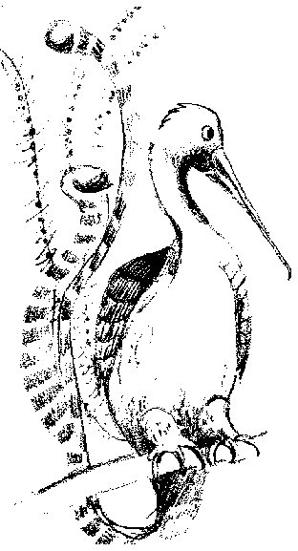

Idea 1: This bird is a combination of a few different birds I drew in year 10. I like the lyre bird tail feathers. Done in pencil. A good start. Ms XXXX said it is too neat but creative.

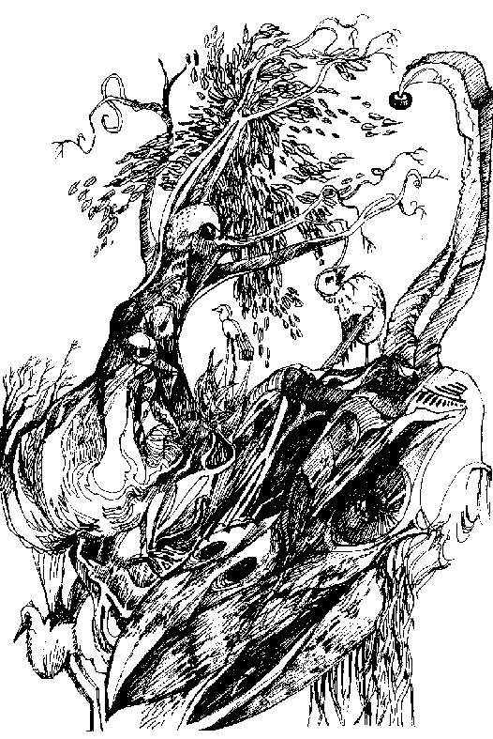

Idea 2: A crazy doodle of different bird shapes in one drawing with a black pen, trying out different tones and textures with lines and scribbles. I made many mistakes which I covered up with more scribbles and lines. I like the flow of the leaves near the top of the drawing.

Practical Application
Series of student ideas 1 to 8 show creative and clear expression of ideas and discerning use of media to develop these ideas.

I will work in black pen from now on and try out different techniques with my birds and backgrounds. Idea 3: Based on a baby chicken. Idea 4: I tried to do the mother hen (below), but it looks more like a rooster in drag. I use cross-hatching a lot more in this one. In am pleased in some ways with this drawing, but I think the character is too cartoon like.(Left over from my days when all I did were cartoons.) I am enjoying scribbling out my mistakes and making them into something else. Ms XXXX says that some areas of the drawing are very abstract, which she is encouraging me to keep doing.
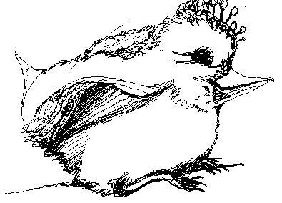
Idea 5: My creativity is starting to work. Down below a scruffy bird flying over a salivating and hungry creature who can’t capture this tasty morsel because of the gross deformity which is the nose which gets in the way. My science fiction films and books that I read are helping my thinking. It’s a cartoon again. When I sketch like this I can’t seem to avoid the cartoons. I am enjoying the accidents all of which help me to decide what I am doing in the middle of doing it …..depending on what I have just done.!! It’s hard to explain. It’s a bit like improvising in drama. I think I am getting better with my pen technique. In this drawing I tried to work in the way William Blake did with his controlled parallel lines or contour lines as Ms XXXX calls them.
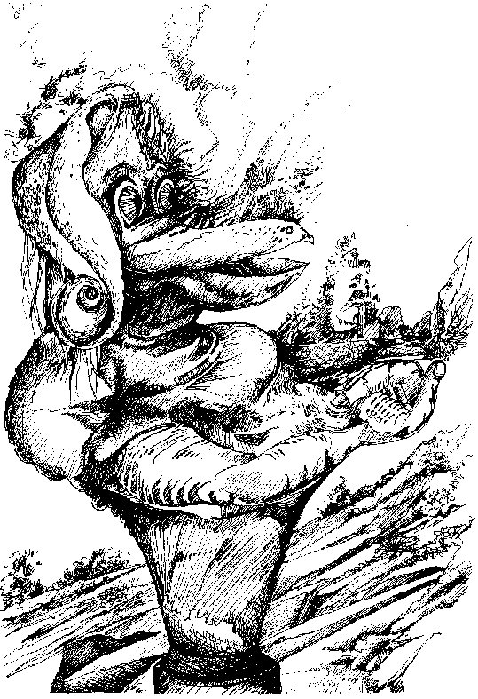
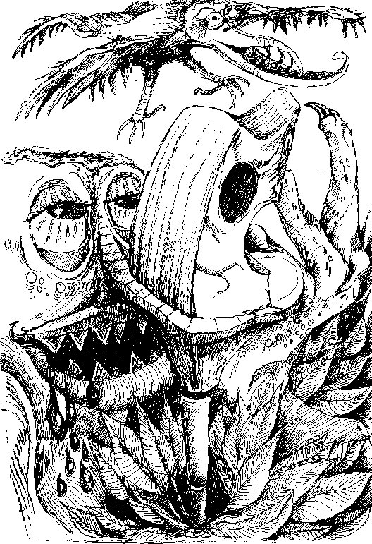

Practical Application
Demonstrates productive collaborative approaches to the creative arts process.
Class talk: The whole class had a talk about how we were all going and how our ideas are coming along. It turns out that lots of people are doing fantasy animals and birds. Good drawings of flamingo looking birds by XXXXX that she will turn into lino prints of. XXXX, XXX and XXXXXX are doing medieval warriors in paint. Two others are doing birds. It’s too many birds. I can change my ideas and try to get away from my cartooning.

I looked at Patrick Woodroffe’s illustrations in the book Second Earth. Most of his ideas are paintings and pencil drawings. I have included this one pencil drawing which I will attempt to base a portrait on. I like his detail and use of patterns and decoration on the clothes.
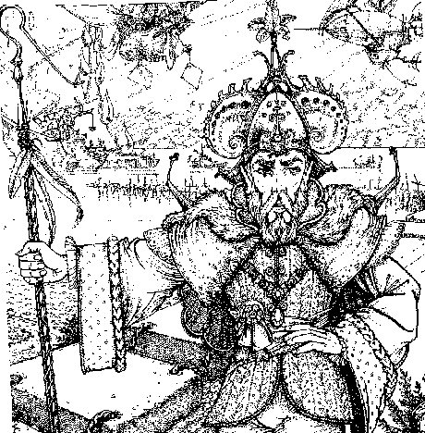
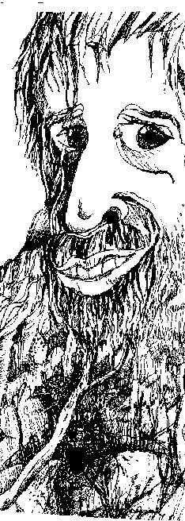

Idea 6: I based this portrait on a photo of my uncle because he has a beard. The bottom of the drawing is again my usual trees, bushes and rocks and is a mess, but some interesting accidental faces of creatures. It looks like cartoons are here to stay. I need to look for more ideas.

I haven’t done any work for this subject for quite a while. Other subjects had work due. I saw Alien again last night on DVD, my dad’s favourite movie. I have always been scared out of my mind of the Alien, and I am always blown away by how good the special effects were from the late 70’s. Dad says that Ridley Scott was the director and that the Alien was designed by an artist named Gigor. I googled the name and he is a German artist and designer. He won an Oscar for his paintings and designs for the film and is a completely obsessed science fiction geek. He designed science fiction images for album covers (Deborah Harry) and many acrylic paintings for exhibitions, all very dark and what I would call hard core science fiction. His work is very dark and often very erotic, but I found some pen drawings that were suitable to show for this project and they were very expressionist in appearance. The use of very sketchy lines gives the feeling of movement and some sense of mystery to the images, especially the alien characters. The combination of line-work with the solid dark areas created with multiple layers of cross hatching result in a believable, living and breathing creature which Gigor has created. He no doubt is trying to visually communicate a creature design to others in the movie making world.

The sketches below inspired me to do Idea 7: I have deliberately avoided mimicking Gigor’s ‘hard core’ science fiction style and made a ‘lighter’ image. It is called The happy lamp and I tried to use patterns and abstract parts with some expressionistic ideas with scribbles, dots (arrrgh), dashes, and layers of cross hatching to show the very dark areas, to get the idea.
Reflection
Some depth of appraisal of an artist/designer’s image in terms of the ideas, processes and decision making.
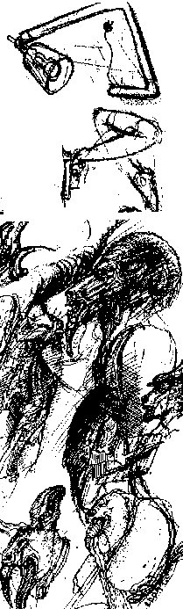
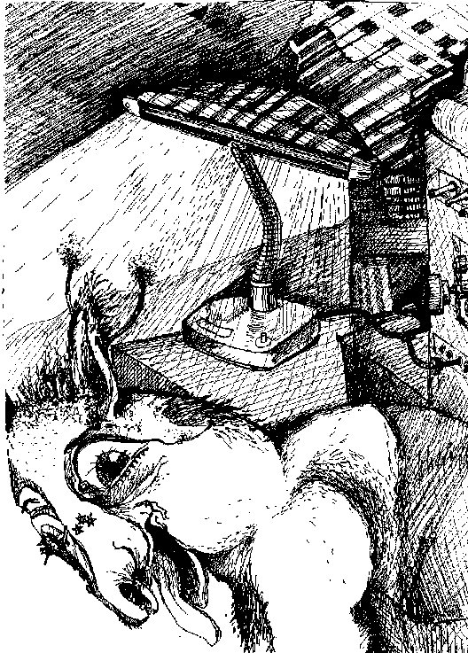

Final Drawings: I need to start my final drawings. Others in the class are now working on theirs and so I need to quickly get started. I can’t seem to change from my cartoon style so I am going to stick with this. My idea is to do two, A3 pictures which are humorous Science Fiction scenes. Gigor painted thirty pictures for the film Alien to help the director with his ideas of the look of the film. This is a similar idea. My pictures will have some dialogue to go with them to help explain the scene. I will make the pictures expressionistic as possible like Gigor’s sketches on the left of this page and Edmund Sullivan’s Jurers and let the details emerge from my mistakes( as with my other drawings.)

“Ah my little friend would you like to come home for dinner?”

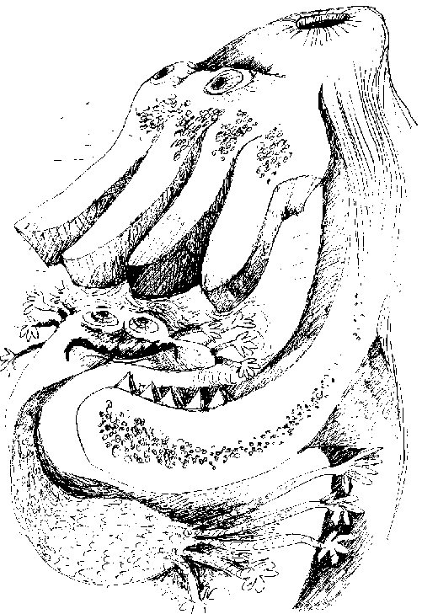

This is part of the first one I tried that has not worked out. It looks too much like an underwater scene. I do like the sketchiness of the hands frantically moving around in the ‘little friends’ attempts to escape. This is very much like Gigor’s technique with sketchy use of line to show movement.

The final exhibition
My drawings are finished and the exhibition is next week on Tuesday lunchtime and Friday evening. We talked about what we all will do to set up and help out. I will mount my drawings on black paper and add the dialogue to each which will help people understand them. I don’t want to talk to people about my drawings and Ms XX said that is OK. AA is and so is BB and CC and that is enough. I will welcome people at the door and give out the pamphlet which explains our work. DD is going to take photos and I can’t remember what all the others are doing, but we are pretty well organized. I have written a paragraph for the pamphlet which helps explain my work.

It all happened last week and we are now finishing the semester’s work.

Reflection

  - I think I expressed and communicated my ideas and opinions very well with this assignment. The creative process that I used was good and I was well organized with my ideas. I did say that I didn’t like some techniques (eg dots) but I didn’t really try any dot drawings to find out how I would go because I had plenty of other techniques to practice. I gave reasons for the steps in my creative process and explained my likes and dislikes of the drawings of my selected artists.
  - I thought my drawings were original and creative and they were not copied from anywhere. I enjoyed doodling and turning my mistakes into part of each drawing. Looking back at what I have done I agree with my dad when he says they look a bit like Star Wars characters. Maybe my ideas have subconsciously come from those films as I have sat and watched these with my dad heaps of times.
Reflection
Reflects thoughtfully on personal creative ideas, opinions and skills relevant to the program focus.
  - I work quite differently to the other students in my class and so my final drawings were quite unusual. I must admit that the cartoon drawing was something I could not change. Maybe I would need more formal instruction in Art to make this change, rather than rely on my own experimentation. I think that my efforts with pen did improve and I am pleased the expressionist techniques and the 3D feel of the characters were well done.
  - I thought we worked well together in our class and that we agreed on most things. I quite enjoyed meeting people at the door and giving out the pamphlets for the Arts Extravaganza. I was far more confident about doing this on the second showing on Friday night as I had some practice by then. Overall we came up with a display that had a variety of fantasy art ideas and I enjoyed being part of it.

Additional comments
- The reflective comments in the summary above are ‘thoughtful’. The more specific reflection/analysis of each of the 8 drawn ideas is at times ‘insightful’. The collective evidence suggests that this student does reflect ‘insightfully’.
- A review of the student’s work provides evidence of their ability to discerningly use the creative arts process in the development and presentation of their creative arts product.
ASSESSMENT TASK 1: CREATIVE ARTS PRODUCT

Vlagalsiti lures the Elelione to his cave and surprises her “ When I say put up your hands, I’ve got you covered……… a couple would do”
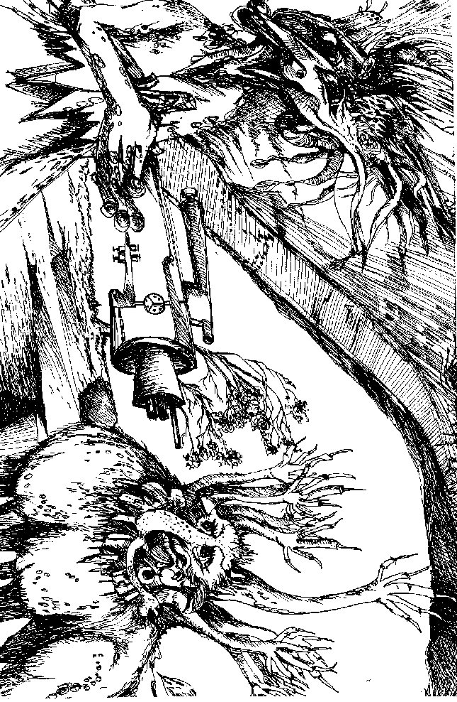

Practical Application
This piece shows sensitive application of different techniques with pen to communicate a variety of textures and tones. Both facial and whole body details and movements and the environmental visual cues, clearly and creatively express the story of this narrative piece.

Practical Application
Both pieces show that the student has been both selective and productive in the individual approach to the task.

On the planet Vegetarious, handsome agent Bortos Tuborias approaches the stunning Miss Violetti Stamenead in a day-club to pass on his message. He is worried they will be overheard. “Can we talk privately?” he whispers.

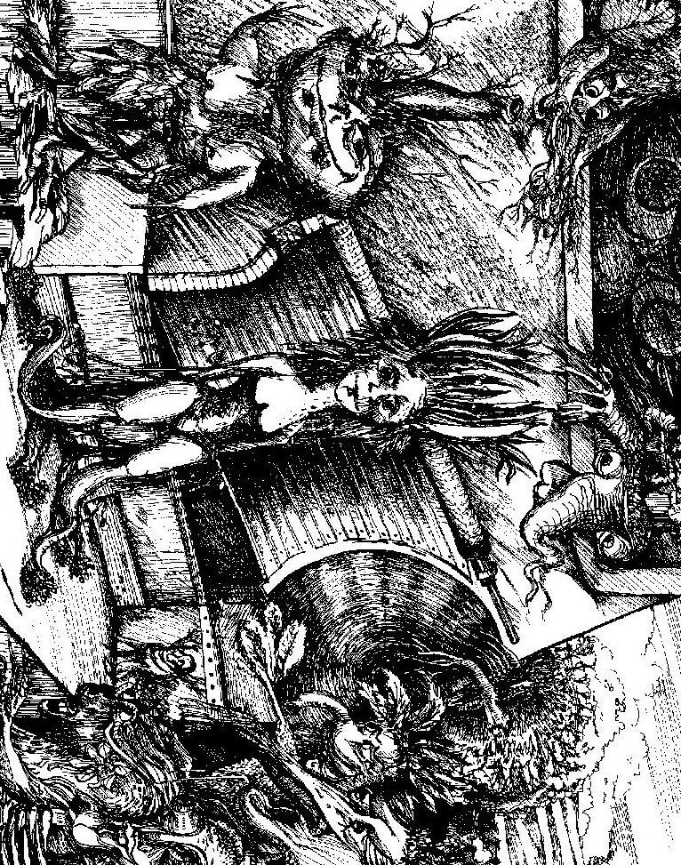

Practical Application
In this piece, techniques and compositional skills have been further polished.

Performance Standards for Stage 1 Creative Arts
 | Knowledge and Understanding | Practical Application | Investigation and Interpretation | Reflection
A | In-depth knowledge and understanding of core concepts specific to relevant creative arts discipline(s).  Accurate and appropriate understanding and use of language specific to relevant creative arts discipline(s).  In-depth knowledge of a broad range of creative arts media, materials, techniques, processes, and technologies. | Creative and clear expression and communication of ideas relevant to the program focus.  Discerning use of the creative arts process in the development and presentation of well-refined creative arts product(s).  Selective and productive approaches appropriate to the creative arts process.  Refined and integrated application of practical skills, techniques, and processes. | Astute identification and use, and thorough acknowledgment, of a variety of appropriate sources.  Clear and perceptive interpretation of the ideas of creative arts practitioners.  Well-planned and in-depth investigation into the nature and processes of working productively in the creative arts. | Insightful appraisal of creative arts products in terms of practitioners’ ideas, processes, and decision-making.  Insightful reflection on personal creative arts ideas, opinions, and skills relevant to the program focus.
B | Some depth of knowledge and understanding of core concepts specific to relevant creative arts discipline(s).  Mostly accurate and appropriate understanding and use of language specific to relevant creative arts discipline(s).  Some depth of knowledge of creative arts media, materials, techniques, processes, and technologies. | Thoughtful and mostly clear expression and communication of ideas relevant to the program focus.  Well-considered use of the creative arts process in the development and presentation of polished creative arts product(s).  Productive approaches to the creative arts process, with some originality.  Generally integrated application, with some refinement, of practical skills, techniques, and processes. | Well-considered identification, use, and acknowledgment of different sources.  Clear interpretation of the ideas of creative arts practitioners.  Mostly well-planned and detailed investigation into the nature and processes of working productively in the creative arts. | Some depth of appraisal of creative arts products in terms of practitioners’ ideas, processes, and decision-making.  Thoughtful reflection on personal creative arts ideas, opinions, and skills relevant to the program focus.
C | Appropriate knowledge and understanding of core concepts specific to relevant creative arts discipline(s).  Generally appropriate understanding and use of language specific to creative arts discipline(s).  Knowledge of key creative arts media, materials, techniques, processes, and technologies. | Generally considered and clear expression and communication of ideas relevant to the program focus.  Competent use of the creative arts process in the development and presentation of appropriate creative arts product(s).  Generally productive approaches to the creative arts process.  Competent application of key practical skills, techniques, and processes. | Considered identification, use, and acknowledgment of appropriate sources.  Generally clear interpretation of the ideas of creative arts practitioners.  Competent investigation into the nature and processes of working productively in the creative arts. | Competent appraisal of creative arts products in terms of practitioners’ ideas, processes, and decision-making.  Considered reflection on personal creative arts ideas, opinions, and skills relevant to the program focus.
D | Some basic knowledge of selected core concepts.  Use of some terms that may be relevant to creative arts discipline(s).  Recognition of some aspects of creative arts media, materials, techniques, processes, or technologies. | Basic expression of an idea that may be relevant to the program focus.  Some use of the creative arts process in the development and/or presentation of a basic creative arts product.  Some basic participation in aspects of a creative arts process.  Some application of a practical skill, technique, or process. | Identification and some use of sources that could inform the creative arts process.  Basic description of the ideas of a creative arts practitioner.  Some basic investigation of the nature of, or processes relevant to, working in the creative arts. | Recognition and description of a practitioner’s idea, intention, process, or decision in creative arts products.  Superficial consideration of personal creative arts ideas, opinions, and/or skills with some relevance to the program focus.
E | Some recognition of one or more selected core concepts.  Limited use of terms that may be relevant to creative arts discipline(s).  Emerging awareness of creative arts media, materials, techniques, processes, or technologies. | Attempted expression of an idea that may be relevant to the program focus.  Attempted use of the creative arts process in the limited development or presentation of a creative arts product.  Attempted participation in aspects of a creative arts process.  Attempted application of a practical skill, technique, or process. | Identification and use of a source.  Attempted description of the ideas of a creative arts practitioner.  Identification of one or more processes relevant to working in the creative arts. | Some identification of a practitioner’s intention or process in a creative arts product.  Attempted consideration of a personal creative arts idea, opinion, or skill with limited relevance to the program focus.

