Mathematical Methods - Trigonometric Functions

- A bungee jump is organised from a platform above a lake.

The function $H\left(t\right)=25e^{-o.5t}\cos{(t-0.464)}+6$is used to model the height of a person above the water surface t seconds after jumping from the platform.

  - Determine the initial height above the water surface.

$t=0$ $H \left(0\right)=25e^{o}\cos{(-0.464)}+6$

=$28.4$m (1 mark)

  - State the height of the person above the water surface as $t→∞$

$t→∞$ $e^{-o.5t}→0$

$∴ H \left(t\right)→6$ (1 mark)

  - Sketch a graph of the function in the space below to show the height of a person above the water surface during the first 10 seconds after the jump.

H

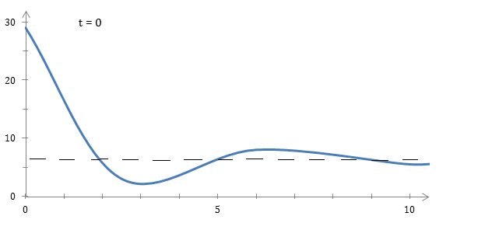

t

(3 marks)

  - Find the minimum distance between the person and the water surface during the jump, giving your answer to an accuracy of 3 significant figures.

From the graph min H = 1.35m

(1 mark)

  - Show that the velocity of the person during the bungee jump is given by $v\left(t\right)=-25e^{-0.5t}(2\sin{(t}-0.464)+cos (t-0.464)$)

$$v\left(t\right) =H'(t)$$

$=25$x$\left[-0.5e^{-0.5t} cos \left(t-0.464\right)+e^{-0.5t}. -\sin{(t-0.464)}\right]$

$${= -12.5e}^{-0.5t}\left[cos \left(t-0.464\right)+2\sin{(t-0.464)}\right]$$
(3 marks)
  - Calculate v(2) and v(5) and give an interpretation for these values.

v(2) = -9.28

person is falling at 9.28m/s (2 marks)

v(5) = 2.19 m/s

person is rising at 2.19 m/s (2 marks)

- If $f\left(t\right)=5sin⁡(3t-4)$ show that $f^{''}\left(t\right)=-9f(t)$

$$f\left(t\right)=5 sin⁡(3t-4)$$

$$f^{'}(t)=5 ×3cos⁡(3t-4)$$

$$f^{''}\left(t\right)=5 ×3×-3 sin⁡(3t-4)$$

= - 9 $×$ 5 $sin⁡(3t-4)$

= - 9 f $⁡(t)$
(2 marks)

- Find the second derivative of the following functions and summarise your results in the table below

i) $f(t)=4sin(2t+5)$

$f^{''}\left(t\right)=-4 × 4sin(2t+5)$ = $-4 f(t)$ (1 mark)

ii) $f\left(t\right)=-sin⁡(t-3)$

$f^{''}\left(t\right)=-1 × - sin(t -3)$ = $-1 f(t)$ (1 mark)

$$f(t)$$ | $$5sin⁡(3t-4)$$ | $$4sin(2t+5)$$ | $$-sin⁡(t-3)$$
$$f''(t)$$ | $$-9f(t)$$ | $$-4f(t)$$ | $$-1f(t)$$

c)
- The general form of the sine function is $f\left(t\right)=Asin(ωt+k)$ where $A,ω and k$ are constants.
Make a conjecture which describes the relationship between the general form of the function $f\left(t\right)$ and the second derivative $f''\left(t\right)$.

$f^{''}\left(t\right)=-w^{2}$ $f(t)$ (1 mark)

- Prove your conjecture

$f\left(t\right)=A sin⁡(wt+k)$

$f^{'}\left(t\right)=A wcos ⁡(wt+k)$

$f^{''}\left(t\right)=A w. -w sin ⁡(wt+k)$

$=-w^{2} A sin ⁡(wt+k)$

$=-w^{2} f(t)$ (3 marks)

$∴$ proven

- Find the minimum value of $y=\frac{e^{x}}{sinx} 0≤x≤π$ giving a simplified answer in exact form.

y = $\frac{e^{x} }{sinx}$ 0 ≤ x ≤ π

$\frac{dy}{dx}$ = $\frac{e^{x} sinx - e^{x}cosx}{sin^{2}x}$ (3 marks)

= $e^{x}$ $\frac{(\sin{ }x -\cos{ }x)}{sin^{2}x}$

$\frac{dy}{dx}$ = 0 if $\sin{x=\cos{x}}$ $x <\frac{π}{4}$ $\sin{x }<\cos{x }$

$∴ \tan{x=1}$ $∴ \frac{dy}{dx} < 0$ (2 marks)
$$∴ x= \frac{π}{4}$$

$x <\frac{π}{4}$ $\sin{x }>\cos{x }$

$\frac{dy}{dx} > 0$
$-$$+$
sign

0 $\frac{π}{4}$ $π$ (1 mark)

$∴$ min value when $x= \frac{π}{4}$ (1 mark)

$y= \frac{e \frac{π}{4}}{\sin{\frac{π}{4}}}$

$y= \sqrt{2}$ ${e }^{\frac{π}{4}}$ (1 mark)

- Triangle AOB is drawn within a circle of radius 5 cm where O is the circle centre and AB is a chord of the circle.
Find the maximum possible area of the triangle.
5
A
B
5
O
$$θ$$

Area A = $\frac{1}{2}$ x ${ 5}^{2}$ x sin $θ$ O $< θ < π$

A = 12.5 sin $θ$ (2 marks)

$\frac{dA}{dθ}$ = 12.5 cos $θ$

$\frac{dA}{dθ}$= O if cos $θ =O$

$∴ θ= \frac{π}{2}$

$$+ -$$

0 $\frac{π}{2}$ $π$

$∴$ max area when $θ= \frac{π}{2}$

$A=12.5 {cm}^{2}$ (4 marks)

(sin $\frac{π}{2}$ = 1)

- The function $H\left(t\right)=1.1\sin{\frac{π}{6}\left(t-3\right)}+1.3 0≤t≤24$ represents the predicted water depth in metres at the Adelaide Outer Harbour Tidal station on Sunday 24 September 2017 where
t is the time in hours.

  - Find $H'(8)$ and give an interpretation for this value in terms of the water depth.

(Could be a calculator use question: Solutions here do not use the calculator)

H(t) = 1.1 sin $\frac{π}{6}$ (t – 3) + 1.3 0 ≤ t ≤ 24

-3 ≤ t – 3 ≤ 21

$H^{'}(t)=1.1 x{\frac{π}{6} \cos{ }\frac{π}{6} \left(t-3\right)}$ $\frac{-3 π}{6}≤ \frac{π}{6} \left(t-3\right)≤ \frac{21 π}{6}$

$$\frac{-π}{2}≤ \frac{π}{6} \left(t-3\right)≤ \frac{7π}{2}$$

$$H^{'}(8)=1.1 x{\frac{π}{6} \cos{ }\left(\frac{5π}{6}\right)}$$

$$=-0.499$$

Depth is decreasing at 0.499 m / hour at 8:00am (3 marks)

  - Find the maximum water depth on this day and the time(s) when that will occur.

H (t) is max when sin $\frac{π}{6}$ (t-3) = 1
$$∴ H \left(t\right)=2.4 m$$

When $\frac{π}{6} \left(t-3\right)= \frac{π}{2} , \frac{5π}{2}$

t= 6, 18

$∴$ max depth is 2.4m at 6:00 and 18:00 hour
(3 marks)

  - Determine the time period in the afternoon when the water depth will be increasing.

Water depth is increasing when H’(t) > 0

$$∴ 1.1 × \frac{π}{6}\cos{\frac{π}{6} \left(t-3\right)>0}$$

Or $\cos{\frac{π}{6} \left(t-3\right)>0}$

0 < $\frac{π}{6}$ (t-3) < $\frac{π}{2}$ or $\frac{3π}{2}<\frac{π}{6} \left(t-3\right)< \frac{5π}{2}$

0 < t - 3 < 3 9 < t – 3 < 15

3 < t < 6 or 12 < t < 18 (afternoon time)

Water depth is increasing between 12:00 and 18:00 hours.
(2 marks)

  - An environmental team wishes to inspect the marine growth on the wharf when the water depth is less than 0.5m, suggest a suitable time for this work.

H (t) < 0.5

10.56 < t < 13.46

Between 10.56am and 1.46 pm (2 marks)

- For the function $f\left(x\right)=\frac{5sinx}{e^{x}} in the domain 0≤x≤2π$
  - Find the zeros of the function

$f \left(x\right)=0 if \sin{x=0}$ $∴ x=0, π, 2π$
(2 marks)

  - Show that $f^{'}\left(x\right)=5\frac{cosx-sinx}{e^{x}}$

$${ f }^{'}\left(x\right)=\frac{5cosx e^{x} -5sinx e^{x}}{e^{2x}}$$

= 5 $\frac{cosx - sinx}{e^{x}}$
(3 marks)

hence find:

  - the position and nature of the stationary points

$$f^{'}\left(x\right)=0 if cosx-sinx =0$$

$\cos{x=\sin{x}}$ $0 ≤x ≤2π$

$x= \frac{π}{4}$ , $\frac{5π}{4}$

$+ - +$
sign $f'(x)$

0 $\frac{π}{4}$ $\frac{5π}{4} 2π$

$∴ local \max{ x= }\frac{π}{4} y= \frac{5}{\sqrt{2} }$ $e^{-\frac{π}{4}}$= 1.61

$local \min{ x= }\frac{5π}{4} y= \frac{5}{\sqrt{2} }$ $e^{-\frac{5π}{4}}$= -0.07

  - the domain for which the function is decreasing.

Function is decreasing if $f^{'}\left(x\right)<0$

$∴ \frac{π}{4} <x < \frac{5π}{4}$ (from the sign diagram)

(6 marks)

  - Sketch a graph of the function showing the information found above
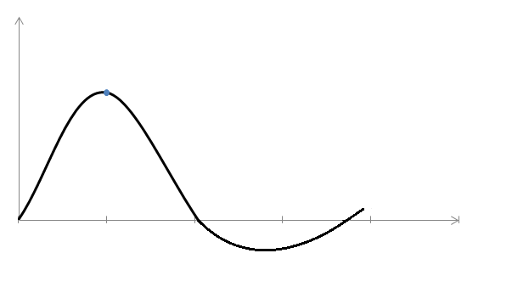
5$\frac{π}{4}$
$$\frac{π}{4}$$
$$( \frac{π}{4}, 1.61 )$$
$$2π$$
$$π$$
X
Y
(3 marks)
(5$\frac{π}{4}$, -0.07)

  - Show that the equation of the tangent to the function at $x=π$ is given by $e^{π}y+5x-5π=0$

$$f^{'}\left(x\right)=5 \frac{cosx - sinx}{e^{x}}$$

When $x=π$ slope of tangent

m = 5 $\frac{-1 -0}{e^{π} }$

m = $\frac{-5}{e^{π} }$

y = - $\frac{5\sin{ }π}{e^{π} }$ = 0

$$∴ y-y_{1} =m (x-x_{1})$$

$$y=\frac{-5}{e^{π} } (x- π)$$

$$e^{π}y=- 5(x- π)$$

$$e^{π}y+ 5x- 5π=0$$
(4 marks)

