VISUAL ARTS – ART

FOLIO: LANDSCAPE BRICKS

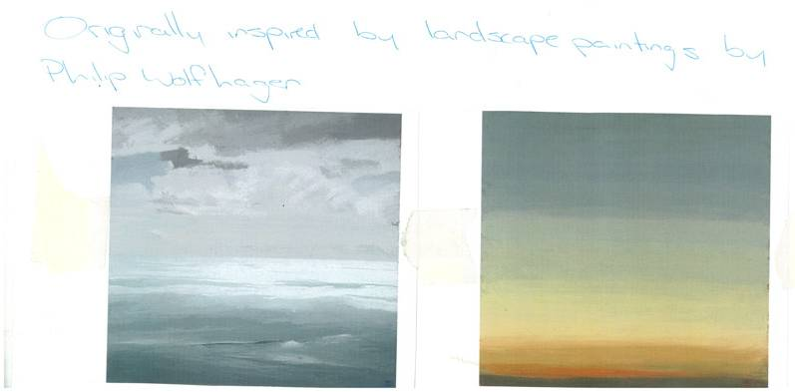
Analysis and Response
Demonstrates the beginnings of clear and consistent use of visual arts language to interpret and respond to works and their contexts.
Left: Originally inspired by landscape paintings by Philip Wolfhagen. The monochromatic seascape on the left shows great control of the paint to create light and dark areas, and the texture in clouds and distance in the sea. The sunset on the right concentrates on the sky and shows beautifully blended changes in colour, probably using washes.

Practical Application
Demonstrates the beginnings of reflective and thorough documentation of creative visual thinking and/or problem-solving processes.

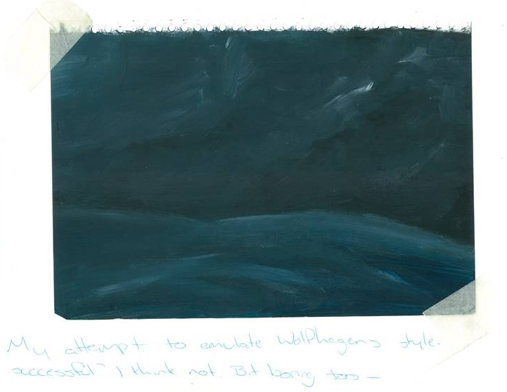
Right: My attempt to emulate Wolfhagen’s style – successful? I think not. It is all too dark, and my technique is clumsy. I should try using washes instead of the impasto technique.

Practical Application
Demonstrates the beginnings of a comprehensive exploration to acquire technical skills, and use media, materials, and technologies.

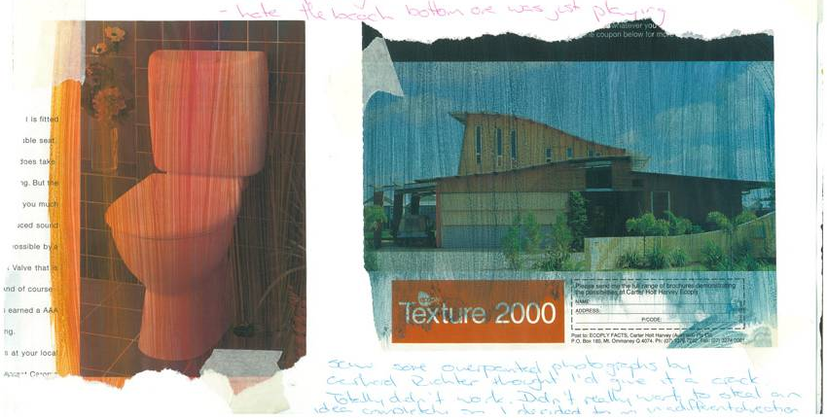

Above: Saw some over painted photographs by Gerhard Richter, thought I’d have a go at it. I used fairly light washes. Totally didn’t work because I didn’t spend enough time on it and I needed to use a variety of subtle changes in colour. Didn’t really work to steal an idea completely so I decided to go in a different direction.

Practical Application
Indicates continuing and improving application of technical skills and sensitive use of media, materials, and technologies to effectively communicate visual ideas in resolved work(s) of art or design.


Above: Started playing with the idea of a landscape – pretty average – like the kind of ‘rural aussie’ look.
Analysis and Response
Demonstrates insightful evaluation of own practical work.

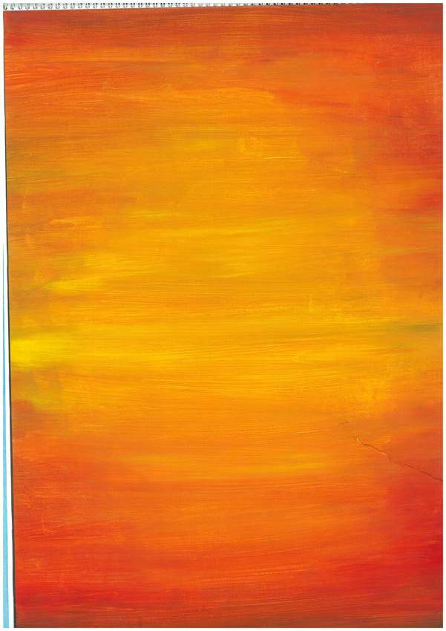
Analysis and Response
Demonstrates continuing clear and consistent use of visual arts language to interpret and respond to works and their context.

.
Left: Just played around with colour and mixing colours. I really liked the symmetry I achieved with the yellow and red one. Hmm.

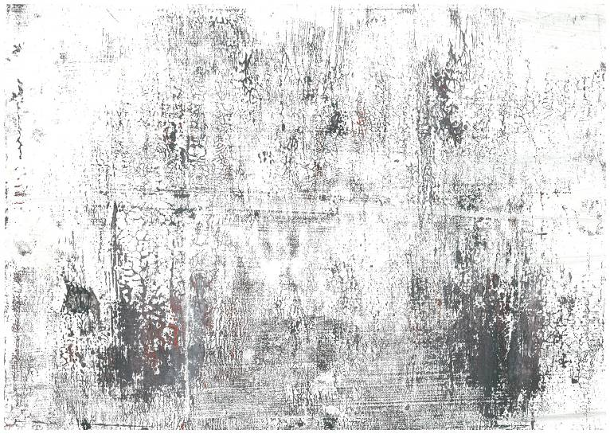
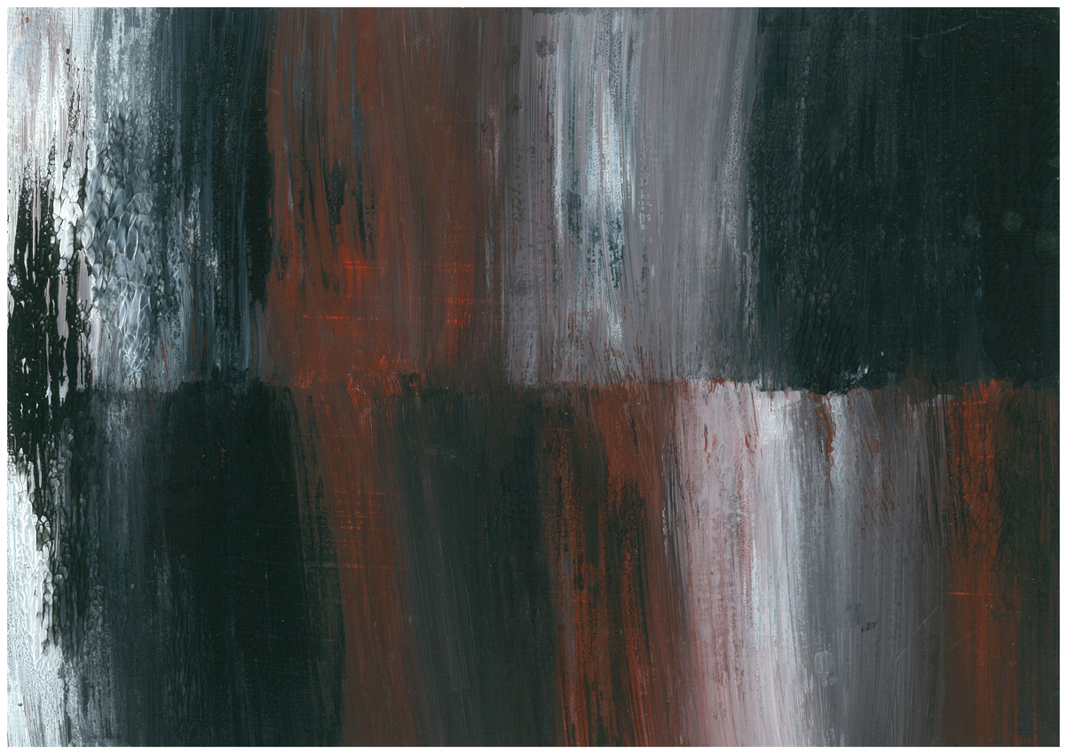

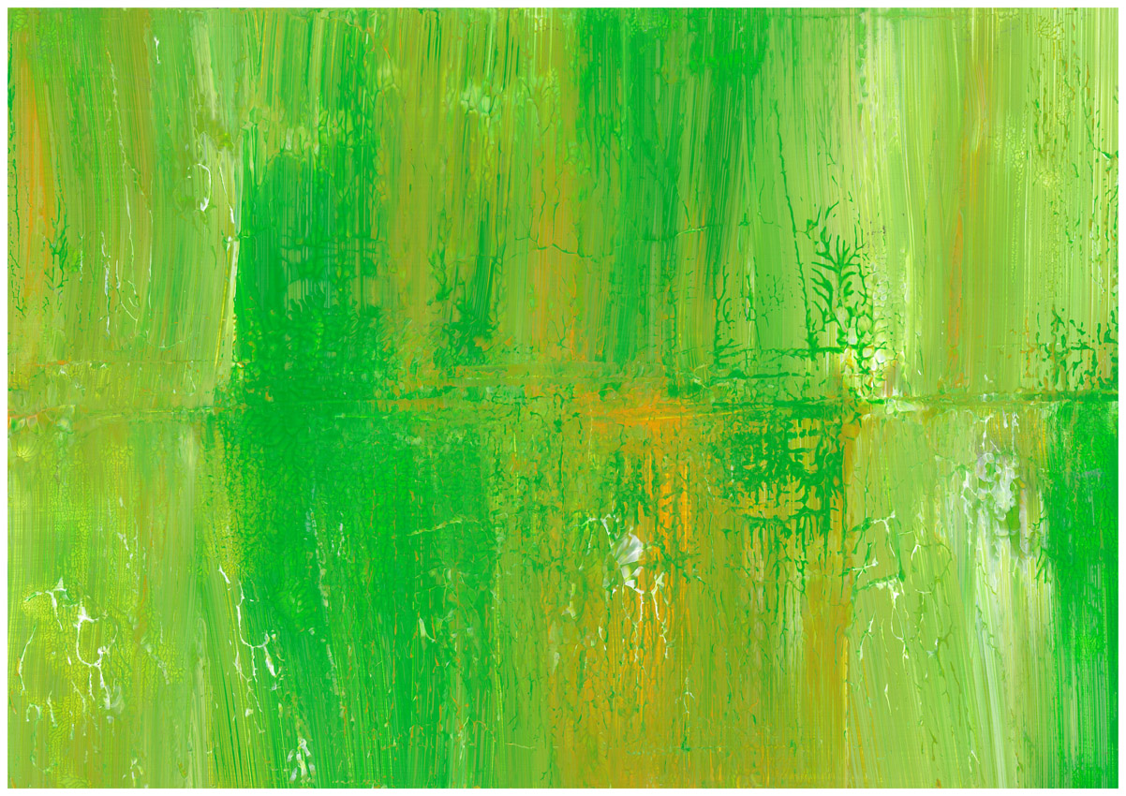
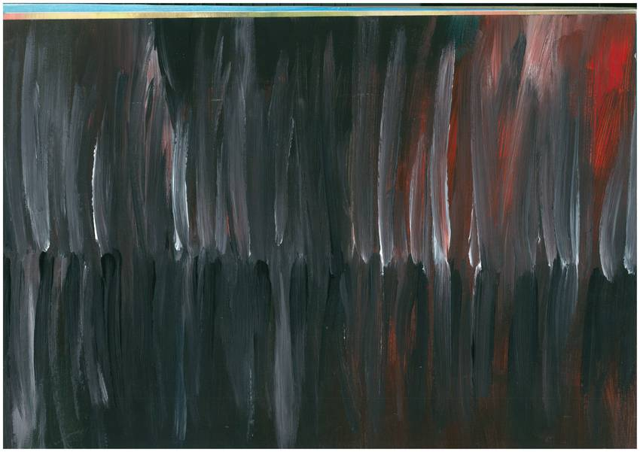

Knowledge and Understanding
Indicates discerning understanding of aesthetic or functional qualities in works of art or design.

This is what I came up with.
Still thinking about landscapes just in a more abstract way.
Now it’s more about the colours and how they work together.

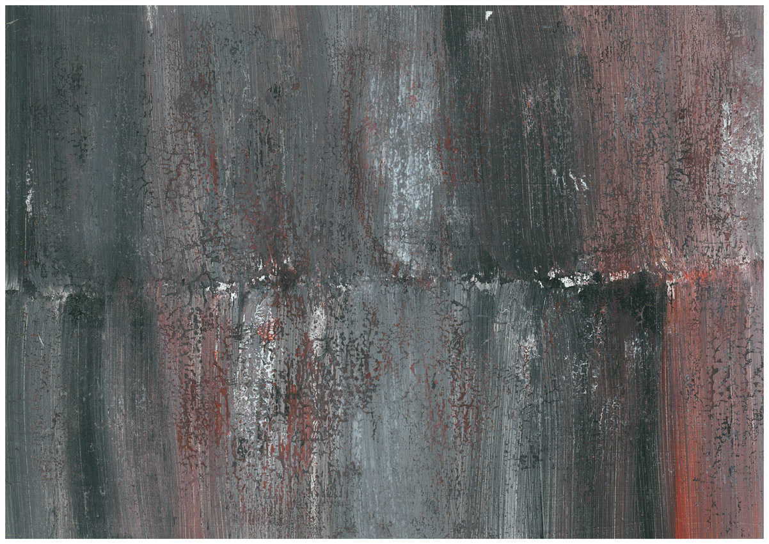
Practical Application
Indicates comprehensive exploration to acquire technical skills, and use media, materials, and technologies.

Right: Continued the colours I used before but note the interesting texture. Happened COMPLETELY by mistake.

I was trying to move the paper and it fell in on itself, but I am so happy it did – changes the look completely.

It’s very earthy and outback like. You get rusted metal, tree bark a whole range of different ideas can be drawn from this.

Can’t imagine my work if I hadn’t dropped the paper – it would’ve been completely different.

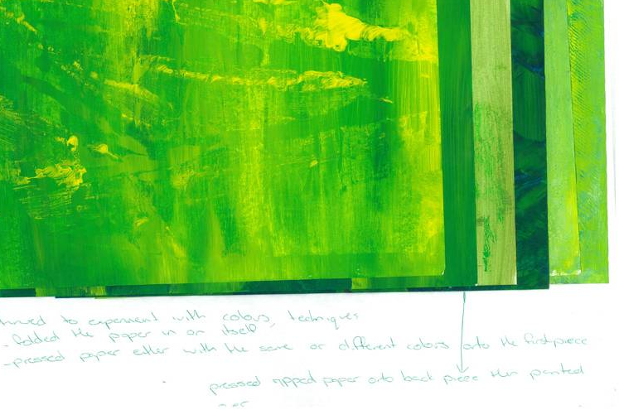
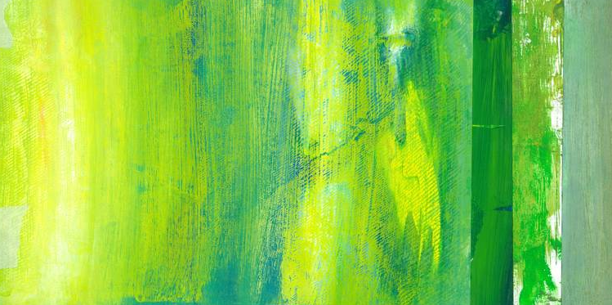

Practical Application
Demonstrates continuing reflective and thorough documentation of creative visual thinking and/or problem-solving processes.

Continued to experiment with colours, techniques and folded the paper in on itself. Pressed paper either with the same or different colours onto the first piece. Pressed ripped paper onto back piece then painted over.

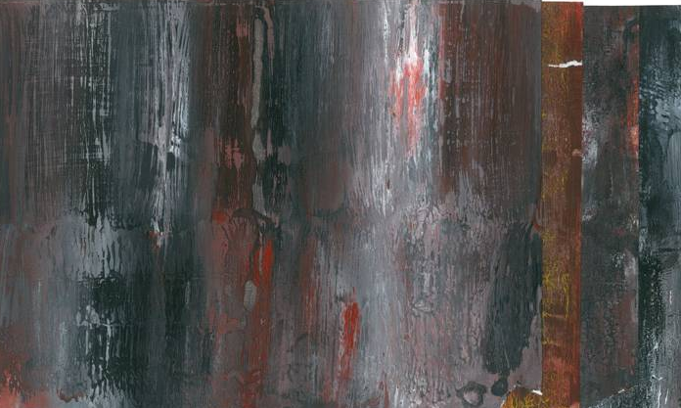

Went back to red, black and white – at this point.
Practical Application
Continues to demonstrate effective application of technical skills and sensitive use of media, materials, and technologies to communicate visual ideas in resolved work(s) of art or design.
I began to paint onto primed MDF board.
Paper was tearing and I had the idea to lay them all out together and paper wouldn’t have worked for this.

Some of the first paintings I did on MDF.

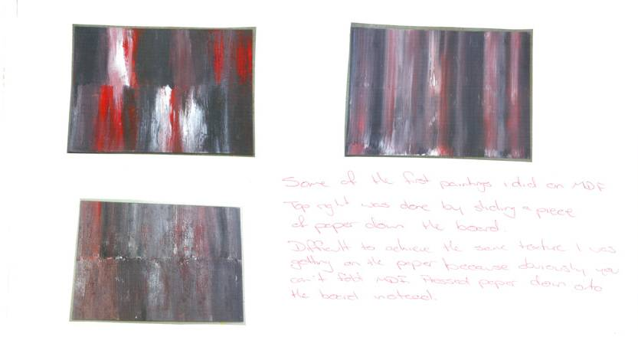
Top right was done by sliding a piece of paper down the board. Difficult to achieve the same texture I was getting on the paper because obviously you can’t fold MDF. I pressed the paper down onto the board instead.
Knowledge and Understanding
Indicates a discerning understanding of aesthetic or functional qualities in works of art or design.

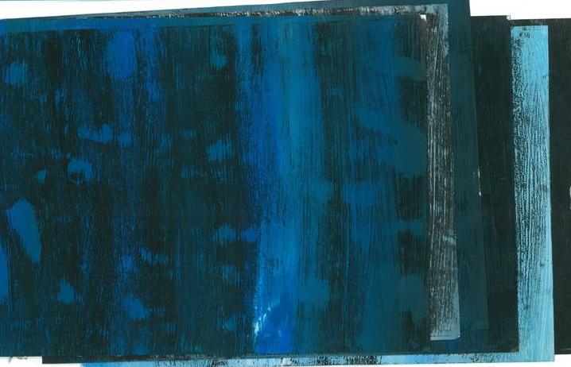
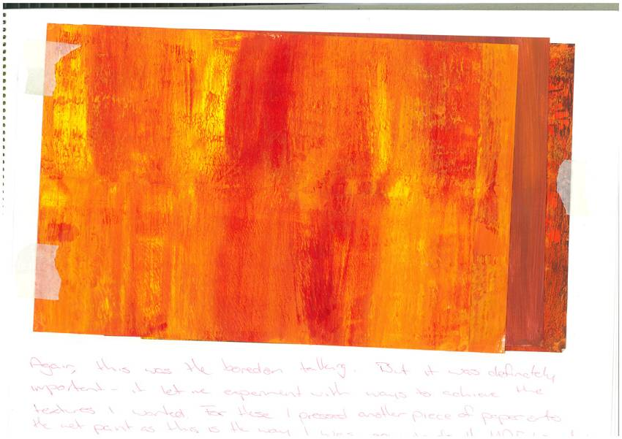
Right: Use of an analageous colour scheme. Red orange and yellow. This let me experiment with ways to achieve the texture I wanted. For these I pressed another piece of paper onto the wet paint as this is the way I was going to do the MDF boards.
The reason for changing my colours was simple – was I missing out on an alternative idea by not trying cool colour schemes? These were more about the textures. I didn’t try to get the reflection line at all in this experiment.
Practical Application
Indicates a reflective and thorough documentation of creative visual thinking and/or problem-solving processes.
The reason for changing my colours was simple – boredom. I was sick of looking at black, white and red. These were more about the textures. I didn’t try to get the reflection line at all.

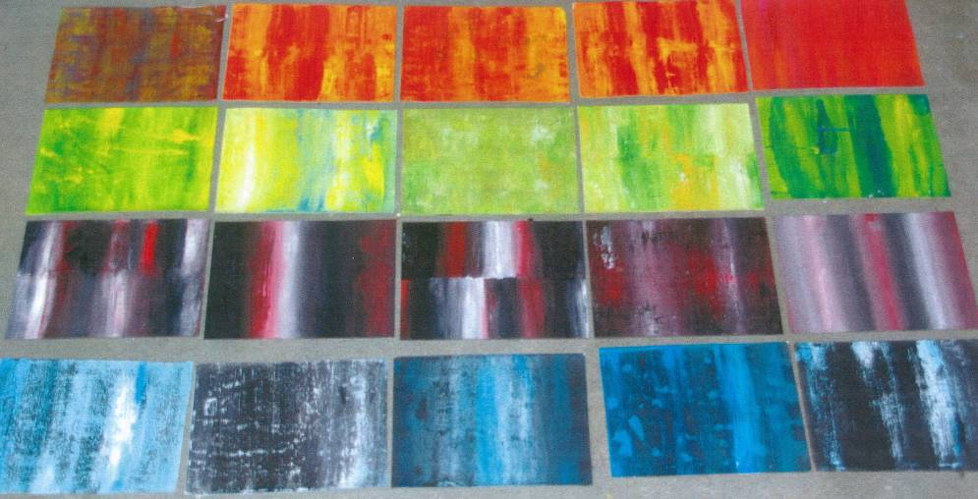
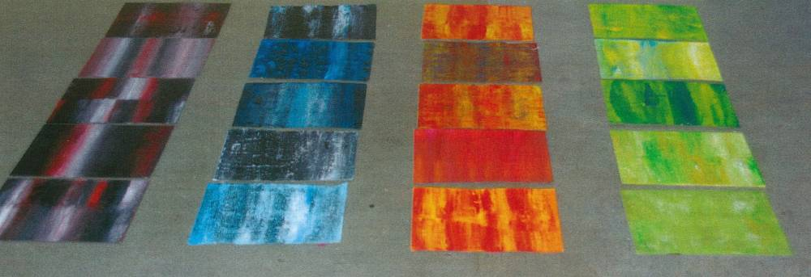
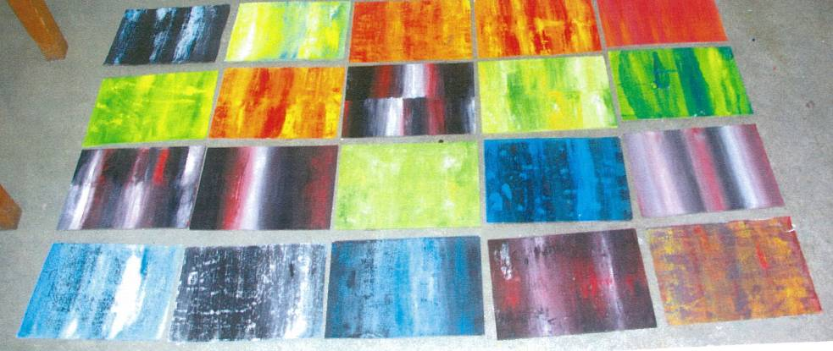
After I did all my colour experiments and had a range of different ideas going, I started arranging the work.

To begin with, I was using all the different colours in my layout because I didn’t want to ‘waste’ any that I had done. These ideas represented the seasons, change which I thought was a good idea.

But it was too full on. There was too much happening and it did not look any good. So I cut back on the colours and tried it with the blue and the red/black.

Practical Application
Demonstrates coherent and well-considered conceptualisation and development of imaginative or personally relevant visual ideas.
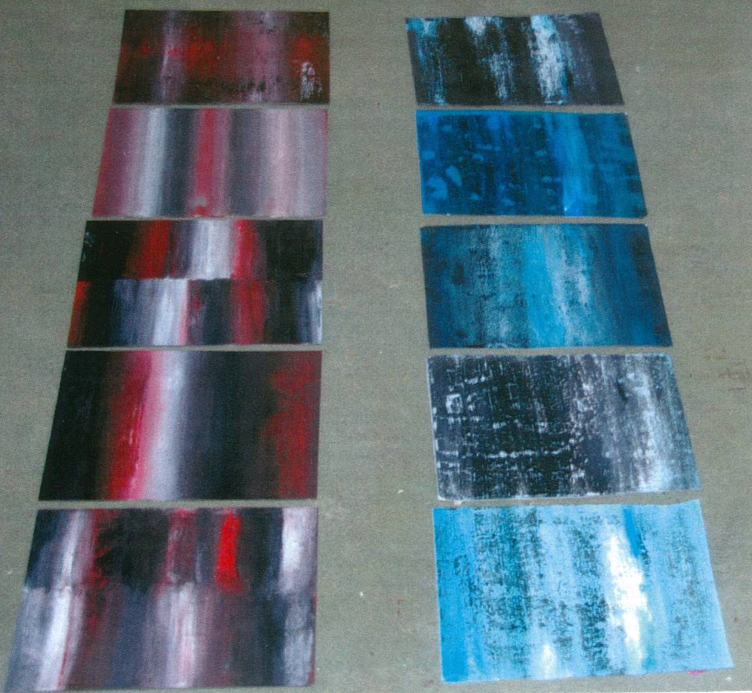
Right: The colours worked fairly successfully together, but I decided against it because the black/white/red is a very strong combination. There are lots of references to Australia – it’s rustic, you get the rusted metal feel, its unpredictable even a bit violent. The blue took away from that – it’s a very calm colour and that’s not the way I want the piece to be seen.
Knowledge and Understanding
Displays a discerning understanding of aesthetic or functional qualities in works of art or design.
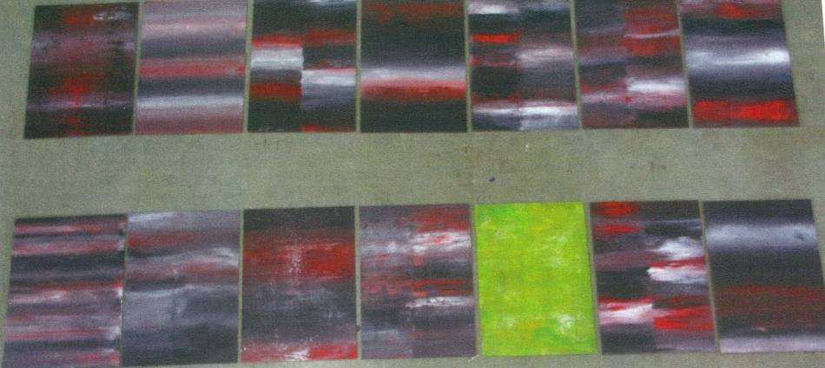
I played around with the layout almost obsessively – it had to be perfect. At this point I was still considering the idea of including one board of a different colour to create a point of interest.
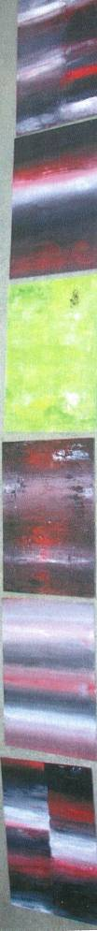
Practical Application
Demonstrates reflective and thorough documentation of creative visual thinking and/or problem-solving processes.

Analysis and Response
Demonstrates insightful evaluation of own practical work.

And create a point of interest it did, to the point where it took away from the overall work.
The piece became about the white, or the green.
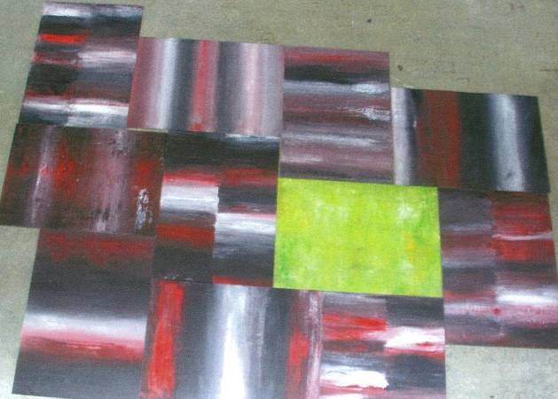

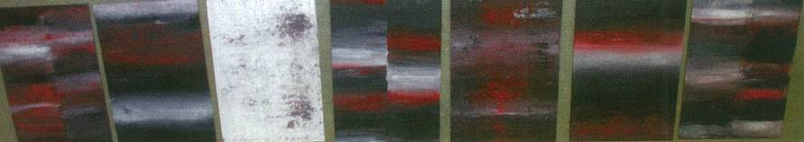

So I decided against using a different coloured board.

Once I had decided on the colours (or lack of) I was using I went through the process of deciding the layout again.
To begin with, I looked at arranging it in a single row either vertical or horizontal.
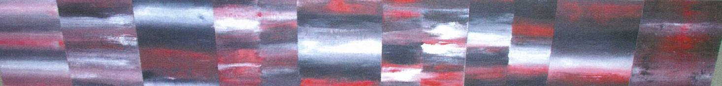

I really liked the flow I got by lining them up this way (above).



The same flow doesn’t work here because the vertical works against the horizontal format (above).

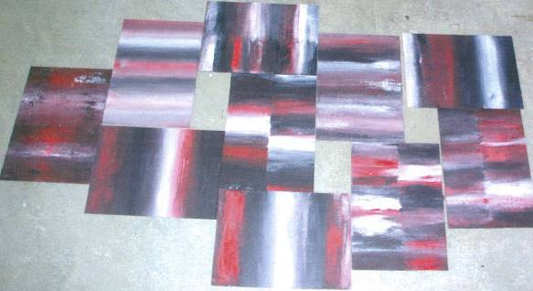
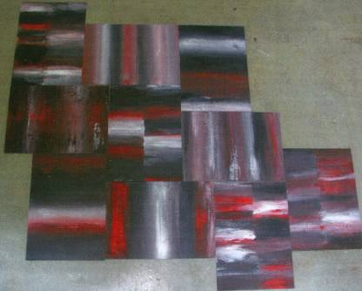
Practical Application
Demonstrates effective application of technical skills and sensitive use of media, materials and technologies to communicate visual ideas in resolved work(s) of art or design.

I also played with the idea of ‘tiling’ them which looked interesting.
Arranging them this way looked a bit messy though and because the painting is so disorganised this became too much.

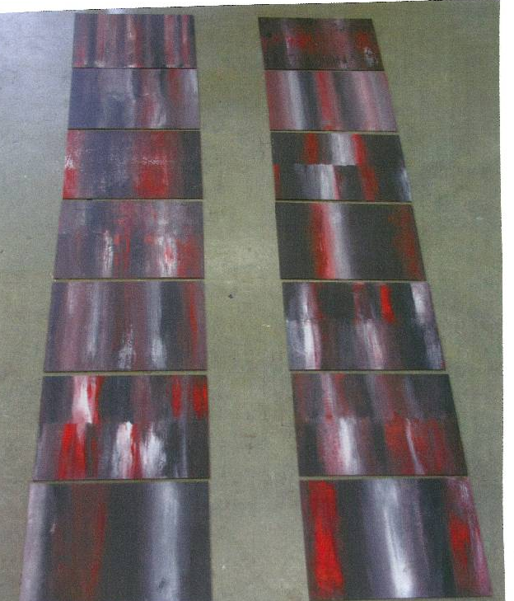
Finally, I decided on two vertical lines to represent the built aspects of the Australian Outback. This is different to my original idea of purely representing the natural Australian outback.I think this will make a more creative finished piece with a more subtle message about how the beauty of central Australia is reflected in old rusty iron.

This is ordered and I achieved the flow that I wanted.

It has a lot of references with outback Australia, it’s rustic, dirty, earthy and looks like rusted corrugated Iron you find in old broken down homesteads. I’m happy with the flow of the piece and the colours.

Overall a success!

Analysis and Response
Demonstrates insightful evaluation of own practical work.

Performance Standards for Stage 1 Visual Arts – Art

 | Practical Application | Knowledge and Understanding | Analysis and Response
A | Coherent and well-considered conceptualisation and development of imaginative or personally relevant visual ideas.  Comprehensive exploration to acquire technical skills, and use media, materials, and technologies.  Reflective and thorough documentation of creative visual thinking and/or problem-solving processes.  Effective application of technical skills and sensitive use of media, materials, and technologies to communicate visual ideas in resolved work(s) of art or design. | In-depth knowledge of selected core visual arts concepts, forms, styles, and conventions.  In-depth knowledge and understanding of visual arts in different cultural, social, and/or historical contexts.  Discerning understanding of aesthetic or functional qualities in works of art or design.  Productive and well-considered research, including locating and appropriately acknowledging sources, exploring, experimenting, and developing perceptive and clear insights into a range of aspects of the visual arts. | Perceptive analysis and interpretation of a variety of works of art or design from different contexts.  Clear and consistent use of visual arts language to interpret and respond to works and their contexts.  Insightful evaluation of own practical work.
B | Well-considered conceptualisation and development of imaginative or personally relevant visual ideas.  Thorough exploration to acquire technical skills and use media, materials, and technologies.  Thoughtful documentation of creative visual thinking and/or problem-solving processes.  Mostly effective application of technical skills, and some sensitive use of media, materials, and technologies to communicate visual ideas in resolved work(s) of art or design. | Some depth of knowledge of selected core visual arts concepts, forms, styles, and conventions.  Some depth of knowledge and understanding of visual arts in different cultural, social, and/or historical contexts.  Clear understanding of aesthetic or functional qualities in works of art or design.  Well-considered research including locating and appropriately acknowledging sources, exploring, experimenting, and developing mostly clear insights into different aspects of the visual arts. | Thoughtful analysis and interpretation of works of art or design from different contexts.  Mostly clear and consistent use of visual arts language to interpret and respond to works and their contexts.  Well-considered evaluation of own practical work.
C | Considered conceptualisation and development of imaginative or personally relevant visual ideas.  Competent exploration to acquire technical skills and use media, materials, and technologies.  Appropriate documentation of creative visual thinking and/or problem-solving processes.  Competent application of some technical skills with media, materials, and technologies to communicate visual ideas in resolved work(s) of art or design. | Knowledge of selected core visual arts concepts, forms, styles, and conventions usually demonstrated in practical work.  Appropriate knowledge and mostly clear understanding of visual arts in different cultural, social, and/or historical contexts.  Appropriate understanding of aesthetic or functional qualities in works of art or design.  Considered research including locating and appropriately acknowledging sources, exploring, experimenting, and developing some insights into different aspects of the visual arts. | Considered analysis and interpretation of two or more works of art or design from different contexts.  Generally clear use of visual arts language to interpret and respond to works and their contexts.  Considered evaluation of own practical work.
D | Elements of conceptualisation and some development of visual ideas.  Some exploration of media, materials, or technologies.  Partial documentation of creative visual thinking or problem-solving processes.  Partial application of technical skills in developing works of art or design. | Some basic knowledge of selected core visual arts concepts, forms, styles, and conventions.  Recognition of one or more elements of visual arts in a cultural, social, or historical context.  Some recognition of aesthetic or functional qualities in works of art or design.  Some basic research, including locating one or more sources, with attempted acknowledgment, exploring, and experimenting. | Some basic consideration of at least one work of art or design, with superficial reference to their context.  Occasional use of visual arts language.  Some description and consideration of own practical work.
E | Emerging skills in the conceptualisation and development of visual ideas.  Some attempted exploration of media, materials, or technologies.  Limited documentation of creative thinking or problem-solving.  Attempted application of technical skills to develop a work of art or design. | Some recognition of selected core visual arts concepts, forms, or styles.  Limited understanding of a visual arts context.  Emerging awareness of the need to understand aesthetic or functional qualities in works of art or design.  Attempted engagement in a directed research process. | Emerging awareness of connections between works of art or design and their context.  Emerging use of visual arts language.  Some description of own practical work.

