This Article has been copied from “Microsoft Support. (n.d.). Export and import OneNote notebooks. Retrieved from [Microsoft Support](https://support.microsoft.com/en-us/office/export-and-import-onenote-notebooks-a4b60da5-8f33-464e-b1ba-b95ce540f309)”, with screenshots of the process included for illustration.

# Export a notebook – OneNote for Microsoft 365 Windows

# 

1. On the **File** menu, select **Export**.

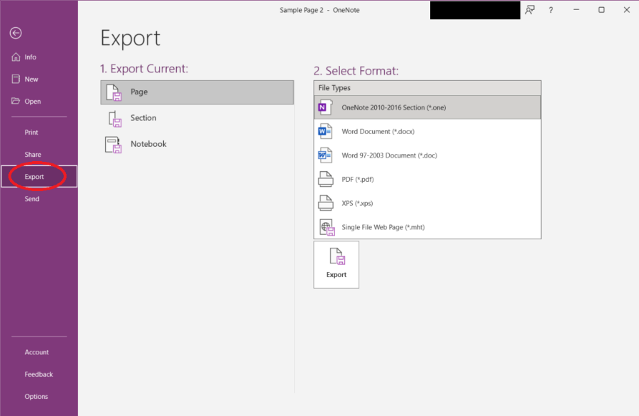

1. Under **Export Current**, select **Notebook**.

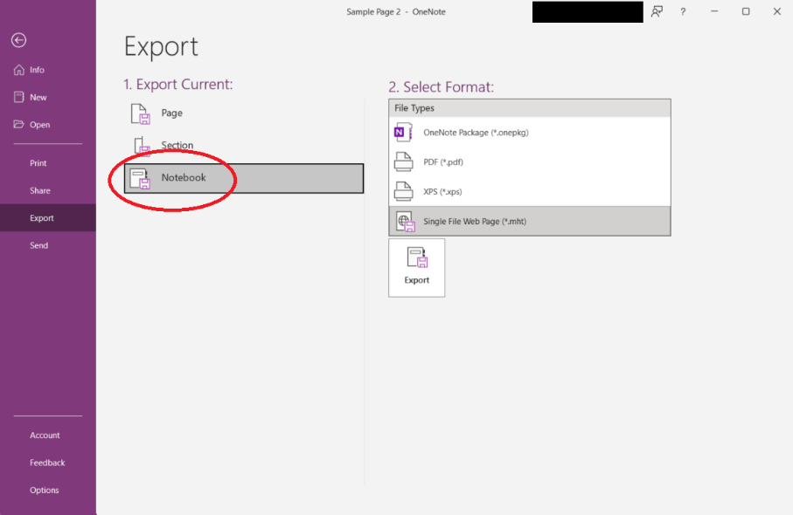

1. Under **Select Format**, choose **OneNote Package (*.onepkg)** to open later in **OneNote**, or **PDF (*.pdf)** to view in a browser or Adobe Acrobat, and then select **Export**.

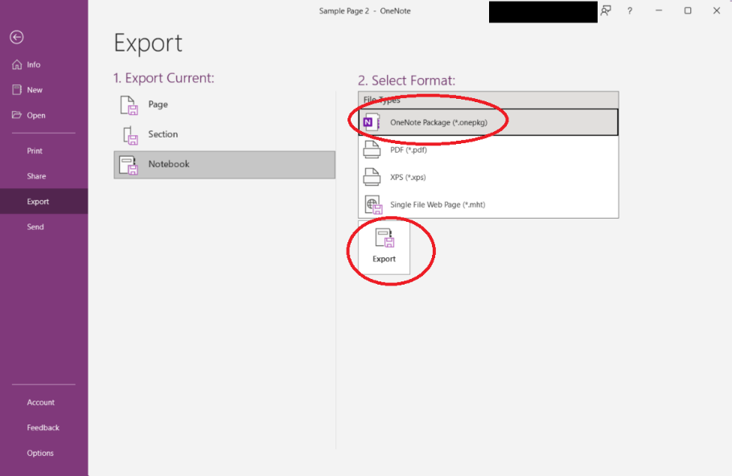

1. Choose a location to save the notebook and select **Open**.

**Note:**For more info see [Export and import OneNote notebooks](https://support.microsoft.com/en-us/office/export-and-import-onenote-notebooks-a4b60da5-8f33-464e-b1ba-b95ce540f309).

# Export a notebook – OneNote for the Web or Onenote for Windows 10

# 

Exporting (sometimes called downloading) a notebook isn't currently possible in OneNote for the web. You can, however, [share a notebook](https://support.microsoft.com/en-us/office/share-a-notebook-298138e1-af75-4af5-b94c-611ff10f8cb8).

You can export or download a notebook in the OneNote desktop app.

* To open the desktop app, at the top of the ribbon, select **Editing**> **Open in Desktop App**.

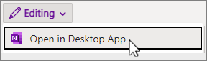

Don't have the app? [Get it for free in the Microsoft Store](https://aka.ms/OneNoteDownload).

# Export a notebook – OneNote for Microsoft 365 Mac

Exporting (sometimes called downloading) a notebook isn't possible yet in OneNote for Mac. You can, however, share a notebook.

* Select Share button icon **Share**in the upper-right corner and choose who to share it with.