GEOCHEMISTRY
IMPACTS OF MINING: BRUKUNGA MINE: FIELD INVESTIGATION
Field Notebook
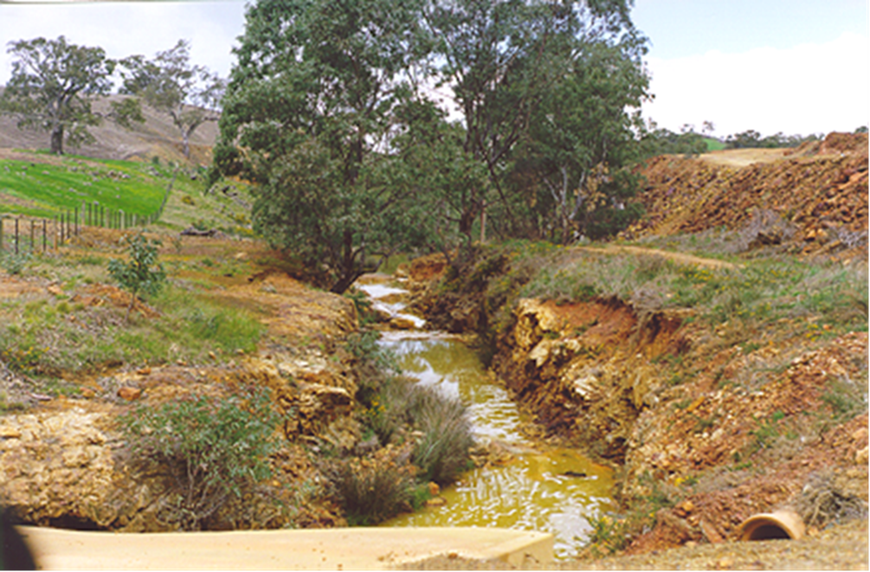
Activity 1: Tour of mine site
  - Introduction to the history of the mine
  - Tour of mine area and rehabilitation/remediation measures
  - Collection of copper sulphide ore samples from mine
    - Pyrite is an iron sulfide with the formula FeS₂.
    - Pyrrhotite an unusual iron sulfide mineral with a variable iron content: Fe_{(1-x)}S (x = 0 to 0.2). Pyrrhotite is also called magnetic pyrite because the color is similar to pyrite and it is weakly magnetic. The magnetism increases as the iron content decreases.
Activity 2: Water quality testing of pH, copper and iron levels
  - Upstream
  - Waste rock (tailings) runoff
  - Settlement pond
  - Treated water

Guide questions
- What ore was extracted from the mine?

- What was purpose of mining the ore?

- What mining method was used to remove the ore?

- List good and bad points of this mining technique.

- Why is the mine now closed?

- What separation technique was used to purify the ore? What problem has this now created?

- Why is there a problem with the waste rock dumps?

- What is being done to the waste rock dumps to try to rehabilitate the mine?

- Dawsley Creek runs through the mine site. Why is this such a problem? What is the latest initiative to reduce this problem?

- What type of acid is neutralised by the plant?

- Where does the acid come from?

- What base is used to neutralise the acid?

- Give two reasons why that particular base is used in this process.

- Write an equation for the neutralisation process.

- What is the final pH of the solution as it leaves the settling tanks?

- What are the other pollutants that are removed by the base? Write a typical equation to illustrate this process.

- Why is it important to remove these substances?

- Suggest a reason why the pH of the treated solution has a pH above 7 when it is put back into the creek?

Brukunga Chemistry

- Acid rock Drainage
- The primary reaction is the oxidation of pyrite to produce sulphuric acid and iron sulphate. Other reactions, mediated by bacteria, also produce the same products. The high acidicty (low pH) mobilises heavy metal ions (cadmium, aluminium, copper, manganese, nickel)
FeS₂ + 3.5 O₂ + H₂O FeSO₄+ H₂SO₄

- Lime Neutralisation
  - Hydrated lime mixed with the acid water to achieve a final pH of 9.5 in the treated water. The CaSO₄ (gypsum) that precipitates out, trapping metal ions, leaving the clean water to overflow from the tank.
H₂SO₄ + Ca(OH)₂ CaSO₄ + 2H₂O

Other notes

Water monitoring investigation
In groups of 3 to 4 complete the following tests and record in the table below:
- pH data harvester
- pH test stick
- conductivity (salinity) data harvester
- temperature (oxygen)
At least two other parameters: copper – Hanna Copper Ultra LR (low range) colorimeter test kit, copper – Hach test strips, iron - Hanna Iron colorimeter test kit, iron – Hach total iron test strips, hardness – Hanna test kit, sulphate, nitrate, phosphate etc.

Be sure to follow the manufactures instructions and safety guidelines. Ensure you put any waste materials in the containers provided and do not leave in the field.

Location | pH  (meter) | pH  (test stick) | Conductivity  µS  (meter) | Temperature  (meter)
Upstream
Waste rock (Tailings) runoff
Settlement pond
Treated water

Downstream

