2022 Music Performance Ensemble Subject Assessment Advice
Overview
Subject assessment advice, based on the 2022 assessment cycle, gives an overview of how students performed in their school and external assessments in relation to the learning requirements, assessment design criteria, and performance standards set out in the relevant subject outline. They provide information and advice regarding the assessment types, the application of the performance standards in school and external assessments, and the quality of student performance.
Teachers should refer to the subject outline for specifications on content and learning requirements, and to the subject operational information for operational matters and key dates.
Across the Assessment Types for this subject, students can present their responses in oral or multimodal form, where 6 minutes is the equivalent of 1000 words. Students should not speed-up the recording of their videos excessively in an attempt to condense more content into the maximum time limit.
From 2023, if a video is flagged by markers/moderators as impacted by speed, schools will be requested to provide a transcript and markers/moderators will be advised to mark/moderate based on the evidence in the transcript, only considering evidence up to the maximum word limit (e.g. up to 2000 words for AT3).
If the speed of the recording makes the speech incomprehensible, it affects the accuracy of transcriptions and it also impacts the ability of markers/moderators to find evidence of student achievement against the performance standards.
School Assessment
Teachers can improve the moderation process and the online process by:
- thoroughly checking that all grades entered in schools online are correct
- checking that PSR grades are consistent with uploaded teacher mark/comment sheets
- ensuring that all files are accurately labelled and uploaded for each student
- Including performance notes sheets in the moderation materials for each individual student.
Assessment Type 1: Performance
Students present an ensemble performance or set of performances to a maximum of 6–8 minutes, of a single work or a set of works by one or more composers, and individual evidence of each student’s contribution to the chosen ensemble through individual part-testing.
Teachers can elicit more successful responses by:
- selecting repertoire that enables the students within the ensemble to present works that appropriately align with their technical and musical capabilities
- providing students with the opportunity to take on both lead and supporting roles, including featured solos within the ensemble (i.e. lead guitar and rhythm guitar; lead vocals and backing vocals)

The more successful responses commonly:
- presented a range of works that demonstrated a depth of knowledge, understanding and application of technical skills and stylistic interpretation
- displayed evidence of complexity through a variety of musical elements within the chosen repertoire, that demonstrated achievement in the higher grade bands
- submitted part test-videos of approximately 2 minutes, for each individual student
- were familiar with process of part testing which was exhibited through evidence of thorough preparation within the time limit
- included part tests that interrogated varied aspects of the repertoire, highlighting the student’s ability to interpret dynamics, articulations, phrasing, intonation, tone control and a range of technical skills
- showcased a very high level of understanding and application of style within the performance and part test
The less successful responses commonly:
- presented chosen works that did not allow students to demonstrate a wide variety of techniques or skills on their instrument
- presented repertoire that did not allow students to demonstrate evidence of achievement within the higher grade bands
- lacked technical fluency and stylistic understanding within the performance and part test
- performed parts that were repetitive in nature restricting their ability to present a variety of techniques and skills
- did not include a separate part-test video for each individual student
- lacked confidence or appeared to be unfamiliar with the requirements of the repertoire within the part test
Assessment Type 2: Performance and Discussion
For this assessment type students present an ensemble performance or set of performances to a maximum of 6–8 minutes, of a single work or a set of works by one or more composers, and individual evidence of each student’s contribution to the chosen ensemble through individual part-testing. This is accompanied by an individual discussion of key musical elements of the repertoire, with a critique of strategies to improve and refine each student’s performance to a maximum or 800 words if written, 4 minutes as an oral presentation, or the multimodal equivalent.
Teachers can elicit more successful responses by:
- selecting repertoire that allows for an in-depth level of analysis
- ensuring that the focus of the Discussion is on musical elements — particularly analysis of structure and style, and practice strategies developed by the student to improve and refine their performance(s)
- marking all the student’s evidence for the assessment type holistically, there is no weighting to the Discussion. Teachers can mark against the features of the criteria as indicated in the diagram below:
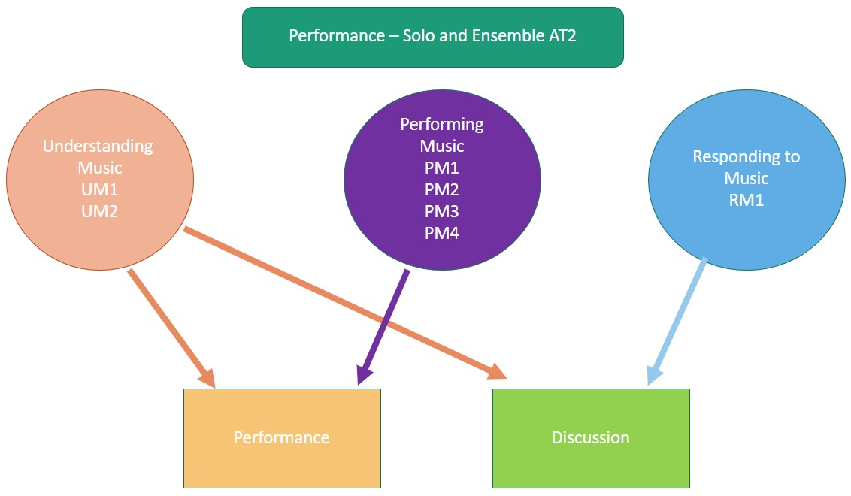
The more successful responses commonly:
- presented a highly fluent and cohesive performance and part test that reflected thorough preparation and understanding of their role within the ensemble
- displayed a high degree of technical skill, musicality and expression
- demonstrated a sophisticated understanding of a range of styles through a highly intuitive interpretation of the chosen works
- demonstrated a high level of collaboration within the ensemble
- addressed within the Discussion the structural and stylistic elements of the chosen repertoire and how these informed the performance
- presented a well-structured Discussion that focused on the analysis of a range of musical elements
- addressed a range of practice strategies applied to develop and prepare their performance as an individual and member of an ensemble within the Discussion
- discussed areas of focus and refinement within the repertoire through relevant examples and annotations, including multimodal evidence
- included consistent, appropriate, and highly effective use of musical terminology within the Discussion
- included a word count in the case of written Discussions.
The less successful responses commonly:
- lacked technical fluency and stylistic understanding within the performance of the repertoire
- included performances that did not allow the student to demonstrate a variety of techniques and skills
- did not display positive collaboration and responsiveness within the ensemble
- did not include a separate part-test video for each individual student
- did not submit the Discussion which is a requirement for Assessment Type 2
- focused on a limited number of musical elements within the discussion (i.e. time signature and key signature)
- made limited use of musical terminology within the Discussion
- omitted a critique of strategies used to improve their skills, technique and accuracy of their performance in the Discussion
- lacked focus towards individual practice strategies and the development of specific skills in relation to their preparation and performance
- included irrelevant information in the Discussion (refer to subject outline)
External Assessment
Teachers can elicit more successful responses by:
- including musical scores relevant to the chosen repertoire
- submitting the Evaluation for each student. The focus of the evaluation should be on performance preparation, critique of their performance and level of responsiveness and collaboration within the ensemble (refer to the subject outline for further detail)
- mark all the student’s evidence for the external assessment AT3 holistically, there is no weighting to the Evaluation.
Assessment Type 3: Performance Portfolio
For this assessment type students present an ensemble performance or set of performances to a maximum of 6–8 minutes, of a musical work or works, and individual evidence of each student’s contribution to the ensemble through individual part-testing. They also provide an individual evaluation of their learning journey to a maximum or 500 words if written, 3 minutes as an oral presentation, or the multimodal equivalent.
The more successful responses commonly:
- demonstrated a variety of musical techniques, fluency and confidence within the performance and part-test to a high level
- showed close attention to all aspects of the repertoire during the performance and part-test, including a high level of rhythmic and note accuracy supported by highly effective use of dynamics, articulation and phrasing
- part tests were supported by clear and concise instructions within a supportive environment
- Aspects of responsiveness and collaboration during rehearsals and performance were addressed within the Evaluation, including what they had learnt from practice and preparation strategies prior to the performance through cited examples
- demonstrated perceptive understanding of their own and others’ roles within the ensemble in the Evaluation
- included accurate, coherent, and highly effective use of musical terminology within the Evaluation.
The less successful responses commonly:
- lacked accuracy, technical fluency and stylistic understanding within the chosen repertoire
- lacked attention to detail relating to musical indications marked on the score (where scores were provided)
- presented repertoire that did not allow the student to demonstrate a variety of techniques and skills in the higher grade bands
- lacked depth and concise detail in relation to responsiveness and collaboration within the ensemble
- required more detail in relation to the learning that had occurred throughout the preparation for the performance, in the Evaluation
- included irrelevant content in the evaluation (refer to subject outline)
- did not submit the Evaluation which is a requirement of Assessment Type 3
General
- Remember that moderators are the audience who will view the videos of students’ performances and part tests. Teachers should ensure that all students in the moderation sample can be clearly identified in all videos by moderators who are unfamiliar with the class of students.
- Ensure that all students are clearly labelled in videos so moderators can identify each student in each video, using arrows and/or headshots or position descriptions.
- Ensure students are clearly visible and not obscured within performance and part test videos. Multiple angles may be required for large ensembles. Smartphone/tablet video recording quality should be sufficient for extra angles.
- It is preferred to submit each student’s individual part-test video in separate files.
- Compress files where possible to mp4 for quicker upload and download.
- Provide students with several formative performance opportunities prior to assessment including both performance and part testing components of each assessment.
- Teachers are reminded that in part testing, it is appropriate to give singers a note or sense of the key of the extract, but it is not acceptable for the accompaniment to continue throughout the part test.
- Ensure multimodal presentations are appropriately formatted and that all links are working and accessible.
- Students should be supported in developing appropriate skills for preparing multimodal presentations. Students should not speed-up the recording of their videos excessively in an attempt to condense more content into the maximum time limit.
- Ensure students understand the differences between the purpose of the Discussion in Assessment Type 2, and the Evaluation in Assessment Type 3. The Discussion focuses on analytical and stylistic features of the repertoire (RM1), and practice techniques used to develop and refine the performance given in Assessment Type 2. The Evaluation in Assessment Type 3 focuses on an evaluation and critique of the final performance and the learning undertaken throughout the year (RM2).
- Take note of the differences in the discussion points between the two performance subjects (Ensemble and Solo). Refer to the subject outline for further details.
- In 2022 the following COVID-19 adjustments were in place:
- students may perform in a virtual ensemble
- where a ‘live audience’ is referred to in the assessment types, replace with ‘an audience such as a live or online audience’
- where part-testing is referred to in the assessment types, as ‘approximately 2 minutes’, replace this with ‘up to 5 minutes’.

