 Auslan Examinations conducted through Zoom Procedure

**Contents**

**Minimum Technical requirements** 2

**Background Information** 3

**On the day of the examination** 4

**Conduct of the examination** 7

**Auslan Exam Format Changes and Improvements** 8

**SUMMARY OF ORAL CONNECTION PROCESS**

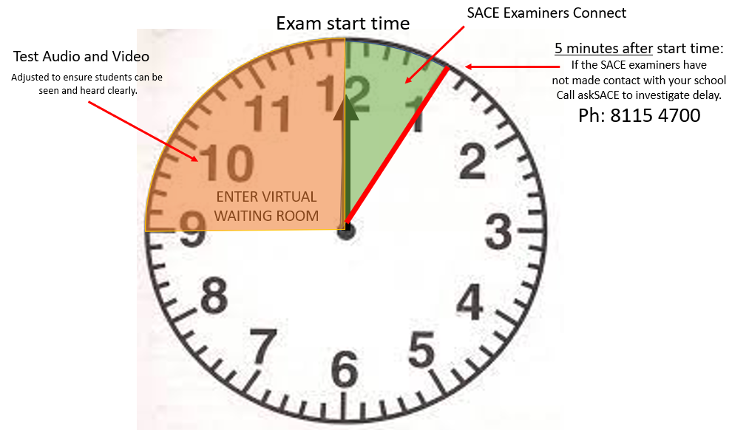

**1300 322 920**

# **Minimum Technical requirements**

In order to ensure the best video and sound quality for connection the SACE Board of SA recommend the examination venue have access to:-

| **Minimum requirements** | |
| --- | --- |
| **Device** | Desktop or Laptop |
|  |  |
| **Operating Systems** | Windows or Mac |
| **Internet browsers** | • Windows: IE 11+,  Edge 12+, Firefox 27+,  Chrome 30+  • Mac: Safari 7+, Firefox 27+,  Chrome 30+  • Linux: Firefox 27+,  Chrome 30+  Any one of the above browsers can be used. |
| **Security** | Up to date anti-virus protection |
| **System Requirements** | |  | | --- | | * An internet connection – broadband wired or wireless (3G or 4G/LTE) * Speakers and a microphone – built-in or USB plug-in or wireless Bluetooth * A webcam or HD webcam - built-in or USB plug-in | |

# **Background Information**

* 1. Each student studying **Auslan** will be examined at their contact school (examination venue) at a time that SACE will advise. Please ensure that all **Auslan** students know their correct oral examination venue.
  2. The **examination** will be **completed** in **Sign Language.**
  3. The SACE board will publish an examination timetable outlining the start and finish times for each examination at each contact school.
  4. Following publication of this timetable the SACE Board will send a spreadsheet to each contact school outlining the individual times, dates and ZOOM examination room URL link.
  5. Students should aim to arrive at the examination area at their contact school 15 to 20 minutes **before** the scheduled time of their individual oral examination.
  6. Schools should access the Zoom examination room URL at least 15 minutes prior to the scheduled start time of their first student’s examination.
  7. Each student’s examination should take approximately 15 minutes.
  8. Once connected to the ZOOM examination room, schools will access a virtual waiting area until the designated start time to allow the school opportunity to ensure that the **video** is working correctly.
  9. At the designated start time of the first student’s examination the SACE examiners will admit the invigilator to the allocated ZOOM examination room.
  10. Where there are several students that are being examined, the SACE Board will remain connected to the same Zoom examination room URL and schools will not need to disconnect or reconnect in between each student.
  11. Where there are several students that are being examined, each student will be examined in alphabetical order, by surname.
  12. In the event, there are 2 or more examinations for a school on the same day and time then schools must ensure that they have adequate spaces set aside for students of one or more languages to be examined simultaneously. **Note:** The ZOOM examination room URL meeting request can be forwarded to any individual invigilator or member of staff at the school to access the examination.
  13. As there may be several different examination room URLs required on a particular day for a school, please ensure that the correct ZOOM examination room link is used for the correct examination.

# **On the day of the oral examination**

* 1. Each examination venue must ensure that there is:
     1. A staff member available to supervise all students on arrival.
     2. A designated waiting area(s) available near the examination room(s)
     3. A designated examination room(s)
     4. A designated invigilator (see point 5)
     5. A dark backdrop in the examination room or a clear background to avoid distractions and distortions, that could create a disadvantage for the student(s).
  2. Office staff should be made aware of the location of the examination and waiting rooms so they can direct students to the examination area if necessary.
  3. Schools should allow student(s) to wear dark clothing on the day of and during the examination, to enable clear communication for the examiners.
  4. Mobile phones and other electronic devices must be switched off and not accessed in the waiting area or examination area.
  5. The examination venue needs to ensure that there is an appropriate invigilator(s) who can provide technical assistance to the student if the need arises. The invigilator requirements are identified below:
     1. The invigilator cannot be a teacher of the language or familiar with the language being examined.
     2. Must be familiar with the use of ZOOM.
     3. There must be at least one invigilator in the examination room throughout the examination period and while any student is in the room. An invigilator may be relieved from time to time if there is always at least one invigilator in the room.
  6. Before the start of the first examination, the school should click the ZOOM URL examination room link allocated to the examination room. If there are multiple students being examined your school will **remain connected to this link until the last student for that room has completed their oral examination.** Please verify upon connection that your school is connected to the correct ZOOM examination room. Please see example below:-

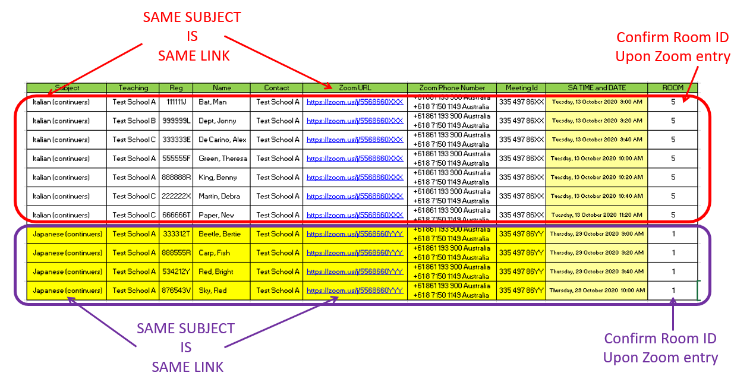

* 1. You will NOT need to download ZOOM on the computer. When you click the URL attached to your schedule, ZOOM will open in your browser. Click on the link ‘Join from your browser’ (NOTE: you need to click launch meeting or download and run zoom first to see this option). Please ensure your internet browser is up to date as you will access online oral examination through the browser version of this software. We recommend that you do not use the application version of ZOOM as this may be out of date.

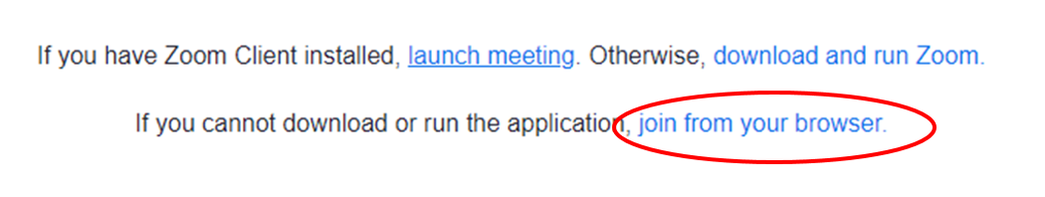

* 1. Enter your school’s name and the language that your students are studying in the ‘Your Name’ field, and tick ‘I’m not a robot’ and follow the directions on screen. Please note that the name of the school and language must be updated each time you enter the online oral examination meeting request. An example of the naming convention is shown below:

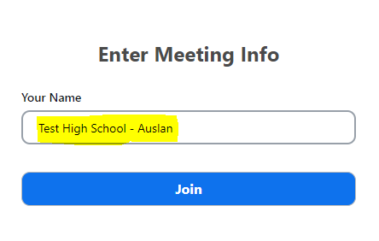

* 1. Your school will be able to test the **video** connection before the first examination commences.
  2. Your school will now enter a virtual waiting room until the SACE examiners are ready for the first student’s examination to commence.

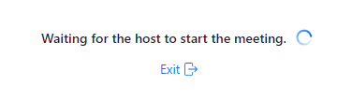

* 1. If the SACE examiners do not make contact within **5 minutes** of the designated first students start time, please contact askSACE on 1300 322 920.
  2. Once the school has connected to the SACE examiners, the invigilator should ensure that the **video devices** are selected and that they **can see the SACE examiners**. The SACE examiners will provide guidance to the invigilator in adjusting the position of the laptop, and camera to ensure the examiners can clearly see the student and the student can clearly see the examiner.
  3. If there are any issues with either of these two connection methods, please contact askSACE on 1300 322 920.
  4. Once contact has been made with the school, the examiners will instruct the invigilator to collect the first student from the waiting area and accompany them into the examination room.

# **Conduct of the Auslan examination**

* 1. Mobile phones and other electronic devices must not be brought into the examination room.
  2. The examination will be completed in **Sign Language**. Schools are to be reminded that there is **no** **voice interaction**.
  3. The invigilator brings the nominated student into the examination room and assists them to adjust the equipment to meet the individual student’s requirements and the Auslan requirements (See Auslan Exam Format Checklists and Improvements)
  4. The examiner will inform the student that there are two examiners in the room, but they are only being examined (conversation) by one. **(As per Auslan Oral Examination script provided)**
     1. As part of the script, the examiner will inform the student that the Auslan Oral examination will be recorded, for the purpose of marking and quality assurance purposes.
  5. Once the set-up meets all the requirements, the examiner will commence the examination in Sign Language. The invigilator must remain in the examination room throughout the examination to provide technical support if the student requires this.
  6. Schools are to ensure that students know their student registration number **before entry** into the examination room. At the start of the examination, students are asked to confirm their student registration number with the examiner.
  7. For Auslan Continuers, the students’ In-depth study overview should be [**emailed**](mailto:askSACE@sa.gov.au?subject=Online%20Orals%202022%20-%20In-depth%20study) to the SACE board before the end of Term 3. The examiners will be provided with hard copies of these forms to refer to during the examination.
  8. Students are **NOT** permitted to bring a hard copy of their IDS outline into the examination room. Other written materials, notes and cue cards are also **NOT** permitted in the examination room.
  9. Students are permitted to bring objects such as photographs, pictures, and maps. Student annotations are not permitted on photographs, pictures, etc. The only writing permitted on maps and charts will be labels or headings. All student materials they wish to use in their online oral examination should be  [**emailed**](mailto:askSACE@sa.gov.au?subject=Online%20Orals%202022%20-%20In-depth%20study) to the SACE board before the end of Term 3. These materials should be clearly labelled with the student’s registration number, subject and allocated time this material will be provided to the examiners.
  10. Students are not permitted to use the computer to present any prepared electronic information to the examiners.
  11. Once students have completed their examination, they must leave the examination area. The examination venue must ensure that students who have completed the examination must not have access to the waiting room or have contact with those still waiting to be examined.
  12. If there are multiple students being examined the ZOOM examination room link **will remain open,** the invigilator must remain in the examination room and wait for instructions from the SACE examiners.
  13. When the SACE examiners are ready to continue with the next examination, the examiners will instruct the invigilator to collect the next student and follow steps in this process until all students have been examined.
  14. If a student cannot be present for the scheduled examination because of medical reasons or other extenuating circumstances, then the student must apply for special provisions via their school. Applications on the grounds of medical reasons must be supported by detailed medical evidence sought on the day of the examination. Catch up oral examinations are not available.
  15. When the last student for a school has been examined, the SACE examiners will advise the invigilator to end the zoom meeting.

# **Auslan Exam Format Improvements**

To reduce visual clutter, support a natural conversation and improve student experience and marker processes.

**Examination Centres and Students**

1. Each examination centre must ensure that the visual requirements are supported, for student performance and functionality.
2. In ZOOM, students:
   1. should be allowed to wear dark clothing.
   2. **cannot** have any alterations to the camera in ZOOM (e.g., background blurring or picture background)
   3. should turn their self-view off, to only be able to see the **one** conducting examiner in full screen.  
      (This is a **recommended**, **not compulsory** **setting** which assists to reduce the amount of clutter on the student’s screen and supports a natural conversation)
3. The invigilator to set these settings for each student.
   * 1. 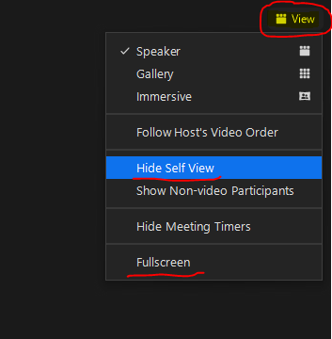Select ‘view’
     2. Select ‘Hide Self View’
     3. Select ‘Fullscreen’

**Examiners**

Improvements to the examiners responsibilities and expectations have been implemented to support and improve marking processes, reduce visual clutter, and support a natural conversation the with student.

1. The examiner conducting the exam will be logged into ZOOM on one device and the marker will be logged into ZOOM on a separate device.
   * 1. The examiner will inform the student that there are two examiners in the room, but they will only be examined by one. Students can opt out of being recorded, by letting the examiner know  
        **(As per Auslan Oral Examination script provided)**
     2. Second examiners camera and microphone is turned off for the duration of the conversation and will only be able to see the student and the examiner, observe and take notes.
2. The examiner conducting the exam:
   1. to wear dark clothing for the purpose of the exam.
   2. To ensure they are in clear view in front of the dark backdrop provided.
   3. **cannot** have any alterations to the camera in ZOOM (e.g., background blurring or picture background)
   4. should turn their self-view off, and **only** be able to see the student in full screen.
3. The examiner can change their settings as
   * 1. Select ‘view’
     2. Select ‘Hide Self View’
     3. Select ‘Fullscreen’