Stage 1 Drama

Assessment Type 3: Creative Synthesis - Summative Task

Description of Task
Following our study as a class of Scattered Lives by Sally McKenzie, devise a hypothetical production which uses new technology in an original way to express McKenzie’s ideas.

You can approach the creation of your hypothetical production as either a director or a designer.

Your hypothetical production and the technology you use needs to apply what you have learnt about the two styles we have studied: Verbatim Theatre and Brechtian Theatre. You may include one or both of these styles in your concept (or vision).

In creating your hypothetical production, you will need to develop a ‘concept’ or ‘vision’ for the play - as discussed in our work on ‘Conceptualising for the Theatre’ earlier in the semester. Once you have created your concept or vision, select 5 key moments or sections of script to illustrate your creative ideas, including your innovative use of technology.

Suggested ways you can explore the use of technology are:

- Creating a short Youtube video to promote and publicise your hypothetical production
- innovative interaction between live performers and video projections, including use of live on-stage camera and projection
- use of headphones and smart phones to individualise the audio experience for viewers of the production
- performing the play in real-time over the internet with a sister school in Canada using filmmaking techniques and live streaming
- applying an intelligent lighting design to the production

Oral Presentation:
You may present your concept (or vision), ideas for staging, including innovative use of technology to the class in an oral presentation of up to 6 minutes.

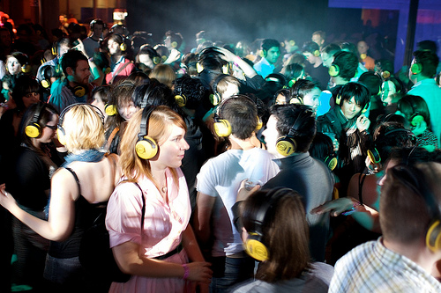

Performance Standards for Stage 1 Drama
 | Understanding and Exploration | Critical and Creative Thinking | Creative Application
A | UE1 Focused and astute understanding and exploration of dramatic roles, conventions and processes  UE2 Highly detailed and in-depth understanding and exploration of dramatic ideas, texts, styles and innovations | CCT1 Highly creative thinking and experimentation in the development of dramatic ideas  CCT2 Perceptive analysis and evaluation of dramatic ideas, products and technologies | CA1 Highly creative and proficient application of dramatic skills  CA2 Focused and sustained collaborative application of ideas and processes
B | UE1 Thorough understanding and exploration of dramatic roles, conventions and processes  UE2 Detailed understanding and exploration of dramatic ideas, texts, styles and innovations | CCT1 Creative thinking and experimentation in the development of dramatic ideas  CCT2 Comprehensive analysis and evaluation of dramatic ideas, products and technologies | CA1 Creative and capable application of dramatic skills  CA2 Focused collaborative application of ideas and processes
C | UE1 Competent understanding and exploration of dramatic roles, conventions and processes  UE2 Considered understanding and exploration of dramatic ideas, texts, styles and innovations | CCT1 Generally creative thinking and experimentation in the development of dramatic ideas  CCT2 Analysis and evaluation of dramatic ideas, products and technologies | CA1 Generally competent application of dramatic skills  CA2 Generally focused collaborative application of ideas and processes
D | UE1 Some understanding and exploration of dramatic roles, conventions and processes  UE2 Attempted understanding and exploration of dramatic ideas, texts, styles and innovations | CCT1 Attempted creative thinking and experimentation in the development of dramatic ideas  CCT2 Some general reflection on dramatic ideas, products and technologies | CA1 Partial application of dramatic skills  CA2 Some focused collaborative application of ideas and processes
E | UE1 Limited understanding and exploration of dramatic roles, conventions and processes  UE2 Limited understanding and exploration of dramatic ideas, texts, styles and innovations | CCT1 Limited thinking and experimentation in the development of dramatic ideas  CCT2 Limited reflection on dramatic ideas, products and technologies | CA1Limited application of dramatic skills  CA2 Limited collaborative application of ideas and processes

