Assessment Component 1: Folio Task 1 - Designing a zoo
Topic: Solving the economic problem
Task Description: Report
Intro
This zoo has been built and designed to raise awareness surrounding native animals and the breeding of them. The placement of native animals within the zoo allows for government funding for the percent of land covered by these native animals. The zoo also aims to make a profit of above $5,000 per square meter of land this allows the zoo to pay for the animals now and into the future. This zoo aims to use the wants of the people who wish to see the Smartian Tiger to get people through the gates and viewing the native animals placed near the front to create awareness of the native species. The zoo has also been built on land inherited by the owner from their dead relative wanted to have their land converted into a zoo for public use.
Goals & wants that the zoo is trying to address
- To make profit of above $5,000/sqm
This way the zoo can sustain itself in the present and into the future.
- Create awareness of native species
This awareness will gain government funding to support the zoo as well as to attract tourists and locals with an interest in the native animals.
- Breed native species
This will allow the zoo to continue to create awareness of the native animals and the government will continue to fund the zoo if the native animals live on. The zoo could also help repopulate the wild population if there was to be some outbreak causing the wild numbers of the animals to drop.
Description
Within the Zoo there are eleven animals of seven different species.
The zoo has two Koalas, two Wombats, two Tasmanian Devils and two Kangaroos because they are native species which allows for government funding, there’s two of them so they can breed, and that satisfies the zoos goal of creating awareness of native species and breeding them.
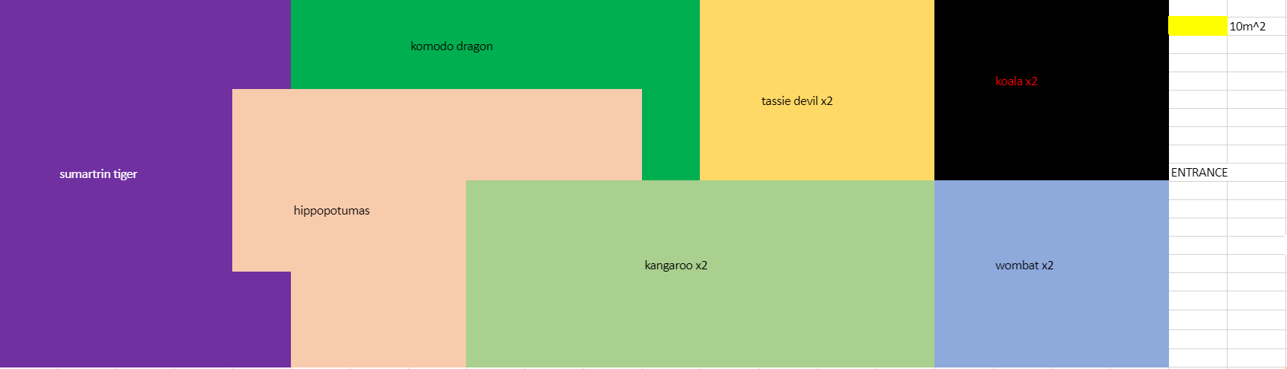
The two Koalas and two Wombats are placed at front of zoo as it has one of the lowest demand rates. Customers coming into the zoo for the higher demand animals (Sumatran Tiger, Komodo Dragon and Hippopotamus) must walk past the Koalas and Wombats.

The Tassie Devil and the Kangaroos are placed towards the front of zoo as it an animal which satisfies less wants of the public than the Sumatran Tiger but more than the Koala’s and the Wombats. Customers coming into the zoo for the higher demand animals must walk past the enclosure.
Behind the native species are the more demanded animals which are the Komodo Dragon, the Hippopotamus and the Sumatran Tiger. These animals are placed towards the back of the zoo so that people must walk past the native animals to see them and therefore creating awareness of native species and satisfying that goal for the zoo. These animals also help towards satisfying the zoo’s goal of creating more than $5,000 profit per square metre. The Sumatran Tiger takes up the most space and was the biggest opportunity cost as there could’ve been more small animals with more demand in place of the Tiger or another big animal.
The ticket price has been set at $20 which allows for the zoo to make a profit of above $5,000 per square metre as well cover the costs of the animals. 50% of the zoo’s land is covered by native animals which allows for the government to cover 50% of the costs of each of the native animals. By having two of each native animal this allows the government to cover the cost of the second animal as it dose not bring in any more visitors to cover its costs.
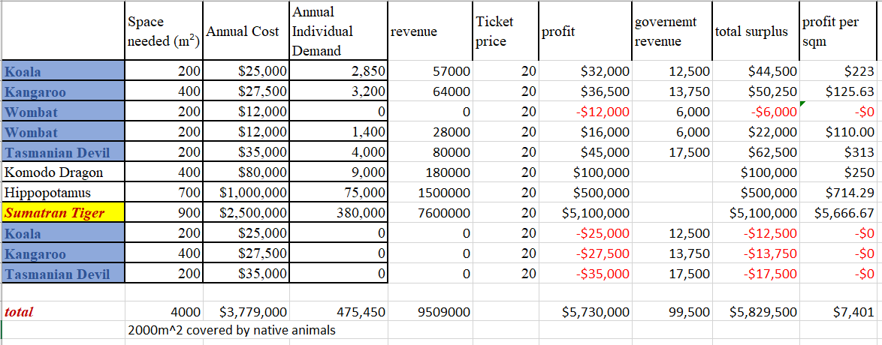
This zoo satisfies the wants by providing natural animals for patrons of the zoo to see and view. This brings in visitors as well as providing a Komodo Dragon, a Hippopotamus and a Sumatran Tiger for visitors to view. The zoo also satisfies the wants of the relative as the land inherited was turned into a zoo as they wished.
The opportunity cost of the zoo is the land area and the animals chosen needed to be the most effective mix to satisfy the maximum amount of goals possible. The native animals were chosen and their opportunity cost was animals with more demand who would have brought more visitors to the zoo and therefore more money to satisfy the zoo’s profit per square metre goal. The opportunity cost of the native animals was created due to the use of scarce space (land) which could have been used for other animals with lower annual costs and higher demand rates (which would bring more visitors to the zoo creating more profit). Breeding native species also had a high opportunity cost as the second animal of each native species did not double the demand rate but instead doubled the annual cost.

Word count: 800

