STAGE 1 POLITICS, POWER & PEOPLE - AT2 - SOURCE ANALYSIS
Source 1 - Elks, S., (2017) ‘Faction pushed Queensland MP Mark Furner’s Promotion,’ The Australian, February 12, 2017.
Queensland Premier Annastacia Palaszczuk promoted her newest minister, Mark Furner, to cabinet after her Right faction selected him, sparking criticism she should be making the decisions herself.
Mr Furner, a former Labor senator who on Friday was sworn in as Minister for Local Government and Aboriginal and Torres Strait Islander Partnerships, ­defended the process as “approp­riate”, while Ms Palaszczuk claimed she wouldn’t endorse someone she wasn’t happy with.
But Opposition Leader Tim Nicholls said the episode proved Ms Palaszczuk was “a creature of the factions”. “She can’t make a decision based on her own judgment on who is best for the roles,” Mr Nicholls said.
The reshuffle was prompted by the resignation on Monday of Ms Palaszczuk’s key Right factional ally Stirling Hinchliffe as minister for transport and the Commonwealth Games, after a damning report into the train driver shortage at Queensland Rail…
… The dominant Left faction’s Mark Bailey, the Minister for Main Roads, Road Safety, Ports Energy, Biofuels and Water ­Supply, said it was “normal” for factions to be part of the decision-making process.
“Every political party has different groupings, and anyone who tells you different is pulling your leg,” Mr Bailey said.
“It’s a part of politics that there are different groupings in every political party.’’
Source 2 - Nicholson, P., (2012), ‘ALP factions back-room deals slammed faceless women,’ The Sydney Morning Herald, December 7th, 2012.
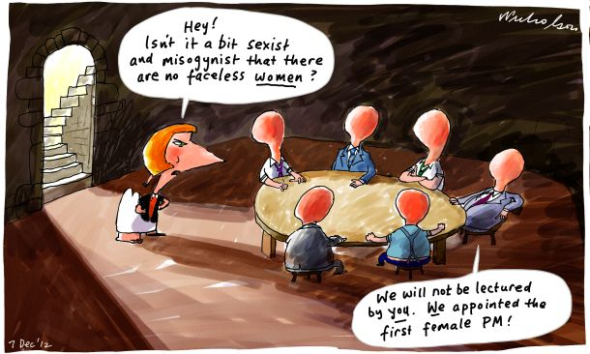
Source 3 - Warhurst, J., (1983). Machine Politics in the Australian Labor Party, George Allen & Unwin. Sydney, Australia (pg 179).
''Factional politics, especially where the strength of the factions is fairly evenly balanced, may contribute to making the party as a whole more energetic in matters such as recruitment and internal policy development. The efforts of opposing factions to recruit their supporters into the party may enlarge the party's membership. It may also ensure healthy competition for party office from the local branch level onwards. The contribution of opposing factions to policy discussion, in sharpening the focus of discussion, contributes to a more ideological party membership.''
Source 4 - Dyson, A., (2013), ‘The Dead Hand of the Party Rises,’ The Sydney Morning Herald, 28th November, 2013.
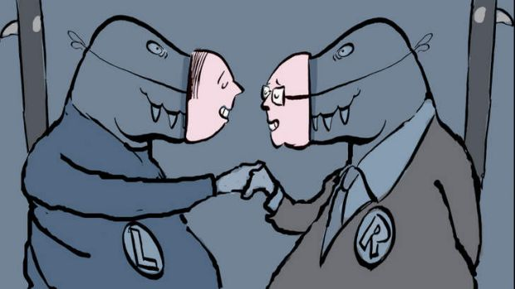
Source 5 - Excerpt from; Grattan, M., (2014), ‘Cut union representation in Labor conferences: Faulkner.’ The Conversation; https://theconversation.com/cut-union-representation-in-labor-conferences-faulkner-32634, 27th October, 2014.
The practice of factions, affiliates or interest groups binding parliamentarians in caucus votes or ballots “must be banned”.
Referring to the revelations at the NSW Independent Commission Against Corruption, which have exposed Liberal wrongdoing over donations, Faulkner said “The recent events in New South Wales should motivate all Australian political parties to work together for far-reaching and long-overdue reform of our electoral donations, funding and expenditure laws. This is a real and urgent challenge for all political leaders”.
Faulkner said ALP preselections “ought to be the opportunity to determine who is best suited to campaign for Labor values in the community and legislate for them in parliament”; he supported the community preselections trialled in NSW with weighted votes from party members equalling declared supporters. These should become the rule rather than the exception.
Lamenting the lack of will among the powerful within the party to stand up for reform, Faulkner said: “The existing and widening chasm between Labor’s commitment to democracy and our internal practice of it, between our focus on the future and our antiquated organisation, undermines our policy agenda and casts doubt on its authenticity.
"I say to those who resist the opening up of our structures to more participation and more democracy because they see their control over managed and pre-negotiated outcomes slipping away – stop clinging to the wheel. You are steering us straight for the rocks.”

Questions
Be sure to refer specifically to sources and include/integrate quotes where appropriate
- What does Source 2 reveal about factions in Australian politics? (2)

- What conclusions can be drawn from Source 1 about factions in Queensland politics? (2)

- Does Source 5 support the current state of factions in Australian politics? Provide evidence to support your view. (2)

- Assess the usefulness and limitations of Sources 1 and 4 in showing the extent to which factions are a negative aspect of Australian politics. (4)

- To what extent do Sources 3 and 5 support each other in showing how factions can be a useful tool in Australian politics? Refer to similarities and difference (4)

- Using all the Sources provided, evaluate the proposition that ‘Factions undermine the democratic processes of Australian democracy’. (6)

