Source 1 https://about.abc.net.au/statements/abc-statement-fox-and-the-big-lie/
ABC Statement: “Fox and the Big Lie”
Posted 26th August 2021
News Corp’s reaction to the Four Corners investigation “Fox and the Big Lie” is as expected. The Australian’s first column attacking the story was published before the first episode had even gone to air. Since then, the striking uniformity of the attacks from News Corp journalists, commentators and outlets across the nation has only further served to highlight the importance of having a range of independent voices in the Australian media.
News Corp not enjoying scrutiny does not mean the scrutiny is unwarranted.
The events around the critical 2020 US Presidential Election and the coverage of it are clearly in the public interest to investigate and the role played by Fox News is legitimate to examine.
News Corp not liking a story does not mean the story is biased or inaccurate.
The Four Corners report is based on multiple on-the-record, on-camera interviews with people who were employed by Fox News who give first-hand, verifiable accounts of their own experiences.
Fox News was given a detailed outline of the proposed program early on as part of the request for Fox staff to appear and Four Corners tried every avenue to get Fox to provide its point of view. It tried for two months to secure an interview with Fox Corp CEO Lachlan Murdoch and made a series of requests for various other senior Fox representatives, as well as for Rupert Murdoch. It also submitted written questions. The responses and information that were provided are incorporated in the program.
Despite the decision not to participate in interviews, communication between Four Corners and Fox was extensive throughout the preparation of the story. Fox was very helpful in providing footage and background briefings on material, including up to the night the program was being finished.
The story was rigorously tested against the ABC’s Editorial Policies and the ABC stands by it.
Media contact | Sally Jackson | ABC Communications
Source 2
https://twitter.com/MrKRudd/status/1429986853042544641
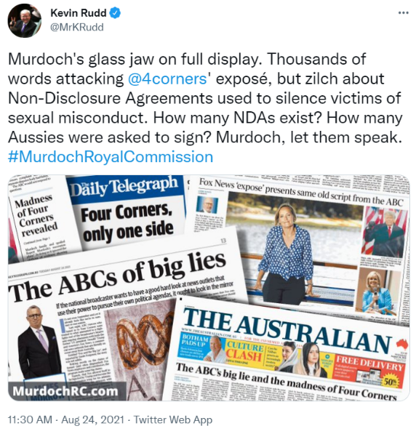

Source 3 https://www.theaustralian.com.au/commentary/the-big-lie-another-big-fail-for-auntys-sloppy-journalism/news-story/99a84114f8c167cf8de8f966f9ea9549
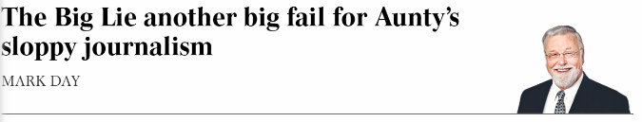
It’s time. Ita Buttrose, are you listening? It’s time to crack heads; to bring to heel the zealots within the ABC’s ranks who believe they have no need to heed the public broadcaster’s charter and editorial guidelines that demand accuracy and balance.
Ita’s responsibility, as ABC chairwoman, is to uphold its legislative charter. This does not allow for partisan frolics such as Sarah Ferguson’s Four Corners special The Big Lie, the first part of which was broadcast on Monday night.
The program was a full-frontal hit job on Rupert Murdoch, News Corp and the US Fox News channel. It had a septic odour, as if it were cobbled together from a trash can with only the rancid bits selected for regurgitation.
Source 4
https://www.theguardian.com/commentisfree/2020/oct/12/there-will-be-no-royal-commission-but-we-need-to-question-news-corps-role-in-australia
Australia’s media ownership is among the most concentrated in the developed world. This is not hyperbole – nor is it in some way “anti-Murdoch rhetoric” to state the facts.
News Corp publish seven of the 10 top Australian newspapers and own 65% of metropolitan newspapers by circulation. To quote their own figures, “more than 16 million Australians consume news and information across News Corp Australia’s suite of products” per month.
An Oxford University study conducted before we relaxed media ownership rules in 2016, a move that will arguably make things worse, concluded Australia has the most concentrated media ownership of all 26 countries surveyed. Australia is “dominated by News Corporation and Fairfax Media who together own the majority of national and capital city newspapers”, they concluded.
Additionally, we have seen a steady decline in the number of daily newspaper titles over the last few decades, culminating in News Corp shuttering over 100 print editions in May this year in response to the pandemic (76 of these will remain as digital mastheads and 36 will disappear entirely). Thousands of jobs have been lost as a consequence.
The trend is largely due to the growth of digital media and the dominance of social media platforms in competing for digital advertising dollars – but it doesn’t help that such a large slice of the news content we read on our screens is produced by one company and then consumed on one platform: Facebook.
The media ecosystem has fallen into the gravitational field of just a few central players and its orbit is spiralling ever closer to the centre.
From the global warming crisis that is still a “debate” in the pages of the Australian to Sky News’ more recent “Dictator Dan” coverage during Melbourne’s lockdown, Murdoch-owned outlets have been producing editorials that have a conservative flavour for some time.

Source 5
https://www.3aw.com.au/what-neil-mitchell-thinks-of-kevin-rudds-call-for-rupert-murdoch-to-face-a-royal-commission/
The 3AW Mornings host (Neil Mitchell) said it’s hard to see how a royal commission would be able to improve media diversity in Australia.
“If you start fiddling, you’re in danger because politicians have this history of writing media policy from their self-interest, not the public interest,” he said.
“They’ll usually draw up rules to suit their perceived mates, who they think will then support them and get rid of their … critics.
“It was Labor that gave Rupert Murdoch this power — Bob Hawke and Paul Keating back in the 80s. They did it because they saw him as a mate and the others were enemies.
“That’s the way politicians design their media policy — they always have!”
Questions:
1) What are two claims made by the ABC in Source 1 rejecting News Corp’s objection to their documentary ‘Fox and the Big Lie’? (2 marks)
2) Twitter and social media platforms play an increasing role in politics in the modern age. With reference to Source 2, how influential is social media for political discourse in Australia? (4 marks)
3) Using Source 1 and Source 3, compare and contrast the two views on the documentary outlining Fox News’ coverage of the 2020 US presidential election. (6 marks)
4) Using Sources 4 and 5, compare the differing views of NewsCorp in Australia and the role it has in political coverage. (6 marks)
5) With reference to All Sources, discuss the issues involved with concentrated media ownership in Australia, and abroad. (8 marks)

Published with the kind permission of Adelaide High School

