Visual Arts – Art

Folio

Penguins

The inspiration for my art piece was drawn from a trip to the South Australian Museum. The Emperor penguins in the Douglas Morson exhibit provided the foundation for my work. While at the Museum I drew and photographed the penguins on display which proved beneficial as they provided sound references. I aimed to portray the connection between the male and the female penguin, so at this point I sourced an image from the internet to use as my subject matter. After experimenting with various mediums I concluded that acrylic paints would be the most effective if highlighted with pastel. After battling with the composition it was only the background that needed to be finalized. I chose a brilliant blue to contrast with the yellow on the neck. I was happy with the final result of my painting and grateful for the opportunity to visit the museum. I feel that in my work I did capture the connection.
Analysis and Response
Indicates the beginnings of a considered evaluation of own practical work.
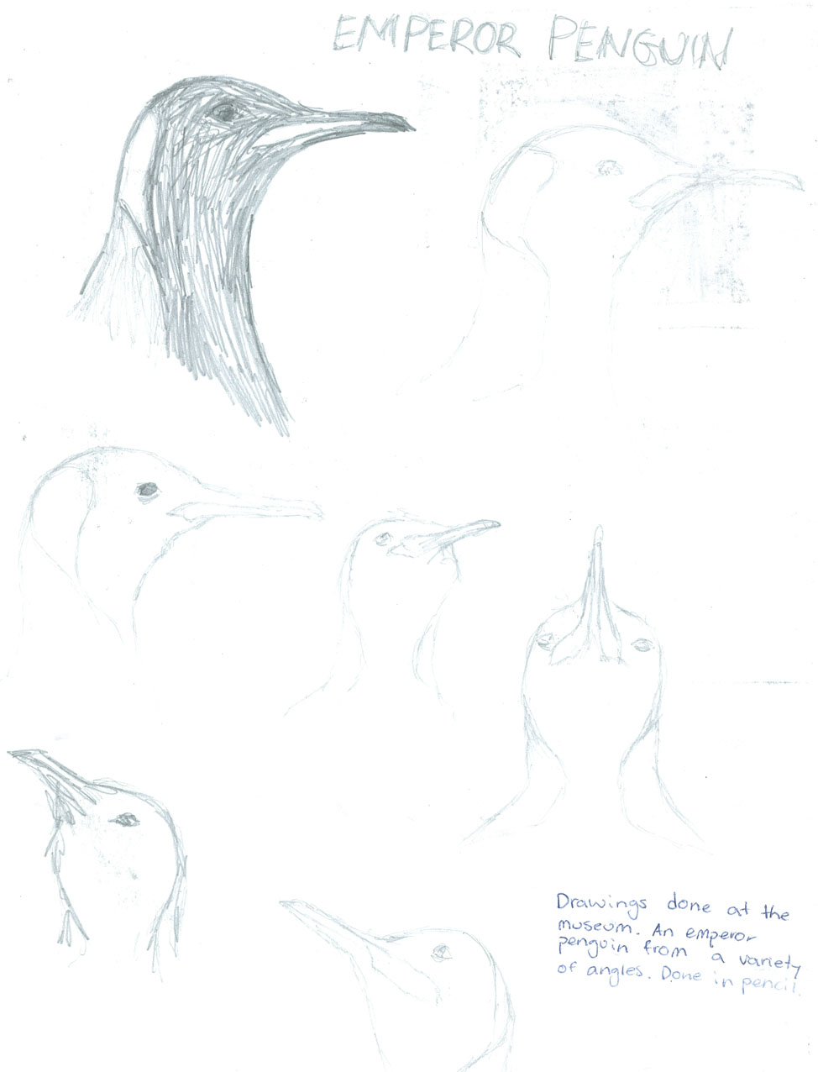
Practical Application
Indicates competent application of some technical skills with media, materials and technologies to communicate visual ideas in resolved work(s) of art or design.
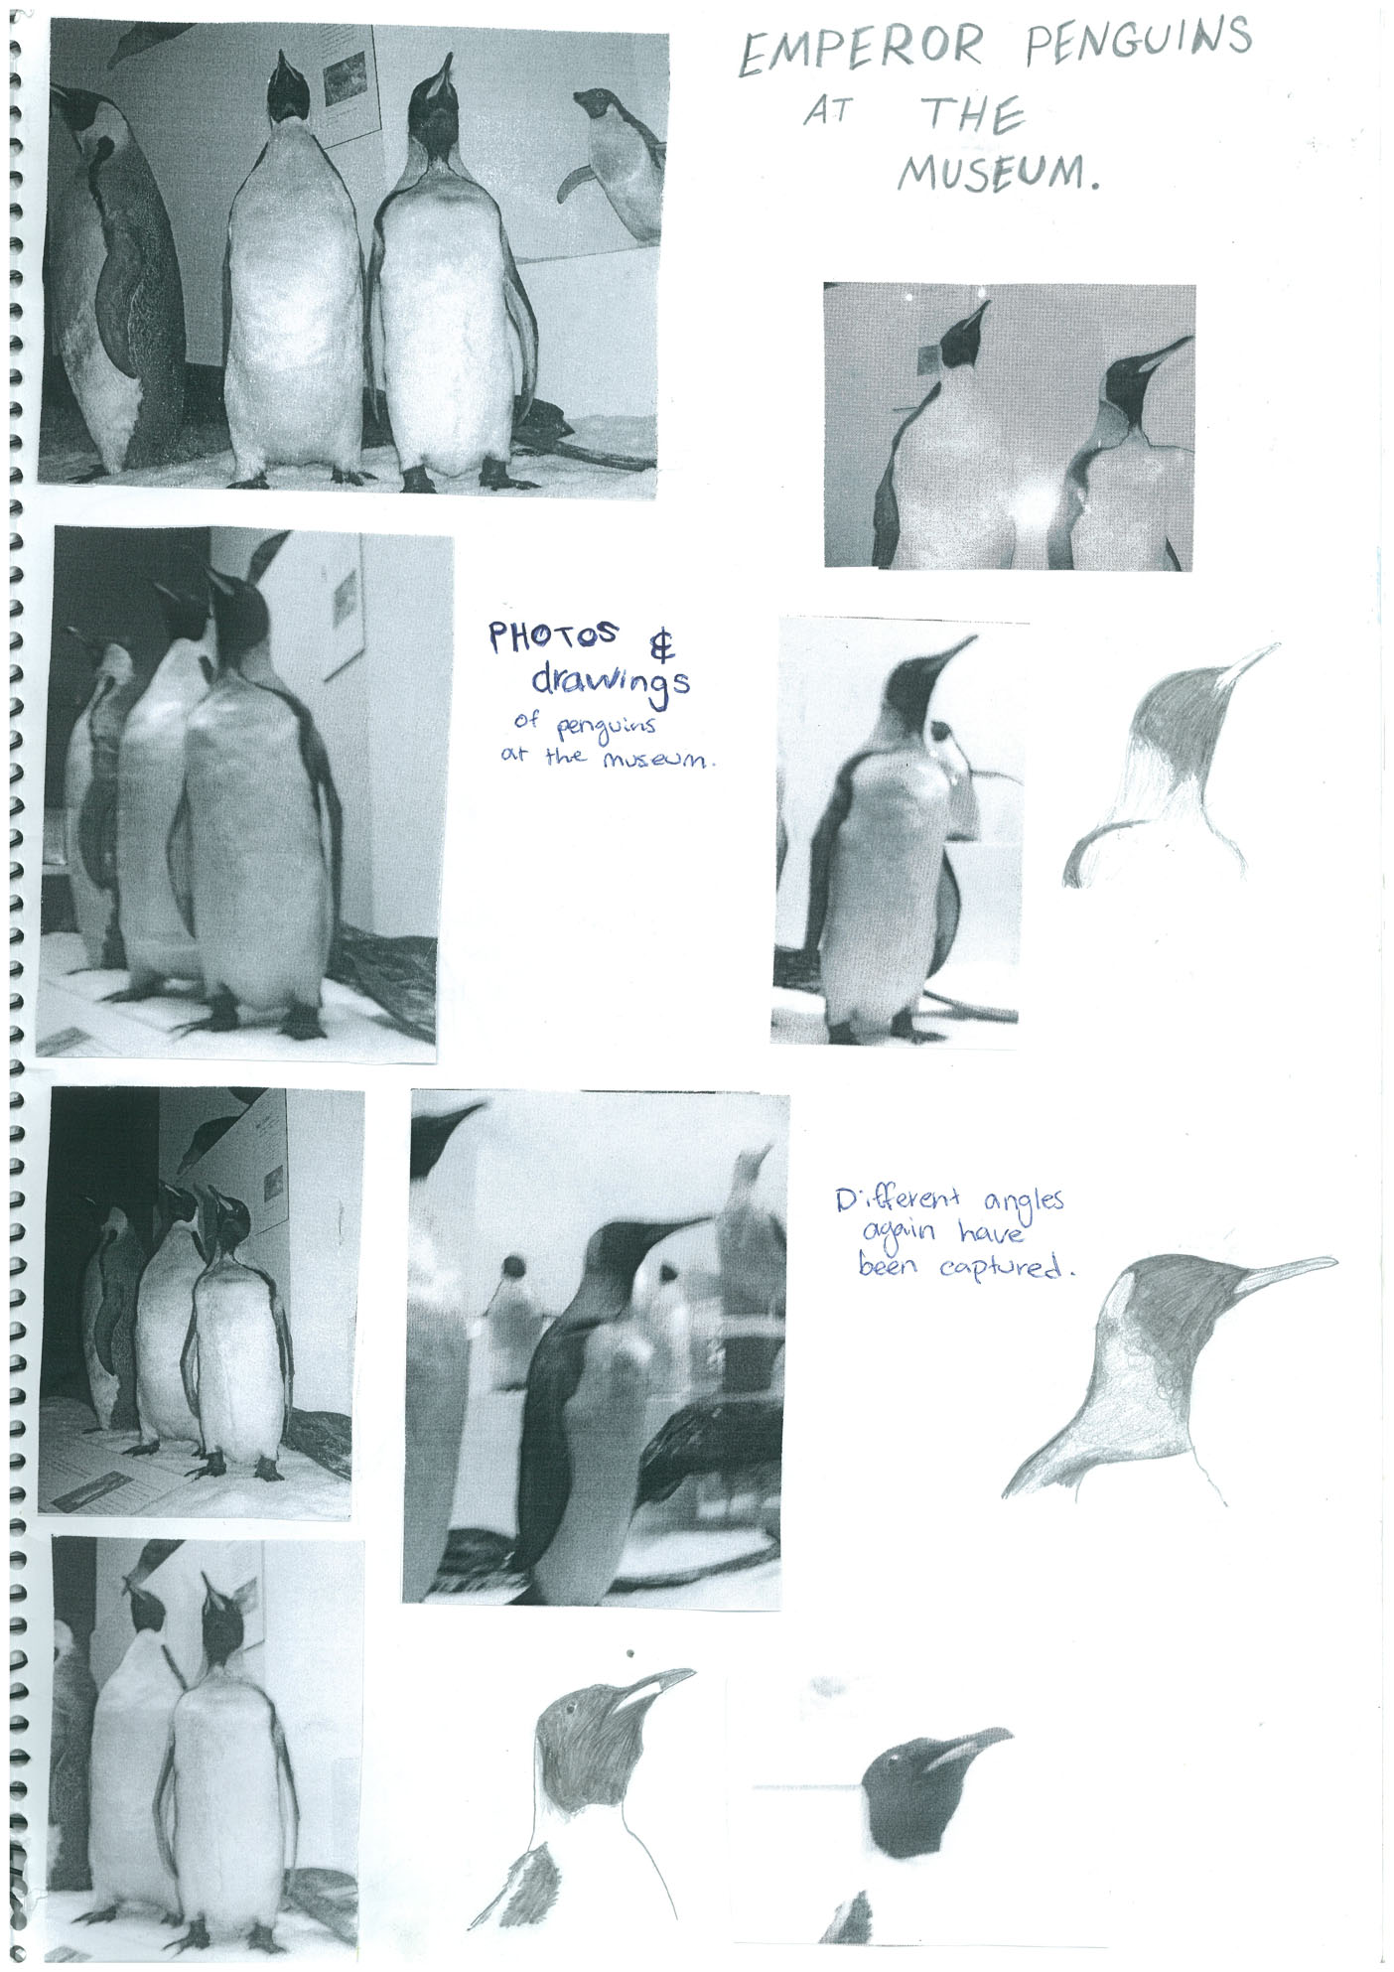
Knowledge and Understanding
Shows some recognition of aesthetic or functional qualities in works of art or design.
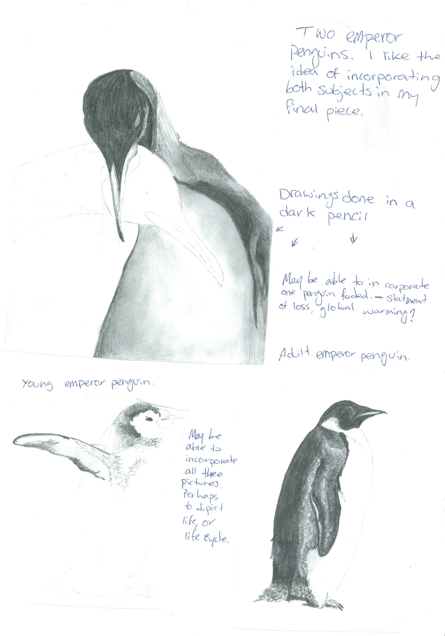
Practical Application
Demonstrates competent exploration to acquire technical skills and use media, materials and technologies.
Knowledge and Understanding
Indicates understanding of aesthetic or functional qualities in works of art or design.
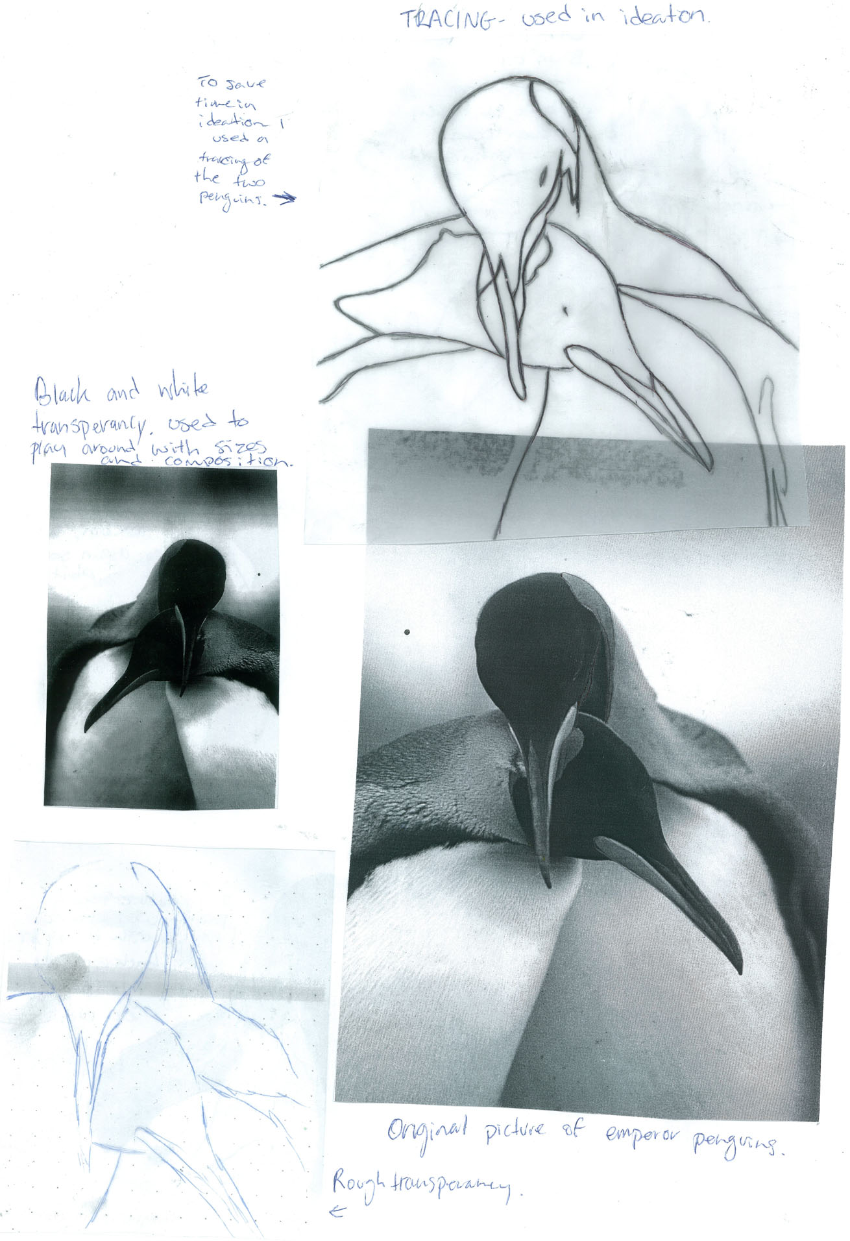
Practical Application
Demonstrates a continuation of exploration to acquire technical skills and use media, materials and technologies.

Also bordering on:

Some exploration of media materials or technologies.
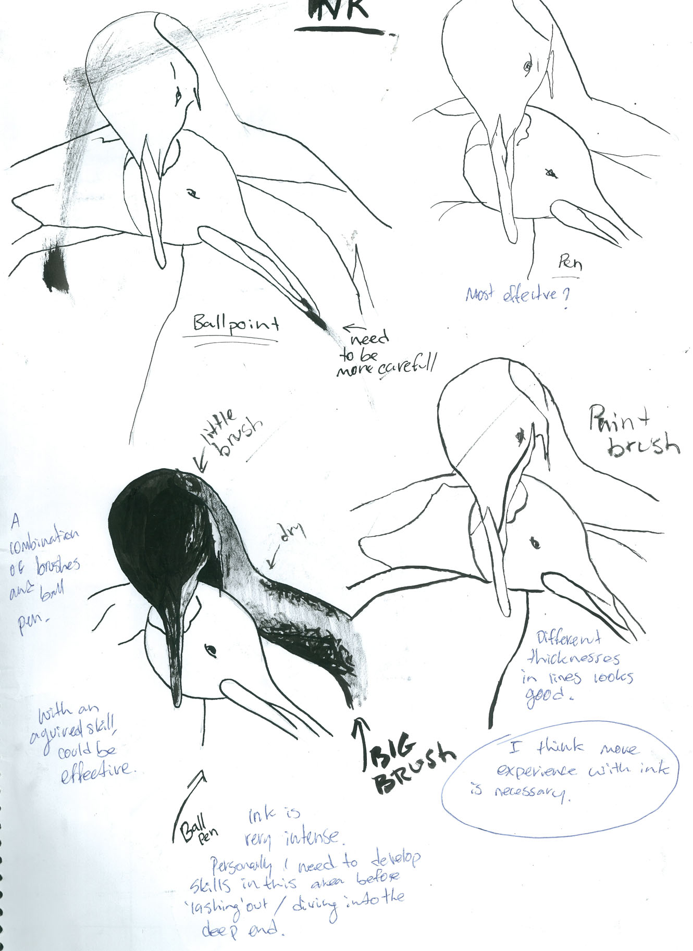
Analysis and Response
Demonstrates considered evaluation of own practical work.
Analysis and Response
Demonstrates generally clear use of visual arts language to interpret and respond to works and their contexts.
Practical Application
Demonstrates appropriate documentation of creative visual thinking and/or problem-solving processes.
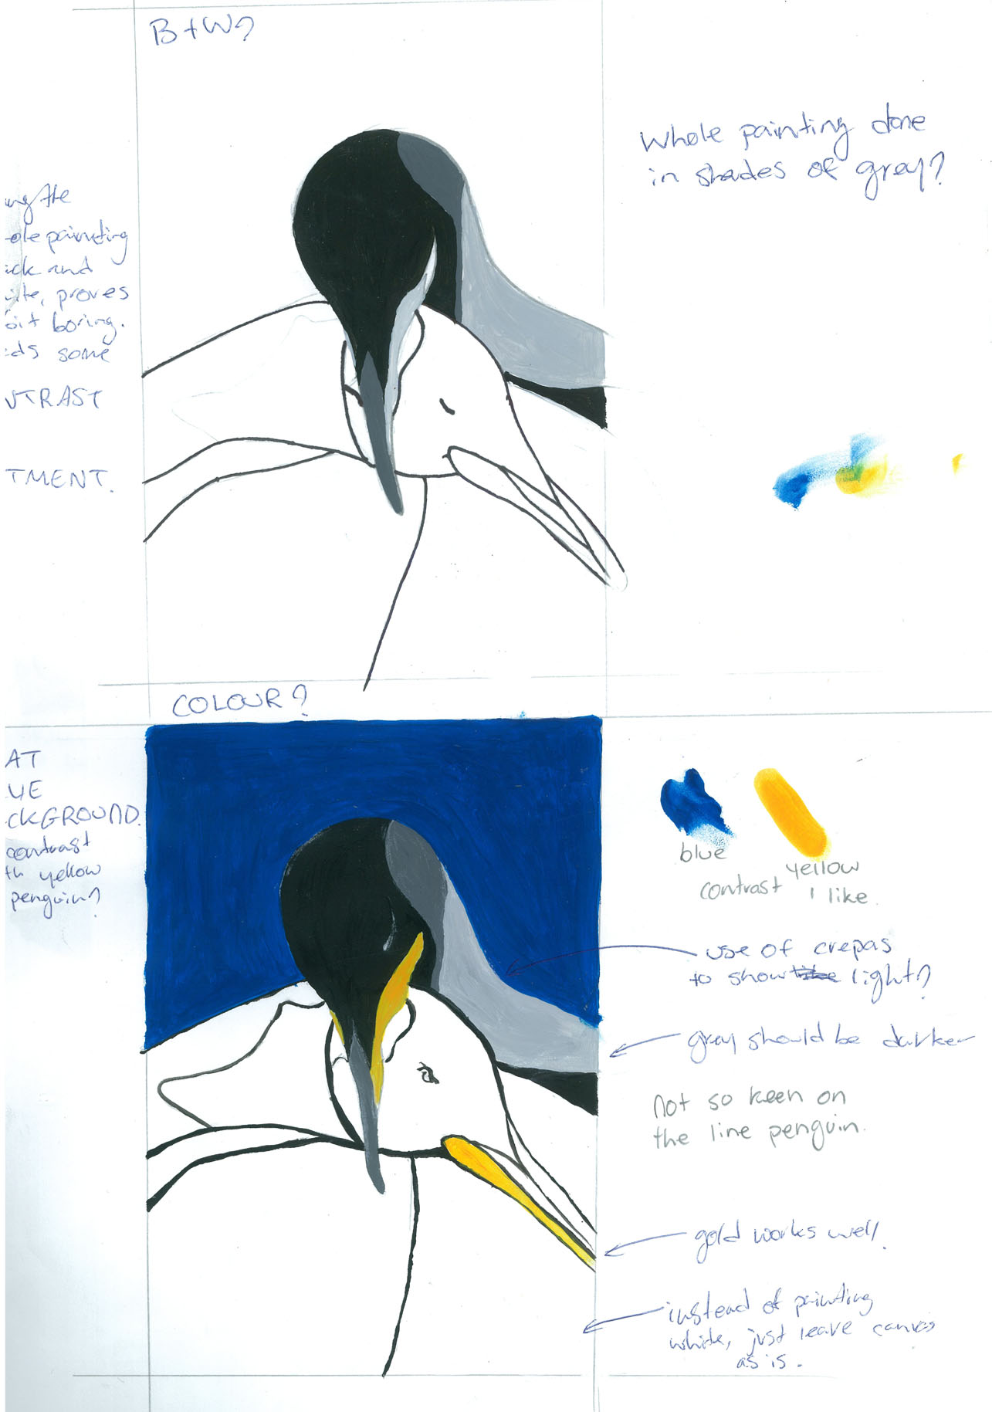
Knowledge and Understanding
Demonstrates appropriate understanding of aesthetic or functional qualities in works of art or design.

Also close to:

Demonstrating some recognition of aesthetic or functional qualities in works of art or design.
Analysis and Response
Demonstrates a generally clear use of visual arts language to interpret and respond to works and their contexts.
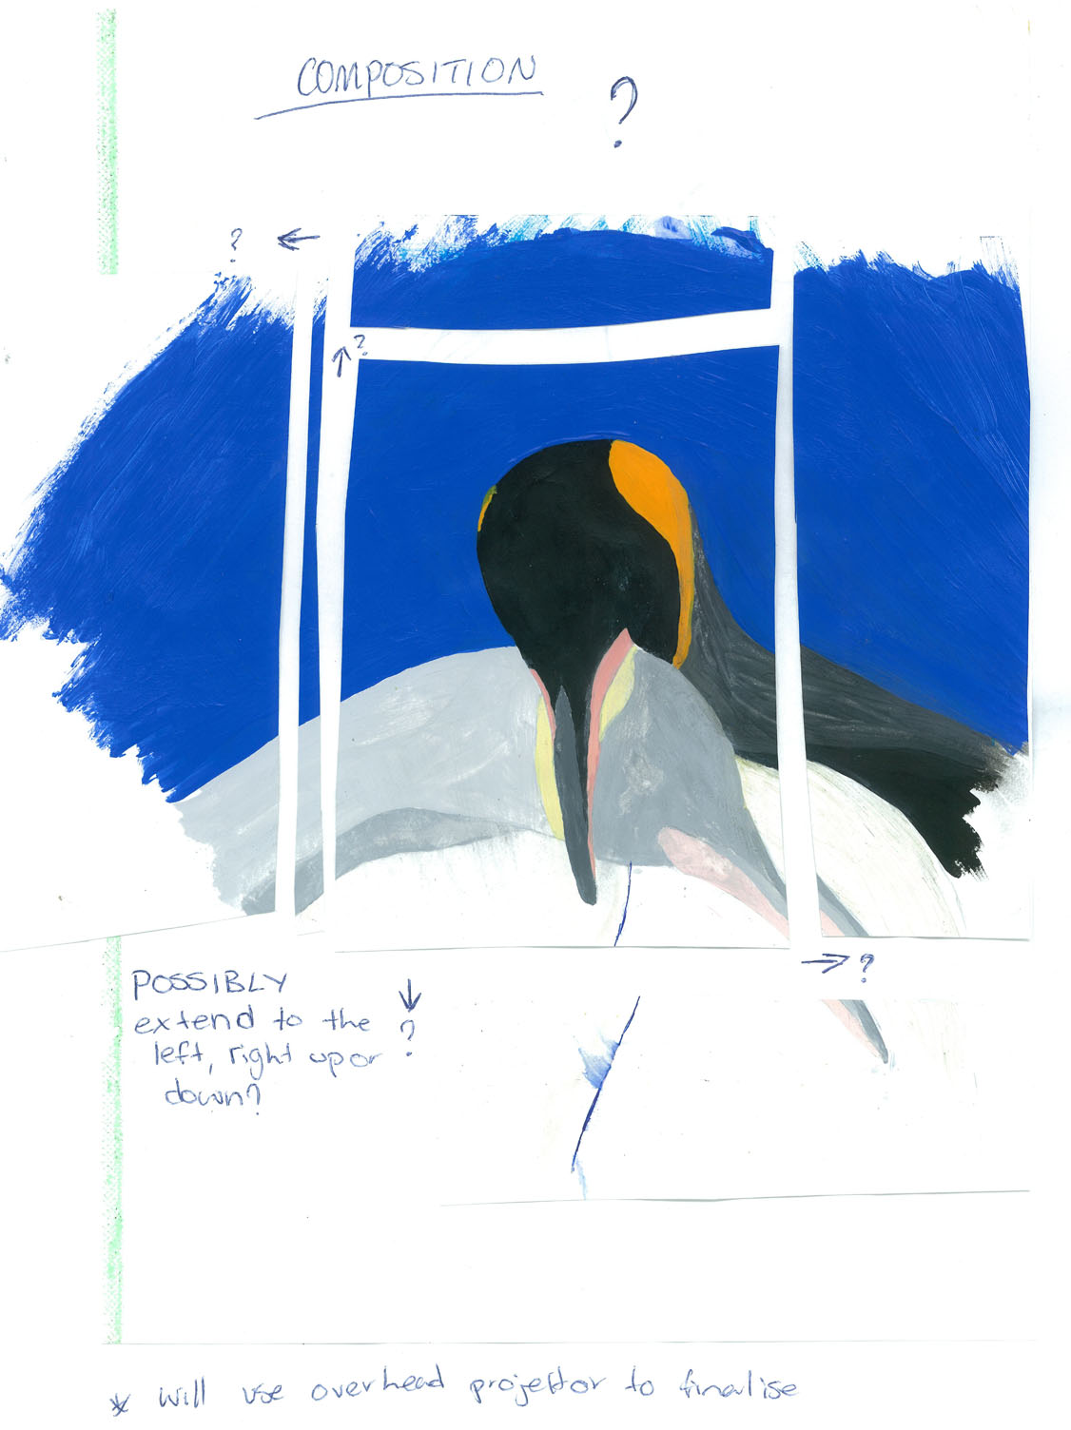
Knowledge and Understanding
Indicates some recognition of aesthetic or functional qualities in works of art or design.

Practical Application
Demonstrates appropriate documentation of creative visual thinking and/or problem-solving processes.

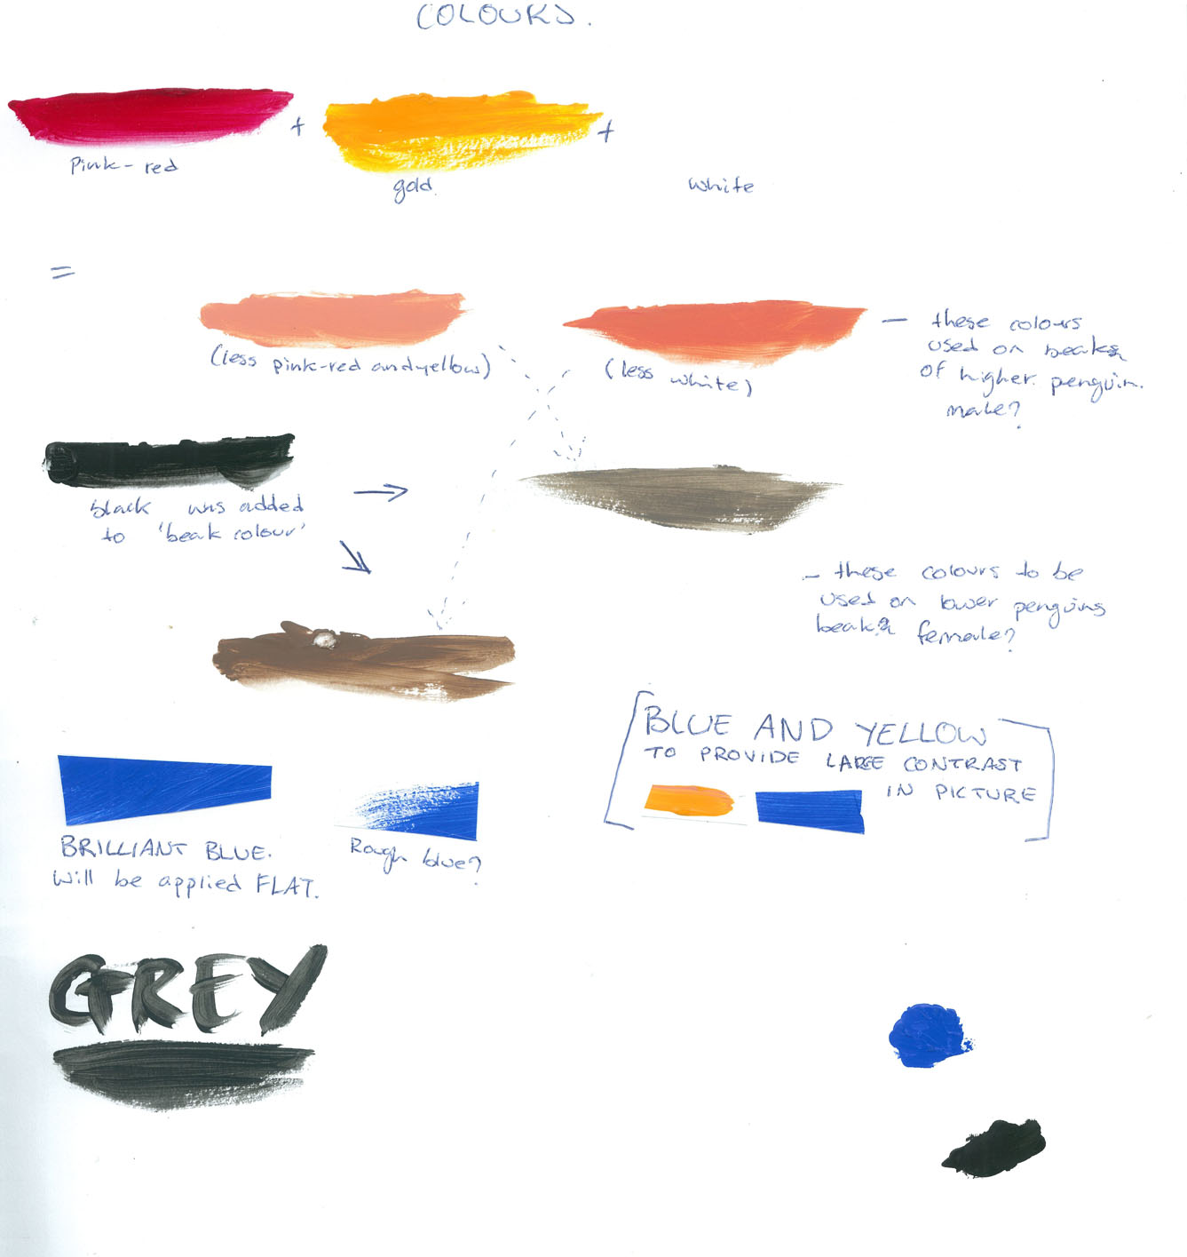
Practical Application
Demonstrates competent application of some technical skills with media, materials and technologies to communicate visual ideas in resolved work(s) of art or design.

Please note: some additional images have been removed from the original student work for copyright reasons.
Additional comments
Throughout the folio the student has conceptualised and developed imaginative and personally relevant visual ideas in a considered manner.
Performance Standards for Stage 1 Visual Arts – Art

 | Practical Application | Knowledge and Understanding | Analysis and Response
A | Coherent and well-considered conceptualisation and development of imaginative or personally relevant visual ideas.  Comprehensive exploration to acquire technical skills, and use media, materials, and technologies.  Reflective and thorough documentation of creative visual thinking and/or problem-solving processes.  Effective application of technical skills and sensitive use of media, materials, and technologies to communicate visual ideas in resolved work(s) of art or design. | In-depth knowledge of selected core visual arts concepts, forms, styles, and conventions.  In-depth knowledge and understanding of visual arts in different cultural, social, and/or historical contexts.  Discerning understanding of aesthetic or functional qualities in works of art or design.  Productive and well-considered research, including locating and appropriately acknowledging sources, exploring, experimenting, and developing perceptive and clear insights into a range of aspects of the visual arts. | Perceptive analysis and interpretation of a variety of works of art or design from different contexts.  Clear and consistent use of visual arts language to interpret and respond to works and their contexts.  Insightful evaluation of own practical work.
B | Well-considered conceptualisation and development of imaginative or personally relevant visual ideas.  Thorough exploration to acquire technical skills and use media, materials, and technologies.  Thoughtful documentation of creative visual thinking and/or problem-solving processes.  Mostly effective application of technical skills, and some sensitive use of media, materials, and technologies to communicate visual ideas in resolved work(s) of art or design. | Some depth of knowledge of selected core visual arts concepts, forms, styles, and conventions.  Some depth of knowledge and understanding of visual arts in different cultural, social, and/or historical contexts.  Clear understanding of aesthetic or functional qualities in works of art or design.  Well-considered research including locating and appropriately acknowledging sources, exploring, experimenting, and developing mostly clear insights into different aspects of the visual arts. | Thoughtful analysis and interpretation of works of art or design from different contexts.  Mostly clear and consistent use of visual arts language to interpret and respond to works and their contexts.  Well-considered evaluation of own practical work.
C | Considered conceptualisation and development of imaginative or personally relevant visual ideas.  Competent exploration to acquire technical skills and use media, materials, and technologies.  Appropriate documentation of creative visual thinking and/or problem-solving processes.  Competent application of some technical skills with media, materials, and technologies to communicate visual ideas in resolved work(s) of art or design. | Knowledge of selected core visual arts concepts, forms, styles, and conventions usually demonstrated in practical work.  Appropriate knowledge and mostly clear understanding of visual arts in different cultural, social, and/or historical contexts.  Appropriate understanding of aesthetic or functional qualities in works of art or design.  Considered research including locating and appropriately acknowledging sources, exploring, experimenting, and developing some insights into different aspects of the visual arts. | Considered analysis and interpretation of two or more works of art or design from different contexts.  Generally clear use of visual arts language to interpret and respond to works and their contexts.  Considered evaluation of own practical work.
D | Elements of conceptualisation and some development of visual ideas.  Some exploration of media, materials, or technologies.  Partial documentation of creative visual thinking or problem-solving processes.  Partial application of technical skills in developing works of art or design. | Some basic knowledge of selected core visual arts concepts, forms, styles, and conventions.  Recognition of one or more elements of visual arts in a cultural, social, or historical context.  Some recognition of aesthetic or functional qualities in works of art or design.  Some basic research, including locating one or more sources, with attempted acknowledgment, exploring, and experimenting. | Some basic consideration of at least one work of art or design, with superficial reference to their context.  Occasional use of visual arts language.  Some description and consideration of own practical work.
E | Emerging skills in the conceptualisation and development of visual ideas.  Some attempted exploration of media, materials, or technologies.  Limited documentation of creative thinking or problem-solving.  Attempted application of technical skills to develop a work of art or design. | Some recognition of selected core visual arts concepts, forms, or styles.  Limited understanding of a visual arts context.  Emerging awareness of the need to understand aesthetic or functional qualities in works of art or design.  Attempted engagement in a directed research process. | Emerging awareness of connections between works of art or design and their context.  Emerging use of visual arts language.  Some description of own practical work.

