Stage 2 Cross-disciplinary Studies
Assessment Type 4: Analysis
Learning Interest – Sustainable Environments
Disciplines – Geography and Agriculture
Students given the opportunity to demonstrate application of aspects of the disciplines to solve problems within creativity and initiative.

Students are provided with a transcript from ‘Landline’. The students watch the program, discuss it, and then have the transcript to work from. Students are provided with a ‘Street Talk’ segment from ‘The Advertiser’.
Time: 60 minutes
After reading the material provided, answer the following questions in your own words. You may use dot points and diagrams to assist you.
Students given the opportunity to demonstrate an understanding of the learning interest.
- Identify the main issue being covered by the material.
Variety of questions allows opportunity for students to demonstrate evidence of all the required criteria at all levels, including the highest level.
- Think of a hard hitting headline that summarises the issue.
- Draw a flow chart that shows how the main points of the issue are linked.
Students given the opportunity to demonstrate evaluation of the contribution of the selected disciplines.
- How does the issue link to “sustainable environments”?
- Is there a “sustainable future” or possible solution to the issue?
- How is the issue related to
- Geography?
- Agriculture?
Open ended questions allow students to explore the learning interest and demonstrate their knowledge and understanding to their ability.
- The ‘Street Talk’ segment asks the question “Does Australia import too much food?” Some of the opinions are quite similar. Comment on the different viewpoints and then provide a more detailed response incorporating your own opinion.

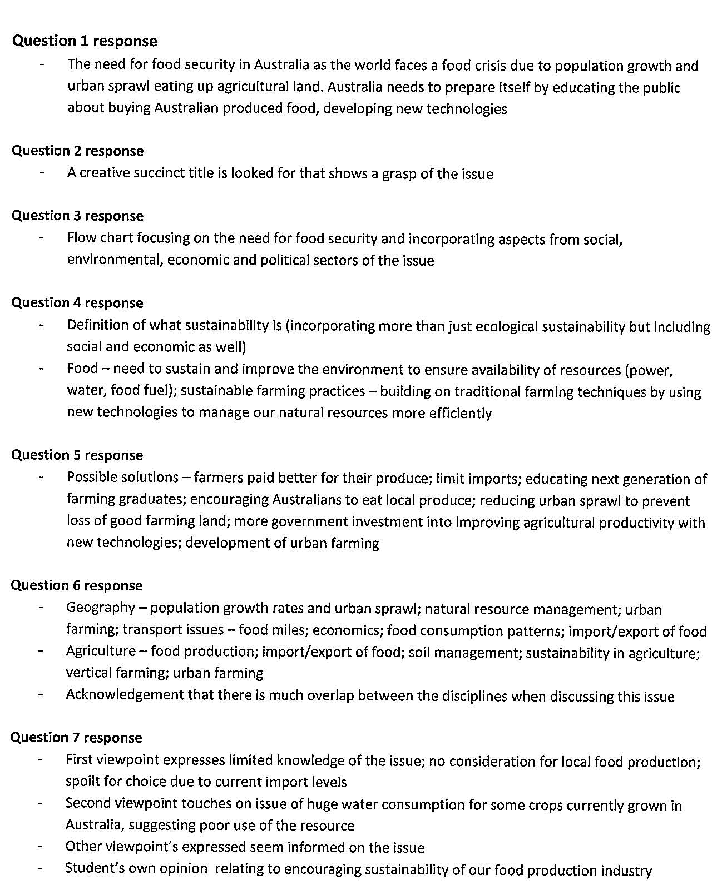
Answer guide provides explicit expected responses demonstrating evidence against the specific features of the assessment design criteria.

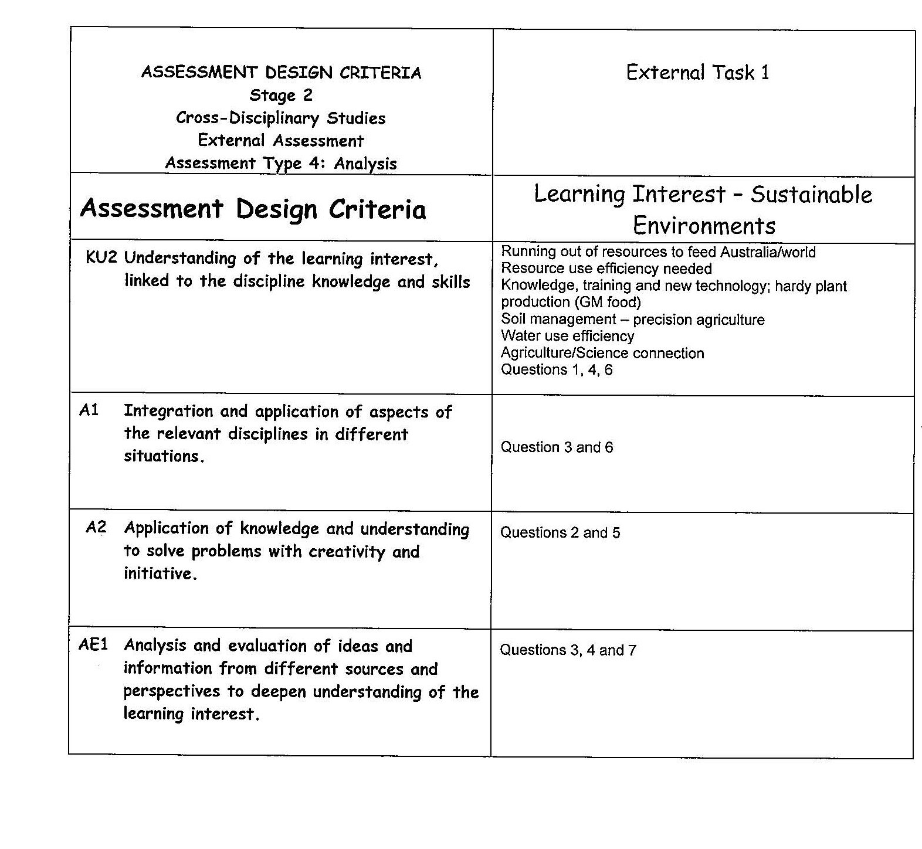
Clear statement of learning interest and key knowledge expected.
Explicit indication of the evidence to be demonstrated against each criterion.
Limiting criteria to those specified in the subject outline.

Performance Standards for Stage 2 Cross-disciplinary Studies
 | Knowledge and Understanding | Application | Analysis and Evaluation | Interaction and Communication
A | Insightful and sophisticated exploration of key elements of the relevant disciplines and their connections to the learning interest.  Well-informed and highly effective understanding of the learning interest, incorporating specific discipline knowledge and skills.  In-depth knowledge and understanding of the relevant capabilities. | Comprehensive integration and application of aspects of the relevant disciplines in familiar as well as complex, less familiar situations.  Highly focused application of knowledge and understanding to solve problems with insightful creativity and initiative.  Convincing and in-depth development of ideas, insights, and further questions. | Comprehensive analysis and evaluation of ideas and information from a variety of sources and perspectives to deepen understanding of the learning interest.  Sustained and insightful evaluation of the contributions of the disciplines.  Well-considered and substantive analysis of and reflection on the student’s own learning.  Perceptive evaluation of feedback from others. | Convincing and sustained demonstration of purposeful interactive and collaborative skills in a range of situations.  Clear, coherent, and highly focused communication of understanding, reasoned conclusions, and new ideas and insights about the learning interest.
B | Well-considered exploration of key elements of the relevant disciplines and their connections to the learning interest.  Well-informed understanding of the learning interest, incorporating discipline knowledge and skills.  Well-informed knowledge and understanding of the relevant capabilities. | Well-informed integration and application of aspects of the relevant disciplines in familiar and less familiar situations.  Well-considered application of knowledge and understanding to solve problems with creativity and initiative.  Thoughtful development of ideas, insights, and further questions. | Detailed analysis and evaluation of ideas and information from a variety of sources and perspectives to deepen understanding of the learning interest.  Sustained evaluation of the contributions of the disciplines.  Well-considered analysis of and reflection on the student’s own learning.  Well-considered evaluation of feedback from others. | Mostly sustained and focused interactive and collaborative skills in a range of situations.  Clear, coherent, and mostly focused communication of understanding, conclusions, and new ideas and insights about the learning interest.
C | Exploration of key elements of the relevant disciplines and their connections to the learning interest.  Informed understanding of the learning interest, linked to discipline knowledge and skills.  Informed understanding of the relevant capabilities. | Informed integration and application of aspects of the relevant disciplines in mostly familiar situations.  Considered application of knowledge and understanding to solve problems with some creativity and initiative.  Competent development of ideas and insights, and further questions. | Considered analysis and evaluation of ideas and information from different sources and perspectives to deepen understanding of the learning interest. Analysis sometimes tends towards summary and narration.  Some evaluation of contributions of the disciplines, tending towards description.  Considered analysis of and reflection on the student’s own learning.  Considered evaluation of feedback from others. | Competent interactive and collaborative skills in different situations.  Generally clear communication of understanding, conclusions, and new ideas and insights about the learning interest.
D | Some basic connections between aspects of two or more disciplines and the learning interest.  Awareness of aspects of the learning interest, discipline knowledge, or skills.  Recognition of some of the capabilities. | Superficial integration or application of aspects of the relevant disciplines in highly familiar situations.  Some creativity evident in occasional problem-solving.  Some development of basic ideas and insights. | Partial summary of ideas and information, with some increased understanding of learning interest.  Description of some elements of the contributions of the disciplines.  Some reflection on the student’s own learning.  Basic consideration of feedback from others. | Simple interactive and collaborative skills.  Basic communication of some ideas and insights about the learning interest, with some attempted conclusions.
E | Identification of limited connections between one or more aspects of disciplines and the learning interest.  Emerging awareness of one or more aspects of the learning interest or skills.  Identification of one or more capabilities. | Attempted application of an aspect of a relevant discipline.  Attempted identification of a possible solution to a problem.  Attempted development of an idea or question. | Simple summary of ideas and/or information that may have some relevance to learning interest.  Attempted description of one or more elements of the contributions of the disciplines.  Attempted description of an aspect of the student’s own learning.  Limited attempt at reflecting on feedback. | Attempted interactive and collaborative skills.  Attempted communication of partially developed ideas that are not necessarily new.

