

Product and Documentation

Stage 1
Information Processing and Publishing

Stage 1
SACE
Contents

Investigating 2

Devising 5

Producing 9

Evaluating 13

Bibliography 14

Investigating

Product:
The document to be produced is an A4 menu for the Principal’s Dinner which is to be held at the College on Wednesday June 25 2008.

The requirements for this menu are:
- A4 page (can be folded or two sided)
- Written text (simplified)
- School logo
- Appropriate graphics
- Appropriate fonts/size

Audience:
The audience that this menu would be aimed at would be the guests of the Principal’s Dinner. It is most likely these guests would be the guest of honour (The Hon Jane Lomax-Smith), members of the college staff and possibly parents. Overall it would be a mature and older audience with a liking for more formal designs.

Hardware:
- Pentium 4 Dell Computer
- HP LaserJet 4050 Series PCL6
Application
Demonstrates proficient application of appropriate hardware and software in the completion of text-based communication tasks. Chose appropriate hardware and software for text and graphic design and manipulation.
- FX ApeosPort C7550 1 PCL6

Software:
- Microsoft Word 97 – 2003
- Microsoft Publisher 2003
- Adobe Photoshop CS3
Investigating

Mussel Mike’s Menu
Front page:
  - Large graphic gives a good idea of what food they sell.
Understanding
Shows comprehensive understanding of the design process and layout principles as they relate to text-based tasks. Uses own terminology which demonstrates assimilation of principles of design – refer to highlighted words.
  - Visible title; blue coloured font against a white background to match the theme, placement is acceptable in the layout of the whole menu.
  - All the writing is a reasonable font size and the title stands out.
  - Writing about their featured cooking oil is unnecessary or not front page material, causes the front to look busy.
  - Red symbol underneath the writing is a bit out of place, along with the cooking oil can.

Inside pages:
  - Keeps the colour theme of blue but maybe a bit more of the teal colour required.
  - Both pages are too busy, although the second page is easy to read because it is set up in rows and columns.
  - Third page is definitely too busy; food graphics overlapping each other and the writing describing the meals barely fit onto the page.
  - Price colours aren’t contrasting with the foods, should have used a cool colour like the blue or teal which would have kept with the theme.

Back page:
  - Last page shouldn’t be as busy as this one.
  - Graphics are placed well and text is easy to read.
  - The description of the cooking oil is more in place here than it is at the front, also because it is already placed here, there is no need for it to be on the front.
Devising

Application
Demonstrates comprehensive application of the design process and layout principles appropriate to a text-based task by deciding not to use colour and to use a more formal font. Further evidence of this is in the student’s evaluation – page 10.
Principal’s Dinner pre-dinner drinks
Viner Hand ITC
Adobe Caslon Pro

Principal’s Dinner pre-dinner drinks
Arial
VPS Long An

Principal’s Dinner pre-dinner drinks
Lucinda Calligraphy
Perpetua
Principal’s Dinner pre-dinner drinks
Forte
Sylfaen
Principal’s Dinner pre-dinner drinks
Bernhard Modern Std Roman
Marydale

Principal’s Dinner pre-dinner drinks
Trajan Pro
Noir-et-Blanc

Principal’s Dinner pre-dinner drinks
Freestyle Script
Tw Cen MT

Principal’s Dinner pre-dinner drinks
Edwardian Script ITC
Centaur

Devising
Understanding
Shows comprehensive understanding of the design process and layout principles as they relate to text-based tasks on pages 6 – 8 e.g. indicates page layout, font and size, alignment and colour.

XXXXXXXXXXX
XXXXXXXX

XXXXXXX

XXXXXXXX
XXXXXXXX

School Logo
Front view of menu
Various graphics
of students and school
SACE College
Wednesday June 25 2008

6pm start

Parchment texture
Main theme of blue and red
(school colours)
Right alignment, could be changed because might be too busy along with side column
Trajan Pro: 36pt
Trajan Pro: 20pt
Trajan Pro: 16pt
Devising
Application
Highly effective application of manipulative skills appropriate to the use of information-processing hardware and software – uses Word to plan layout before transferring to Publisher for actual production. Uses symbol ’X’ instead of text and shapes for graphics on pages 6 – 8.

Program Page
Menu
Inside view of menu

XXXX

Xxxxxxxxxxxx
Xxxxxxxx

Xxxxxxxxxxxxxxx
Xxxxxxxxxx

Xx

Xxxxxxxxxxxxxx
Xxxxxxxxxxx

Xxxxxxxxxxxxxx
xxxxxxxxxxxx

XXXXXXX

xxxxxxxxxxxxxxxxx

xxxxxxxxxxxxxxxxxx

xxxxxxxxxxxxxxxxxx

xxxxxxxxxxxxxxxxxxx

xxxxxxxxxxxxxxxxxxxx

Various graphics of
students and school

Entrée
Herbed Seafood Crepes
Crepes flavoured with fresh herbs, prawn, crab and scallops filling with a fresh tomato sauce.

Main Course
Veal with lemon
Served with vegetables and hot broccoli salad.
or
Spinach and brie flan
Served with vegetables julienne and crisp potatoes

Desserts
Hot passionfruit soufflé
served with raspberry cream

Coffee/Tea and chocolate mint squares
Program
6:00pm – Pre-dinner drinks

6:30pm – Start of Dinner

8:00pm – ‘The Implementation of Future SACE’ The Hon Jane Lomax-Smith, Minister for Education

8:30pm – PowerPoint Presentation on future plans for SACE College Principal,

9:00pm – Presentation of gifts

Drinks
Champagne
Shiraz 2004
Sauvignon Blanc 2005
Soft Drinks

Adobe Caslon Pro: 12pt
Trajan Pro: 40 pt
Adobe Caslon Pro: 12pt
Devising

Back view of menu

XXX XXXX XX XXX XXXXXX XXXXX XXXXXXX

SACE College
Graphic of the College
Trajan Pro: 12pt

Application
Comprehensively applies the design process and layout principles appropriate to a text-based task by devising a plan for a menu that meets the requirements.

Producing

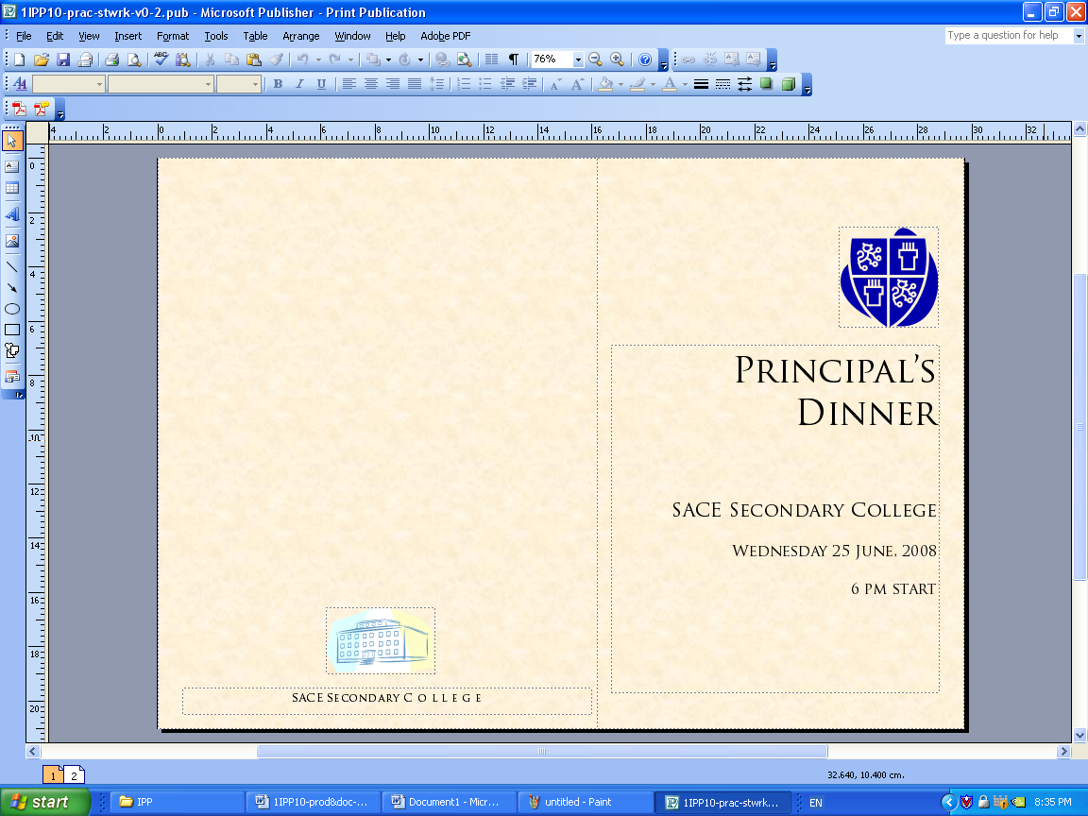
Production of menu in Microsoft Publisher

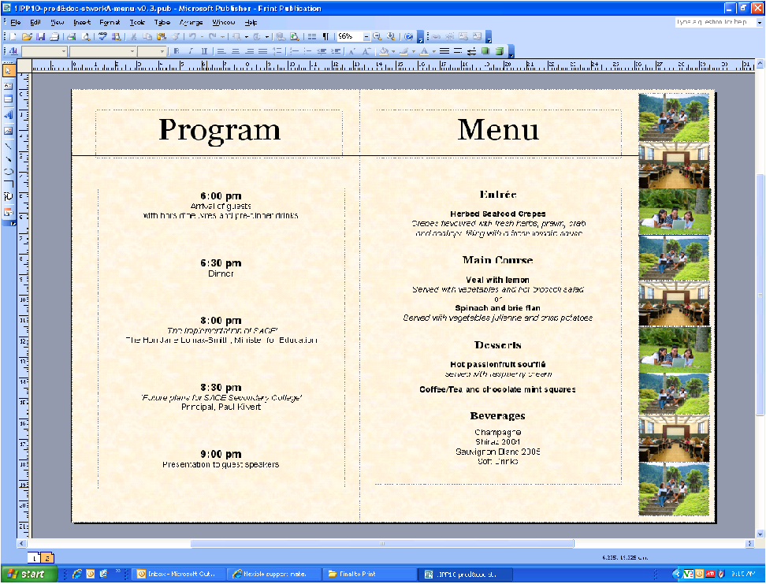

Application
Demonstrates proficient application of appropriate hardware and software in the completion of text-based communication tasks in both screenshots.
Application
Shows highly proficient application of acquired skills to produce text-based information accurately e.g. consistent formatting, use of fonts, accurate keying.
Evaluating

Analysis and Evaluation
Shows perceptive and thorough evaluation of a text-based task against design principles e.g. mentioned layout, white space, balance, highlighting, colour, all in reference to audience and occasion (refer to highlighted text).

The task was to create a menu for the Principal’s Dinner. It was to be A4 sized, foldable, and to include specified details.

Before beginning devising the menu, I investigated styles. I made comments in the investigation section about a menu I found. This helped me to devise my own product because it demonstrated everything I disliked in a menu. Overcrowding, unnecessary words and too little white space made it unappealing to me and I made sure that they were not faults of my product.

I began by investigating fonts as this is vital. The audience for this menu would be a more mature group who would probably prefer sophisticated simplicity over bright, bold decoration. I began the planning in Microsoft Word using basic shapes without input texts or graphics. This stage was valuable as if we just rushed straight into producing it in Microsoft Publisher, we would not have put as much thought into it. Once the layout details such as the off centre fold and placement of graphics and text were planned, I transferred all my ideas onto Publisher where it was simple to change features that did not work the way I thought it would.

I kept the text black as this is often easier to read. A parchment texture background gave the menu a classic feel. After investigation, I chose a simple serif font for the titles and main text. I was concerned that the title font (Trajan Pro) was all capitals so when I discovered this font was not supported by the school system I changed to Georgia. I used Arial as my contrasting font.

The best part of this menu is the picture sidebar. I used Adobe Photoshop CS3 to blend six graphics together and left some navy blue background behind them to display the school colour. This sidebar also shows the cultural diversity in our school which would stand out to guests.

White space in the right place is important. It provides a sense of balance and won’t crowd your eyes.

I am satisfied with my product and the process which I have taken to complete it. Although simple, it has met the requirements and I think the target audience would appreciate it too.
Additional comment on evidence
Overall, the student has demonstrated proficient application of appropriate hardware and software in the completion of this text-based communication task.
Teacher observation of the student’s choice and use of hardware and software would be needed to assess the level of proficiency.
Bibliography

Investigation

Mussel Mike Menu
Shellfish Plaza, 1313 Main Sea Road, Seaview Plains

Internet
www.designingmenus.com.au accessed 15 July 2009

www.designing_menus.com accessed 15 July 2009

www.fontfrolics.com.au accessed 16 July 2009

Books

Smith, J. The Designer’s Design Book. Pumpkin Publishers, Goolwa, 2008

Performance Standards for Stage 1 Information Processing and Publishing
 | Understanding | Analysis and Evaluation | Application
A | Comprehensive understanding of the design process and layout principles as they relate to text-based tasks.  Insightful and well-informed understanding of the impact of social and/or ethical issues closely related to information-processing and publishing technologies. | Perceptive and thorough evaluation of a text-based product and the design process used.  Perceptive analysis and evaluation of the impact of social and/or ethical issues related to information-processing and publishing technologies. | Highly proficient application of appropriate hardware and software in the completion of text-based communication tasks.  Highly effective application of manipulative skills appropriate to the use of information-processing hardware and software.  Comprehensive application of the design process and layout principles appropriate to a text-based task.  Highly proficient application of acquired skills to produce text-based information accurately.
B | Well-informed understanding of the design process and layout principles as they relate to text-based tasks.  Well-informed understanding of the impact of social and/or ethical issues related to information-processing and publishing technologies. | Well-considered evaluation of a text-based product and the design process used.  Well-considered analysis and evaluation of the impact of social and/or ethical issues related to information-processing and publishing technologies. | Proficient application of appropriate hardware and software in the completion of text-based communication tasks.  Effective application of manipulative skills appropriate to the use of information-processing hardware and software.  Well-considered application of the design process and layout principles appropriate to a text-based task.  Proficient application of acquired skills to produce text-based information accurately.
C | Informed understanding of the design process and layout principles as they relate to text-based tasks.  Informed understanding of the impact of social and/or ethical issues related to information-processing and publishing technologies. | Competent evaluation of a text-based product and the design process used.  Considered analysis and evaluation of the impact of social and/or ethical issues related to information-processing and publishing technologies. | Competent application of appropriate hardware and software in the completion of text-based communication tasks.  Generally consistent application of manipulative skills appropriate to the use of information-processing hardware and software.  Competent application of the design process and layout principles appropriate to a text-based task.  Competent application of acquired skills to produce text-based information accurately.
D | Some understanding of basic aspects of the design process and layout principles as they relate to text-based tasks.  Some recognition of the impact of social and/or ethical issues related to information-processing and publishing technologies. | Some basic assessment of a text-based product, with some reference to the design process, using mostly description.  Recognition of aspects of the impact of social or ethical issues related to information-processing and publishing technologies. | Application of some basic appropriate hardware and software in undertaking text-based communication tasks.  Some application of basic manipulative skills appropriate to the use of some information-processing hardware and software.  Some application of elements of the design process and layout principles appropriate to a text-based task.  Application of some acquired skills to produce some simple text-based information with some inconsistencies.
E | Identification of one or more aspects of the design process and layout principles as they relate to text-based tasks.  Emerging awareness of a social or ethical issue that may have little relationship to information-processing and publishing technologies. | Attempted description of aspects of a text-based product, with limited reference to the design process.  Emerging awareness of one or more aspects of the impact of a social or ethical issue related to information-processing and publishing technologies. | Limited application of basic hardware and software in attempting text-based communication tasks.  Limited application of simple manipulative skills in attempting to use some information-processing hardware or software.  Attempted application of few elements of the design process and layout principles appropriate to a text-based task.  Attempted application of one or more skills to produce elements of simple text-based information with limited accuracy.

