Stage 2 Biology

Assessment Type 2: Skills and Applications Tasks

Organisms Test

Purpose

This task allows you to demonstrate your knowledge and understanding of the concepts of organisms from a cellular level to a systems level.

Description of the assessment

This test assesses:

* knowledge and understanding of concepts of the structure, material exchange, control and energy flow in organisms
* knowledge and understanding of investigation design
* knowledge and understanding of the concepts related to reproduction and variation.
* analysis of data to formulate conclusions.

Assessment conditions

* Time allowance: 90 minutes

|  |  |  |
| --- | --- | --- |
| *Learning Requirements* | *Assessment Design Criteria* | *Capabilities* |
| 1. identify and formulate questions, hypotheses, concepts, and purposes that guide biological investigations  2. design and conduct individual and collaborative biological investigations  3. manipulate apparatus and use technological tools and numeracy skills to obtain, represent, analyse, interpret, and evaluate data and observations from biological investigations  4. select and critically evaluate biological evidence from different sources and present informed conclusions and personal views on social, ethical, and environmental issues  5. communicate their knowledge and understanding of biological concepts using appropriate biological terms and conventions  6. demonstrate and apply biological knowledge and understanding of concepts and interrelationships to a range of contexts and problems, including by presenting alternative explanations. | Investigation  The specific features are as follows:  I1 Design of biological investigations.  I2 Selection and acknowledgment of information about biology and issues in biology from different sources.  I3 Manipulation of apparatus and technological tools to implement safe and ethical investigation procedures.  I4 The obtaining, recording, and display of findings of investigations using appropriate conventions and formats.  Analysis and Evaluation  The specific features are as follows:  AE1 Analysis and evaluation of connections between data, concepts, and issues in biology.  AE2 Evaluation of procedures, with suggestions for improvement.  Application  The specific features are as follows:  A1 Application of biological concepts and evidence from investigations to solve problems in new and familiar contexts.  A2 Use of appropriate biological terms, conventions, formulae, and equations.  A3 Demonstration of skills in individual and collaborative work.  Knowledge and Understanding  The specific features are as follows:  KU1 Demonstration of knowledge and understanding of biological concepts.  KU2 Use of knowledge of biology to understand and explain social or environmental issues.  KU3 Communication of knowledge and understanding of biology in different formats. | Communication  Citizenship  Personal Development  Work  Learning |

Performance Standards for Stage 2 Biology

|  | Investigation | Analysis and Evaluation | Application | Knowledge and Understanding |
| --- | --- | --- | --- | --- |
| A | Designs logical, coherent, and detailed biological investigations.  Critically and logically selects and consistently and appropriately acknowledges information about biology and issues in biology from a range of sources.  Manipulates apparatus and technological tools carefully and highly effectively to implement well-organised safe and ethical investigation procedures.  Obtains, records, and displays findings of investigations using appropriate conventions and formats accurately and highly effectively. | Critically and systematically analyses data and their connections with concepts, to formulate logical and perceptive conclusions and make relevant predictions.  Critically and logically evaluates procedures and suggests a range of appropriate improvements. | Applies biological concepts and evidence from investigations to suggest solutions to complex problems in new and familiar contexts.  Uses appropriate biological terms, conventions, formulae, and equations highly effectively.  Demonstrates initiative in applying constructive and focused individual and collaborative work skills. | Consistently demonstrates a deep and broad knowledge and understanding of a range of biological concepts.  Uses knowledge of biology perceptively and logically to understand and explain social or environmental issues.  Uses a variety of formats to communicate knowledge and understanding of biology coherently and highly effectively. |
| B | Designs well-considered and clear biological investigations.  Logically selects and appropriately acknowledges information about biology and issues in biology from different sources.  Manipulates apparatus and technological tools carefully and mostly effectively to implement organised safe and ethical investigation procedures.  Obtains, records, and displays findings of investigations using appropriate conventions and formats mostly accurately and effectively. | Clearly and logically analyses data and their connections with concepts, to formulate consistent conclusions and make mostly relevant predictions.  Logically evaluates procedures and suggests some appropriate improvements. | Applies biological concepts and evidence from investigations to suggest solutions to problems in new and familiar contexts.  Uses appropriate biological terms, conventions, formulae, and equations effectively.  Applies mostly constructive and focused individual and collaborative work skills. | Demonstrates some depth and breadth of knowledge and understanding of a range of biological concepts.  Uses knowledge of biology logically to understand and explain social or environmental issues.  Uses a variety of formats to communicate knowledge and understanding of biology coherently and effectively. |
| C | Designs considered and generally clear biological investigations.  Selects with some focus, and mostly appropriately acknowledges, information about biology and issues in biology from different sources.  Manipulates apparatus and technological tools generally carefully and effectively to implement safe and ethical investigation procedures.  Obtains, records, and displays findings of investigations using generally appropriate conventions and formats with some errors but generally accurately and effectively. | Analyses data and their connections with concepts, to formulate generally appropriate conclusions and make simple predictions, with some relevance.  Evaluates some procedures in biology and suggests some improvements that are generally appropriate. | Applies biological concepts and evidence from investigations to suggest some solutions to basic problems in new or familiar contexts.  Uses generally appropriate biological terms, conventions, formulae, and equations with some general effectiveness.  Applies generally constructive individual and collaborative work skills. | Demonstrates knowledge and understanding of a general range of biological concepts.  Uses knowledge of biology with some logic to understand and explain one or more social or environmental issues.  Applies different formats to communicate knowledge and understanding of biology with some general effectiveness. |
| D | Prepares the outline of one or more biological investigations.  Selects and may partly acknowledge one or more sources of information about biology or an issue in biology.  Uses apparatus and technological tools with inconsistent care and effectiveness and attempts to implement safe and ethical investigation procedures.  Obtains, records, and displays findings of investigations using conventions and formats inconsistently, with occasional accuracy and effectiveness. | Describes basic connections between some data and concepts, and attempts to formulate a conclusion and make a simple prediction that may be relevant.  For some procedures, identifies improvements that may be made. | Applies some evidence to describe some basic problems and identify one or more simple solutions, in familiar contexts.  Attempts to use some biological terms, conventions, formulae, and equations that may be appropriate.  Attempts individual work inconsistently, and contributes superficially to aspects of collaborative work. | Demonstrates some basic knowledge and partial understanding of biological concepts.  Identifies and explains some biological information that is relevant to one or more social or environmental issues.  Communicates basic information to others using one or more formats. |
| E | Identifies a simple procedure for a biological investigation.  Identifies a source of information about biology or an issue in biology.  Attempts to use apparatus and technological tools with limited effectiveness or attention to safe or ethical investigation procedures.  Attempts to record and display some descriptive information about an investigation, with limited accuracy or effectiveness. | Attempts to connect data with concepts, formulate a conclusion, and make a prediction.  Acknowledges the need for improvements in one or more procedures. | Identifies a basic problem and attempts to identify a solution in a familiar context.  Uses some biological terms or formulae.  Shows emerging skills in individual and collaborative work. | Demonstrates some limited recognition and awareness of biological concepts.  Shows an emerging understanding that some biological information is relevant to social or environmental issues.  Attempts to communicate information about biology. |

Year 12 Biology Organisms Test

*Section A: Multiple choice questions*

*All questions in this section are worth 2 marks.*

Tests generally begin with straight forward questions assessing

Knowledge and Understanding

which most students should be able to answer correctly.

1. Cells in a tissue have

J. similar structures but different functions.

K. different structures but similar functions.

L. different structures and different functions.

M. similar structures and similar functions.

2. Refer to the following diagrams, which illustrate epithelial cells and smooth muscle cells from the same human body.

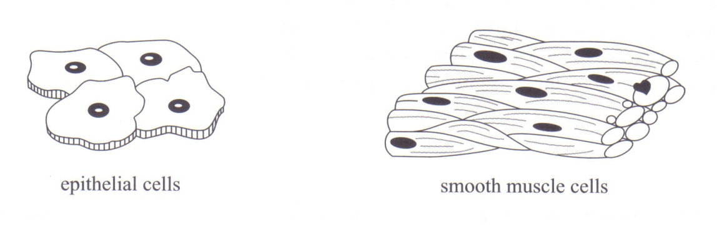

These smooth muscle cells have

J. identical genes to, and different functions from, these epithelial cells.

K. different genes from, and similar functions to, these epithelial cells.

L. different genes from, and different functions from, these epithelial cells.

M. identical genes to, and similar functions to, these epithelial cells.

3. Which one of the following statements is true of regulation in the human body?

1. Some processes are controlled by both nerves and hormones.
2. The effects of nerve messages generally last longer than the effects of hormone messages.
3. Hormones are always transported direct from a gland to a target tissue.

M. Nerve messages travel more slowly than hormonal messages.

4. Refer to the following diagram, which shows structures in the small intestine:

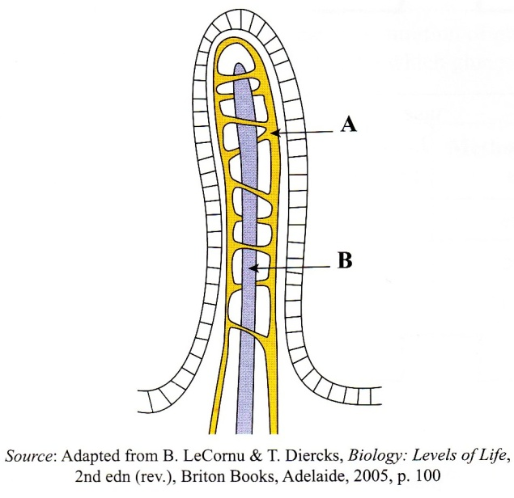

Which one of the following statements is correct?

J. Structure **B** returns nutrients to the small intestine.

K. Structure **A** is called a villus.

L. Structure **A** carries out filtration and reabsorption.

M. Structure **B** transports lipids.

5. Which one of the following changes to the structure of the villi is likely to result in an increase in the rate of absorption of glucose into the blood?

J. A thickening of the epithelial lining of the villi.

K. An increase in the number of blood capillaries.

L. A thickening of the walls of the blood capillaries.

M. An increase in the diameter of the lymph capillaries.

6. Which one of the following statements about temperature control in human beings is incorrect?

Questions such as this which requires the selection of an *incorrect* alternative are generally more demanding than those requiring the selection of a correct alternative.

1. A change in body temperature is the stimulus that causes temperature control mechanisms to be activated.
2. A change in body temperature is detected by receptors in the brain.
3. The transmission of information from the receptors to the effectors involves only hormones.
4. The action of the effectors alters the stimulus for temperature control.

7. Refer to the following graph, which shows heat loss from a healthy human being at different air temperatures. All other factors remained constant through the period of measurement.

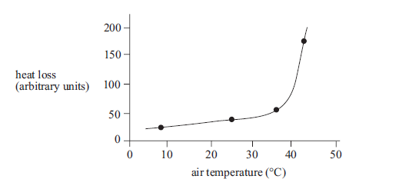

Questions such as this allow students to analyse data and their connections with concepts, to formulate conclusions.

Which one of the following statements about temperature regulation is correct?

1. More blood flow to the skin would occur at an air temperature of 8ºC than at an air temperature of 25ºC.
2. Less shivering would occur at an air temperature of 25ºC than at an air temperature of 37ºC.
3. More thyroxine would be released at an air temperature of 42ºC than at an air temperature of 25ºC.
4. Less sweat would be produced at an air temperature of 8ºC than at an air temperature of 37ºC.

8. Fluid that moves out of blood capillaries forms the tissue fluid that surrounds cells.

Which one of the following statements is correct?

1. Tissue fluid is formed from fluid that moves out of the blood capillaries only by diffusion.
2. Red blood cells move out of blood capillaries in order to transport oxygen to cells.
3. The presence of proteins in the blood in the capillaries causes water to move from tissue fluid back into the capillaries.
4. The main function of lymph vessels is to collect and remove urea from tissue fluid.

9. Refer to the following diagram, which shows the mechanisms responsible for

regulating the level of calcium ions in the blood of human beings. Calcium and PTH are both hormones.

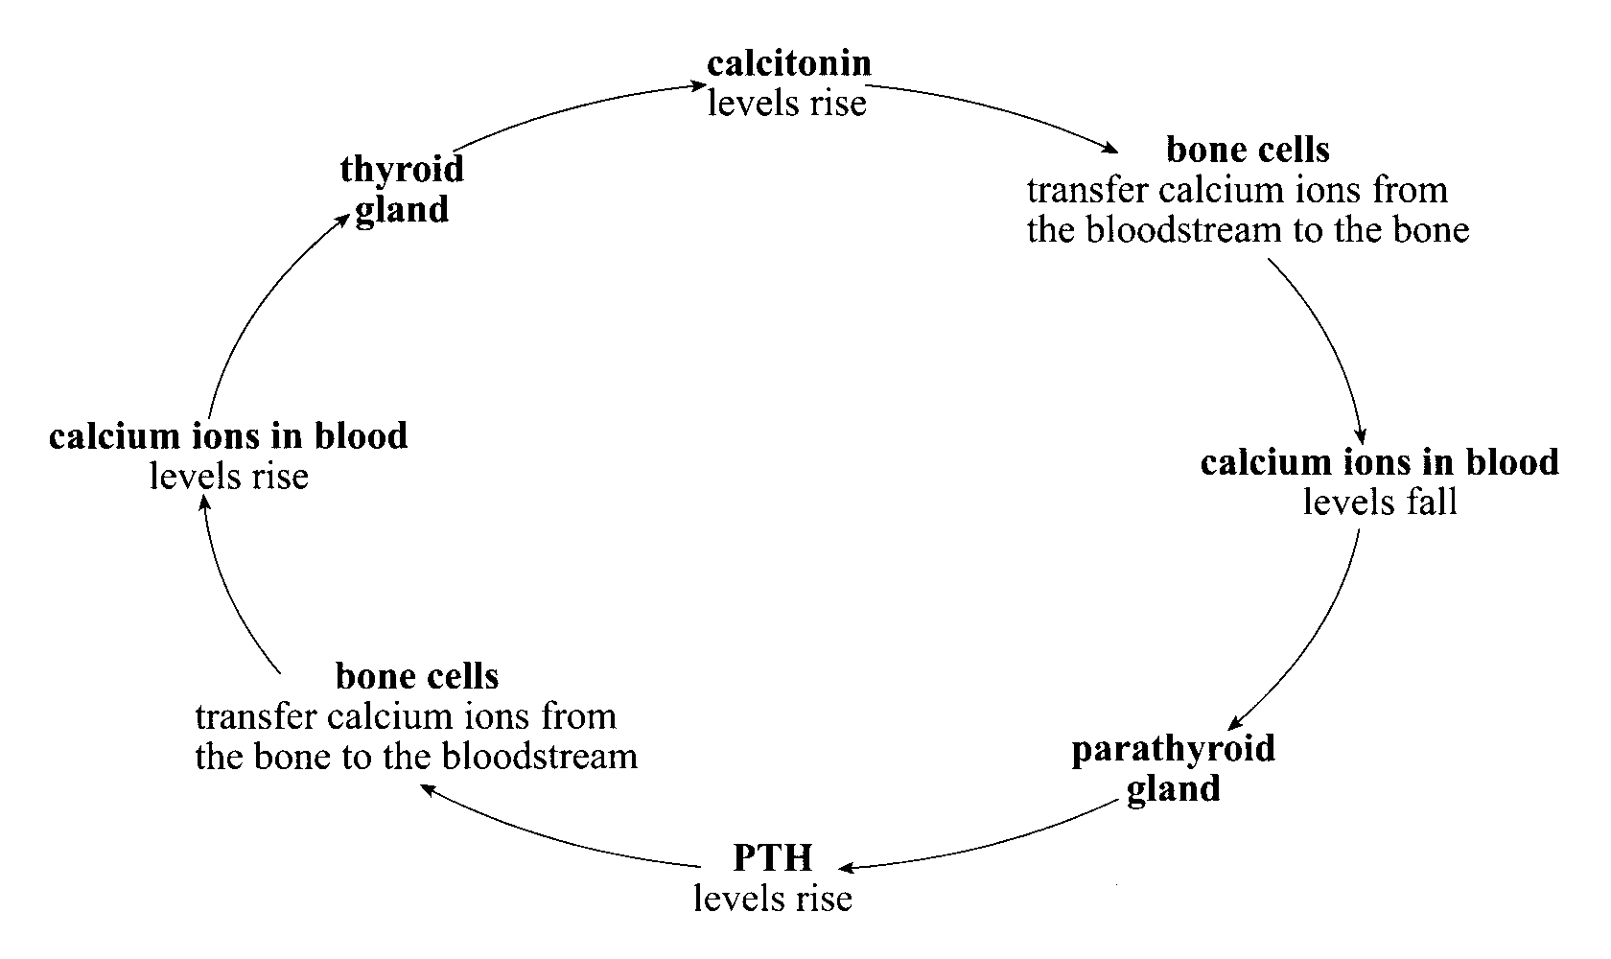

Questions such as this are more challenging because they require students to connect two or more ideas and carry out some problem solving. Correctly answering the question provides evidence of **Application** at an A level.

Which one of the following combinations correctly identifies the stimulus, receptor, effector and response in a mechanism responsible for regulating the level of calcium ions in the blood of human beings?

|  |  |  |  |  |
| --- | --- | --- | --- | --- |
|  | **Stimulus** | **Receptor** | **Effector** | **Response** |
| J. | Low levels of calcium ions in blood | Bone cells | Thyroid gland | Levels of PTH rise |
| K. | High levels of calcium ions in blood | Bone cells | Parathyroid gland | Calcium ions transferred from the bloodstream to the bone |
| L. | Low levels of calcium ions in blood | Parathyroid gland | Bone cells | Calcium ions transferred from bone to the bloodstream |
| M. | High levels of calcium ions in the blood | Parathyroid gland | Bone cells | Levels of calcitonin rise |

10. The banding patterns on a chromosome are produced by particular sequences of genes.

Which one of the following diagrams, J, K, L, or M, shows a pair of homologous chromosomes?

J 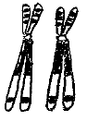K L 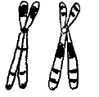M

11. During meiosis, chromatids in homologous pairs of chromosomes often twist around each other, break, exchange segments, and rejoin.

Questions such as this allow students the opportunity to demonstrate their **Application** of appropriate biological terminology.

This process is known as

1. crossing over, and results in genetically variable daughter cells.
2. independent assortment, and results in genetically identical daughter cells.
3. independent assortment, and results in haploid daughter cells.
4. crossing over, and results in diploid daughter cells.

12. Refer to the following table, which shows short-term and long-term changes to the body that are triggered by stress.

|  |  |
| --- | --- |
| **Short-term changes triggered by stress** | **Long-term changes triggered by stress** |
| * Release of glucose into the bloodstream * Increase in breathing rate * Increase in blood pressure * Increase in metabolic rate | * Increase in breakdown of fats * Suppression of immune system |

Stress triggers both short and long term changes to the body through the action of hormones. In a stressful situation a mammal’s brain will send an immediate nerve signal to the adrenal gland, triggering the release of adrenalin and producing short term effects. The brain will also begin to release adrenocorticotrophic hormone (ACTH). This hormone travels through the blood to the adrenal gland, triggering the production and release of glucocorticoid hormone, which has long term effects.

Which one of the following statements is consistent with the above information?

1. The sight of a dangerous animal will immediately increase the heart rate of a mammal through the action of glucocorticoid hormones.
2. Nerve damage may affect adrenalin levels.
3. The long term suppression of the immune system is due to the effect of adrenalin.
4. The injection of ACTH will increase blood pressure.

13. Heterotrophic, but not autotrophic, organisms

J. release carbon dioxide and water as products of respiration.

K. manufacture their own organic molecules for their nutrition.

L. rely on carbon dioxide and water for their nutrition.

M. rely on existing organic molecules for their nutrition.

14. Refer to the following table, which lists the concentrations (in g/100 cm3) of various substances in the blood plasma, the glomerular filtrate, and the urine of a hospital patient:

|  |  |  |  |
| --- | --- | --- | --- |
| **Substance** | **Blood plasma** | **Glomerular filtrate** | **Urine** |
| water | 92 | 99 | 96 |
| urea | 0.03 | 0.03 | 2.00 |
| glucose | 0.01 | 0.01 | 0.00 |
| amino acids | 0.05 | 0.05 | 0.00 |
| proteins | 8.00 | 2.00 | 2.00 |
| chloride ions | 0.50 | 0.49 | 0.01 |

Questions such as this allow students to analyse data and their connections with concepts, to formulate conclusions.

Which one of the following statements is not consistent with the information in the table above?

J. Glucose is filtered from the blood.

K. Proteins are not filtered from the blood.

L. Water is reabsorbed into the blood.

M. Proteins are not reabsorbed into the blood.

15. Refer to the following graph, which shows the total volume of oxygen produced by three small plants during an investigation:

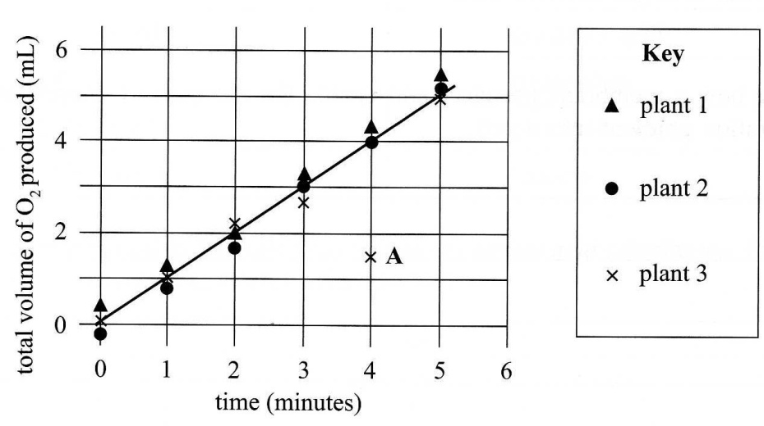

The measurements for all three plants were taken at the same times during the investigation.

Point A, shown on the graph, is most likely the result of

J. a random error when measuring the independent variable.

K. a systematic error when measuring the independent variable.

L. a systematic error when measuring the dependent variable.

M. a random error when measuring the dependent variable.

16. Refer to the following diagram, which shows a capillary in the human body:

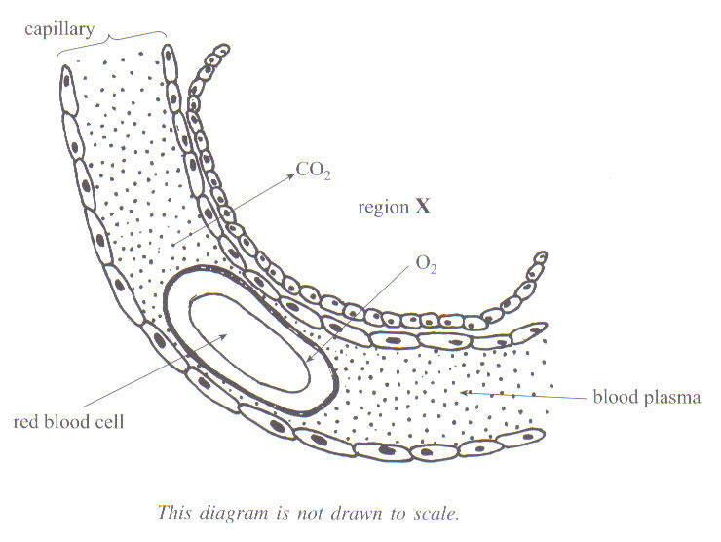

The region marked X represents part of

1. a glomerulus.
2. an alveolus.
3. a villus.
4. a body cell.

17. Refer to the following diagram, which represents structures in a nerve pathway for a reflex response. The arrows indicate the direction of the nerve impulse.

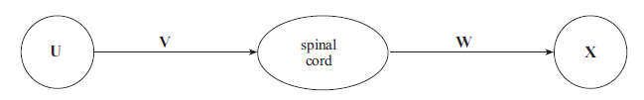

In the diagram

J. structure U is an effector and structure V is a motor nerve.

K. structure W is a sensory nerve and structure X is an effector.

L. structure V is a sensory nerve and structure X is a sensory receptor.

M. structure U is a sensory receptor and structure W is a motor nerve.

18. Hybrid animals that result from mating between two different species are usually infertile. However, sometimes female hybrids are able to produce viable offspring.

Female hybrids that are able to produce viable offspring produce

J. genetically identical haploid cells by meiosis.

K. viable diploid cells by meiosis which can be fertilised to retain the diploid number.

L. viable haploid cells by meiosis which can be fertilised to restore the diploid number.

M. genetically different diploid cells by meiosis.

Section B: Short Answer Section

19. Stem cells are able to differentiate into a range of specialised cells.

Stem cells in the bone marrow of adult rats normally differentiate into blood cells. However, if these stem cells are injected into the brains of rats suffering from brain damage, the stem cells differentiate into brain cells.

Explain why stem cells that normally differentiate into blood cells still have the potential to differentiate into brain cells.

Note:

The mark scheme used in this test for the short answer questions follows the pattern that is used for marking the external examination.

Two marks are allocated for one well-expressed piece of information. Questions that require an explanation are worth four marks.

Therefore, in order to obtain full marks, students need to supply two relevant and connected pieces of information.

In addition, where the answer to a question requires a biological term that is used in the subject outline, students are expected to spell it correctly to be awarded full marks.

______________________________________________________________________________________________________________________________________________________________________________________________________________________________________________________________________________________________________________________________________________________________________________________________ (4 marks)

20. *Refer to the following graph, which shows a plant’s oxygen uptake and oxygen release over 12 hours. For the first 6 hours the plant was kept in the dark, and for the next 6 hours the plant was kept in the light. All other factors were kept constant.*

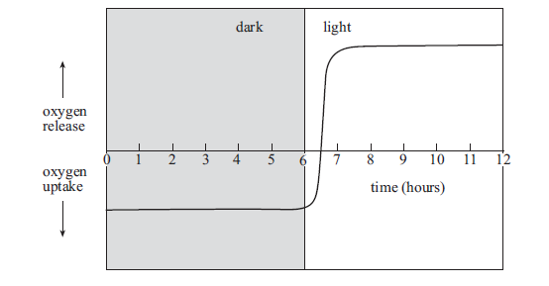

Questions such as this allow students to analyse data and their connections with concepts, to formulate conclusions.

1. At what time was the oxygen uptake equal to the oxygen release?

____________________________________________________ (2 marks)

Questions such as this allow students the opportunity to demonstrate their **Application** of appropriate biological formulae and equations.

(b) (i) Name a chemical process in plant cells that requires oxygen.

_____________________________________________ (2 marks)

(ii) Write a chemical equation for the process in plant cells that releases oxygen.

______________________________________________ (2 marks)

(c) Oxygen is a molecule that is required by most heterotrophs.

1. State one *other* molecule that is required by most heterotrophs.

______________________________________________ (2 marks)

(ii) Describe how heterotrophs use the molecule you stated in part (i) above.

______________________________________________________

______________________________________________ (2 marks)

21. Refer to the following diagram, which shows a cell that is undergoing division:

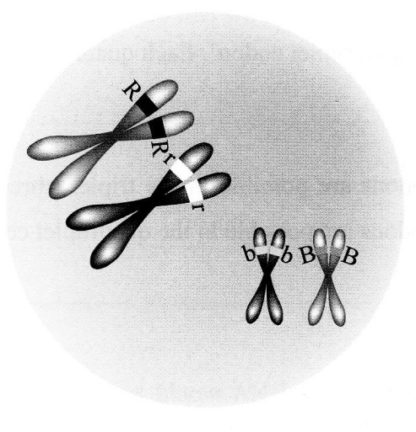

(a) State the diploid number of this cell.

___________________________________________________ (2 marks)

(b) Using the information in the diagram above, draw all possible combinations of chromosomes in the daughter cells. Assume that independent assortment ***did*** occur and that crossing over ***did not*** occur.

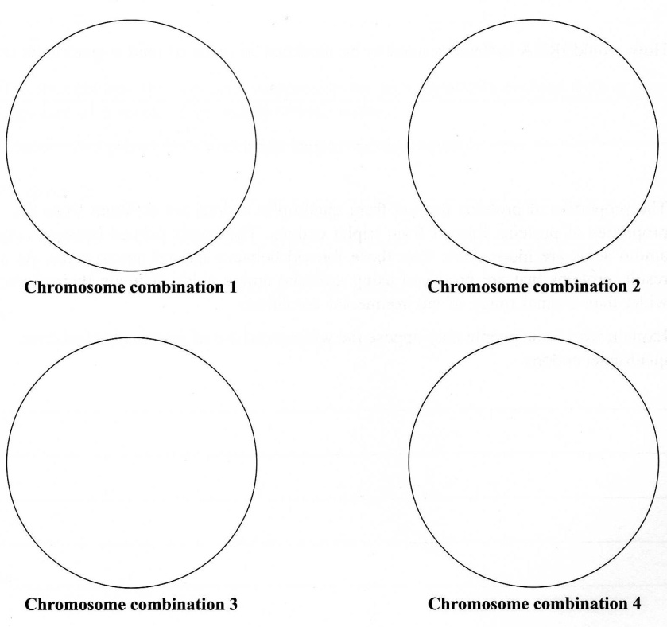

Knowledge and Understanding

Provides opportunity to communicate their knowledge and understanding of biological concepts in a non-written format.

(4 marks)

(c) State the effect that crossing over would have on the daughter cells produced by this division.

________________________________________________________________________________________________________________ (2 marks)

Questions such as this allow a wide range of students to provide evidence of their **Knowledge and Understanding.** *‘Explain …..’* questions are more demanding than ‘*State ….’* questions.

(d) Explain the importance for a species of crossing over and independent assortment.

____________________________________________________________________________________________________________________________________________________________________________ (4 marks)

22. Refer to the following table, which shows the results of an experiment conducted to test the effect of increasing the concentration of ATP on the average rate of ATP breakdown by an enzyme.

Two sets of test-tubes were used in the experiment and the results were averaged.

|  |  |
| --- | --- |
| **Concentration of ATP**  (mmol dm−3) × 10−2 | **Average rate of ATP breakdown by an enzyme** (μmol dm−3 s−1) × 10−2 |
| 0 | 0 |
| 1 | 6 |
| 2 | 9 |
| 4 | 15 |
| 8 | 16 |
| 16 | 19 |
| 24 | 19 |

1. State one hypothesis that is being tested in this experiment.

____________________________________________________ (2 marks)

(b) State the dependent variable in this experiment.

Questions such as this allow students the opportunity to demonstrate their understanding of **Investigation** design.

____________________________________________________ (2 marks)

(c) (i) State one quantity that would have to be kept constant in this

experiment.

_____________________________________________ (2 marks)

(ii) State one reason why it is necessary to keep most quantities constant in an experiment.

_____________________________________________ (2 marks)

(d) State one reason why two sets of test-tubes were used in the experiment.

___________________________________________________ (2 marks)

(e) Graph the data from the table on the page opposite on the grid which follows. Draw a curve of best fit.



Questions such as this allow students the opportunity to demonstrate their ability to display the findings of **Investigations** using appropriate conventions and formats.

(4 marks)

(f) Describe the pattern shown by the results of the experiment.

_______________________________________________________________________________________________________________________________________________________________________________________________________________________________________________________________________________________________________________________________________________________________________________________________________________________________________________________________________________________ (4 marks)

(g) State why the experiment must be repeated before a valid conclusion can be reached.

___________________________________________________________________________________________________________________________________________________________________________ (2 marks)

Section C: Extended Response Section

*You should spend about 15 minutes on this question, up to 5 minutes planning and approximately 10 minutes writing.*

*Credit will be given for a clear, well-expressed answer that is well-organised and relevant to the question.*

23. The efficient supply of oxygen and glucose to cells enhances athletic performance. At times the supply of oxygen to cells is inadequate to meet their energy demand. Some athletes choose to use performance-enhancing drugs to improve the supply of oxygen and/or glucose to their cells.

* Explain how the structure of blood capillaries facilitates the supply of glucose to cells.
* Describe how energy is made available in the cells of athletes under *anaerobic* conditions.
* Describe how choices about drug use can affect the well-being of an athlete.

Content: 12 Marks Communication: 3 Marks

_______________________________________________________________________________________________________________________________________________________________________________________________________________________________________________________________________________________________________________________________________________________________________________________________________________________________________________________________________________________________________________________________________________________________________________________________________________________________________________________________________________________________________________________________________________________________________________________________________________________________________________________________________________________________________________________________________________________________________________________________________________________________________________________________________________________________________________________________________________________________________________________________________________________________________________________________________________________________________________________________________________________________________________________________________________________________________________________________________________________________________________________________________________________________________________________________________________________________________________________________________________________________________________________________________________________________________________________________________________________________________________________________________________________________________________________________________________________________________________________________________________________________________________________________________________________________________________________________________________________________________________________________________________________________________________________________________________________________________________________________________________________________________________________________________________________________________________________________________________________________________________________________________________________________________________

An Extended Response Question provides a student the opportunity to display their depth of knowledge of biological concepts as well as demonstrate their written communication skills.

It provides evidence of **Knowledge and Understanding** of biological concepts, communication in the extended response format, and the **Application** of appropriate biological terms and conventions.

This question also provides the opportunity for the student to provide evidence of their understanding of the connection between biological concepts and social issues although this specific feature is not being directly assessed in this task.

**Note** – The following is an excerpt from the Chief Assessor’s report:

An extended-response question is marked out of 15, with 12 marks being allocated for content (each well-made point is worth 2 marks) and 3 marks for communication. This question has three content parts, with each part being marked out of 4.

In awarding a communication mark, the following factors are taken into account:

* Is the response at least half a page in length and is it structured in the form of sentences and paragraphs?
* Does the response use correct grammar and spelling?
* Does the response clearly explain concepts using relevant and concise biological language?

Students should be able to fully answer an extended-response question in about one page of writing. It is unnecessary for students to re-write the question or to provide an introduction to their response. Both of these practices are time-wasting, receive no credit, and may even result in a reduction in the communication mark.