Stage 2 Chemistry
Assessment Type 1: Investigations Folio
Student Response
Introduction:
To better interpret the unsaturated:saturated fat ratio, the ratios will be converted into percentages showing the percentage of saturated fat in the entire fat content. Also, positive values for energy released are given in all tables and graphs as it also easier to interpret with the graphs.
The energy released from combustion of the fat or oil can be used to determine which fats or oils release the most energy. A calorimeter can be used to analyse the energy released in a chemical reaction. A calorimeter is a device used for measuring the heat of chemical reactions. A simple calorimeter comprises of a thermometer attached to a container of a known amount of water suspended above a heat chamber. The heat chamber could be as simple as a candle inside a foam cup to provide insulation. By heating the known sample of water by a predetermined increase in temperature (e.g. 10°C) an equation can be used to calculate the amount of energy released.
Knowledge and Understanding
Coherent and highly effective communication of chemical knowledge.
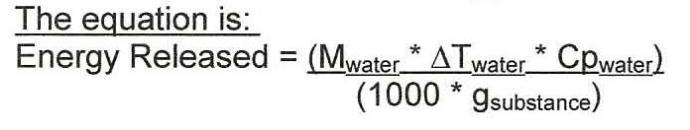

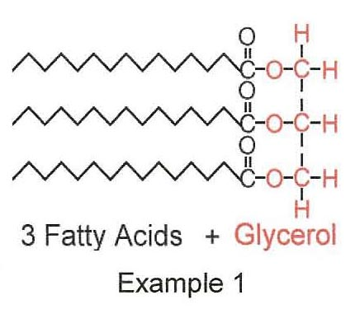
In order to obtain and store energy for an animal's (including humans) body to function, food is consumed. Food contains energy which, when consumed, the body uses to function or stores for later use through metabolic processes (chemical reactions which occur to sustain the life of living organisms. The type of food and the amount of food consumed determines the amount of energy obtained.
Edible fats are solids at room temperature while edible oils are liquids at room temperature. Fatty and oily foods contain certain carboxylic acids (or fatty acids) which are called triglycerides. Triglycerides are formed from the alcohol propan-1,2,3-triol, which is commonly called glycerol (and seen in the red section of Example 1), and carboxylic acids with long, straight chains (as seen in the black section of example 1). They can be saturated or unsaturated, depending on the carbon chain.
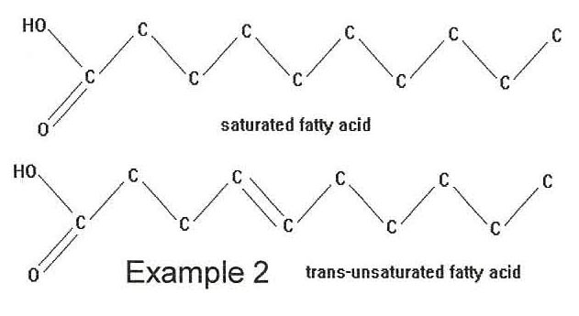
A saturated carbon chain is a carbon chain which has only single carbon to carbon bonds (C - C) as seen in Example 2. An unsaturated carbon chain has one or more double carbon to carbon bonds (C = C) as seen in Example 2. If the chain has only one double carbon to carbon bond, it is monounsaturated. If the chain has two or more double carbon to carbon bonds, it is polyunsaturated.
As the amount of double carbon to carbon bonds in the chain increases, the melting point decreases. The structure of a saturated chain is much more ordered than the structure of an unsaturated chain. Consequently, the saturated chains can pack together much more closely than unsaturated chains which results in weaker dispersion forces (secondary interactions between molecules) between unsaturated chains than saturated chains.
Hypothesis:
As the percentage of saturated fat in the entire fat content increases, the energy released from combustion of the fat or oil will decrease as unsaturated triglycerides have lower melting points than saturated triglycerides due to weaker dispersion forces acting between the molecules and are able to release more energy from combustion.
Aim:
To determine the energy released from combustion for a range of oils and determine a link between the enthalpy of combustion and the percentage of saturated fat in the entire fat content in the oils.
Materials:

- Copper wire  - Empty tea light candle  - Wick  - Scissors  - Matches  - Foam cup  - Aluminium foil | - Ruler  - Electronic balance  - Retort stand  - Boss head clamp  - Heat proof mat  - Thermometer  - Distilled water | - 20mL measuring cylinder  - Variety of oils to be tested (macadamia, apricot kernel, olive, flaxseed & sunflower)  - 50mL beaker  - Sticky tape

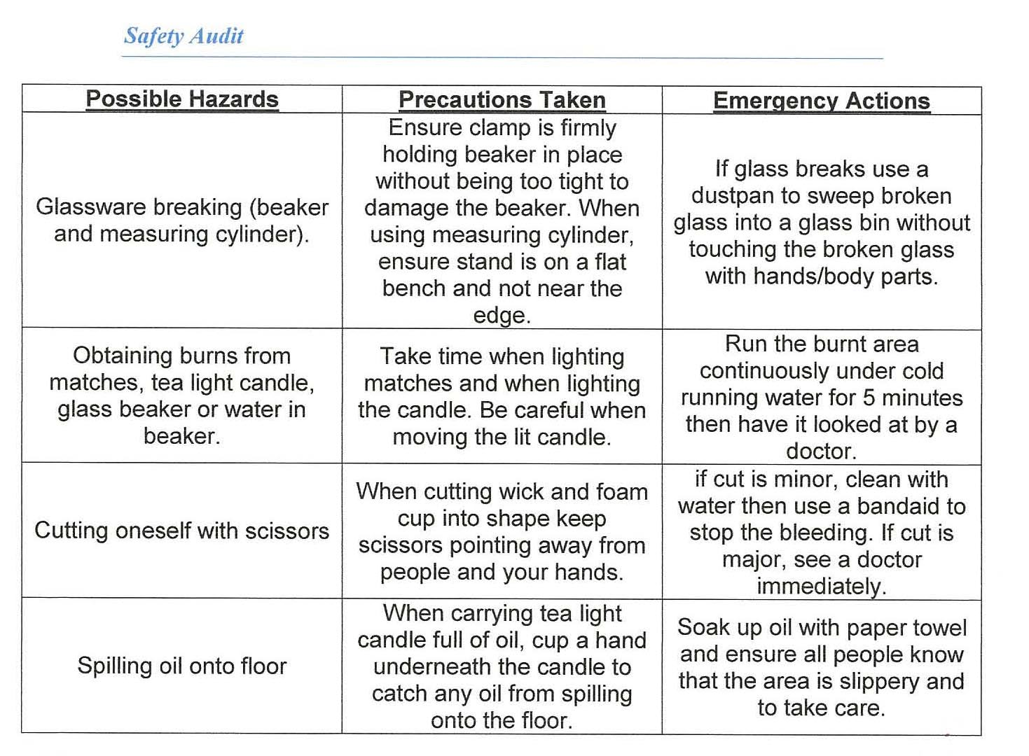
Procedure:
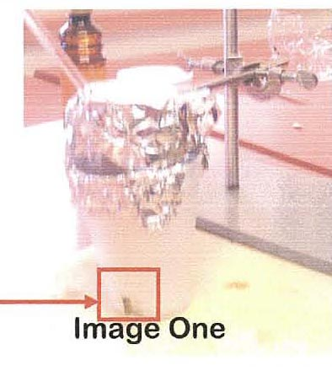
- Cut the base of the foam cup off and then cut l cmX1 cm sections out from the bottom of the cup on both sides (as seen in Image One) to allow ventilation for the flame of the candle.
- Layer the inside of the foam cup with aluminium foil to increase insulation of the foam cup.
- Measure 15mL of distilled water using the measuring cylinder and add to the beaker.
- Wrap the beaker in aluminium foil (as seen in Image One)
with a small hole for the thermometer to be inserted into the water.
- Put the beaker into the clamp attached to the retort stand (as seen in Image One).
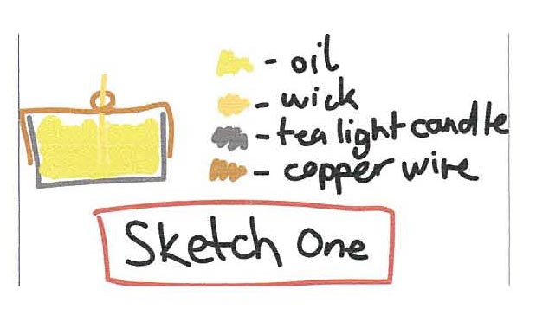
- Bend the copper wire around the tea light candle (as seen in Sketch One), ensuring that there is 3 loops tight enough for the wick to be inserted and held upright in the tea light candle. Sticky tape the copper wire to the side of the tea light candle to secure it in place.
- Measure 3cm of wick with a ruler then cut using scissors. Place the wick into the tea light candle through the loops in the copper wire (as seen in Sketch One).
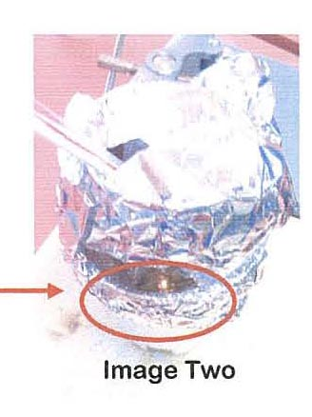
- Fill the tea light candle almost to the top (as seen in Sketch One) with the first oil to be tested, ensuring that the wick is coated in the oil.
- Measure the mass of the tea light candle on the electronic balance and the mass recorded.
- Place the tea light candle on the heat proof mat and light using the matches.
- Place the foam cup over the tea light candle and adjust the beaker of water on the retort stand so the beaker is blocking most the heat from the candle from escaping the foam cup (as seen in Image Two). Record the initial temperature of the water.
- After the water temperature has increased by 10°C, blow the candle flame out.
- Re-measure the mass of the tea light candle and record the final mass.
- Remove the old wick and replace with a new wick, also 3cm in length which is coated in the oil.
Investigation
Well-considered, clear and detailed design.
- Repeat steps 9-14 until 5 values for the oil being tested are recorded.
- Repeat steps 9-15 until all 5 oils have 5 values each.
Scientific Diagram
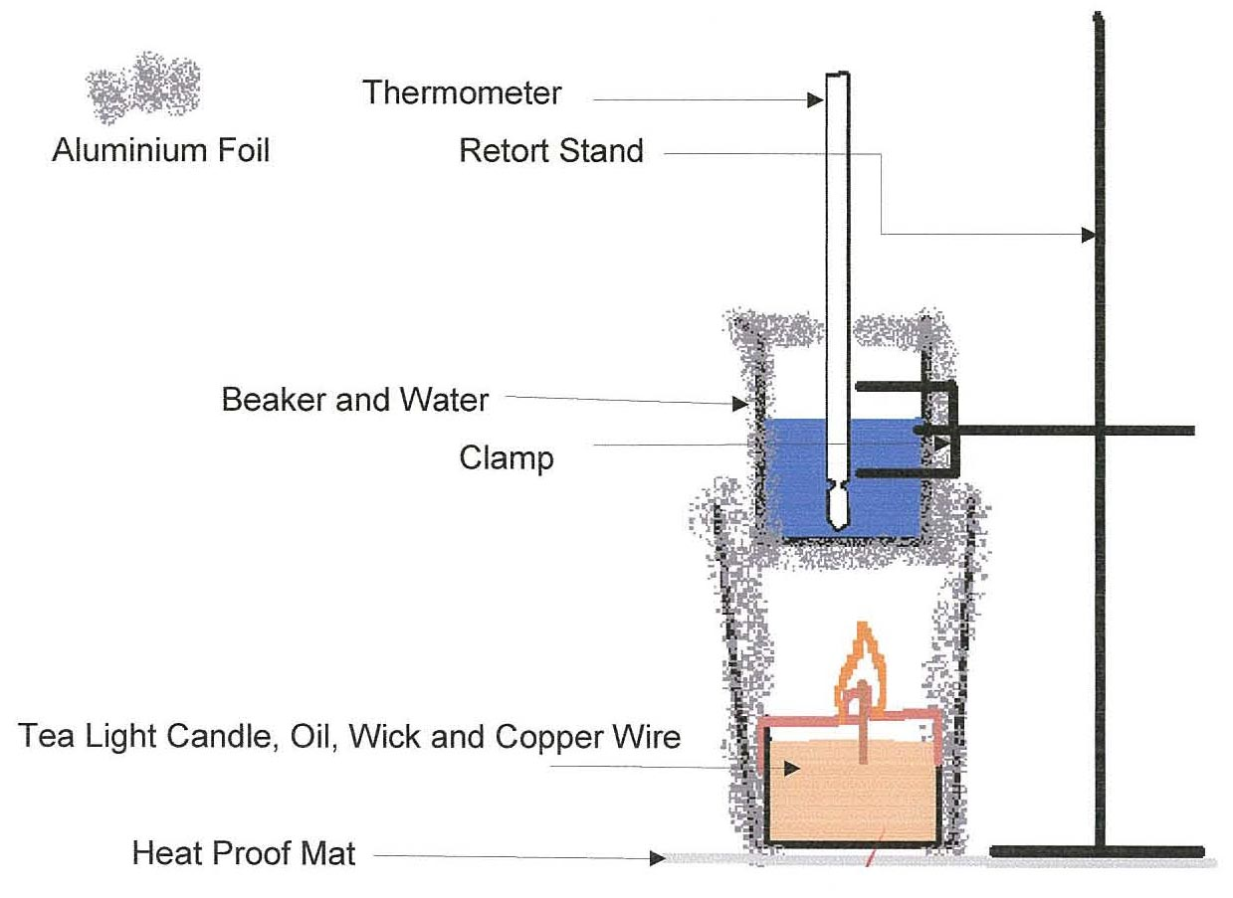

Data
Raw Data:
Oil | Initial | Initial | Final | Final | Mass of oil
 | temperature ('C) | massic0 | temperature ('C) | mass (q) | burnt (g)
Olive x 1 | 18.0 | 8.65 | 28.0 | 8.50 | 0.15
Olive x 2 | 22.0 | 8.33 | 32.0 | 8.18 | 0.15
Olive x 3 | 29.0 | 8.41 | 39.0 | 8.23 | 0.18
Olive x 4 | 37.0 | 8.31 | 47.0 | 8.13 | 0.18
Olive x 5 | 48.0 | 9.41 | 58.0 | 9.25 | 0.16
Sunflower x 1 | 18.0 | 9.45 | 28.0 | 9.23 | 0.22
Sunflower x 2 | 28.0 | 9.23 | 38.0 | 9.03 | 0.20
Sunflower x 3 | 36.0 | 8.85 | 46.0 | 8.69 | 0.16
Sunflower x 4 | 44.0 | 8.54 | 54.0 | 8.36 | 0.18
Sunflower x 5 | 50.0 | 8.37 | 60.0 | 8.12 | 0.25
Flaxseed x 1 | 14.0 | 9.91 | 24.0 | 9.64 | 0.27
Flaxseed x 2 | 24.0 | 9.79 | 34.0 | 9.67 | 0.12
Flaxseed x 3 | 32.0 | 9.68 | 42.0 | 9.43 | 0.25
Flaxseed x 4 | 39.0 | 9.61 | 49.0 | 9.38 | 0.23
Flaxseed x 5 | 45.0 | 9.61 | 55.0 | 9.38 | 0.23
Macadamia x 1 | 20.0 | 6.18 | 30.0 | 6.05 | 0.13
Macadamia x 2 | 30.0 | 6.01 | 40.0 | 5.86 | 0.15
Macadamia x 3 | 15.0 | 7.05 | 25.0 | 6.95 | 0.10
Macadamia x 4 | 29.0 | 6.83 | 39.0 | 6.74 | 0.09
Macadamia x 5 | 38.0 | 7.20 | 48.0 | 7.04 | 0.16
Apricot kernel x 1 | 16.0 | 8.76 | 26.0 | 8.49 | 0.27
Apricot kernel x 2 | 26.0 | 8.58 | 36.0 | 8.20 | 0.38
Apricot kernel x 3 | 34.0 | 8.14 | 44.0 | 7.88 | 0.26
Apricot kernel x 4 | 20.0 | 7.81 | 30.0 | 7.56 | 0.25
Apricot kernel x 5 | 30.0 | 7.50 | 40.0 | 7.37 | 0.13

Average Of Trials:
 | Average mass of oil burnt
Oil | Trial 1 | Trial 2 | Trial 3 | Trial 4 | Trial 5 | Average (g)  Investigation  Appropriate conventions and formats used mostly appropriately and effectively.
Olive | 0.150 | 0.150 | 0.180 | 0.180 | 0.160 | 0.164 ,
Sunflower | 0.220 | 0.200 | 0.160 | 0.180 | 0.250 | 0.202
Flaxseed | 0.270 | 0.120 | 0.250 | 0.230 | 0.230 | 0.220
Macadamia | 0.130 | 0.150 | 0.100 | 0.090 | 0.160 | 0.126
Apricot kernel | 0.270 | 0.380 | 0.260 | 0.250 | 0.130 | 0.258

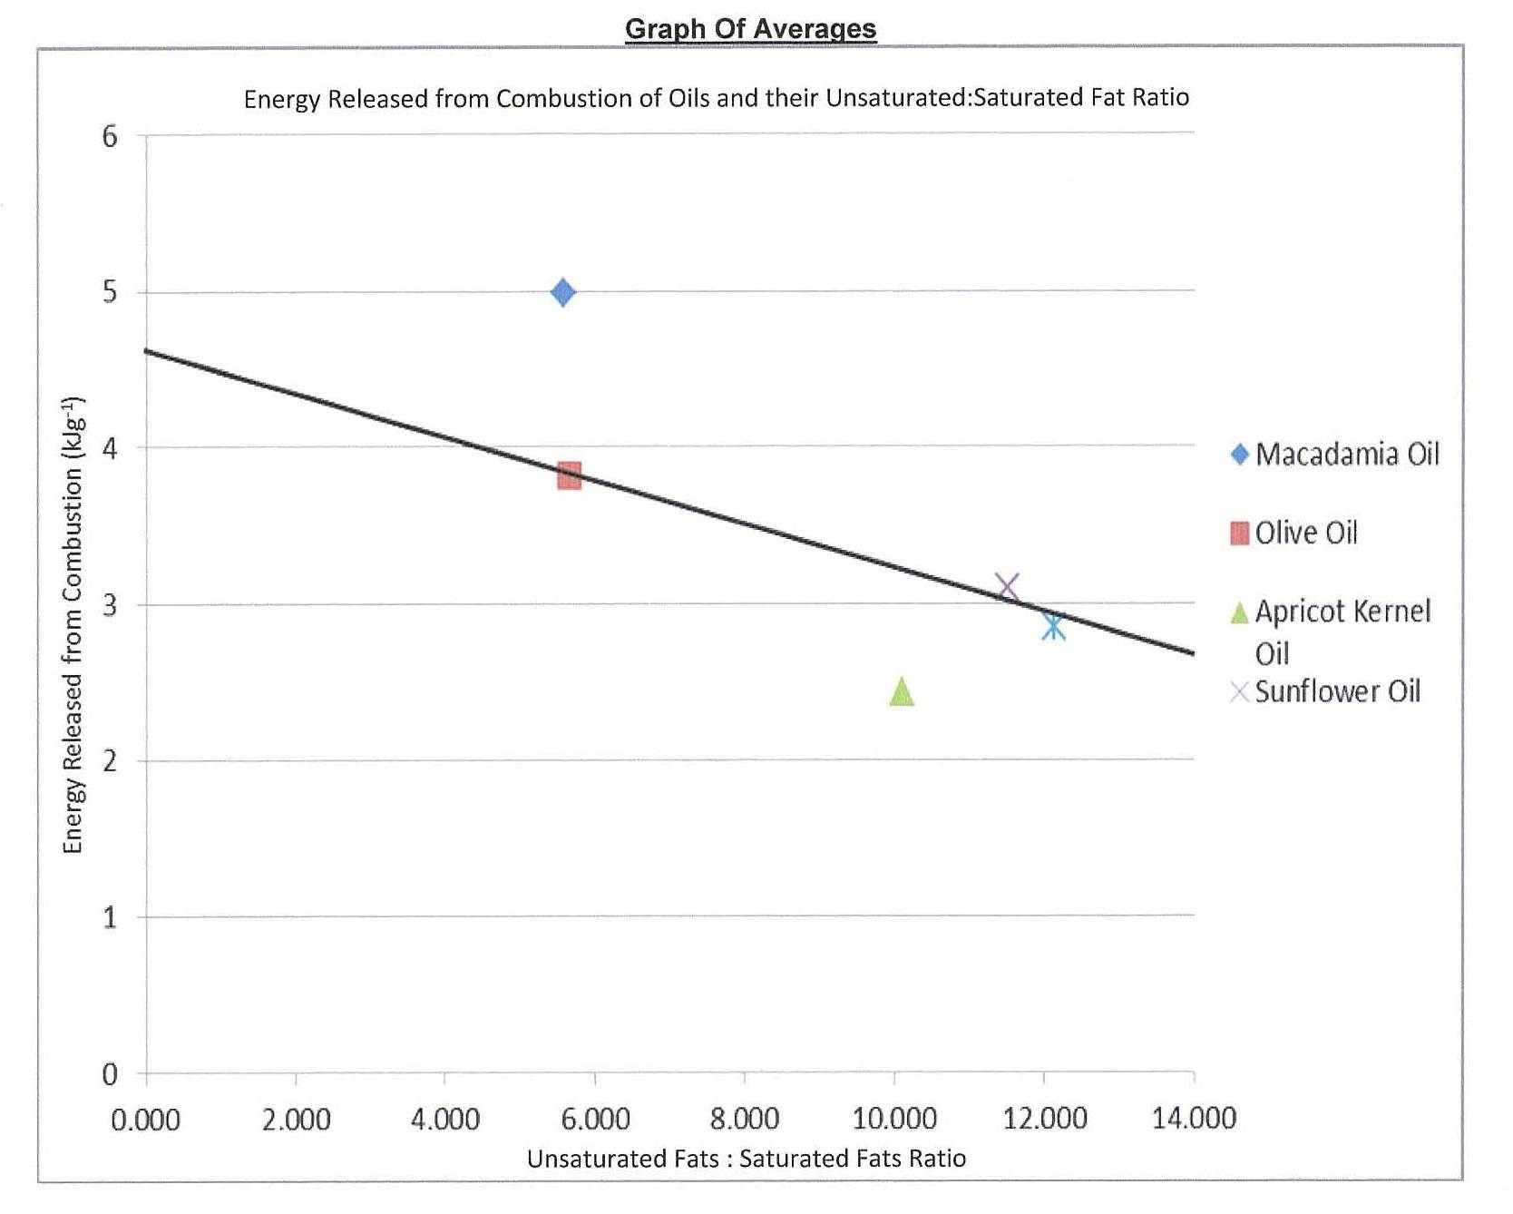
Calculations
oil trial | mass of water | change in temp of water | Cp of water | mass of substance | mass of substance * 1000 | energy released from combustion
oil trial |  | AT(water) | Cp (water) | g (substance) | g (substance) * 1000 | kJg^(-1)
Olive x 1 | 15.00 | 10.00 | 4.180 | 0.150 | 150.0 | 4.180
Olive x 2 | 15.00 | 10.00 | 4.180 | 0.150 | 150.0 | 4.180
Olive x 3 | 15.00 | 10.00 | 4.180 | 0.180 | 180.0 | 3.483
Olive x 4 | 15.00 | 10.00 | 4.180 | 0.180 | 180.0 | 3.483
Olive x 5 | 15.00 | 10.00 | 4.180 | 0.160 | 160.0 | 3.919
Olive Average | 15.00 | 10.00 | 4.180 | 0.164 | 164.0 | 3.823
Sunflower x 1 | 15.00 | 10.00 | 4.180 | 0.220 | 220.0 | 2.850
Sunflower x 2 | 15.00 | 10.00 | 4.180 | 0.200 | 200.0 | 3.135
Sunflower x 3 | 15.00 | 10.00 | 4.180 | 0.160 | 160.0 | 3.919
Sunflower x 4 | 15.00 | 10.00 | 4.180 | 0.180 | 180.0 | 3.483
Sunflower x 5 | 15.00 | 10.00 | 4.180 | 0.250 | 120.0 | 5.225
Sunflower Average | 15.00 | 10.00 | 4.180 | 0.202 | 202.0 | 3.104
Flaxseed x 1 | 15.00 | 10.00 | 4.180 | 0.270 | 270.0
Flaxseed x 2 | 15.00 | 10.00 | 4.180 | 0.120 | 120.0
Flaxseed x 3 | 15.00 | 10.00 | 4.180 | 0.250 | 250.0 | 2.508
Flaxseed x 4 | 15.00 | 10.00 | 4.180 | 0.230 | 230.0 | 2.726
Flaxseed x 5 | 15.00 | 10.00 | 4.180 | 0.230 | 230.0 | 2.726
Flaxseed Average | 15.00 | 10.00 | 4.180 | 0.220 | 220.0 | 2.850
Macadamia x 1 | 15.00 | 10.00 | 4.180 | 0.130 | 130.0 | 4.823
Macadamia x 2 | 15.00 | 10.00 | 4.180 | 0.150 | 150.0 | 4.180
Macadamia x 3 | 15.00 | 10.00 | 4.180 | 0.100 | 100.0 | 6.270
Macadamia x4 | 15.00 | 10.00 | 4.180 | 0.090 | 90.00 | 6.967
Macadamia x 5 | 15.00 | 10.00 | 4.180 | 0.160 | 160.0 | 3.919
Macadamia Average | 15.00 | 10.00 | 4.180 | 0.126 | 126.0 | 4.976
Apricot kernel x 1 | 15.00 | 10.00 | 4.180 | 0.270 | 270.0
Apricot kernel x 2 | 15.00 | 10.00 | 4.180 | 0.380 | 380.0 | 1.650
Apricot kernel x 3 | 15.00 | 10.00 | 4.180 | 0.260 | 260.0 | 2.412
Apricot kernel x 4 | 15.00 | 10.00 | 4.180 | 0.250 | 250.0 | 2.508
Apricot kernel x 5 | 15.00 | 10.00 | 4.180 | 0.130 | 130.0 | 4.823
Apricot Kernel Average | 15.00 | 10.00 | 4.180 | 0.258 | 258.0 | 2.430

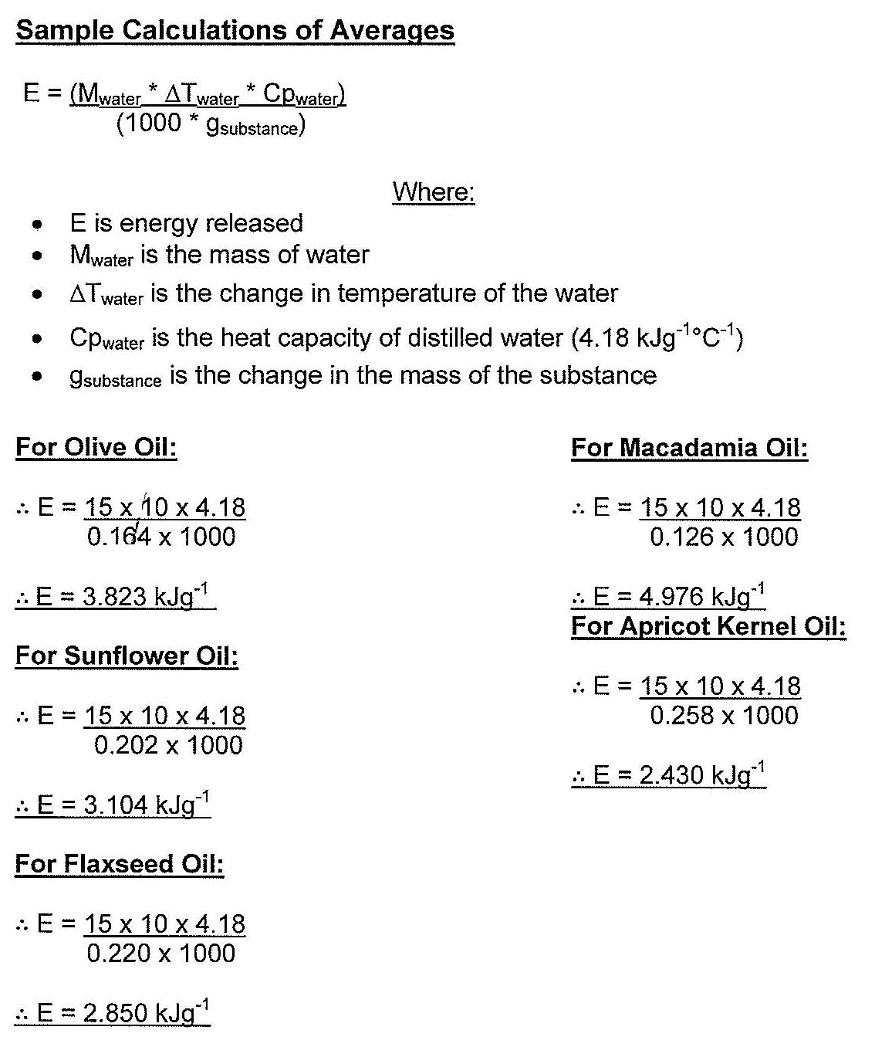

Conclusion
A calorimeter was used to measure the mass of oil burnt. The mass burnt was then used in the equation for the energy released from combustion,
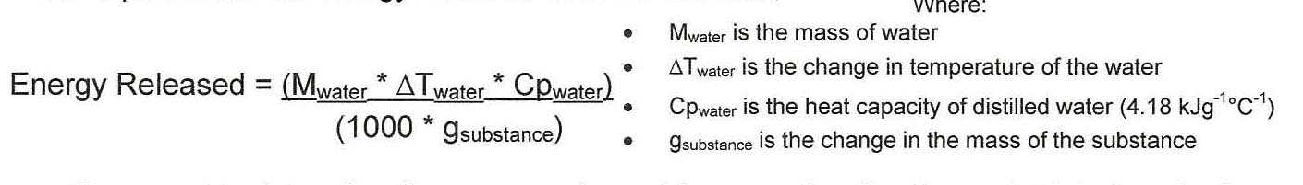
was then used to determine the energy released from combustion for each trial of each of the oil (in 1(4⁻¹). The value for the energy released from combustion is a negative for all trials as the reactions are exothermic. From this, an average energy released from combustion for each of the five oils tested was able to be determined. The average value of each oil was then compared to the percentage of saturated fat in the entire fat content. It was seen that there is a link between percentage of saturated fats in the entire fat content of the oil and the change in enthalpy for that oil. It was seen that as the percentage of saturated fat in the entire fat content increased, the energy released from combustion of the oil decreased.
Discussion
Out of the oils tested, Macadamia Oil had the highest percentage (15.22%), then Olive Oil (15.01%), Apricot Kernel Oil (9.00%), Sunflower Oil (8.00%) and lastly Flaxseed Oil (7.61%). It was found that the Enthalpy of Combustion was highest for Macadamia Oil (4.976 Lig⁻¹), followed by Olive Oil (-3.823 idg⁻¹), Sunflower Oil (-3.104 kJg⁻¹), Flaxseed Oil (2.850 lag^{-I}) and lastly Apricot Kernel Oil (-2.430 Ug⁻¹). With the exception of Apricot Kernel Oil, the order of percentages from highest to lowest corresponds with the energy released from combustion values from highest to lowest also.
A trend line has been included on the graph of averages which shows that as the percentage of saturated fat in the entire fat content increases, the energy released from combustion of the fat or oil decreases. This is because unsaturated triglycerides have weaker dispersion forces acting between the molecules. These weaker dispersion forces causes the oil to have lower melting points than saturated triglycerides and allow the oil to release more energy from combustion
Analysis and Evaluation
Generally logical analysis of data connected to concepts.
The Apricot Kernel Oil trials provided inconsistent results throughout the trials. Three of the five measurements of the mass of oil burnt were within 0.02g of each other. The other two measurements had a difference of greater than 0.1g from the three consistent measurements. This may be due to spilling a small amount of oil from the tea light candle when walking back from the electronic balancer to the calorimeter. As the measurements are so inconsistent, the data for the Apricot Kernel Oil is imprecise and can, therefore, be classified as an outlier.
With the Apricot Kernel Oil being classified as an outlier, it is seen that the oils with a greater percentage of saturated fats (which have a smaller amount of carbon to carbon double bonds (C=C)) have a greater energy released from combustion.
Evaluation
Both random and systematic errors occurred in the calorimetric experiment. A random error which occurred was how the movement of air around the calorimeter resulted in an inconsistent flame. An inconsistent flame results in a varied amount of heat being given off during each trial which would take longer to heat the water the required 10°C as the flame was not concentrated in a single point.
The water in the beaker was not stirred during each trial which may have resulted in the temperature of the water varying throughout the beaker. Due to this, the temperature recorded may not have been the true temperature of the water which is also a random error.
Another source of random error in the experiment is the measuring cylinder used to measure the 15mL of water to the beaker in the calorimeter set up. The measuring cylinder did not have a high resolution so the actual amount of water transferred to the beaker may not have been 15.00mL even though the meniscus was on the calibration mark of the measuring cylinder when measured at 90° to the cylinder. Also, the stand for the measuring cylinder was not at 90° to the measuring cylinder, which caused the measuring cylinder to sit on an angle and provided an imprecise reading.
The main systematic error which occurred includes how the water in the calorimeter does not absorb all the heat energy released from the combustion reaction. The air surrounding the flame absorbs a large portion of the heat energy along with the material which the calorimeter is made of (the foam cup, the aluminium foil and the copper wire holding the wick up). This is due to the minimal insulation of the simple calorimeter used in the experiment.
Analysis and Evaluation
Logical evaluation of procedures.
The electronic balance may have been incorrectly calibrated which reduces the accuracy of the experiment as the recorded masses may be incorrect. Also, different electronic balancers were used throughout the practical which could provide inconsistent readings as the balances could be calibrated differently.
A random error that may have affected the conclusion is how the measuring cylinder not sitting at 90° and providing an imprecise reading for the meniscus could have affected the value of energy released from combustion as it would have taken a longer/shorter time to heat up the water by 10°C if there was more/less water in one trial than in another for the same oil. The value for energy released from combustion would be affected by this error. This could also be responsible for the imprecise values found for Apricot Kernel Oil. The systematic error of using different electronic balances throughout the trials would also have affected the conclusion as the balances may have been calibrated differently and the masses used in the calculations may have been inaccurate.
These errors which affected the conclusion could be minimised by using 20mL of distilled water in the calorimeter and measuring the water in a volumetric pipette instead of a measuring cylinder. By using only one electronic balance for every trial the systematic error of incorrectly calibrated balances is reduced and has less effect on the conclusion. By using this new method, the calculations for energy released from combustion will be of greater accuracy.

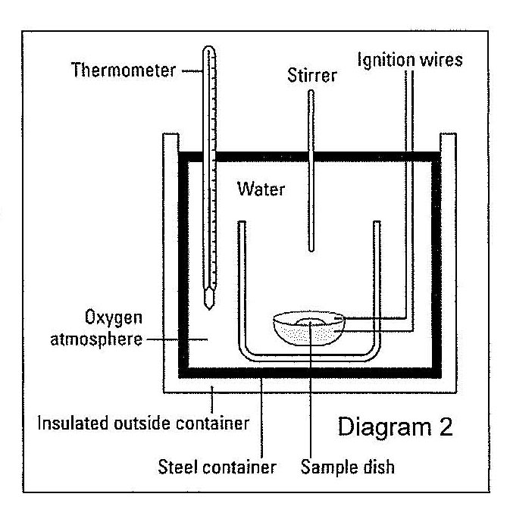
A bomb calorimeter could be used to minimise errors throughout the experiment (see Diagram 2). A bomb calorimeter incorporates the combustion reaction taking place in pure oxygen inside a steel container and immersing the container in water (stirring the water throughout the experiment). This reduces both the systematic error of heat loss along with the random errors of inconsistent flames, the water being inconsistently stirred and the low resolution of the measuring cylinder as the calorimeter would be completely filled with water each time. By using the same set of electronic balances throughout the entire experiment reduces the systematic error of inconsistent recorded mass. values.
Analysis and Evaluation
Some appropriate improvements are suggested.
Knowledge and Understanding
Coherent and highly effective communication of chemical knowledge.

Sources

Example 1: Unknown Author. (2012). Triglycerides. Available: http://www.bioworld.com/productinfo/0/6275/Triglyceride0/020(GPO).html. Last accessed 31st July 2012.
Example 2: Abedon, S T. (1997). Lipids. Available: http://www.mansfield.ohiostate.edu/—sabedon/bio11030.htm. Last accessed 31st July 2012.
Diagram 2: Unknown Author. (2011). Combustion Reactions of Fuels and Foods. Available: http://wvvw.dummies.com/how-to/content/combustion-reactions-of-fuelsand-foods.html. Last accessed 2nd August 2012.
Information: Evans, C; McCann, M; & Mrton B (2011). Chemistry SACE2 Workbook. 7th ed. Adelaide: Greg Eather. p133 & p284-289.

Teacher Checklist for A3
Skill | very good | good | satisfactory | poor | limited
Collaboration in  discussion/development of plan | ✓
Collaboration in preliminary laboratory work | ✓
Collaboration in final investigation | ✓
Individual initiative and focus during investigation |  | ✓
Leadership demonstrated throughout investigation |  | ✓

Performance Standards for Stage 2 Chemistry
 | Investigation | Analysis and Evaluation |  | Application | Knowledge and Understanding
A | Designs logical, coherent, and detailed chemistry investigations.  Critically and logically selects and consistently and appropriately acknowledges information about chemistry and issues in chemistry from a range of sources.  Manipulates apparatus and technological tools carefully and highly effectively to implement well-organised safe and ethical investigation procedures.  Obtains, records, and displays findings of investigations using appropriate conventions and formats accurately and highly effectively. |  | Critically and systematically analyses data and their connections with concepts to formulate logical and perceptive conclusions and make relevant predictions.  Critically and logically evaluates procedures and suggests a range of appropriate improvements. | Applies chemistry concepts and evidence from investigations to suggest solutions to complex problems in new and familiar contexts.  Uses appropriate chemical terms, conventions, formulae, and equations highly effectively.  Demonstrates initiative in applying constructive and focused individual and collaborative work skills. |  | Consistently demonstrates a deep and broad knowledge and understanding of a range of chemistry concepts.  Uses knowledge of chemistry perceptively and logically to understand and explain social or environmental issues.  Uses a variety of formats to communicate knowledge and understanding of chemistry coherently and highly effectively.
B | Designs well-considered and clear chemistry investigations.  Logically selects and appropriately acknowledges information about chemistry and issues in chemistry from different sources.  Manipulates apparatus and technological tools carefully and mostly effectively to implement organised safe and ethical investigation procedures.  Obtains, records, and displays findings of investigations using appropriate conventions and formats mostly accurately and effectively. |  | Clearly and logically analyses data and their connections with concepts to formulate consistent conclusions and make mostly relevant predictions.  Logically evaluates procedures and suggests some appropriate improvements. | Applies chemistry concepts and evidence from investigations to suggest solutions to problems in new and familiar contexts.  Uses appropriate chemical terms, conventions, formulae, and equations effectively.  Applies mostly constructive and focused individual and collaborative work skills. |  | Demonstrates some depth and breadth of knowledge and understanding of a range of chemistry concepts.  Uses knowledge of chemistry logically to understand and explain social or environmental issues.  Uses a variety of formats to communicate knowledge and understanding of chemistry coherently and effectively.
C | Designs considered and generally clear chemistry investigations.  Selects with some focus, and mostly appropriately acknowledges, information about chemistry and issues in chemistry from different sources.  Manipulates apparatus and technological tools generally carefully and effectively to implement safe and ethical investigation procedures.  Obtains, records, and displays findings of investigations using generally appropriate conventions and formats with some errors but generally accurately and effectively. |  | Analyses data and their connections with concepts to formulate generally appropriate conclusions and make simple predictions with some relevance.  Evaluates some procedures in chemistry and suggests some improvements that are generally appropriate. | Applies chemistry concepts and evidence from investigations to suggest some solutions to basic problems in new or familiar contexts.  Uses generally appropriate chemical terms, conventions, formulae, and equations with some general effectiveness.  Applies generally constructive individual and collaborative work skills. |  | Demonstrates knowledge and understanding of a general range of chemistry concepts.  Uses knowledge of chemistry with some logic to understand and explain one or more social or environmental issues.  Uses different formats to communicate knowledge and understanding of chemistry with some general effectiveness.
D | Prepares the outline of one or more chemistry investigations.  Selects and may partly acknowledge one or more sources of information about chemistry or an issue in chemistry.  Uses apparatus and technological tools with inconsistent care and effectiveness and attempts to implement safe and ethical investigation procedures.  Obtains, records, and displays findings of investigations using conventions and formats inconsistently, with occasional accuracy and effectiveness. |  | Describes basic connections between some data and concepts and attempts to formulate a conclusion and make a simple prediction that may be relevant.  For some procedures, identifies improvements that may be made. | Applies some evidence to describe some basic problems and identify one or more simple solutions, in familiar contexts.  Attempts to use some chemical terms, conventions, formulae, and equations that may be appropriate.  Attempts individual work inconsistently, and contributes superficially to aspects of collaborative work. |  | Demonstrates some basic knowledge and partial understanding of chemistry concepts.  Identifies and explains some chemistry information that is relevant to one or more social or environmental issues.  Communicates basic information to others using one or more formats.
E | Identifies a simple procedure for a chemistry investigation.  Identifies a source of information about chemistry or an issue in chemistry.  Attempts to use apparatus and technological tools with limited effectiveness or attention to safe or ethical investigation procedures.  Attempts to record and display some descriptive information about an investigation, with limited accuracy or effectiveness. |  | Attempts to connect data with concepts, formulate a conclusion and make a prediction.  Acknowledges the need for improvements in one or more procedures. | Identifies a basic problem and attempts to identify a solution in a familiar context.  Identifies some chemical terms or formulae.  Shows emerging skills in individual and collaborative work. |  | Demonstrates some limited recognition and awareness of chemistry concepts.  Shows an emerging understanding that some chemistry information is relevant to social or environmental issues.  Attempts to communicate information about chemistry.

Performance Standards for Stage 2 Chemistry
Additional Comments
Some teachers have found this format of the performance standards useful in making assessment decisions for an individual task.
 | A | B | C | D | E
Investigation | Designs logical, coherent, and detailed chemistry investigations.  Critically and logically selects and consistently and appropriately acknowledges information about chemistry and issues in chemistry from a range of sources.  Manipulates apparatus and technological tools carefully and highly effectively to implement well-organised safe and ethical investigation procedures.  Obtains, records, and displays findings of investigations using appropriate conventions and formats accurately and highly effectively. | Designs well-considered and clear chemistry investigations.  Logically selects and appropriately acknowledges information about chemistry and issues in chemistry from different sources.  Manipulates apparatus and  technological tools carefully and mostly effectively to implement organised safe and ethical investigation procedures.  Obtains, records, and displays findings of investigations using appropriate conventions and formats mostly accurately and effectively. | Designs considered and generally clear chemistry investigations.  Selects with some focus, and mostly appropriately acknowledges, information about chemistry and issues in chemistry from different sources.  Manipulates apparatus and technological tools generally carefully and effectively to implement safe and ethical investigation procedures.  Obtains, records, and displays findings of investigations using generally appropriate conventions and formats with some errors but generally accurately and effectively. | Prepares the outline of one or more chemistry investigations.  Selects and may partly acknowledge one or more sources of information about chemistry or an issue in chemistry.  Uses apparatus and technological tools with inconsistent care and effectiveness and attempts to implement safe and ethical investigation procedures.  Obtains, records, and displays findings of investigations using conventions and formats inconsistently, with occasional accuracy and effectiveness. | Identifies a simple procedure for an chemistry investigation.  Identifies a source of information about chemistry or an issue in chemistry.  Attempts to use apparatus and technological tools with limited effectiveness or attention to safe or ethical investigation procedures.  Attempts to record and display some descriptive information about an investigation, with limited accuracy or effectiveness.
Analysis and Evaluation | Critically and systematically analyses data and their connections with concepts to formulate logical and perceptive conclusions and make relevant predictions.  Critically and logically evaluates procedures and suggests a range of appropriate improvements. | Clearly and logically analyses data and their connections with concepts to formulate consistent conclusions and make mostly relevant predictions.  Logically evaluates procedures and suggests some appropriate improvements. | Analyses data and their connections with concepts to formulate generally appropriate conclusions and make simple predictions with some relevance.  Evaluates some procedures in chemistry and suggests some improvements that are generally appropriate. | Describes basic connections between some data and concepts and attempts to formulate a conclusion and make a simple prediction that may be relevant.  For some procedures, identifies improvements that may be made. | Attempts to connect data with concepts, formulate a conclusion and make a prediction.  Acknowledges the need for improvements in one or more procedures.
Application | Applies chemistry concepts and evidence from investigations to suggest solutions to complex problems in new and familiar contexts.  Uses appropriate chemistry terms, conventions, formulae, and equations highly effectively.  Demonstrates initiative in applying constructive and focused individual and collaborative work skills. | Applies chemistry concepts and evidence from investigations to suggest solutions to problems in new and familiar contexts.  Uses appropriate chemistry terms, conventions, formulae, and equations effectively.  Applies mostly constructive and focused individual and collaborative work skills. | Applies chemistry concepts and  evidence from investigations to suggest some solutions to basic problems in new or familiar contexts.  Uses generally appropriate chemistry terms, conventions, formulae, and equations with some general effectiveness.  Applies generally constructive individual and collaborative work skills. | Applies some evidence to describe some basic problems and identify one or more simple solutions, in familiar contexts.  Attempts to use some chemistry terms, conventions, formulae, and equations that may be appropriate.  Attempts individual work inconsistently, and contributes superficially to aspects of collaborative work. | Identifies a basic problem and attempts to identify a solution in a familiar context.  Uses some chemistry terms or formulae.  Shows emerging skills in individual and collaborative work.
Knowledge and Understanding | Consistently demonstrates a deep and broad knowledge and understanding of a range of chemistry concepts and practices.  Uses knowledge of chemistry perceptively and logically to understand and explain social, economic, or environmental issues.  Uses a variety of formats to communicate knowledge and understanding of chemistry coherently and highly effectively. | Demonstrates some depth and breadth of knowledge and understanding of a range of chemistry concepts and practices.  Uses knowledge of chemistry logically to understand and explain social, economic, or environmental issues.  Uses a variety of formats to communicate knowledge and understanding of chemistry coherently and effectively. | Demonstrates knowledge and understanding of a general range of chemistry concepts and practices.  Uses knowledge of chemistry with some logic to understand and explain one or more social, economic, or environmental issues.  Uses different formats to communicate knowledge and understanding of chemistry with some general effectiveness. | Demonstrates some basic knowledge and partial understanding of chemistry concepts and/or practices.  Identifies and explains some chemistry information that is relevant to one or more social, economic, or environmental issues.  Communicates basic information to others using one or more formats. | Demonstrates some limited recognition and awareness of chemistry concepts or practices.  Shows an emerging understanding that some chemistry information is relevant to social, economic, or environmental issues.  Attempts to communicate information about chemistry.

