Ancient Studies
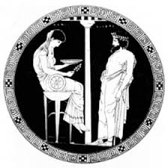
Assessment Type 1: Skills and Applications
Topic 4: Religion
Purpose:
The purpose of this task is for you to be able to showcase your:
- knowledge and understanding of the worship of a chosen deity in ancient times
- knowledge and understanding of how the work of archaeologists can inform our understanding of the ancient world and the types of issues they must consider in handling sources from the past
- research and synthesis skills in using a range of secondary sources and drawing on photographs, drawings, and archaeological evidence to build a rich understanding of your topic
- communication skills to an audience including your oral presentation skills, the structuring of your material and your use of communication aids
Task:
Prepare and present a virtual tour of a sacred site. Your tour should include the following:
- information on the deity worshipped at the site and the forms of worship practiced there
- primary source evidence at the site and how it can inform the historian of the ancient world
- archaeological reconstructions of what the site might have looked like and how that can inform the historian of the ancient world
- artefacts found at the site and what they reveal about the worship and the worshippers
You must use primary and secondary sources in your presentation.
Assessment design criteria:
KU1 knowledge and understanding of texts, artefacts, ideas, events, and or people
KU3 Knowledge and understanding of historical and or archaeological concepts
RA1 Research into and analysis of primary and secondary sources and perspectives
A1 Synthesis of evidence and appropriate acknowledgement of sources
A1 Synthesis of evidence and appropriate acknowledgement of sources
Assessment conditions:
5 -6 minute oral/multi-modal/1000 word equivalency.

