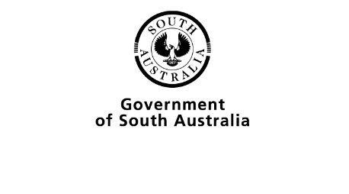
Modified Subjects review feedback
The SACE Board provides formal feedback about the outcomes of review. The following guidelines have been provided to support your school to respond to the feedback.

Guidelines for responding to Modified Subjects feedback

What is the purpose of the feedback?
To provide information that schools can use to confirm or adjust (as appropriate) final assessment decisions.

What is the focus of the feedback?
The focus is on supporting the interpretation and application of ‘completed’ and ‘not completed’ assessment decisions are consistent within and between schools.

What can schools and teachers do after receiving their feedback?
Schools and teachers are asked to carefully consider the feedback to ensure students’ final results are consistent with the assessment decisions recommended for the review sample.
Schools can:
  - Note the assessment decisions that the feedback supports and those recommended for adjustment (if any).
If assessment decisions have been recommended for adjustment, teachers ensure the final results for all students with evidence of learning comparable to evidence included in the review sample are consistent with recommended assessment decisions.
  - If the review sample included students’ evidence of learning pending completion of the final task, consider and adjust individual student’s final assessment decision to reflect significant achievement in the final assessment task.
  - Consider ‘P’ (pending) status for ‘not completed’ assessment decisions.
  - Consider how the feedback might be used to inform school practices.
For example,
  - What processes are in place to maintain the consistency of assessment decisions in the future?
  - Could participation in SACE Board clarifying activities provide support?
  - Consider how the feedback may be shared with the wider school community (e.g. parents, governing council).
Schools can seek advice on submitting results following review from the AskSACE team.

