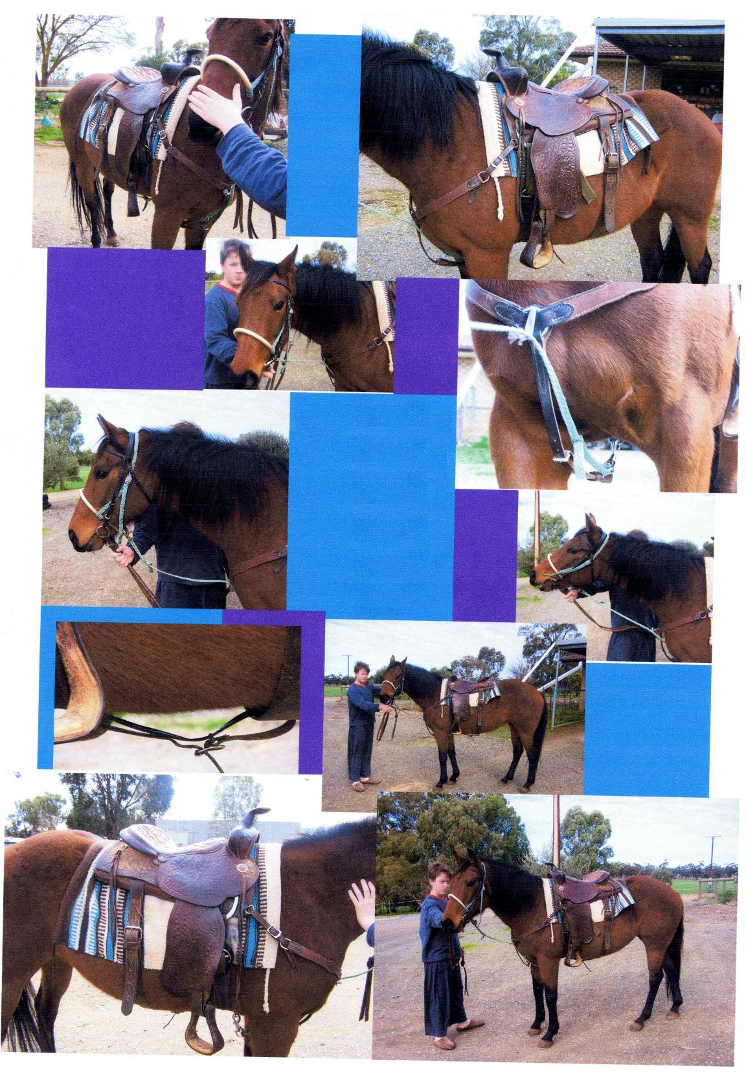
My
Design
Folio

PART 1

Need or Problem
For my major project this semester I thought I would like to do something to do with my horse-riding. I thought it would be good to make a saddle stand.

Design Brief
Investigation
Demonstrates considered creation of a design brief by stating three requirements of the design.

My saddle stand must be capable of holding three saddles and it should have a place to store horse blankets that go under the saddle like you see on my title page. There should also be a place to hold bridles. Everything should be easy to get to.

PART 2
Investigation of ideas

I looked at the ones other people had. One was a old school desk, and one was a wall mounted frame.
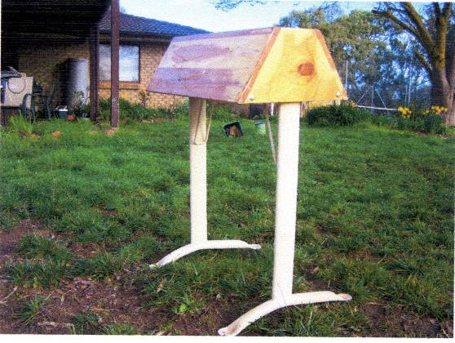  Old desk still there – top attached to that  Free standing – good shape and size | only fits one – no blanket, bridle storage  hollow –storage inside?  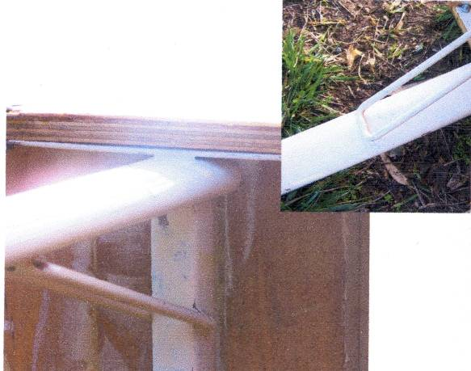
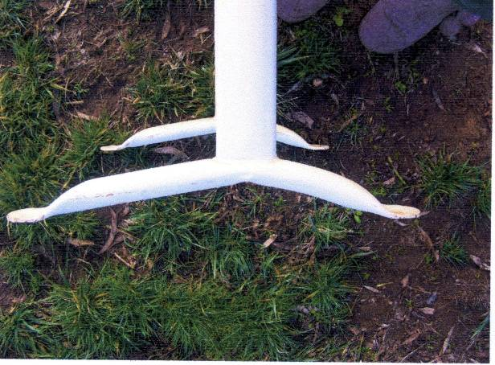 | portable  Planning  Shows ability to use relevant investigated information to create individual product design ideas on pages 3 and 4. Refer to highlighted text.  metal legs and brace  I plan to use wooden legs.  I want more storage

Investigation of ideas.

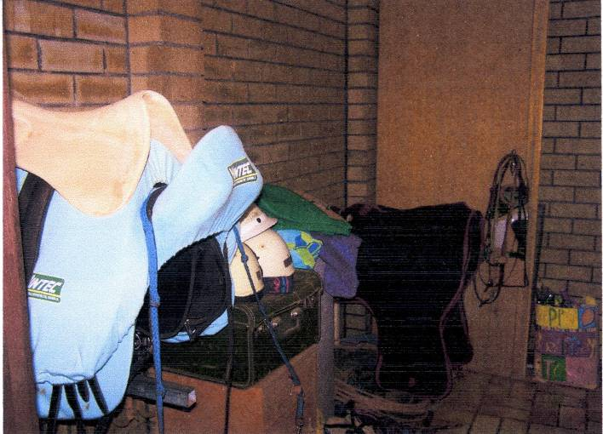 | Wall mounted rack – basically just a bar. (will it tear saddle?) have to balance  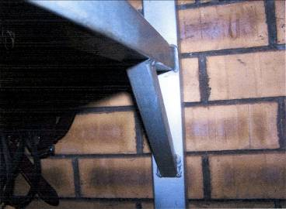  Brace to support it
Bridles are hung on pegs on wall  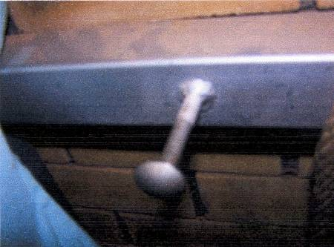  Pegs are just gutter bolts | 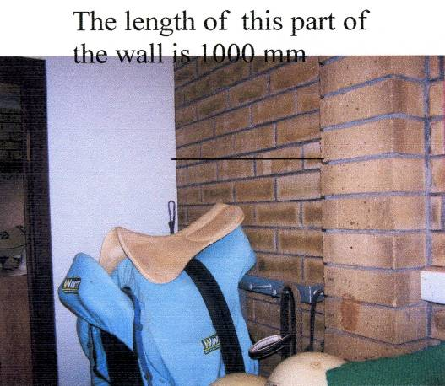
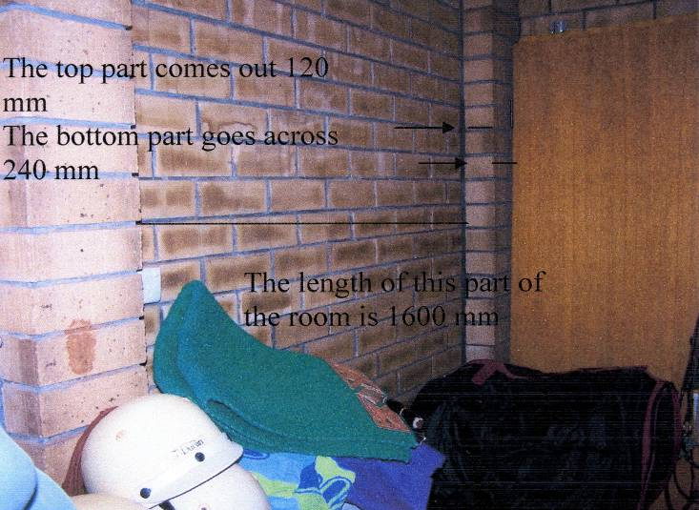 | 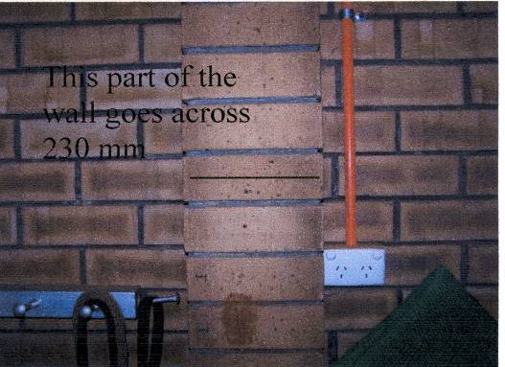  No blanket storage

Developing my ideas

I also looked at the Internet. I saw lots of pictures, for example
http://www.cals.ncsu.edu/an_sci/extension/horse/Images/wood%20saddle%20rack.jpg
This was like the desk, but had knob at front for bridle (would drag)
http://i.ehow.com/images/GlobalPhoto/Articles/4967633/179032-main_Full.jpg
This had instructions but the rack was just an inverted V pretty crude
Planning
Demonstrates use of relevant investigated information to create individual design ideas for a product on pages 5-7. Refer to highlighted text.

I gave up because I knew what I wanted – basically the shape and size of the desk:

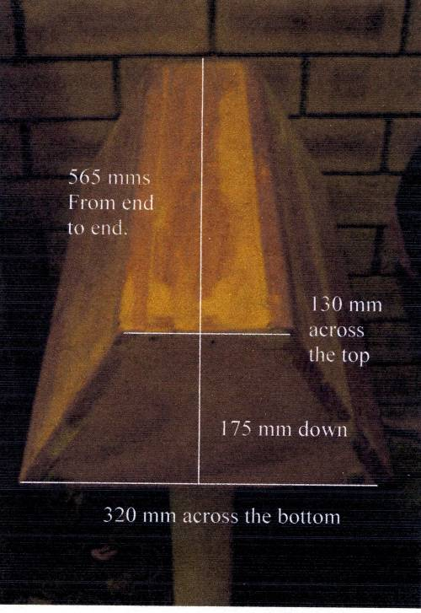

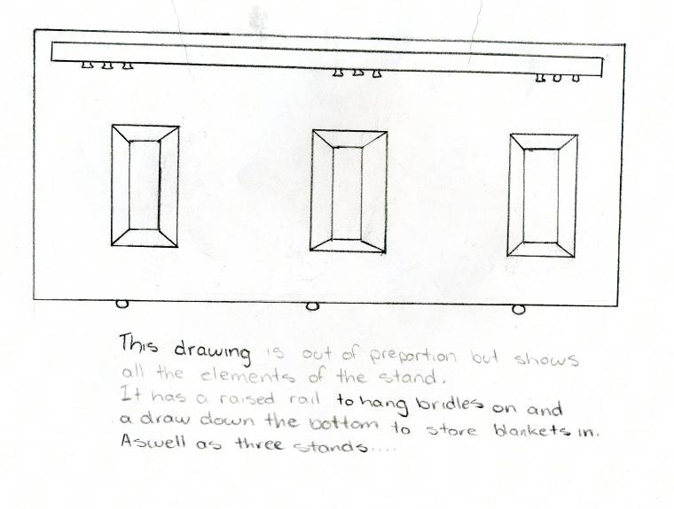
Planning
Provides first considered compilation of sketches.

I would like to make it for three saddles. My first idea is like the drawing here. I need to have a kickboard under the draw.

Kickboard sizes in my house
Lounge cabinate | 90 mm
stereo | 90 mm
TV cabinate | 55 mm
Camphor wood chest | 55 mm
Kitchen cupboards | 95 mm
Laundry cupboards | 90 mm
Desk | 55 mm

Investigating
Provides an informed investigation and analysis of the characteristics of existing products and materials in pages 3 - 8.

I need to make sure it will fit two different saddle dimensions. These are some photos.

SADDLE 1
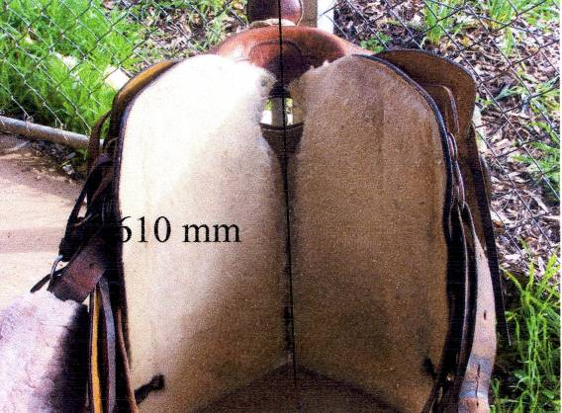 | 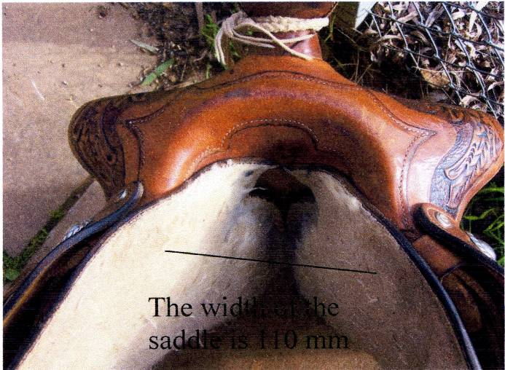  From the top to the bottom of the stirrup is 800mm
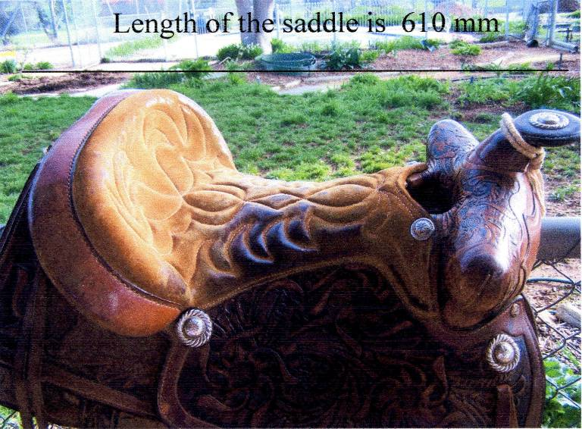 | 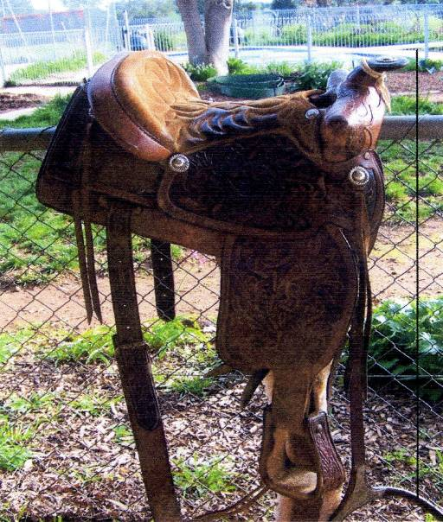

SADDLE 2
There is another saddle that weighs 14.5 kg’s  It has a length of 710 mm from the horn to the bottom of stirrup | 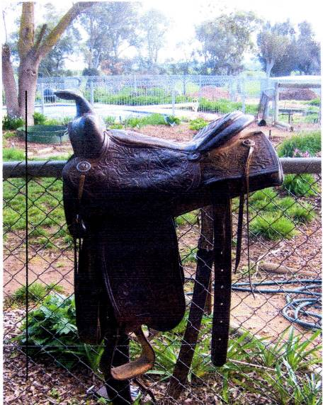
The length of the saddle is 630mm  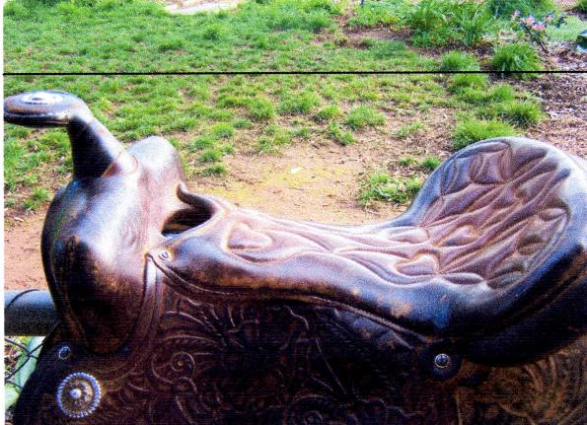 | 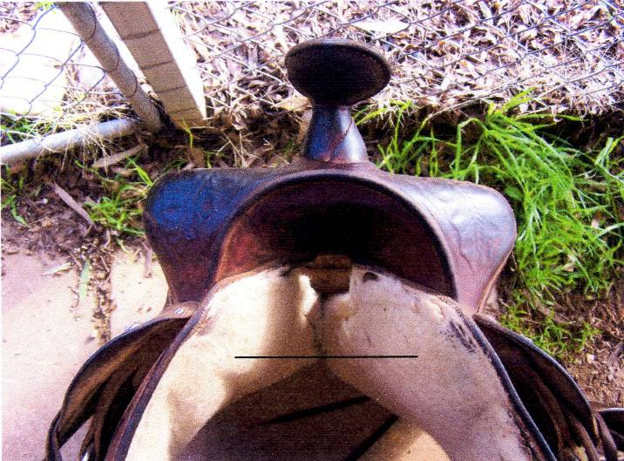  The width of the saddle is 130mm

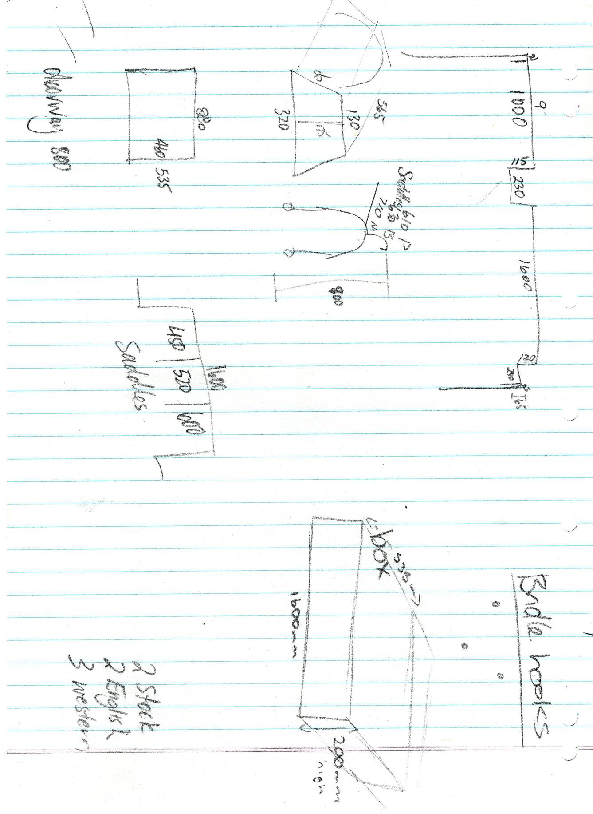
Planning
Demonstrates some basic testing, modification, and validation of aspects of ideas.
Evaluating
Some consideration of a possible modification to improve ideas.
Planning
Provides more sketches of ideas for product.

Error in calculations i.e. length of hypotenuse < adjacent side remains uncorrected throughout the testing, modification and validation process.
Part 3
Investigation of impact
Planning
Use of basic technical language relevant to the context. Refer to highlighted text.
For my project I chose to use pine and pine veneer mdf because it is cheap and in good supply. It is a very soft wood and very easy to work with – also easy to damage if you knock it. So for my investigation I want to talk about the impact of using pine in South Australia.

In South Australia, it really means pinus radiata. Pinus radiata is a whitewood, and grows quickly. It comes from California, which has a similar climate. From around 1926 major plantations were made because it grew well in our climate. (5) It is very important to SA, because we don’t have a lot of commercially usable timber. When the South East was used for the plantations, it also was not easy to farm that land, so timber was a smart choice.
Investigation
Provides details of some investigation into the impact of technological practices and products on individuals, society and the environment.
It’s impact on society is we are supporting a local industry. The Primary Industry and Resources department has a web site which says “In 2008, South Australia had 81,754 hectares of plantation forests. Of this 122,871 hectares were softwood, mostly Radiata pine (Pinus radiata)” Most is in the South East, and nearly half is on government land. (3)

By using local timber we provide jobs for people, so that is one impact of using pine.. There are over 13,000 people who work in timber related industries which are worth more than $2.8 billion of value to the state’s economy each year. (source: ForestWorks - "Forest and Wood Products Industry Workforce and Industry Data Collection Survey Report 2006) .

That is also good for the environment. It is local so that reduces pollution from trucks. It is a harvested product – that is the SA forests are all planted, so we are not damaging natural areas, or the rainforests.

Also, this helps with the carbon in the atmosphere. The growing trees absorb carbon, then the products we make take them out of the carbon cycle. This helps reduce greenhouse gases and global warming. The world needs as many trees as possible, and it definitely needs all its natural trees. So using a quick growing tree planted for harvesting helps as well. Also, cutting a tree down when it is mature, then planting a quick growing tree uses up carbon dioxide(2). When a tree is at its fastest growing part it uses more carbon.(1)(6)
Evaluation
Demonstrates an ability to analyse some of the impacts of technological practices, products e.g. on individuals e.g. energy used to produce the material, society e.g. supporting a local industry, and the environment e.g. fewer trucks on the road.

You also have to think about the energy needed to produce the material. The National Australian Forestry Industries Association (4) claims milled timber is the cheapest in energy used. They also say that waste from timber products can be used to generate some of the energy needed to make the milled timber. There will always be a cost, but that would make the impact less.

The most important sites I visited
(1) http://www.ec.gc.ca/envirozine/english/issues/58/any_questions_e.cfm
(2) http://www.birdlist.org/phpbb/viewtopic.php?t=15
(3) http://www.pir.sa.gov.au/forestry/forestry_in_south_australia)
(4) http://www.nafi.com.au/bioenergy_factsheets/WWFS19.pdf
(5) http://www.australianforests.org.au/managingforests/plantations-history.htm
(6) http://www.madsci.org/posts/archives/2000-08/965676157.Bt.r.html

Part 4

My final plan

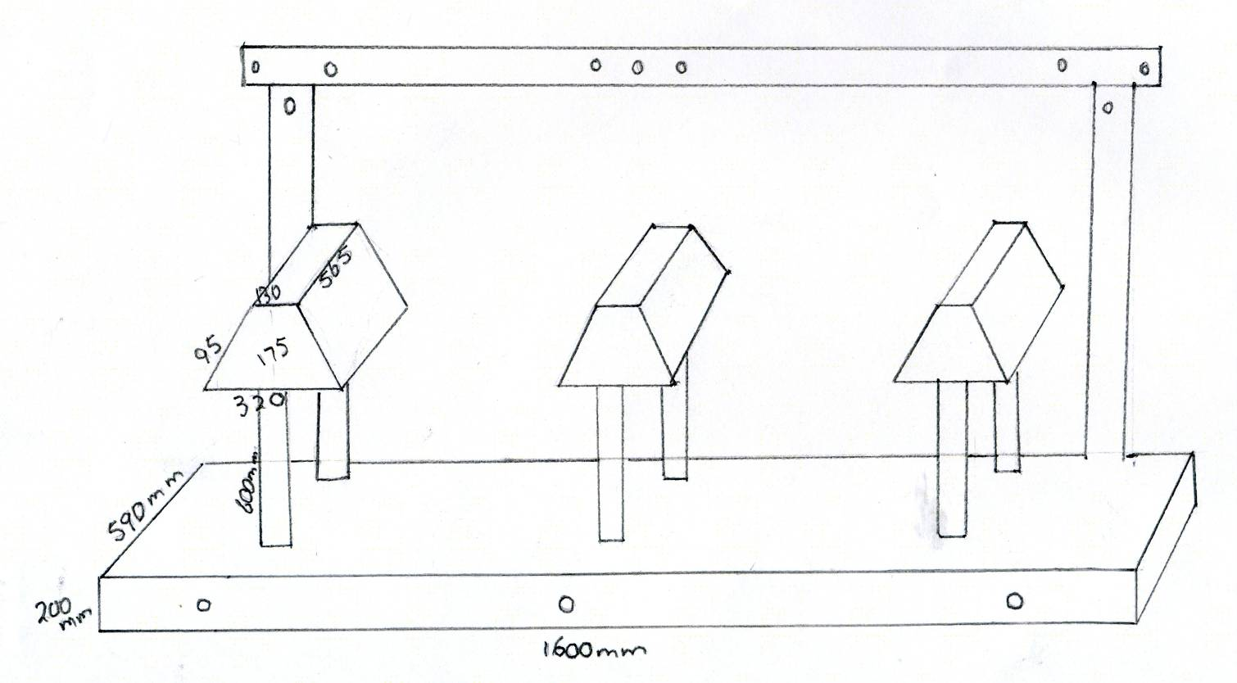

 |  |  | Cost list
Part name | No | Material Used | Cost of material | (Length x Cost x Number of) or (length x width x Cost x Number of)
Base
kickboards | 2 | 90 x 35 | $3.75 m | 1620 | $12.20
 | 2 | 90 x 35 | $3.75 m | 610 | $ 4.60
Cupboard base (& top) | 2 | 19 mm mdf | $28.70 m² | 1600 x 590 | $54.20
doors | 1 | 19 mm mdf | $28.70 m² | 1600 x 166 | $ 7.60
back | 1 | 19 mm mdf | $28.70 m² | 1600 x 166 | $ 7.60
sides | 2 | 19 mm mdf | $28.70 m² | 590 x 166 | $ 5.60
Saddle stands
legs | 6 | 120 x 45 mm | $6.45 m | 800 | $31.00
Bridle stand | 2 | 70 x 45 mm | $3.75 m | 1400 | $10.50
Bridle rail | 1 | 70 x 45 | $3.75 m | 1400 | $ 5.30
Saddle stand tops | 3 | 19 mm mdf | $28.70 m² | 130 x 565 | $ 6.30
Saddle stand sides | 6 | 19 mm mdf | $28.70 m² | 565 x 95 | $ 9.20
Saddle stand ends | 6 | 19 mm mdf | $28.70 m² | 320 x 175 | $ 9.70
TOTAL $ |  |  |  |  | 163.80
Planning
Use of basic technical language with some relevance to the context.

Additional comments
- The student demonstrates considered compilation of varied and refined sketches, concept drawings and plans throughout their folio. There is evidence of planning for production e.g. the number of parts required in the above table, but minimal information about the production techniques to be used (Planning).
- The table of kickboard sizes and bibliography on page 10 contain information used to finalise the design brief. They are not included in the word count.

Word count - 778

Performance Standards for Stage 1 Design and Technology
 | Investigating | Planning | Producing | Evaluating
A | Comprehensive and well-considered identification of a need, problem, or challenge.  Creation and insightful validation of a clear and well-considered initial design brief.  In-depth investigation and analysis of the characteristics of existing products, materials, processes, systems and/or production techniques  Planned and thorough investigation into the impact of technological practices, products or systems on individuals, society, and/or the environment. | Insightful use of relevant investigated information to create individual product design ideas for a product or system.  Thoughtful compilation of broad, varied, and refined sketches, concept drawings, plans, and sequences for planned outcomes.  Polished use of technical language most relevant to context and purpose.  Broad and varied testing, modification, and validation of ideas or procedures. | Highly proficient application of skills, processes, procedures, and techniques to create a product or system to a chosen standard and specification.  Sophisticated use of a variety of materials, components, techniques, and equipment to create a product or system safely and accurately.  Development of sophisticated solutions to problems that arise during product or system realisation. | Comprehensive evaluation of how well the design brief requirements have been met.  Insightful and detailed evaluation of the effectiveness of the product or system realisation process.  Sophisticated and focused consideration of possible modifications to improve ideas or procedures.  Perceptive analysis of the impact of technological practices, products, or systems on individuals, society, and/or the environment.
B | Clear and considered identification of a need, problem, or challenge.  Well-considered creation and validation of an initial design brief.  Some depth of investigation into the characteristics of existing products, materials, processes, systems, and/or production techniques.  Detailed investigation into the impact of technological practices, products, or systems on individuals, society, and/or the environment. | Thoughtful use of relevant investigated information to create individual design ideas for a product or system.  Well-considered compilation of quality sketches, concept drawings, plans, and sequences for planned outcomes.  Capable use of technical language relevant to context and purpose.  Considered testing, modification, and validation of ideas or procedures. | Proficient application of skills, processes, procedures, and techniques to create a product or system to a chosen standard and specification.  Thorough use of different materials, components, techniques, and equipment to create a product or system safely and mostly accurately.  Development of thoughtful solutions to problems that arise during product or system realisation. | Well-informed evaluation of how well the design brief requirements have been met.  Well-considered and detailed evaluation of the effectiveness of the product or system realisation process.  Thorough and focused consideration of possible modifications to improve ideas or procedures.  Well-considered analysis of the impact of technological practices, products, or systems on individuals, society, and/or the environment.

 | Investigating | Planning | Producing | Evaluating
C | Considered identification of a need, problem, or challenge.  Considered creation and validation of an initial design brief.  Informed investigation into the characteristics of existing products, materials, processes, systems, and/or production techniques.  Generally competent investigation into the impact of technological practices, products, or systems on individuals, society, and/or the environment. | Use of relevant investigated information to create individual design ideas for a product or a system.  Considered compilation of sketches, concept drawings, plans, and sequences for planned outcomes.  Competent use of technical language relevant to the context and purpose.  Competent testing, modification, and validation of ideas or procedures. | Competent application of skills, processes, procedures, and techniques to create a product or system to a chosen standard and specification.  Appropriate use of materials, components, techniques, and equipment create a product or system safely and sometimes accurately.  Development of appropriate solutions to problems that arise during product or system realisation. | Informed evaluation of how well the design brief requirements have been met.  Considered evaluation of the effectiveness of the product or system realisation process.  Some focus in consideration of possible modification to improve ideas or procedures.  Considered analysis of some of the impacts of technological practices, products, or systems on individuals, society, and/or the environment, with mostly relevant detail.
D | Partial identification of a need, problem, or challenge.  Development and some testing of a basic, or perhaps incomplete, initial design brief.  Identification of a few of the characteristics of existing products, materials, processes, systems, or production techniques.  Some accessing of information on the impact of aspects of technological practices, products, or systems on individuals, society, and/or the environment. | Some use of identified information to create one or more individual design ideas for a product or system that may be only partially completed.  Some sketches, concept drawings, plans, and/or sequences for planned outcomes are completed.  Use of basic technical language with some relevance to the context and purpose.  Some basic testing, modification, and validation of aspects of one or more ideas or procedures. | Basic application of some skills in some processes, procedures, and techniques to create part of a product or system to a basic standard and specification.  Some use of materials, components, techniques, or equipment to create part of a product or system with some elements of safety and accuracy considered.  Some endeavour to solve problems that arise during product or system realisation. | Some description of how well the design brief requirements have been met.  Some description of the effectiveness of the product or system realisation process.  Some consideration of a possible modification to improve ideas or procedures.  Identification and description of one or more impacts of technological practices, products, or systems on individuals, society, and/or the environment.
E | Limited identification of a need, problem, or challenge.  Attempted development and testing of a design brief.  Attempted identification of one or more characteristics of existing products, materials, processes, systems, or production techniques.  Isolated and disjointed evidence of accessing information on the impact of an aspect of the technological practice, product, or system on individuals, society, or the environment. | Limited use of information to create an individual design idea for a product or system that may not be completed.  Compilation of few sketches, concept drawings, plans, or sequences for planned outcomes.  Limited use of technical language.  Recognition of the need for testing, modification, and validation of ideas or procedures, with some limited attempts. | Limited application of emerging skills and/or techniques to attempt to create part of a product or system to a limited standard or specification.  Attempted use of one or more basic materials, components, techniques, or equipment with limited consideration of safety procedures.  Some attempted description of problems that arise during product or system realisation. | Identification of some aspects of the design brief requirements that were attempted.  Identification of some aspects of the effectiveness of the product or system realisation process.  Emerging recognition of the need for modification to improve ideas or procedures.  Emerging recognition of one or more impacts of technological practices, products, or systems on individuals, society, or the environment.

