
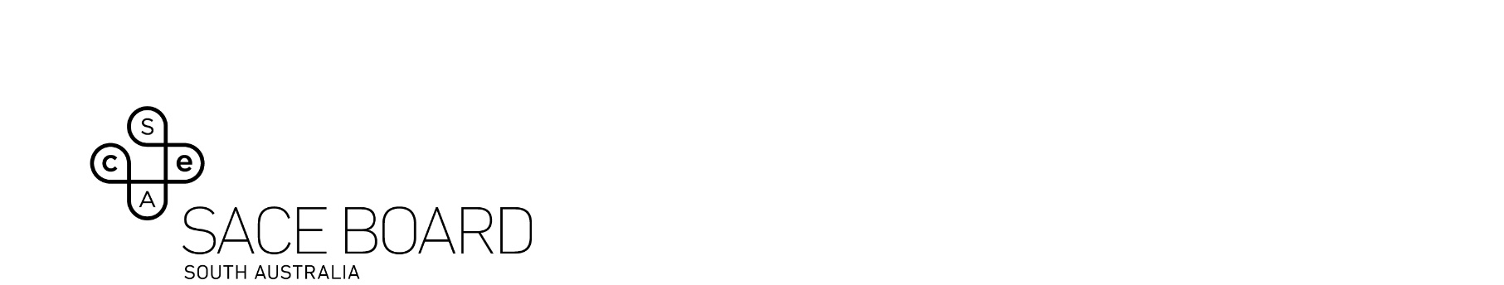
Stage 2 Nationally Assessed Languages at continuers level (CCAFL) from 2025

Discussion outline for oral examination
This form is only required to be completed by students undertaking a Nationally Assessed Language that is hosted by the SACE Board (Hungarian, Khmer, Nepali, Polish).
Please ensure you know your registration number before you enter the examination room as the examiners require this before conducting your examination. If you are uncertain of this information, please contact your school’s SACE coordinator who will be able to provide your SACE registration number.
Language studied:
Examination date: |  | Time:

SACE registration number:

Family name: |  | Given name(s)
Teaching school:

Please complete in English the subtopic for discussion and the main points covered as this assists the examiners with their questions.
Subtopic for discussion:
Main points covered:
Students are NOT permitted to bring a hard copy of this information into the examination room.

Supportive Visual Material

- The supporting visual material must consist of one image which must NOT exceed this single page.
- The supporting visual material should NOT include any writing.
- The quality of the supporting visual material will not be assessed.

Students are permitted to bring a hard copy of this image into the examination room.
Please click here to email this form to the SACE Board before the end of
Term 3 Friday 26 September 2025.

