STAGE 2 ITALIAN

ASSESSMENT TYPE 1: FOLIO - TEXT ANALYSIS

Purpose expressed clearly and succinctly and Learning Requirements highlighted.
Purpose
To analyse texts in Italian to interpret meaning and examine relationships between language, culture, and identity, and reflect on the ways in which culture influences communication.

Description of assessment
Assessment Design Criteria highlighted.
Read the following text, and answer (a) to (d) in English and (e) in Italian. These questions primarily focus on being able to demonstrate evidence of interpretation and reflection.

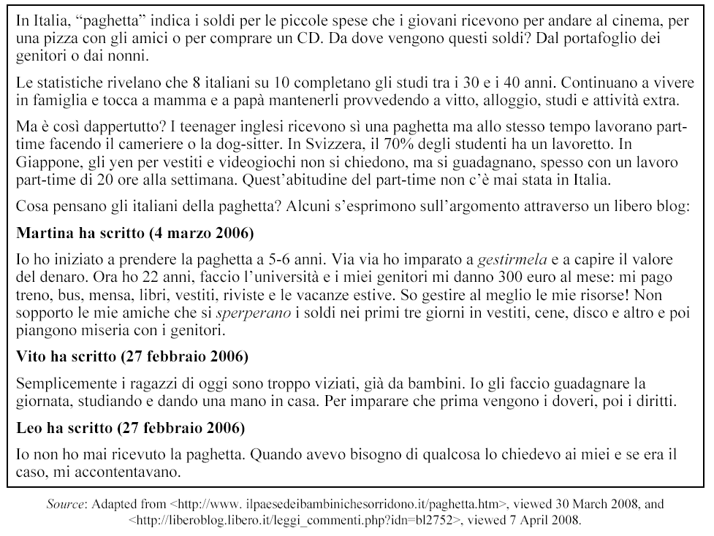
(From 2008 Italian Continuers Examination)
Lessico
gestire – to manage
sperperare – to waste

Questions

(a) Why does the paghetta still seem to be necessary in Italy today and what does this reflect about Italian culture?
Explicit questions which support students to achieve to the highest level against the performance standards.

(b) Explain the formation of the word ‘paghetta’ in relation to the word ‘paga’.
(c) How do young people in other countries earn their pocket money?

(d) What impression does Martina convey about herself and her abilities?

(e) Perché l’opinione di Vito è diversa da quella di Martina e Leo?

Your response should demonstrate:

Expression:
- Accurate language use
- Logically and coherently organised information and ideas.

Interpretation and Reflection:
Explicit reference to performance standards at the highest level.
- Detailed and appropriate use of evidence from text to support conclusions
- Interpretation of content, context, purpose, audience and message
- Identification and clear explanation of concepts, ideas & perspectives presented in texts
- Clear explanation of particular linguistic and cultural features
- Critical reflection on how culture, values, beliefs, practices, and ideas are represented in the text.

Assessment conditions
45 minutes under supervision, with use of bilingual dictionaries.

Audience
Teacher
Learning Requirements | Assessment Design Criteria
- interact with others to exchange information, ideas, opinions, and experiences in Italian  - create texts in Italian to express information, feelings, ideas, opinions  - analyse texts that are in Italian to interpret meaning  - examine relationships between language, culture, and identity, and reflect on the ways in which culture influences communication | Ideas  The specific features are as follows:  I1 Relevance  - relevance to context, purpose, audience, and topic  - conveying appropriate detail, ideas, information, or opinions  - creating interest and engaging the audience.  I2 Depth of treatment of ideas, information, or opinions  - depth and breadth of content  - elaboration of ideas and support of opinions  - planning and preparation.  Expression  The specific features are as follows:  E1 Capacity to convey information accurately and appropriately  - range of expression (i.e. linguistic structures and features)  - accuracy of expression (i.e. linguistic structures and features, grammar)  - use of cohesive devices  - appropriateness of expression, including cultural appropriateness  - clarity of expression, including fluency, pronunciation, and intonation.  E2 Coherence in structure and sequence  - organisation of information and ideas  - use of the conventions of text types.  E3 Capacity to interact and maintain a conversation and discussion  - interaction on topics (i.e. relating to the interlocutor, interest in the topic)  - use of communication strategies (i.e. comprehension, responding to cues)  - fluency of responses.  Interpretation and Reflection  The specific features are as follows:  IR1 Interpretation of meaning in texts, by identifying and explaining  - the content (general and specific information)  - the context, purpose, and audience of the text  - concepts, perspectives, and ideas represented in the text.  IR2 Analysis of the language in texts  - linguistic and cultural features (e.g. word choice, expressions, idiom)  - stylistic features (e.g. tone, register, phrasing and repetition, textual features and organisation).  IR3 Reflection  - reflection on how cultures, values, beliefs, practices, and ideas are represented or expressed in texts  - reflection on own values, beliefs, practices, and ideas in relation to those represented or expressed in the texts studied  - reflection on own learning.

Performance Standards for Stage 2 Locally Assessed Languages at Continuers Level
 | Ideas | Expression |  | Interpretation and Reflection
A | Relevance  Responses are consistently relevant to context, purpose, audience, and topic.  Responses consistently convey the appropriate detail, ideas, information, opinions.  Responses successfully create the desired impact and interest, and engage the audience.  Depth of Treatment of Ideas, Information, or Opinions  Depth and breadth in the treatment of the topic and content is very detailed and varied.  Ideas are elaborated, opinions and arguments are supported and justified, and complex ideas are communicated effectively with originality and creativity.  Comprehensive evidence of planning and preparation. | Capacity to Convey Information Accurately and Appropriately  Use of an extensive range of complex linguistic structures and features with a high degree of accuracy to achieve interest, flow, and cohesion.  A few errors may be evident when attempting to use more complex language, but errors do not impede meaning.  Effective use of a range of sophisticated cohesive devices to connect ideas.  Expression consistently appropriate to the cultural and social context.  Very effective communication with a high degree of fluency. Pronunciation is accurate, and there is little hesitation in the choice of linguistic resources. Intonation and stress are used effectively to enhance meaning.  Coherence in Structure and Sequence  Information and ideas are organised logically and coherently.  Conventions of the text type are observed. | Capacity to Interact and Maintain a Conversation and Discussion  Interaction is initiated, sustained, and spontaneous across a wide range of topics. Comments or opinions are adjusted or elaborated on in response to reactions and comments. Interest, enthusiasm, and passion for the topic of discussion are conveyed.  A variety of communication strategies are used with effect during interaction (e.g. using new vocabulary encountered during interaction, seeking clarification, using appropriate pause fillers).  Responses are quick, confident, and fluent. Topic shifts and unpredictable elements are handled well. | Interpretation of Meaning in Texts  Detailed and appropriate use of evidence from texts to support arguments/conclusions. Interpretations of text are enhanced by making connections within and/or between texts (e.g. comparing and contrasting information, ideas, and opinions).  Conclusions are drawn about the purpose, audience, and message (argument) of the text, and justified with evidence from the text.  Concepts, perspectives, and ideas represented in texts are identified and explained with clarity and insight.  Analysis of the Language in Texts  The functions of particular linguistic and cultural features in the text are explained with clarity and insight.  Detailed explanation of how stylistic features are used for effect in the text (e.g. register, tone, textual features/organisation).  Reflection  Critical reflection on how cultures, values, beliefs, practices, and ideas are represented or expressed in texts.  Sophisticated recognition and explanation of connections between own values, beliefs, practices, and ideas, and those explored in texts.  Critical reflection on own learning.
B | Relevance  Responses are mostly relevant to context, purpose, audience, and topic.  Responses mostly convey the appropriate detail, ideas, information, and opinions.  Responses generally create the desired impact and interest, and engage the audience.  Depth of Treatment of Ideas, Information, or Opinions  Breadth and some depth in the treatment of the topic.  Ideas are elaborated by offering additional details, and opinions are supported with examples. When dealing with unfamiliar topics, ideas are presented as a series of statements rather than as an argued position.  Sound planning and preparation. | Capacity to Convey Information Accurately and Appropriately  Use of a range of linguistic structures and features with good control to convey meaning.  Mostly accurate use of high-frequency vocabulary and sentence structures. Attempts are made to use some complex language, and errors sometimes impede meaning.  A range of cohesive devices are used to connect ideas.  Expression is mostly appropriate to the cultural and social context.  Effective communication with some degree of fluency. Reasonably accurate pronunciation and intonation.  Coherence in Structure and Sequence  Mostly coherent organisation of information and ideas.  Most conventions of the text type are observed. | Capacity to Interact and Maintain a Conversation and Discussion  Interaction is maintained on a range of familiar topics. Some clarification or repetition is required to comprehend topic shifts into unfamiliar areas or when complex sentence constructions are used. Interest in the topic is conveyed effectively.  A number of communication strategies are used to maintain interaction (e.g. self-correcting, responding to correction by the interlocutor, seeking support and clarification).  Occasional pauses to process questions and to search for linguistic resources. | Interpretation of Meaning in Texts  Key ideas represented in texts are identified and explained. Interpretations of meaning are supported with some appropriate examples from the text.  Some conclusions are drawn about the purpose, audience, and message (argument) of the text and supported with some relevant examples from the text.  Concepts, perspectives, and ideas represented in texts are generally identified and explained with some clarity.  Analysis of the Language in Texts  The functions of particular linguistic and cultural features in the text are described.  Some detail in explaining stylistic features in the text (e.g. register, tone, textual features/organisation).  Reflection  Some depth in reflection on how cultures, values, beliefs, practices, and ideas are represented or expressed in texts.  Some depth in reflection on own values, beliefs, ideas, and practices in relation to those represented in texts.  Thoughtful reflection on own learning.
C | Relevance  Responses are generally relevant to topic and purpose, with some relevance to context and audience.  Responses generally convey simple ideas and opinions with generally appropriate information.  Responses generally create some interest, and partly engage the audience.  Depth of Treatment of Ideas, Information, or Opinions  Some variety in the treatment of information and simple ideas or opinions on mostly familiar topics.  Short simple sentences usually containing one idea are used to convey meaning with some effectiveness and support an opinion.  Competent planning and preparation. | Capacity to Convey Information Accurately and Appropriately  Use of a range of linguistic structures and features to convey meaning. Reliance on rehearsed patterns.  Accuracy tends to be variable, with some basic errors. Generally accurate when using formulaic expressions and rehearsed patterns.  Cohesive devices are simple and repetitive. Reliance on a limited range of cohesive devices to connect ideas at sentence, paragraph, and whole text level.  Expression is generally appropriate to the cultural and social context.  Some hesitancy in responding. Pronunciation and intonation are understandable.  Coherence in Structure and Sequence  Generally coherent organisation of information and ideas.  Responses generally conform to the conventions of the text type. | Capacity to Interact and Maintain a Conversation and Discussion  Use of well-rehearsed language to maintain an interaction by responding to questions on familiar topics. Some reliance on the interlocutor to take the lead. Some interest in the topic is conveyed.  Use of prepared phrases to indicate lack of comprehension and ask for support. Often relies on the interlocutor’s sentence patterns to respond.  Occasional silences because of lack of comprehension and time required to process more complex language and to search for words. Responses may be repetitive. Some hesitation in communication when dealing with unfamiliar contexts. | Interpretation of Meaning in Texts  Identifies and explains some relevant information from texts on familiar topics containing predictable and familiar language structures.  Competent understanding of context, purpose, and audience, supported with isolated examples from the text.  Main concepts, ideas, and one or more perspectives in texts are identified, with some explanation.  Analysis of the Language in Texts  Particular linguistic and cultural features of the text are identified.  Identification of stylistic features in texts (e.g. idioms, rhetoric, expressions).  Reflection  Some reflection on cultures, values, beliefs, practices, and ideas represented or expressed in texts.  Some reflection on, with mostly description of, own values, beliefs, ideas, and practices in relation to those represented in texts.  Some reflection on own learning.
D | Relevance  Responses partially relevant to the topic and purpose.  Responses convey some basic information that may be appropriate.  Responses include one or more elements of interest that may engage the audience.  Depth of Treatment of Ideas, Information, or Opinions  Some basic treatment of information or ideas relating to simple aspects of familiar topics.  Short and generally incomplete sentences are used with partial effectiveness to convey an idea or opinion.  Some planning and preparation. | Capacity to Convey Information Accurately and Appropriately  Use of simple vocabulary, short sentences, formulaic expressions, and rehearsed patterns to convey meaning. When attempts are made to elaborate, the structure is often based on word order derived from English.  Frequent errors and incorrect selection of words from the dictionary impede meaning.  A cohesive device may be used with some effectiveness.  Expression occasionally appropriate to cultural and social context.  Frequent hesitancy in responding. Pronunciation may impede meaning.  Coherence in Structure and Sequence  Some basic organisation of information and/or ideas.  Some use of very basic conventions of the text type. | Capacity to Interact and Maintain a Conversation and Discussion  Routine courtesy phrases and basic structures are used to respond to simple questions on familiar topics. Reliance on the interlocutor to take the lead and maintain interaction. Some interest in the topic may be conveyed.  Reliance on repetition and rephrasing of questions. Partial understanding of questions may lead to a response that is not relevant.  Frequent silences may occur because of lack of comprehension and time required to search for words and construct answers. | Interpretation of Meaning in Texts  Keywords and some supporting detail are identified in texts dealing with familiar situations.  Some basic understanding of context, purpose, and/or audience.  Identification of one or more concepts or ideas, with specific information in texts transcribed rather than interpreted.  Analysis of the Language in Texts  One or more basic linguistic and/or cultural features of the text are identified.  One or more stylistic features are identified.  Reflection  One or more familiar aspects of cultures, values, beliefs, practices, or ideas represented or expressed in texts are identified.  One or more of the student’s own values, beliefs, practices, or ideas in relation to those represented in texts are described.  Learning experiences are recounted.
E | Relevance  Responses have limited relevance to the topic and purpose.  Responses attempt to convey some basic information, with limited appropriateness.  Responses attempt to include an element of interest.  Depth of Treatment of Ideas, Information, or Opinions  Attempted treatment of simple information relating to one or more aspects of familiar topics.  Responses are brief and often rely on a keyword to convey basic meaning.  Attempted planning or preparation. | Capacity to Convey Information Accurately and Appropriately  Relies heavily on the dictionary. Use of a very limited range of vocabulary and sentence structures, with single words and set formulaic expressions to convey basic information. Reliance on anglicisms to convey meaning.  Frequent errors impede meaning.  Limited appropriateness of expression.  Attempted use of a cohesive device, with limited effectiveness.  Always or mostly hesitant in responding. Pronunciation impedes meaning.  Coherence in Structure and Sequence  Limited organisation of information or ideas.  Limited evidence of conventions of text type. | Capacity to Interact and Maintain a Conversation and Discussion  Reliance on interlocutor to assist with communication breakdowns to complete sentences or to interpret intended meanings.  Repetition, rephrasing of questions, and a slowed rate of speech are required for comprehension. Utterances rarely consist of more than two or three words. Frequent misunderstandings of simple questions.  Frequent long pauses to process questions and to search for words. May resort to using English to convey meaning. | Interpretation of Meaning in Texts  Isolated items of information are identified in short texts on familiar topics containing simple language.  Identification of a context, purpose, or audience.  Understanding of information is limited to occasional isolated words (e.g. borrowed words, high-frequency social conventions).  Analysis of the Language in Texts  Attempted identification of a basic linguistic feature of the text.  Attempted identification of a stylistic feature.  Reflection  One or more formulaic cultural expressions are identified.  One or more of the student’s own values, beliefs, practices, or ideas are identified.  Learning experiences are listed.

