STAGE 1 MATHEMATICS PATHWAYS

FOLIO – INVESTIGATION

Purpose
This assessment provides opportunities for you to demonstrate your ability to use problem-solving strategies as well as your knowledge, skills, and understanding of mathematical ideas and processes.

Description of assessment
You are required to investigate a problem from the measurement topic and develop a solution. This investigation involves two parts. In the first part you draw a scale diagram of a commercial kitchen and calculate an approximate cost of setting it up. The second part allows you to choose your preferred option and complete a more detailed task involving measurement, costing, and problem solving.

Assessment conditions
You have 3 weeks to complete this assessment. Use of technology is required. Your investigation should include:
- an introduction that demonstrates your understanding of the problem to be explored;
- the method that you used to reach your solution(s);
- details of the data used, evidence of the developed solution, and the solution reached;
- analysis and interpretation of the results;
- a conclusion in the context of the original problem;
- appendices and bibliography, if used.

Learning Requirements | Assessment Design Criteria | Capabilities
- Demonstrate an understanding of mathematical concepts and relationships, making use of electronic technology where appropriate to aid and enhance understanding.  - Identify, collect, and organise mathematical information relevant to investigating and finding solutions to questions/problems.  - Recognise and apply the mathematical techniques needed when analysing and finding a solution to a question/problem in context.  - Interpret results, draw conclusions, and reflect on the reasonableness of these in the context of the question/problem.  - Communicate mathematical ideas and reasoning, using appropriate language and representations. | Mathematical Knowledge and Skills and Their Application  The specific features are as follows:  - MKSA1 Knowledge of content and understanding of mathematical concepts and relationships.  - MKSA2 Use of mathematical algorithms and techniques (implemented electronically where appropriate) to find solutions to routine and complex questions.  - MKSA3 Application of knowledge and skills to answer questions set in applied and theoretical contexts.  Mathematical Modelling and Problem-solving  The specific features are as follows:  - MMP1 Application of mathematical models.  - MMP2 Development of solutions to mathematical problems set in applied and theoretical contexts.  - MMP3 Interpretation of mathematical results in the context of the problem.  - MMP4 Understanding of the reasonableness and possible limitations of the interpreted results, and recognition of assumptions made.  Communication of Mathematical Information  The specific features are as follows:  - CMI1 Communication of mathematical ideas and reasoning to develop logical arguments.  - CMI2 Use of appropriate mathematical notation, representations, and terminology. | Communication  Citizenship  Personal Development  Work  Learning

Performance Standards for Stage 1 mathematics PATHWAYS

 | Mathematical Knowledge and Skills and Their Application | Mathematical Modelling and  Problem-solving | Communication of Mathematical Information
A | Comprehensive knowledge of content and understanding of concepts and relationships.  Appropriate selection and use of mathematical algorithms and techniques (implemented electronically where appropriate) to find efficient solutions to complex questions.  Highly effective and accurate application of knowledge and skills to answer questions set in applied and theoretical contexts. | Development and effective application of mathematical models.  Complete, concise, and accurate solutions to mathematical problems set in applied and theoretical contexts.  Concise interpretation of the mathematical results in the context of the problem.  In-depth understanding of the reasonableness and possible limitations of the interpreted results, and recognition of assumptions made. | Highly effective communication of mathematical ideas and reasoning to develop logical arguments.  Proficient and accurate use of appropriate notation, representations, and terminology.
B | Some depth of knowledge of content and understanding of concepts and relationships.  Use of mathematical algorithms and techniques (implemented electronically where appropriate) to find some correct solutions to complex questions.  Accurate application of knowledge and skills to answer questions set in applied and theoretical contexts. | Attempted development and appropriate application of mathematical models.  Mostly accurate and complete solutions to mathematical problems set in applied and theoretical contexts.  Complete interpretation of the mathematical results in the context of the problem.  Some depth of understanding of the reasonableness and possible limitations of the interpreted results, and recognition of assumptions made. | Effective communication of mathematical ideas and reasoning to develop mostly logical arguments.  Mostly accurate use of appropriate notation, representations, and terminology.
C | Generally competent knowledge of content and understanding of concepts and relationships.  Use of mathematical algorithms and techniques (implemented electronically where appropriate) to find mostly correct solutions to routine questions.  Generally accurate application of knowledge and skills to answer questions set in applied and theoretical contexts. | Appropriate application of mathematical models.  Some accurate and generally complete solutions to mathematical problems set in applied and theoretical contexts.  Generally appropriate interpretation of the mathematical results in the context of the problem.  Some understanding of the reasonableness and possible limitations of the interpreted results, and some recognition of assumptions made. | Appropriate communication of mathematical ideas and reasoning to develop some logical arguments.  Use of generally appropriate notation, representations, and terminology, with some inaccuracies.
D | Basic knowledge of content and some understanding of concepts and relationships.  Some use of mathematical algorithms and techniques (implemented electronically where appropriate) to find some correct solutions to routine questions.  Sometimes accurate application of knowledge and skills to answer questions set in applied or theoretical contexts. | Application of a mathematical model, with partial effectiveness.  Partly accurate and generally incomplete solutions to mathematical problems set in applied or theoretical contexts.  Attempted interpretation of the mathematical results in the context of the problem.  Some awareness of the reasonableness and possible limitations of the interpreted results. | Some appropriate communication of mathematical ideas and reasoning.  Some attempt to use appropriate notation, representations, and terminology, with occasional accuracy.
E | Limited knowledge of content.  Attempted use of mathematical algorithms and techniques (implemented electronically where appropriate) to find limited correct solutions to routine questions.  Attempted application of knowledge and skills to answer questions set in applied or theoretical contexts, with limited effectiveness. | Attempted application of a basic mathematical model.  Limited accuracy in solutions to one or more mathematical problems set in applied or theoretical contexts.  Limited attempt at interpretation of the mathematical results in the context of the problem.  Limited awareness of the reasonableness and possible limitations of the results. | Attempted communication of emerging mathematical ideas and reasoning.  Limited attempt to use appropriate notation, representations, or terminology, and with limited accuracy.

STAGE 1 MATHEMATICS PATHWAYS

FOLIO - INVESTIGATION

The Canny Catering Company is setting up a commercial kitchen. The company has employed you to create a scale diagram of the layout of the kitchen and to calculate an approximate cost of the project. Kitchens of this type cost an average of $1750 per m² to set up.

PART A

Draw the following diagram using a scale of 1 cm representing 500 mm (1:50) and calculate the cost of construction.

Mathematical Knowledge and Skills and their Application
Part A provides the opportunity, within a routine problem, for students to demonstrate their knowledge and understanding of ratio and scale, to use appropriate techniques to draw a diagram, and to calculate the cost of construction.

PART B

Choose ONE of the following options based on your chosen industry pathway:
- automotive
- carpentry
- electrical.

AUTOMOTIVE PATHWAY

Background Information:
Birthday cakes are baked in the commercial kitchen, decorated, and delivered in boxes to shops in a delivery van.

There are three sizes of boxes to transport the birthday cakes.
Small: 35 × 35 × 30 cm
Medium: 45 × 45 × 40 cm
Large: 55 × 55 × 50 cm

The dimensions of the holding capacity of the delivery van are:
2600mm × 1800mm × 1500mm.
Mathematical Knowledge and Skills and Their Application
Questions 1 and 2 provide opportunities for students to demonstrate their knowledge and understanding of volume and perform calculations to find capacity, with the aid of technology.

Task:
- Calculate the volume of each of the cake boxes.
- Calculate the overall holding capacity of the van.
- Draw a scale diagram of the floor plan (top view) of the van. Include a scale drawing of one of each of the three birthday cake boxes.
- How many of the large size boxes can fit in one layer on the floor of the van? Repeat for small and medium boxes. How will you take into account the fact that the boxes don’t fit exactly?
- Birthday cakes need to be transported very carefully. The rules for stacking boxes are as follows:
Mathematical Modelling and Problem-solving
Question 5 provides opportunities for students to demonstrate their ability to develop a mathematical model which leads to mathematical results in an unfamiliar context.
Rule 1: You cannot stack a large box on top of another large box.
Rule 2: You cannot stack a box that is larger than another box on top of it, i.e. you cannot stack medium on small, or large on medium or small.
Rule 3: You can stack medium on medium, small on small, medium on large, small on medium or large
- What is the maximum number of boxes that can be packed in the van given that you must include all three box sizes? You must have at least 12 large and 12 medium boxes in any load.
- Decide how many of each size you are able to take and provide a suitable diagram(s) to illustrate this.

- Calculate how much room this will occupy.
Mathematical Modelling and Problem-solving
Questions 7 and 8 provide opportunities for students to demonstrate their understanding of the reasonableness and possible limitations of the results, and recognition of assumptions made and possible new mathematical questions to be investigated.
- Calculate the percentage of wasted space.
- Show your calculations to determine the least number of trips required if a business requires 169 decorated birthday cakes that are to be transported in 105 small boxes, 40 medium boxes, and 24 large boxes.
- Discuss the reasonableness and possible limitations of your mathematical results.
- Discuss any assumptions made during this investigation, and describe possible new questions that could be investigated.

Communication of Mathematical Information
- The sequential set of questions that require building on previous answers provides opportunities for students to demonstrate their ability to communicate mathematical ideas and reasoning to develop logical arguments.
- Use of appropriate mathematical notation (appropriate use of units), representations (scale and other diagrams), and terminology (e.g. correct labelling for area and volume calculations) are required throughout the task.

BUILDING AND CARPENTRY PATHWAY

Background Information

The design of a kitchen is often determined by the space that is available and the individual requirements of the users, particularly the convenience of working in it.

The following tasks relate to a small commercial kitchen.

Task

Complete these tasks in the order in which they are listed.
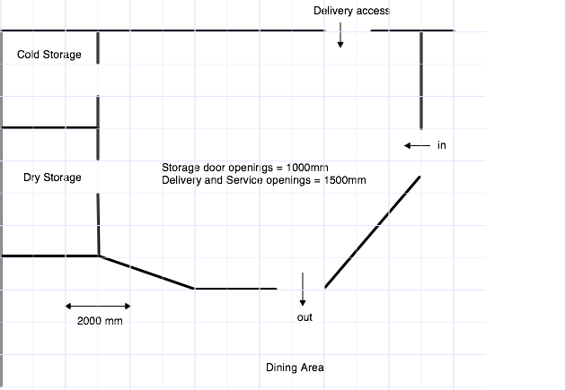
Mathematical Knowledge and Skills and Their Application
Question 1 provides the opportunity for students to demonstrate their knowledge and understanding of ratio and scale and apply this to develop an appropriate scale diagram for a complex context.

- Use the measurements of the available space given in the diagram above to draw a scale plan (viewed from above) of the kitchen space.
All measurements are in millimetres. Use 1cm grid paper. Scale: 1 cm represents 500 mm (1:50).

- Investigate some designs of small commercial kitchens – you may use the Internet, visit one or more businesses, or consider the features of your kitchen at home.
Mathematical Modelling and Problem-solving
Question 2 allows students to develop a mathematical model which leads to mathematical results in an unfamiliar situation.
- Make a copy of your scale diagram and use this to draw a draft plan of a kitchen that would be suitable.
- Clearly indicate the placement of the different required items, and any optional items that you decide to include, as specified in the table below. The kitchen has twin access to and from the dining area.
- No extra walls can be added. Remember the kitchen must be functional. All bottom cupboards will have workbench space above them.
- Justify your decisions regarding the placement of your units in the overall design of your kitchen. This should include the reasonableness and possible limitations of your design and discussion of any assumptions made.
Mathematical Modelling and Problem-solving
Question 2 provides the opportunity for students to demonstrate their understanding of the reasonableness and possible limitations of the results, and recognition of assumptions made.

Items that must be included: electrical | Items that must be included: storage | Optional items
freezer  microwaves  commercial size upright stoves  dishwasher  exhaust hood over the stoves | pot drawers  bottom cupboards  top cupboards  bank of drawers  pantry cupboards  corner cupboards if required | broom cupboard  rubbish bin space  telephone
Other essential items: sinks
Mathematical Modelling and Problem-solving
Questions 3 and 4 provide the opportunity for students to consider possible new mathematical questions to be investigated.

- Accurately plan a kitchen using your design from Question 2. You can use an electronic kitchen planner from the internet.

- Discuss reasons for any changes you have made from your draft plan developed in Question 2.

Mathematical Knowledge and Skills and Their Application
Question 5 provides the opportunity for students to demonstrate their knowledge and understanding of area and costing for a sequential set of instructions, ranging from routine to complex, that lead to a mathematical result of the total cost.
- To finish off the kitchen you need to paint the interior walls and ceiling.

Paint type | Wall paint | Ceiling paint
Number of coats required | 2 | 1
Coverage per litre | 16m² | 10m²
Cost per 10L tin | $54 | $70

If the ceiling is 3.6m high determine the:
- area of each of the interior walls (do not include the inside of the cold or dry storage rooms);

- area of the ceiling;
- amount of paint needed for the walls;
- amount of paint needed for the ceiling;
- total cost of painting the walls and ceiling of the kitchen.

Communication of Mathematical Information
- The sequential set of questions that require building on previous answers provides opportunities for students to demonstrate their ability to communicate mathematical ideas and reasoning to develop logical arguments.
- Use of appropriate mathematical notation (appropriate use of ratios and units), representations (scale and other diagrams), and terminology (e.g. correct labelling for area and cost calculations) are required throughout the task.

ELECTRICAL PATHWAY

Background Information
The design of a kitchen is often determined by the space that is available and the individual requirements of the users, particularly the convenience of working in it.
The following tasks relate to a small commercial kitchen.
Task
Complete these tasks in the order in which they are listed.
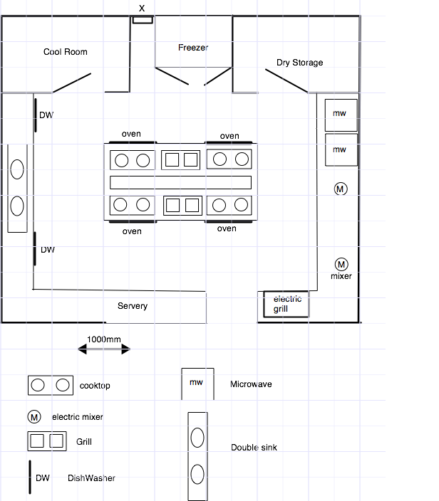

A typical commercial kitchen layout is shown above. The point X indicates the position of the internal circuit breaker box for the kitchen. The box is positioned 2m from the floor and the ceiling is 3.6m high.
- Use the measurements of the available space to draw a scale plan (viewed from above) of the kitchen space, without appliances or cupboards. Ensure that you clearly indicate all dimensions on your plan. All measurements are in millimetres. Scale: 1 cm represents 500 mm (1:50).
- Make a copy of your scale diagram, include the spot X, and use this diagram for the remainder of this task.
Mathematical Knowledge and Skills and Their Application
Question 1 provides the opportunity for students to demonstrate their knowledge and understanding of ratio and scale and apply this to develop an appropriate scale diagram for a complex context.
- Clearly indicate the probable position of electrical outlets (power points) needed for all the electrical appliances indicated. Note: the ovens are hard-wired directly back to the fusebox so they do not require power point outlets. All the cooktops are gas, not electric.
- Justify your decisions regarding the placement of the electrical outlets. This should include the reasonableness and possible limitations of your design and discussion of any assumptions made.
Mathematical Modelling and Problem-solving
Question 2 allows students to develop a mathematical model which leads to mathematical results in an unfamiliar situation.
- A downlight, positioned in a 3.6m high ceiling, causes a circle of light of diameter 1.5m to illuminate the bench-top. Determine the spacing of downlights required to illuminate all the bench tops and workspaces, assuming little or no overlap of the illumination, in the kitchen.
- How many downlights are needed?
Mathematical Modelling and Problem-solving
Question 2 provides the opportunity for students to demonstrate their understanding of the reasonableness and possible limitations of the results, and recognition of assumptions made.
- Indicate on the scale diagram developed in Question 2 positions of the downlights to provide sufficient lighting for all workspace areas.
Assume that regulations allow for 15 downlights to be connected to the same cable whereas only ten 10A power points are able to be connected to the same cable. Each oven needs to be connected to its own individual circuit. The cabling for the central workspace (where the ovens are positioned) is fed through a vertical channel from the ceiling down to the middle.
- Determine the minimum amount of electrical cable required to connect:
- all of the lights back to the point X;
- all of the power-points back to the point X;
Mathematical Knowledge and Skills and Their Application
Questions 3 and 4 provide the opportunity for students to use appropriate algorithms and techniques to find solutions to complex problems by varying the initial constraints.
- all of the ovens back to the point X.
- Due to constraints caused by the ceiling construction, the electrical cables can only run, with 90º bends, horizontally or vertically across the ceiling. How does this affect the minimum length of cable required to connect all the lights back to the point X?
- Similarly, the wiring in the walls can only run vertically or horizontally across the walls. How does this affect the minimum length of cable required to connect all the power points and the ovens back to the point X?
- Assume that lighting requires 1.5 mm² electrical cable, whereas power requires 2.5 mm² electrical cable, and ovens require 3.5 mm² electrical cable due to their high power requirement.
Mathematical Knowledge and Skills and Their Application
Questions 6 & 7 provide opportunity for students to demonstrate their knowledge and understanding of length and area, and perform costing calculations for more complex problems.

Cable size | 1.5 mm² | 2.5 mm² | 3 mm²
Cost per metre | $1.95 | $ 2.65 | $ 4.85

Use the cabling costs indicated in the table above and your results obtained from Question 4 to calculate the cost of all the cable required to complete the wiring of the kitchen.
- To fully illuminate the bench tops and workspaces the downlights should be positioned so that the diameters of their illumination overlap by 25%. Recalculate the spacing and, hence, the number of downlights required to effectively illuminate all the bench tops and workspaces.
Mathematical Modelling and Problem-solving
Questions 5, 6, and 8 provide the opportunity for students to consider possible new mathematical questions to be investigated.

Communication of Mathematical Information
- The sequential set of questions that require building on previous answers provides opportunities for students to demonstrate their ability to communicate mathematical ideas and reasoning to develop logical arguments.
- Use of appropriate mathematical notation (appropriate use of ratios and units), representations (scale and other diagrams), and terminology (e.g. correct labelling for length and cost calculations) are required throughout the task.

