Stage 2 Specialist Mathematics

Assessment Type 2: Mathematical Investigation

Topic 6: Rates of Change and Differential Equations

The study of predator-prey models

Introduction

Differential equations may be developed to model the situation of predator-prey interactions. Usually, in models of a single population, the growth rate of the population and the carrying capacity of the environment are considered. In predator-prey situations populations are interacting and therefore affecting each other’s population growth. Examples of pairs of predator-prey species may be lions and gazelles, birds and insects, rabbits and dingos.

**Task 1**

The numbers of predator and prey populations was studied over a number of years.

The following graph results from the years of study:

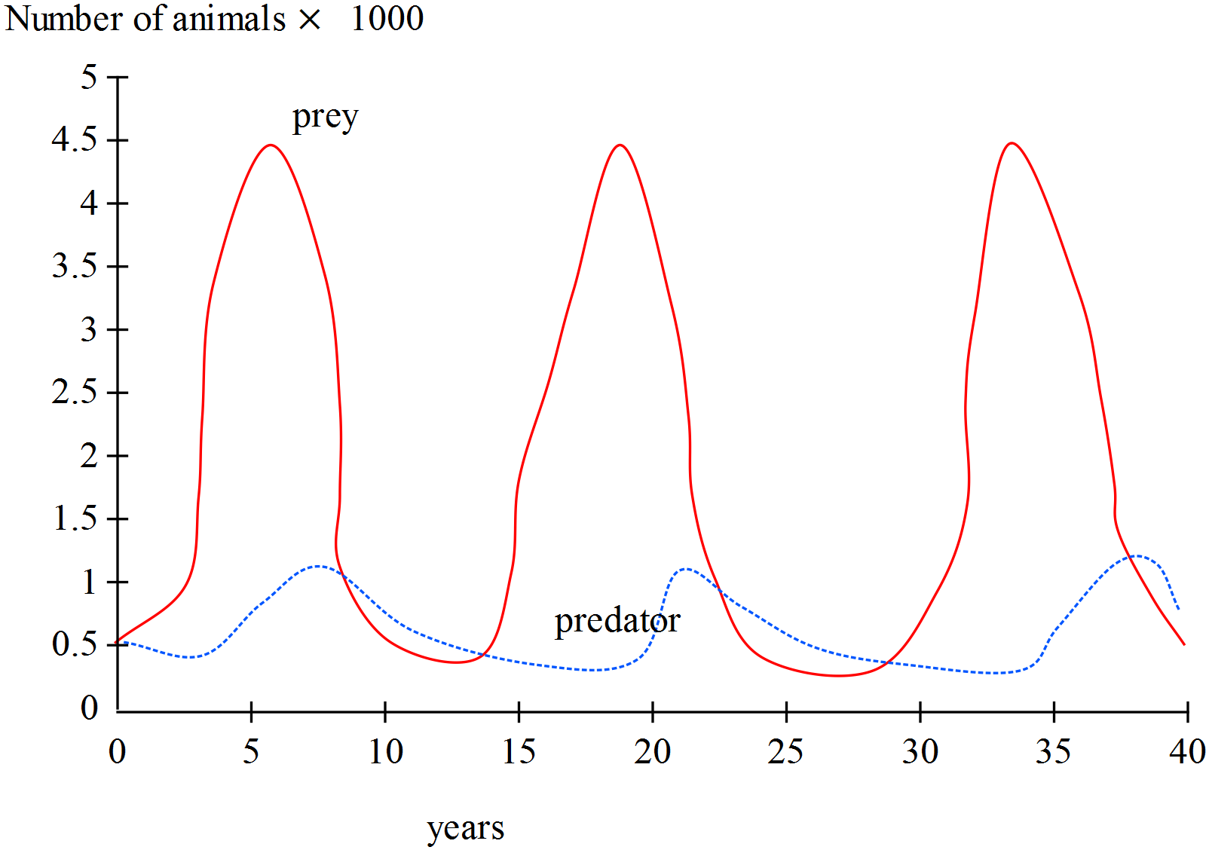

1. Discuss the possible average period of oscillations of both populations and the timing of, on average, the peaks and troughs of the population numbers. Is there a lag between peaks of predator population and the troughs of prey populations? If so, by how much do they differ (perhaps find a measure of the difference as a fraction of the average period).
2. What would be some of the assumptions made when modelling these two populations?

**Task 2**

The Lotka-Volterra Model for predator-prey systems may be developed using basic growth models as a basis. For instance, consider a prey species population at time *t* as 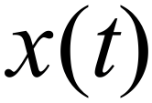.

With the situation of no predators, the population of prey will grow exponentially, 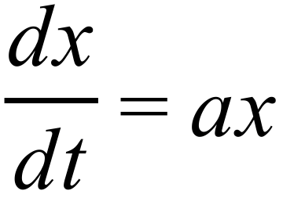 where *a* is a positive constant. However, there are predators, 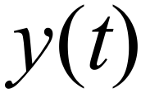. The assumptions for developing the predator-prey model are that the rate of interaction between the two species is proportional to the product of the sizes of the populations and that a fixed proportion of the interactions lead to the death of prey. This means that a negative component of 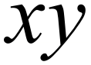 affects the population of the prey. So the differential equation becomes:

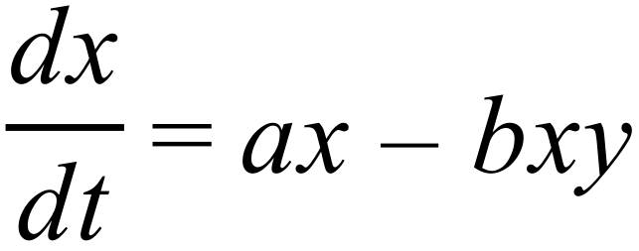 where *b* is a positive constant.

1. Using this above information in a similar way it may be established that the growth rate of the predator species is given by 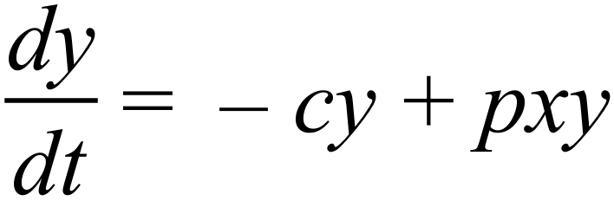 where *c* and *p* are positive constants.

Discuss how this differential equation, used to describe the predator population growth, was developed.

1. Consider the case when the system of equations results in a stable population of no change in the population of either species. This means the rate of growth of each species is zero (that is 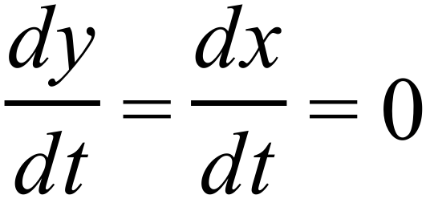 ).

Let 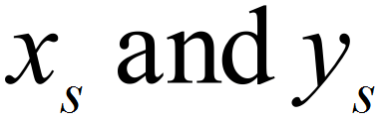 represent the stable populations, where 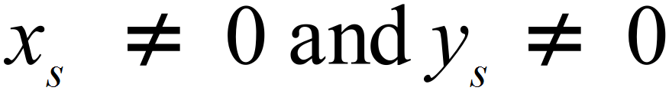 , and find 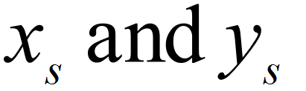 in terms of the non-zero positive constants *a*, *b*, *c* and *p*. Discuss the meaning of this situation.

Find an expression for 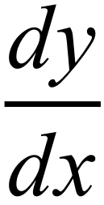 given that 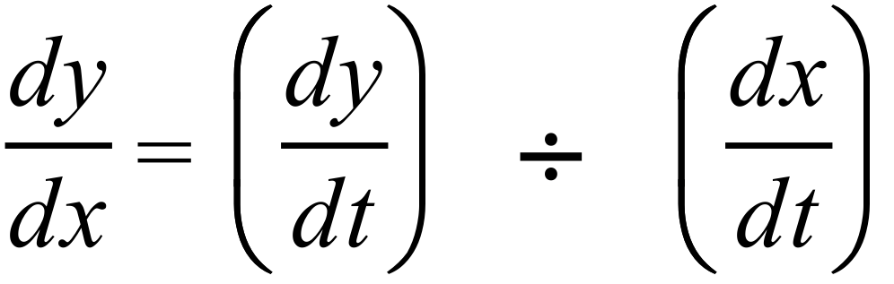 .

Separate the variables and integrate to obtain a solution for the differential equation in terms of x and y and a constant of integration.

Using the following values for the constants a, b, c, and p and the initial conditions to find a solution curve. Let a = 1, b = 0.03, c = 0.4, p = 0.01 and initial conditions x(0) = 10 and y(0) = 20.

Using a graphing package draw the solution curve.

On your curve mark the position of the point 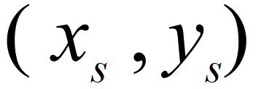 using the values given for a, b, c and p. Interpret this result.

Draw a vertical line through 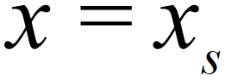 . What can you deduce about the values of 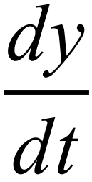 on this line? What is happening to the values of  on this line?

Draw a horizontal line through 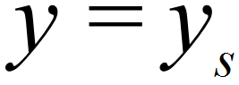 and discuss the values of 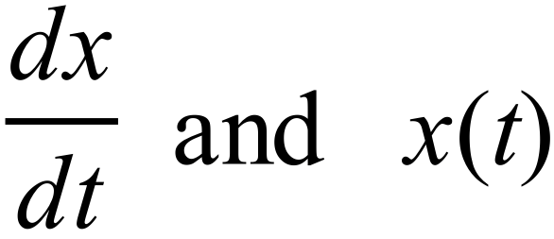 on this line. Consider the signs of 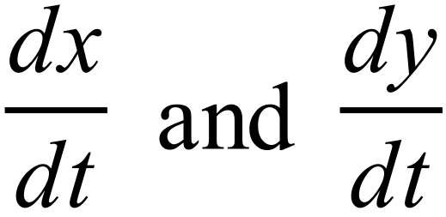 in each of the sections of the graph produced by the vertical and horizontal lines and explain what the signs mean with respect to the predator and prey populations.

**Task 3**

The following graph displays slope field for solutions to the differential equations  .

The curve shown is the solution curve for the given values of *a*, *b*, *c* and *p* and the initial conditions stated above. The cross represents the equilibrium state of 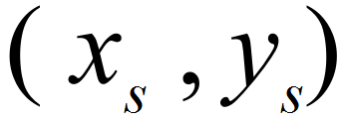 for the values of *a*, *b*, *c* and *p* given.



Experiment with increasing and decreasing each coefficient (*a*, *b*, *c* and *p*)while leaving the other three coefficients the same. Leave the initial conditions as set earlier.

For each change discuss

* how the equilibrium point changes
* how the solution curve changes
* the resulting changes to the populations and their interactions.

**Task 4**

Another system of equations is given below. In this system there may be two species with unlimited access to food, but who tend to fight each other when they meet.

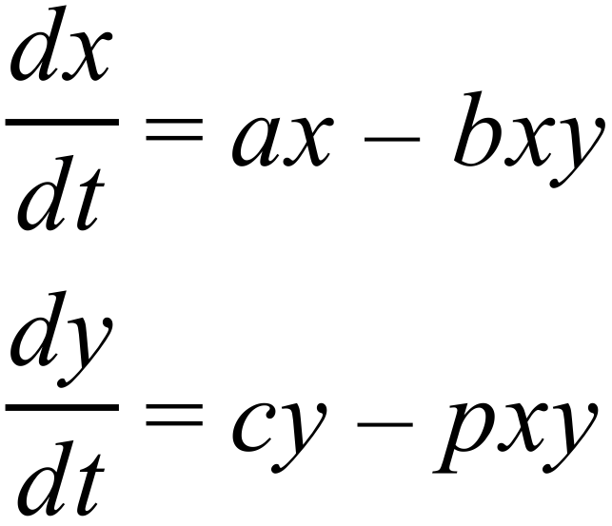

where *a*, *b*, *c* and *d* are positive constants.

Explain, in terms of the biological scenario, the different sign in this system compared to the previous system described in Task 2.

This new system also has a stable population point, or equilibrium point. Using the same process as that in Task 2 find the equilibrium or stable populations 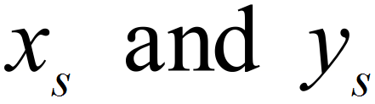 in terms of the constants (where  are not zero).

If *a* = 1, *b* = 0.1, *c* = 1 and *p* = 0.2 the slope field for the solutions to the system becomes:

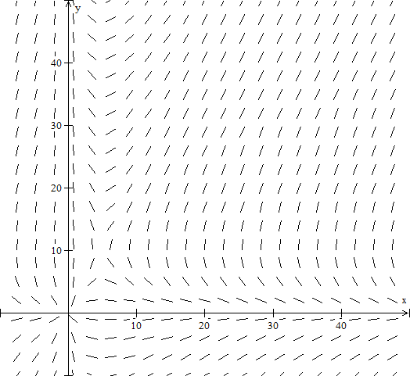

Calculate the coordinates of the equilibrium point  and label it on the above graph.

For each of the coefficients *a*, *b*, *c* and *p* experiment with increasing and decreasing that coefficient while leaving the other three unchanged. Leave the initial conditions as set earlier.

For each change discuss:

* how the equilibrium point changes
* how the solution curve changes
* the resulting changes to the populations and their interactions.

Discuss what happens if the populations are not exactly at the stable population point. What does this mean to the species?

**The format of the investigation report may be written or multimodal.**

**The report should include the following:**

* **an outline of the problem and context**
* **the method required to find a solution, in terms of the mathematical model or strategy used**
* **the application of the mathematical model or strategy, including**
* relevant data and/or information
* mathematical calculations and results, using appropriate representations
* the analysis and interpretation of results, including consideration of the reasonableness and limitations of the results
* **the results and conclusions in the context of the problem.**

**A bibliography and appendices, as appropriate, may be used.**

**The investigation report, excluding bibliography and appendices if used, must be a maximum of 15 A4 pages if written, or the equivalent in multimodal form.**

The maximum page limit is for single-sided A4 pages with minimum font size 10. Page reduction, such as 2 A4 pages reduced to fit on 1 A4 page, is not acceptable. Conclusions, interpretations and/or arguments that are required for the assessment must be presented in the report, and not in an appendix. Appendices are used only to support the report, and do not form part of the assessment decision.

Performance Standards for Stage 2 Specialist Mathematics

| - | Concepts and Techniques | Reasoning and Communication |
| --- | --- | --- |
| A | Comprehensive knowledge and understanding of concepts and relationships.  Highly effective selection and application of mathematical techniques and algorithms to find efficient and accurate solutions to routine and complex problems in a variety of contexts.  Successful development and application of mathematical models to find concise and accurate solutions.  Appropriate and effective use of electronic technology to find accurate solutions to routine and complex problems. | Comprehensive interpretation of mathematical results in the context of the problem.  Drawing logical conclusions from mathematical results, with a comprehensive understanding of their reasonableness and limitations.  Proficient and accurate use of appropriate mathematical notation, representations, and terminology.  Highly effective communication of mathematical ideas and reasoning to develop logical and concise arguments.  Effective development and testing of valid conjectures, with proof. |
| B | Some depth of knowledge and understanding of concepts and relationships.  Mostly effective selection and application of mathematical techniques and algorithms to find mostly accurate solutions to routine and some complex problems in a variety of contexts.  Some development and successful application of mathematical models to find mostly accurate solutions.  Mostly appropriate and effective use of electronic technology to find mostly accurate solutions to routine and some complex problems. | Mostly appropriate interpretation of mathematical results in the context of the problem.  Drawing mostly logical conclusions from mathematical results, with some depth of understanding of their reasonableness and limitations.  Mostly accurate use of appropriate mathematical notation, representations, and terminology.  Mostly effective communication of mathematical ideas and reasoning to develop mostly logical arguments.  Mostly effective development and testing of valid conjectures, with substantial attempt at proof. |
| C | Generally competent knowledge and understanding of concepts and relationships.  Generally effective selection and application of mathematical techniques and algorithms to find mostly accurate solutions to routine problems in a variety of contexts.  Successful application of mathematical models to find generally accurate solutions.  Generally appropriate and effective use of electronic technology to find mostly accurate solutions to routine problems. | Generally appropriate interpretation of mathematical results in the context of the problem.  Drawing some logical conclusions from mathematical results, with some understanding of their reasonableness and limitations.  Generally appropriate use of mathematical notation, representations, and terminology, with reasonable accuracy.  Generally effective communication of mathematical ideas and reasoning to develop some logical arguments.  Development and testing of generally valid conjectures, with some attempt at proof. |
| D | Basic knowledge and some understanding of concepts and relationships.  Some selection and application of mathematical techniques and algorithms to find some accurate solutions to routine problems in some contexts.  Some application of mathematical models to find some accurate or partially accurate solutions.  Some appropriate use of electronic technology to find some accurate solutions to routine problems. | Some interpretation of mathematical results.  Drawing some conclusions from mathematical results, with some awareness of their reasonableness or limitations.  Some appropriate use of mathematical notation, representations, and terminology, with some accuracy.  Some communication of mathematical ideas, with attempted reasoning and/or arguments.  Attempted development or testing of a reasonable conjecture. |
| E | Limited knowledge or understanding of concepts and relationships.  Attempted selection and limited application of mathematical techniques or algorithms, with limited accuracy in solving routine problems.  Attempted application of mathematical models, with limited accuracy.  Attempted use of electronic technology, with limited accuracy in solving routine problems. | Limited interpretation of mathematical results.  Limited understanding of the meaning of mathematical results, their reasonableness, or limitations.  Limited use of appropriate mathematical notation, representations, or terminology, with limited accuracy.  Attempted communication of mathematical ideas, with limited reasoning.  Limited attempt to develop or test a conjecture. |