**STAGE 1 MATHEMATICS**

**ASSESSMENT TYPE 2: MATHEMATICAL INVESTIGATION**

**VECTORS APPLICATION – BÉZIER CURVES**

Quadratic Bézier Curves may be used to model the path of a point between two set points and one control point. The following is an example of how to produce the parametric equations of a moving point, *S*, on a Bézier curve. It does not need to be part of the final report.

Consider two points *A*(-3, 4) and *B*(2, 5). A point between *A* and *B* called *P* represents a pencil tip moving along the line segment *AB*. The movement of this tip can be modelled by producing parametric equations:

**Introduction**

1. If the point *P* divides the segment *AB* in a ratio of $t :1-t$, find if it is *t* units along *AB*. Note that for Bézier curves the value for *t* is such that $0≤t≤1$.

P

O

B

*t*

1 - *t*

A

Do the calculations here:

The vector equation for a moving point *P* is =

The parametric equations for moving point *P* are:

1. Now do the same to obtain the parametric equations for a point *Q* along the line segment *BC* if *C* is (4, -6) and *Q* divides the segment *BC* in the ratio $t :1-t$. Include a diagram below which is an extension of the diagram above and show calculations for the development of the vector equation for and the parametric equations for the point *Q*.

The vector equation for the moving point *Q*:  =

The parametric equations for the moving point *Q*:

1. Consider *PQ* is a moving (invisible) line segment. The point *S* divides this line in the ratio $t :1-t$. The point *S* moves along *PQ* as *P* moves on *AB* and *Q* moves on *BC*. As *S* moves along  then . Using results for  and , find  and the parametric equations for the point *S*.

Using the points *A*, *B* and *C* and the moving points *P* and *Q*, the movement of *S* is traced out as shown in the diagram below using software, such as Geogebra.

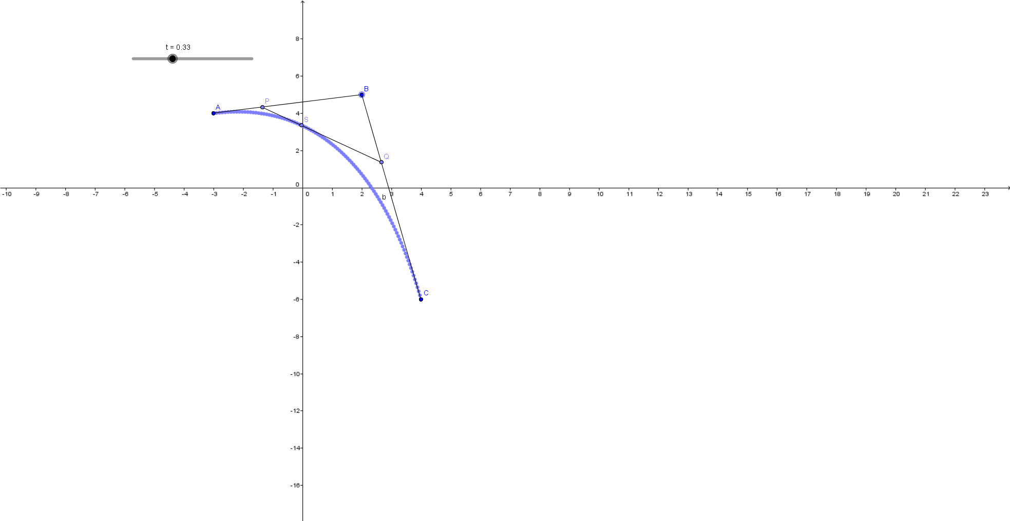

**Task**

Using the approach above, design an application or scenario where Bézier curves could be used. For example,

* Two Trapeze Artists swing to have one catch the other and their movement may be modelled by Bézier curves. Find their parametric equations and the point of contact.
* One missile is launched and another must be launched at a different site to collide with it.
* Your own idea!

Your report on the mathematical investigation should include the following:

* an outline of the problem and context
* the method required to find a solution, in terms of the mathematical model or strategy used
* the application of the mathematical model or strategy, including:
  + relevant data and/or information
  + mathematical calculations and results, using appropriate representations
  + the analysis and interpretation of results, including consideration of the reasonableness and limitations of the results
* the results and conclusions in the context of the problem
* a bibliography and appendices, as appropriate.

The format of an investigation report may be written or multimodal.

The investigation report should be a **maximum of 8 A4 pages** if written, or the equivalent in multimodal form.

**Assessment Design Criteria**

**Concepts and Techniques**

CT1 Knowledge and understanding of concepts and relationships

CT2 Selection and application of mathematical techniques and algorithms to find solutions to problems in a variety of contexts

CT3 Application of mathematical models

CT4 Use of electronic technology to find solutions to mathematical problems

**Reasoning and Communication**

RC1 Interpretation of mathematical results

RC2 Drawing conclusions from mathematical results, with an understanding of their reasonableness and limitations

RC3 Use of appropriate mathematical notation, representations, and terminology

RC4 Communication of mathematical ideas and reasoning to develop logical arguments

RC5 Development and testing of valid conjectures

Performance Standards for Stage 1 Mathematics

|  |  |  |
| --- | --- | --- |
|  | **Concepts and Techniques** | **Reasoning and Communication** |
| **A** | Comprehensive knowledge and understanding of concepts and relationships.  Highly effective selection and application of mathematical techniques and algorithms to find efficient and accurate solutions to routine and complex problems in a variety of contexts.  Successful development and application of mathematical models to find concise and accurate solutions.  Appropriate and effective use of electronic technology to find accurate solutions to routine and complex problems. | Comprehensive interpretation of mathematical results in the context of the problem.  Drawing logical conclusions from mathematical results, with a comprehensive understanding of their reasonableness and limitations.  Proficient and accurate use of appropriate mathematical notation, representations, and terminology.  Highly effective communication of mathematical ideas and reasoning to develop logical and concise arguments.  Effective development and testing of valid conjectures. |
| **B** | Some depth of knowledge and understanding of concepts and relationships.  Mostly effective selection and application of mathematical techniques and algorithms to find mostly accurate solutions to routine and some complex problems in a variety of contexts.  Some development and successful application of mathematical models to find mostly accurate solutions.  Mostly appropriate and effective use of electronic technology to find mostly accurate solutions to routine and some complex problems. | Mostly appropriate interpretation of mathematical results in the context of the problem.  Drawing mostly logical conclusions from mathematical results, with some depth of understanding of their reasonableness and limitations.  Mostly accurate use of appropriate mathematical notation, representations, and terminology.  Mostly effective communication of mathematical ideas and reasoning to develop mostly logical arguments.  Mostly effective development and testing of valid conjectures. |
| **C** | Generally competent knowledge and understanding of concepts and relationships.  Generally effective selection and application of mathematical techniques and algorithms to find mostly accurate solutions to routine problems in a variety of contexts.  Successful application of mathematical models to find generally accurate solutions.  Generally appropriate and effective use of electronic technology to find mostly accurate solutions to routine problems. | Generally appropriate interpretation of mathematical results in the context of the problem.  Drawing some logical conclusions from mathematical results, with some understanding of their reasonableness and limitations.  Generally appropriate use of mathematical notation, representations, and terminology, with reasonable accuracy.  Generally effective communication of mathematical ideas and reasoning to develop some logical arguments.  Development and testing of generally valid conjectures. |
| **D** | Basic knowledge and some understanding of concepts and relationships.  Some selection and application of mathematical techniques and algorithms to find some accurate solutions to routine problems in some contexts.  Some application of mathematical models to find some accurate or partially accurate solutions.  Some appropriate use of electronic technology to find some accurate solutions to routine problems. | Some interpretation of mathematical results.  Drawing some conclusions from mathematical results, with some awareness of their reasonableness or limitations.  Some appropriate use of mathematical notation, representations, and terminology, with some accuracy.  Some communication of mathematical ideas, with attempted reasoning and/or arguments.  Attempted development or testing of a reasonable conjecture. |
| **E** | Limited knowledge or understanding of concepts and relationships.  Attempted selection and limited application of mathematical techniques or algorithms, with limited accuracy in solving routine problems.  Attempted application of mathematical models, with limited accuracy.  Attempted use of electronic technology, with limited accuracy in solving routine problems. | Limited interpretation of mathematical results.  Limited understanding of the meaning of mathematical results, their reasonableness or limitations.  Limited use of appropriate mathematical notation, representations, or terminology, with limited accuracy.  Attempted communication of mathematical ideas, with limited reasoning.  Limited attempt to develop or test a conjecture. |