Science as a Human Endeavour Investigation – Organic Chemistry
This task has a focus on science as a human endeavour; how science interacts with society.
Select and explore a recent discovery, innovation, issue, or advancement linked to your learning in the organic chemistry section. Examples could come from the use of polymers, alternative fuels for transport or new materials.
Use one or more of the key concepts of science as a human endeavour to develop a focus for your investigation. Make your topic quite specific to enable you to analyse information in depth.

Part A: Information Search and Planning
Use the internet and other sources of information to do an initial search related to one aspect of organic chemistry you have studied. Record the resources in a reference list to assist in your selection of information for your report.
Check your sources and the topic you have chosen with your teacher before you proceed.
Date Due:
Search for any further information that will enable you to provide a comprehensive and detailed report, with relevant chemistry.
Choose the format of your work. The report may be presented in any suitable format; suggestions include interview with an expert, newspaper article, multimedia presentation or poster.
Check in with your teacher for feedback.
Date Due:

Part B: Report
Your report should include:
- A clear explanation of the connection of your topic to science as a human endeavour
- Relevant organic chemistry concepts
- An analysis of your findings about this topic
- A conclusion
- In text referencing and a reference list

Assessment Conditions:
Some class time is provided for research and support. Students have 3 weeks to complete the task.
Students may submit one draft for feedback.
Word Count: maximum of 1000 words or 6 minutes for an oral presentation.

Assessment Design Criteria
Investigation, Analysis and Evaluation: IA 3 Knowledge and Application: KA 3, 4
Performance Standards for Stage 1 Chemistry
 |  | A | B | C | D | E
Investigation, Analysis and Evaluation | 1  2  3  4 | Designs a logical, coherent, and detailed chemistry investigation.  Obtains records, and represents data using appropriate conventions and formats accurately and highly effectively.  Systematically analyses and interprets data and evidence to formulate logical conclusions.  Critically and logically evaluates procedures and their effects on data. | Designs a well-considered and clear chemistry investigation.  Obtains, records, and represents data using appropriate conventions and formats mostly accurately and effectively.  Logically analyses and interprets data and evidence to formulate suitable.  Logically evaluates procedures and their effects on data. | Designs a considered and generally clear chemistry investigation.  Obtains, records, and represents data using generally appropriate conventions and formats with some errors but generally accurately and effectively.  Undertakes some analysis and interpretation of data and evidence to formulate generally appropriate conclusions.  Evaluates procedures and some of their effects on data. | Prepares the outline of a chemistry investigation.  Obtains, records, and represents data using conventions and formats inconsistently, with occasional accuracy and effectiveness.  Describes data and undertakes some basic interpretation to formulate a basic conclusion.  Attempts to evaluate procedures or suggest an effect on data. | Identifies a simple procedure for a chemistry investigation.  Attempts to record and represent some data with limited accuracy or effectiveness.  Attempts to describe results and/or interpret data to formulate a basic conclusion.  Acknowledges that procedures affect data.
Knowledge and Application | 1  2  3  4 | Demonstrates deep and broad knowledge and understanding of a range of chemical concepts.  Develops and applies chemical concepts highly effectively in new and familiar contexts.  Critically explores and understands in depth the interaction between science and society.  Communicates knowledge and understanding of chemistry coherently with highly effective use of appropriate terms, conventions and representations. | Demonstrates some depth and breadth of knowledge and understanding of a range of chemical concepts.  Develops and applies chemical concepts mostly effectively in new and familiar contexts.  Logically explores and understands in some depth the interaction between science and society.  Communicates knowledge and understanding of chemistry mostly coherently with effective use of appropriate terms, conventions, and representations. | Demonstrates knowledge and understanding of a general range of chemical concepts.  Develops and applies chemical concepts generally effectively in new or familiar contexts.  Explores and understands aspects of the interaction between science and society.  Communicates knowledge and understanding of chemistry generally effectively using some appropriate terms, conventions, and representations. | Demonstrates some basic knowledge and partial understanding of chemical concepts.  Develops and applies some chemical concepts in familiar contexts.  Partially explores and recognises aspects of the interaction between science and society.  Communicates basic chemical information, using some appropriate terms, conventions, and/or representations. | Demonstrates some limited recognition and awareness of chemical concepts.  Attempts to develop and apply chemical concepts in familiar contexts.  Attempts to explore and identify an aspect of the interaction between science and society.  Attempts to communicate information about chemistry.

Which drug are you after; Iodine or Lodine? Look confusing?
Or perhaps Brintellix or Brilinta – sound confusing?
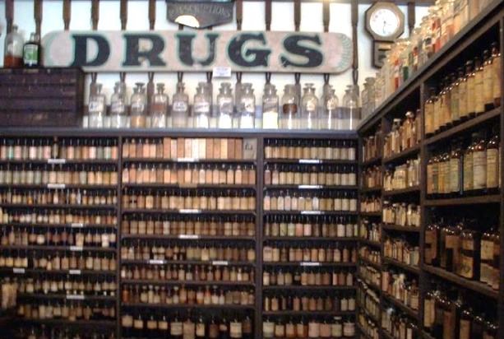¹
Confusion between drugs with similar names has been one of the most common causes of medication error all over the world for some time. ²
Drug Confusion
“An 8-year-old died, it was suspected, after receiving methadone instead of methylphenidate, a drug used to treat attention deficit disorders. A 19-year-old man showed signs of potentially fatal complications after he was given clozapine instead of olanzapine, two drugs used to treat schizophrenia. And a 50-year-old woman was hospitalized after taking Flomax, used to treat the symptoms of an enlarged prostate, instead of Volmax, used to relieve bronchospasm. ³
These are some examples of serious situations that occurred because the name of a prescribed drug looked or sounded like the name of a very different drug. The Institute of Medicine estimates that more than 1.5 million Americans are sickened, injured or killed each year by errors in prescribing, dispensing and taking medications.4 Medical error is the third leading cause of death in the US, after heart disease and cancer making it vital to avoid what are called LASAs: lookalikes, sound-alikes.
Control of naming
Science is a global enterprise that relies on clear communication and international conventions. The conventions used for naming drugs should be easily understood by health practitioners and consumers to avoid confusion about what substance is being prescribed.
Communication and Collaboration SHE key concept
The naming of drugs is controlled by various authorities in individual countries. The Therapeutic Goods Administration, TGA, is a branch of the Australian Government Department of Health that regulates medicines available in Australia.
In America the Food and Drug Administration (FDA) has a division of Medication Error Prevention and Analysis, which reviews about 400 brand names (proprietary names) a year and another two departments that check each proposed name prior to approval.³ About one-third are rejected in order to avoid confusion with other drugs. This process involves considerable collaboration between health professionals to allocate unique names. The last time the FDA changed a drug name after it was approved was in 2005, when the diabetes drug Amaryl was being confused with the Alzheimer's medication Reminyl, and one person died. Now the Alzheimer's medicine is called Razadyne.⁴
How drugs are named
The Therapeutic Goods Administration, TGA, is a branch of the Australian Government Department of Health that regulates medicines available in Australia. 5 They approve the names of drugs sold in Australia. Each drug has three names; a chemical name, a generic name and usually one or more brand names. The chemical name follows systematic chemistry rules, established by the International Union of Pure and Applied Chemistry, which describe the structure of the molecule. When a company releases a new drug they apply for a patent and a trademark brand name. Once a patent has expired any company can then sell the drug under the generic name. New generic names must meet standards set by the World Health Organisation's International Non-proprietary Names (INN)⁸ This step assures that there is one nonproprietary (generic) name throughout the world for the drug.⁴
Chemistry concept linked to SHE Communication and Collaboration
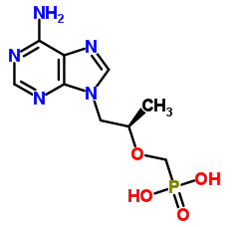
The chemical formula is the name that really defines the drug. The chemical name of one drug, tenofovir, used to treat HIV infection is ({[(2R)-1-(6-amino-9H-purin-9-yl)propan-2-yl]oxy}methyl)phosphonic acid. Try saying that 3 times quickly!
Relevant Chemistry concept
structural formula of tenofovir.⁶
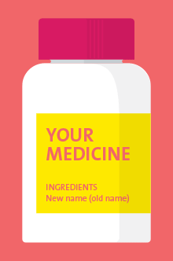
Some of the information contained in this name is that the basic molecule is phosphonic acid with side groups such as methyl and amino. However the brand name describes its structure, function and molecular targets. The scientists who discovered tenovir came up with this much more convenient and memorable name. The stem describes the structure and function and the ending, –vir, describes the target; a virus.⁷
Influence of society on naming
Companies use brand names where possible not only because of their simpler pronunciation. Brand names are designed to sound more effective or impressive than the generic names. Consumers reinforce this practice because they are willing to pay more for drugs with more impressive names. This illustrates how the use of scientific knowledge can be influenced by social considerations. Many drug companies even use consultants who specialise in creating new names for drugs that appeal to both doctors and patients.²
Influence SHE key concept
Naming in different countries
The fact that a drug is known by several different names can be a source of confusion for consumers. One example of a very commonly used drug is para-acetylaminophenol, which is known generically as paracetamol in Australia, Britain and some other countries but is known as acetaminophen in the United States and other countries. Added to this confusion are the number of different brand names, such as Panadol and Tylenol. Confusion for consumers because brand names are different from chemical name and there are also different brand names. If a person is use to using Panadol for headaches and is offered paracetamol by a pharmacy assistant they may be unwilling to take a cheaper generic brand because they believe that only Panadol will be effective.
Influence SHE key concept
Collaboration for minimising risks
In an attempt to minimise the confusion for consumers between drug names, the regulatory authorities in different countries have collaborated over recent years to produce registers of drugs with names that are the same in the different countries. The TGA has recently included more than 200 medicine ingredients on a list of drugs that will have their names changed on medicine labels over four years, ending in April 2020.⁸ This is so that they will have the same names in Australia as in other countries.
Collaboration, Application SHE key concept
Monitoring and evaluating risk of use of scientific knowledge
Some medicines with high risks such as lignocaine, which will become lidocaine, will have seven years to transition to the new names. During this time the new name will be printed on the label with old name following in brackets, as shown in this diagram.⁸
Others will simply have minor spelling changes such as amoxycillin, which will become amoxicillin.
The reliable provision of pharmaceutical products to consumers globally relies on effective communication between scientists, health practitioners and consumers. This requires standardised conventions in the naming of pharmaceutical products to avoid confusion in prescription, supply and consumption of these chemicals.
Conclusion shows the connection between the SHE key concepts and the solution

Reference List

1. Nial Wheate June 2013 The Conversation Can’t pronounce the name of your medicine? Here’s why http://theconversation.com/cant-pronounce-the-name-of-your-medicine-heres-why-15416
2. Look-Alike, Sound-Alike Medication Names, May 2007, http://www.who.int/patientsafety/solutions/patientsafety/PS-Solution1.pdf
3. Scutti S 2016 Creation Engineering: The art and science of naming drugs, http://edition.cnn.com/2016/11/25/health/art-of-drug-naming/index.html
4. Drug Name Confusion: Preventing Medication Errors, Carol Rados, http://www.medicinenet.com/script/main/art.asp?articlekey=53208 accessed 13/6/17
5. Therapeutic Goods Administration https://www.tga.gov.au/who-we-are-what-we-do
6. Chem Spider http://www.chemspider.com/Chemical-Structure.408154.html
7. Boyle R, 2013, How does a drug get its name? Australian Popular Science, http://www.popsci.com.au/science/fyi-how-does-a-drug-get-its-name,379461
8. Updating medicine ingredient names - list of affected ingredients
https://www.tga.gov.au/updating-medicine-ingredient-names-list-affected-ingredients
9. Wikipedia hexachlorophene https://en.wikipedia.org/wiki/Hexachlorophene accessed 13/6/17
10. ChemSpider hexachlorophene http://www.chemspider.com/Chemical-Structure.3472.html?rid=0c71f2f9-7bfa-4a7f-9834-a5c7027040aa accessed 13/6/17

