Stage 2 Biology

Assessment Type 2: Skills and Applications Tasks

Macromolecules Test

Purpose

This task allows students to demonstrate their knowledge and understanding of the concepts of macromolecules.

Description of the assessment

This test assesses:

* knowledge and understanding of concepts of macromolecules, including DNA structure, transcription, translation and protein synthesis, enzyme activity, replication, genetic manipulation, genetic evolution, social issues
* application of concepts related to macromolecules in new and familiar contexts
* communication of the concepts related to macromolecules using different formats
* analysis and evaluation of data from investigations.

Assessment conditions

* Time allowance: 90 minutes

|  |  |  |
| --- | --- | --- |
| ***Learning Requirements*** | ***Assessment Design Criteria*** | ***Capabilities*** |
| 1. identify and formulate questions, hypotheses, concepts, and purposes that guide biological investigations  2. design and conduct individual and collaborative biological investigations  3. manipulate apparatus and use technological tools and numeracy skills to obtain, represent, analyse, interpret, and evaluate data and observations from biological investigations  4. select and critically evaluate biological evidence from different sources and present informed conclusions and personal views on social, ethical, and environmental issues  5. communicate their knowledge and understanding of biological concepts using appropriate biological terms and conventions  6. demonstrate and apply biological knowledge and understanding of concepts and interrelationships to a range of contexts and problems, including by presenting alternative explanations. | Investigation  The specific features are as follows:  I1 Design of biological investigations.  I2 Selection and acknowledgment of information about biology and issues in biology from different sources.  I3 Manipulation of apparatus and technological tools to implement safe and ethical investigation procedures.  I4 The obtaining, recording, and display of findings of investigations using appropriate conventions and formats.  Analysis and Evaluation  The specific features are as follows:  AE1 Analysis of data and concepts and their connections, to formulate conclusions and make relevant predictions.  AE2 Evaluation of procedures, with suggestions for improvement.  Application  The specific features are as follows:  A1 Application of biological concepts and evidence from investigations to solve problems in new and familiar contexts.  A2 Use of appropriate biological terms, conventions, formulae, and equations.  A3 Demonstration of skills in individual and collaborative work.  Knowledge and Understanding  The specific features are as follows:  KU1 Demonstration of knowledge and understanding of biological concepts.  KU2 Use of knowledge of biology to understand and explain social or environmental issues.  KU3 Communication of knowledge and understanding of biology in different formats. | Communication  Citizenship  Personal Development  Work  Learning |

Performance Standards for Stage 2 Biology

|  | | Investigation | | Analysis and Evaluation | Application | | Knowledge and Understanding |
| --- | --- | --- | --- | --- | --- | --- | --- |
| A | Designs logical, coherent, and detailed biological investigations.  Critically and logically selects and consistently and appropriately acknowledges information about biology and issues in biology from a range of sources.  Manipulates apparatus and technological tools carefully and highly effectively to implement well-organised safe and ethical investigation procedures.  Obtains, records, and displays findings of investigations using appropriate conventions and formats accurately and highly effectively. | | Critically and systematically analyses data and their connections with concepts, to formulate logical and perceptive conclusions and make relevant predictions.  Critically and logically evaluates procedures and suggests a range of appropriate improvements. | | Applies biological concepts and evidence from investigations to suggest solutions to complex problems in new and familiar contexts.  Uses appropriate biological terms, conventions, formulae, and equations highly effectively.  Demonstrates initiative in applying constructive and focused individual and collaborative work skills. | Consistently demonstrates a deep and broad knowledge and understanding of a range of biological concepts.  Uses knowledge of biology perceptively and logically to understand and explain social or environmental issues.  Uses a variety of formats to communicate knowledge and understanding of biology coherently and highly effectively. | |
| B | Designs well-considered and clear biological investigations.  Logically selects and appropriately acknowledges information about biology and issues in biology from different sources.  Manipulates apparatus and technological tools carefully and mostly effectively to implement organised safe and ethical investigation procedures.  Obtains, records, and displays findings of investigations using appropriate conventions and formats mostly accurately and effectively. | | Clearly and logically analyses data and their connections with concepts, to formulate consistent conclusions and make mostly relevant predictions.  Logically evaluates procedures and suggests some appropriate improvements. | | Applies biological concepts and evidence from investigations to suggest solutions to problems in new and familiar contexts.  Uses appropriate biological terms, conventions, formulae, and equations effectively.  Applies mostly constructive and focused individual and collaborative work skills. | Demonstrates some depth and breadth of knowledge and understanding of a range of biological concepts.  Uses knowledge of biology logically to understand and explain social or environmental issues.  Uses a variety of formats to communicate knowledge and understanding of biology coherently and effectively. | |
| C | Designs considered and generally clear biological investigations.  Selects with some focus, and mostly appropriately acknowledges, information about biology and issues in biology from different sources.  Manipulates apparatus and technological tools generally carefully and effectively to implement safe and ethical investigation procedures.  Obtains, records, and displays findings of investigations using generally appropriate conventions and formats with some errors but generally accurately and effectively. | | Analyses data and their connections with concepts, to formulate generally appropriate conclusions and make simple predictions, with some relevance.  Evaluates some procedures in biology and suggests some improvements that are generally appropriate. | | Applies biological concepts and evidence from investigations to suggest some solutions to basic problems in new or familiar contexts.  Uses generally appropriate biological terms, conventions, formulae, and equations with some general effectiveness.  Applies generally constructive individual and collaborative work skills. | Demonstrates knowledge and understanding of a general range of biological concepts.  Uses knowledge of biology with some logic to understand and explain one or more social or environmental issues.  Applies different formats to communicate knowledge and understanding of biology with some general effectiveness. | |
| D | Prepares the outline of one or more biological investigations.  Selects and may partly acknowledge one or more sources of information about biology or an issue in biology.  Uses apparatus and technological tools with inconsistent care and effectiveness and attempts to implement safe and ethical investigation procedures.  Obtains, records, and displays findings of investigations using conventions and formats inconsistently, with occasional accuracy and effectiveness. | | Describes basic connections between some data and concepts, and attempts to formulate a conclusion and make a simple prediction that may be relevant.  For some procedures, identifies improvements that may be made. | | Applies some evidence to describe some basic problems and identify one or more simple solutions, in familiar contexts.  Attempts to use some biological terms, conventions, formulae, and equations that may be appropriate.  Attempts individual work inconsistently, and contributes superficially to aspects of collaborative work. | Demonstrates some basic knowledge and partial understanding of biological concepts.  Identifies and explains some biological information that is relevant to one or more social or environmental issues.  Communicates basic information to others using one or more formats. | |
| E | Identifies a simple procedure for a biological investigation.  Identifies a source of information about biology or an issue in biology.  Attempts to use apparatus and technological tools with limited effectiveness or attention to safe or ethical investigation procedures.  Attempts to record and display some descriptive information about an investigation, with limited accuracy or effectiveness. | | Attempts to connect data with concepts, formulate a conclusion, and make a prediction.  Acknowledges the need for improvements in one or more procedures. | | Identifies a basic problem and attempts to identify a solution in a familiar context.  Uses some biological terms or formulae.  Shows emerging skills in individual and collaborative work. | Demonstrates some limited recognition and awareness of biological concepts.  Shows an emerging understanding that some biological information is relevant to social or environmental issues.  Attempts to communicate information about biology. | |

Year 12 Biology Macromolecules Test

Section A: Multiple Choice

*Answer all questions in this section. (2 marks each)*

1. Studies of macromolecules in cells have shown that

Tests generally begin with straight forward questions assessing **Knowledge and Understanding** which most students should be able to answer correctly.

1. chitin is a structural component of cell membranes.
2. polysaccharides are an important energy reserve in cells.
3. lipids are not a structural component of cell membranes.
4. glycogen is not an important energy reserve in cells.
5. A codon is a group of three

J. tRNA bases that code for one polypeptide chain.

K. tRNA bases that code for one amino acid.

L. mRNA bases that code for one polypeptide chain.

M. mRNA bases that code for one amino acid.

1. Which one of the following statements correctly describes a process that occurs during protein synthesis?

J. tRNA directs the assembling of nucleotide bases in the transcription of mRNA.

K. The sequence of mRNA codons directs that assembling of a polypeptide chain during translation.

L. mRNA is synthesised from free nucleotides in the nucleus during translation.

M. Transcription is a process in which tRNA molecules are synthesised from mRNA codons.

1. The feature of a DNA molecule that leads to the manufacture of a specific polypeptide is the

J. type of sugar in the molecule.

K. the sequence of amino acids.

L. sequence of bases.

M. double helical shape.

1. Refer to the following table, which shows the mRNA codons for the amino acids leucine, glycine, threonine and tyrosine.

|  |  |
| --- | --- |
| **Amino acid** | **mRNA codons for the amino acid** |
| Leucine  Glycine  Threonine  Tyrosine | CUU, CUC, CUA, CUG, UUA, UUG  GGU, GGC, GGA, GGG  ACU, ACC, ACA, ACG  UAU, UAC |

Which one of the following is a **DNA base sequence** that codes for the amino acid sequence:

leucine – glycine – threonine – tyrosine?

J. GAG CCT TGC ATA

K. GAG CCU UGC AUA

L. CUC GGA ACG UAU

M. CTC GGA ACG TAT

1. Refer to the following graph, which shows the energy changes during a chemical reaction that has **not** been catalysed by an enzyme and the energy changes for the same chemical reaction that **has** been catalysed by an enzyme.

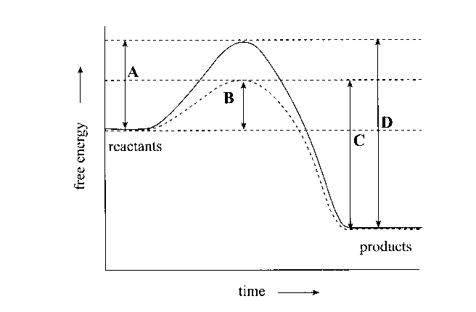

Which letter on the graph indicates the energy of activation for the chemical reaction that has been catalysed by an enzyme?

J. **A**.

K. **B**.

L. **C**.

M. **D**.

1. Increasing the number of samples in an investigation will reduce
2. the effects of random errors and decrease the accuracy of the data.
3. systematic errors and increase the precision of the data.
4. random errors and decrease the resolution of the data.
5. the effects of random errors and increase the reliability of the data.
6. The synthesis of protein with the cell involves the attachment of a molecule of

J. DNA to the surface of a ribosome.

K. messenger RNA to an amino acid molecule.

L. amino acid to a molecule of transfer RNA.

M. DNA to a molecule of amino acid.

1. Refer to the graph below which shows the effect of different levels of pH on the activity of the human enzymes urease and trypsin at 35oC.

Questions such as this allow students to analyse data and their connections with concepts, to formulate conclusions.

1 2 3 4 5 6 7 8 9 10

' ' ' ' ' ' ' ' ' '

pH of solution

Enzyme activity at 35° C

urease

trypsin

Which one of the following combinations of changes in pH and in temperature would result in the greatest increase in activity of the enzyme named?

|  |  |  |  |
| --- | --- | --- | --- |
|  | **Enzyme** | **Change in pH** | **Change in temperature** |
| J | Trypsin | 7 to 8 | 35°C to 25°C |
| K | Urease | 5 to 6 | 25°C to 35°C |
| L | Urease | 4 to 5 | 35°C to 25°C |
| M | Trypsin | 6 to 5 | 25°C to 35°C |

1. Haemoglobin is a respiratory protein in human beings. The foetal form of the haemoglobin protein differs from the adult form of the haemoglobin protein.

The foetal form of haemoglobin consists of a total of four polypeptide chains: α1, α 2, Gγ, and Aγ. The adult form of haemoglobin also consists of a total of four polypeptide chains: α 1, α 2, β, and δ.

According to the information above, the production of haemoglobin in human beings requires

1. one gene because one gene codes for one protein.
2. two genes because one gene codes for the foetal form of haemoglobin and the other gene code for the adult form of haemoglobin.
3. four genes because one gene codes for each of the four polypeptide chains in a haemoglobin protein.
4. six genes because one gene codes for each of the α 1, α 2, β, Gγ, Aγ and δ polypeptide chains.
5. Refer to the following diagram, which shows a non-radioactive DNA strand and a radioactive DNA strand:

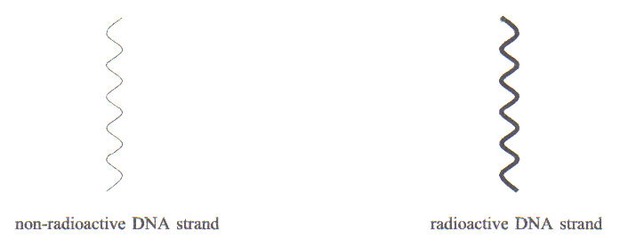

A cell with non-radioactive DNA underwent cell division in a medium containing radioactive nucleotides.

Which one of the following diagrams, J, K, L, or M, best represents the chemical composition of DNA molecules in the two resulting daughter cells?

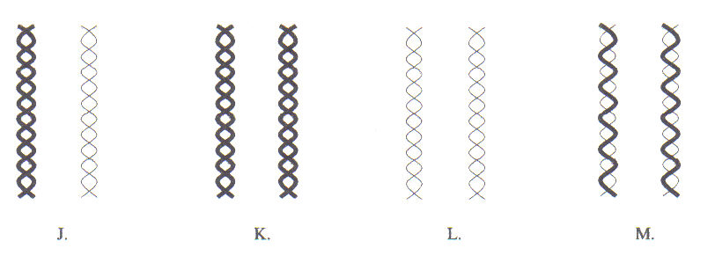

1. In the polymerase chain reaction (PCR), a solution containing DNA and an enzyme is repeatedly heated and cooled.

The solution is heated to

1. provide activation energy for the enzyme.
2. denature the enzyme.
3. break the weak bonds in the sugar-phosphate backbone of DNA.
4. break the weak bonds between the bases in DNA.
5. When body tissue is damaged the surrounding cells release the enzyme cyclo-oxygenase 2 (COX-2). COX-2 catalyses a reaction that manufactures prostaglandins, hormone-like substances that trigger pain and swelling.

Aspirin is a COX-2 inhibitor designed to relieve pain. Aspirin is able to

1. bind to the active site on the substrate molecules that form prostaglandins.
2. have the same molecular shape as the active site on the COX-2 enzyme.
3. have a molecular shape complementary to that of the active site on the COX-2 enzyme.
4. have a molecular shape complementary to that of prostaglandins.
5. Refer to the following diagram, which shows DNA fingerprints from four sources.

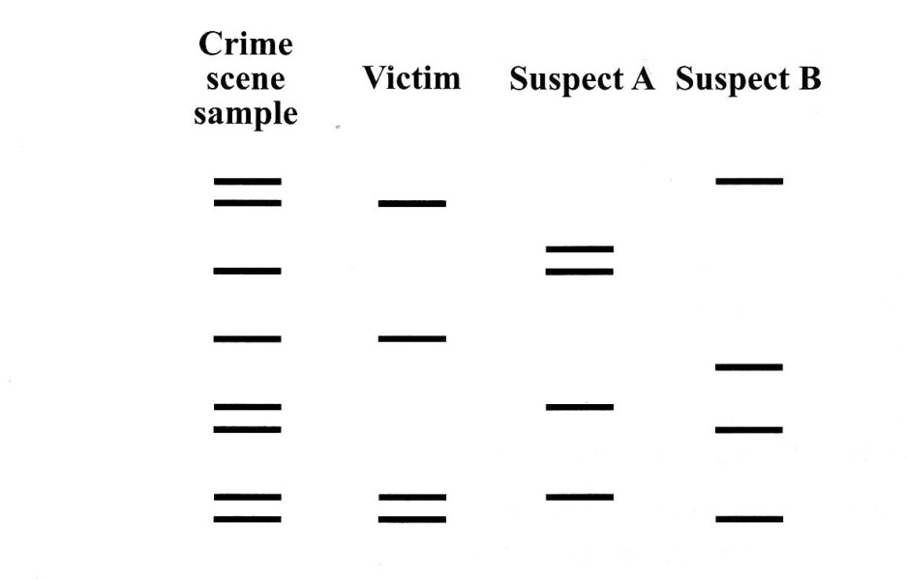

The sample taken from the crime scene contains DNA from

J. the victim and suspect A.

K. the victim and suspect B.

L. the victim, suspect A, and suspect B.

M. the victim and an unknown individual.

1. Refer to the following diagram, which shows the DNA fingerprint obtained from blood cells at a crime scene. One section of a DNA molecule from the blood cells was multiplied. A restriction enzyme was used to cut the section into six fragments, which were then separated by gel electrophoresis. The smaller DNA fragments move the greatest distance on the gel.

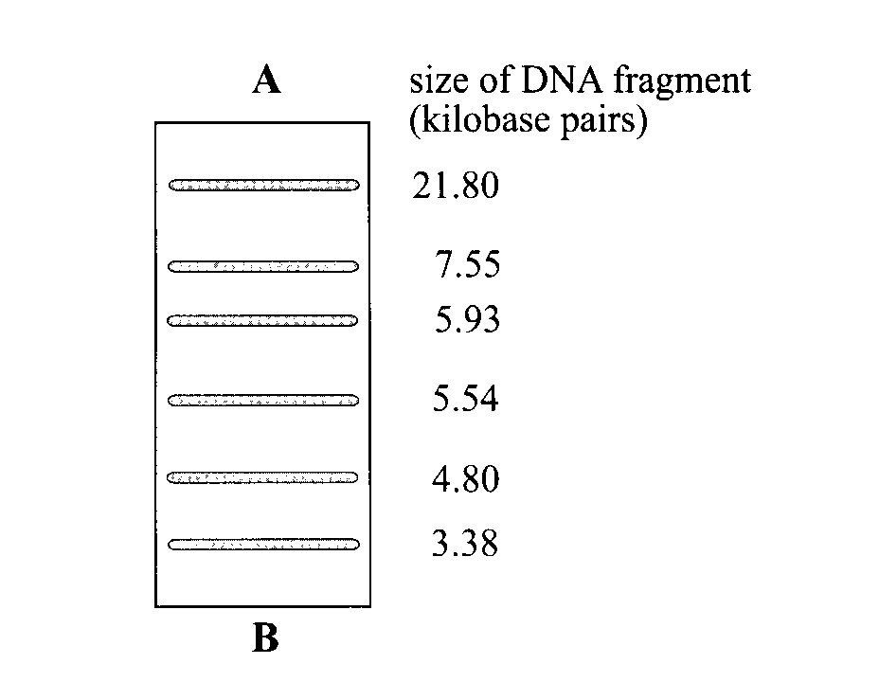

Questions such as this allow students to analyse data and their connections with concepts, to formulate conclusions.

Which one of the following statements is correct?

J. The polymerase chain reaction could have been used to multiply the section of the DNA molecule.

K. The restriction enzyme must have cut the section of the DNA molecule in six places.

L. Three of the DNA fragments must have been inherited from the individual’s mother.

M. The direction of movement of the DNA fragments is from **B** towards **A**.

1. A student was investigating the effect of pH on the germination of cress seeds. She used the following method to conduct an investigation:

* Solutions with pH values of 4, 5, 6, 7, 8, and 9 were prepared.
* 15 mL of each pH solution was poured over separate pieces of filter paper in six glass dishes.

Questions such as this allow students to analyse data and their connections with concepts, to formulate conclusions.

* 100 cress seeds were sprinkled onto each piece of filter paper.
* Each of the glass dishes, containing filter paper and seeds, was left for one week in a temperature-controlled incubator set at 20°C.

Which one of the following statements indicates a source of a random error in this investigation?

J. The student did not accurately measure the volumes of pH solution for each filter paper.

K. All the filter papers dried out after two days in the incubator.

L. The temperature in the incubator was actually 5ºC lower than the reading on the thermostat.

M. The student used only one type of seed.

1. Refer to the following table, which shows the amino acid sequence for the same part of a beta-haemoglobin polypeptide in five species. Each letter represents one amino acid.

Questions such as this are more challenging because they require students to connect two or more ideas and carry out some problem solving. Correctly answering the question provides evidence of **Knowledge and Understanding** at an A level.

|  |  |  |  |  |  |  |  |  |  |  |  |
| --- | --- | --- | --- | --- | --- | --- | --- | --- | --- | --- | --- |
| **Species** | **Amino acid sequence** | | | | | | | | | | |
| Ghost bat | V | K | A | H | G | K | K | V | L | N | S |
| Rose-ringed parakeet | V | R | A | H | G | K | K | V | L | T | S |
| Hamster | V | K | A | H | G | K | K | V | I | H | S |
| Platypus | V | K | A | H | G | A | K | V | L | T | S |
| Black-headed gull | V | R | A | H | G | K | K | V | L | T | S |

It is reasonable to conclude from the information in the table above that the

J. ghost bat is descended from the hamster.

K. platypus is more closely related to the ghost bat than to the hamster.

L. rose-ringed parakeet and the black-headed gull have the same DNA

sequence.

M. hamster is more closely related to the platypus than to the black-headed gull.

SECTION B: SHORT ANSWER QUESTIONS

Answer all questions in this section in the spaces provided.

Answers may be in note form. Marks allocated for each answer are show in brackets.

Note:

The mark scheme used in this test for the short answer questions follows the pattern that is used for marking the external examination.

Two marks are allocated for one well-expressed piece of information. Questions that require an explanation are worth four marks.

Therefore, in order to obtain full marks, students need to supply two relevant and connected pieces of information.

In addition, where the answer to a question requires a biological term that is used in the subject outline, students are expected to spell it correctly to be awarded full marks.

1. Refer to the following diagram, which shows part of one strand of a DNA molecule with the bases cytosine (C), adenine (A), and thymine (T)

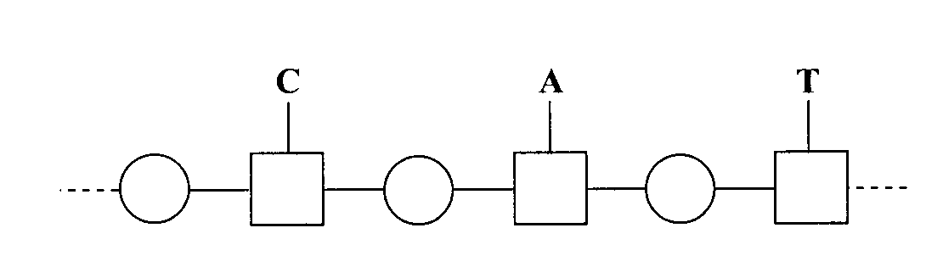

(a) Complete the diagram above, by drawing the corresponding part of the complementary DNA strand. 2 marks

(b) On the diagram, write the letter P in every shape that represents a phosphate group.

2 marks

(c) State one reason why it is necessary for the strands of a DNA molecule to separate during DNA replication.

2 marks

1. Refer to the following diagram, which shows molecule **1** and molecule **2**, and process **A**, which occurs during protein synthesis.

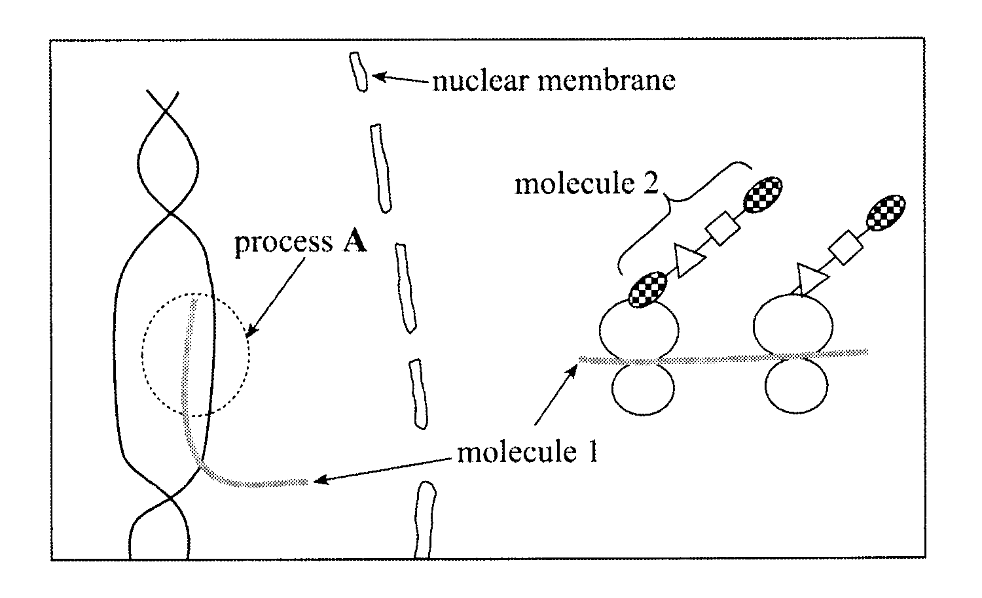

Questions such as this allow students the opportunity to demonstrate their **Application** of appropriate biological terminology.

(a) Name process **A**.

2 marks

(b) Name molecule **1** and molecule **2**.

Molecule **1**:

Molecule **2**: 2 marks

(c) State one function of tRNA in protein synthesis.

2 marks

1. Refer to the diagram below which shows part of a DNA molecule in an active cell.

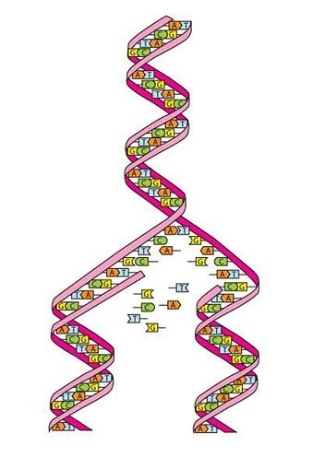

Source: The University of Waikato, www.sciencelearn.org.nz/Contexts/You-Me-and-UV/Sci -Media/Images

1. Name the process shown in the diagram.

2 marks

Questions such as this allow students the opportunity to demonstrate their **Application** of appropriate biological terminology.

(b) Name the part of a eukaryotic cell in which this process occurs.

2 marks

(c) Explain how a change in the DNA sequence could affect a protein produced by this cell.

4 marks

1. When soft-centred chocolates are made, the enzyme invertase is used to convert sucrose into the smaller molecules glucose and fructose. This causes the centres of the chocolates to become softer and sweeter.
2. State why the invertase must not be heated to temperatures above 45 o C.

2 marks

1. State how invertase increases the rate of conversion of sucrose into glucose and fructose.

Questions such as this allow a wide range of students to provide evidence of their **Knowledge and Understanding.** *‘Explain …..’* questions are more demanding than ‘*State ….’* questions.

2 marks

(c) Explain why the effect of an inhibitor on an enzyme may be reduced by increasing the concentration of the substrate.

4 marks

1. Cholesterol is a type of lipid molecule found in some foods. Some people have an altered enzyme that can break down cholesterol ten times more efficiently than the normal enzyme can. The increased activity of the altered enzyme is due to one change in its amino acid sequence.

(a) State the name of the change in DNA that results in a change in the amino acid sequence in an enzyme.

2 marks

(b) People with high levels of cholesterol in their blood have a greater than normal risk of developing heart disease.

Plant sterols are chemicals that reduce the absorption of cholesterol into the blood. Margarine normally contains plant sterols. However, some manufacturers add extra plant sterols to margarine.

State one concern that people may have about the addition of extra plant sterols to margarine.

4 marks

1. Refer to the following table, which shows the temperature and pH of four flasks set up by a student to investigate the rate of fermentation in yeast cells under various conditions. Each flask contained 50 mL of glucose solution and 0.3 g of yeast.

|  |  |  |
| --- | --- | --- |
| **Flask** | **Temperature (oC)** | **pH** |
| 1 | 35 | 7 |
| 2 | 70 | 7 |
| 3 | 10 | 7 |
| 4 | 35 | 4 |

One hypothesis being tested in this series of investigations is that pH affects the rate of fermentation.

Questions such as this allow students the opportunity to demonstrate their **Knowledge and Understanding** of experimental design.

1. State the independent variable in this hypothesis.

2 marks

(b) To test the hypothesis that pH affects the rate of fermentation the student would have to compare the results from some of the flasks.

1. Which flasks would the student need to compare?

2 marks

(ii) Explain the reason for choosing these flasks.

4 marks

(c) The student used only one flask for each set of conditions.

State why the use of only one flask for each set of conditions reduces the reliability of the results obtained in an experiment.

(4 marks)

SECTION: EXTENDED RESPONSE

*Credit will be given for clear, well-expressed answers that are well organised and relevant to the questions.*

1. Silk, which is produced by spiders when building webs, is one of the strongest substances known.

It is five times stronger than steel in a weight-to-weight comparison, more elastic than nylon, and lighter and stronger than Kevlar®. It has many potential uses.

Spider silk is made of a protein. Scientists have located and isolated the gene for the spider silk protein from orb-weaving spiders that produce the strongest silk.

Scientists have recently inserted the gene for the spider silk protein into goats in such a way that it is present in all the goats’ cells, but it is expressed only in their milk-producing cells.

* Describe the features of a probe that would be used to locate the gene for the spider silk protein in the spider DNA.
* Describe one method that the scientists would use to insert the isolated gene for the spider silk protein into goats.
* Explain one argument that may be used *against* the genetic modification of goats to produce silk.

*Content: 12 Marks Communication: 3 Marks*

________________________________________________________________________________________________________________________________________________________________________________________________________________________________________________________________________________________________________________________________________________________________________________________________________________________________________________________________________________________________________________________________________________________________________________________________________________________________________________________________________________________________________________________________________________________________________________________________________________________________________________________________________________________________________________________________________________________________________________________________________________________________________________________________________________________________

An Extended Response Question provides a student the opportunity to display their depth of knowledge of biological concepts as well as demonstrate their written communication skills.

It provides evidence of **Knowledge and Understanding** of biological concepts, communication in the extended response format, and the **Application** of appropriate biological terms and conventions.

This question also provides the opportunity for the student to provide evidence of their understanding of the connection between biological concepts and social issues although this specific feature is not being directly assessed in this task.

__________________________________________________________________________________________________________________________________________________________________________________________________________________________________________________________________________________________________________________________________________

______________________________________________________________________________________________________________________________________________________________________________________________________________________________________________________________________________________________________________________________________________________________________________________________________________________________________________________________________________________________________________________________________________________________________________________________________________________________________________________________________________________________________________________________________________________

__________________________________________________________________

________________________________________________________________________________________________________________________________________________________________________________________________________________________________________________________________________

**Note** – The following is an excerpt from the Chief Assessor’s report:

An extended-response question is marked out of 15, with 12 marks being allocated for content (each well-made point is worth 2 marks) and 3 marks for communication. This question has three content parts, with each part being marked out of 4.

In awarding a communication mark, the following factors are taken into account:

* Is the response at least half a page in length and is it structured in the form of sentences and paragraphs?
* Does the response use correct grammar and spelling?
* Does the response clearly explain concepts using relevant and concise biological language?

Students should be able to fully answer an extended-response question in about one page of writing. It is unnecessary for students to re-write the question or to provide an introduction to their response. Both of these practices are time-wasting, receive no credit, and may even result in a reduction in the communication mark.