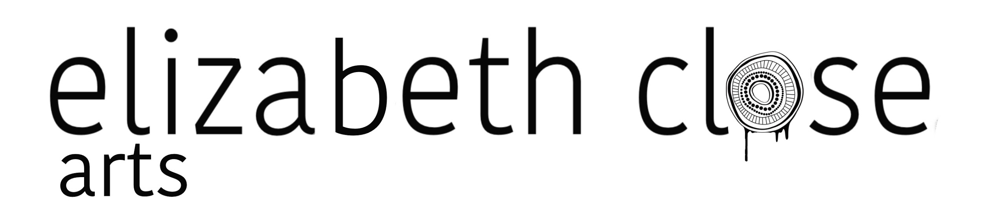

SACE Board
Shared Journey; Own Path
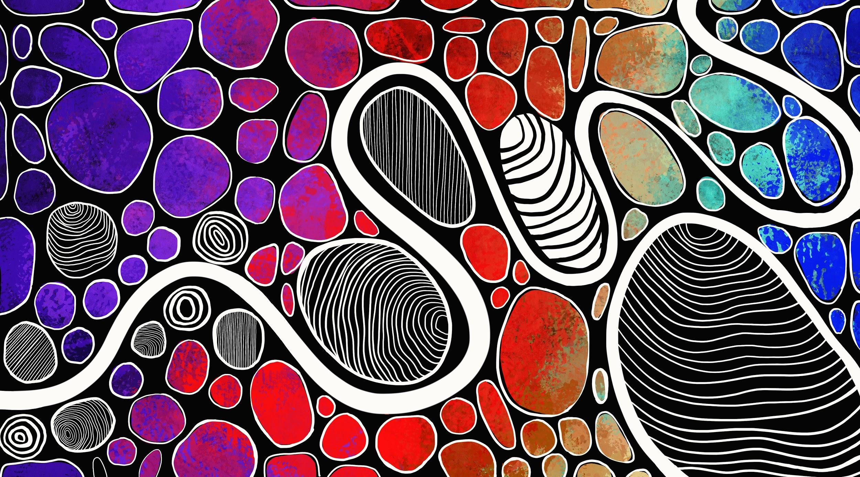
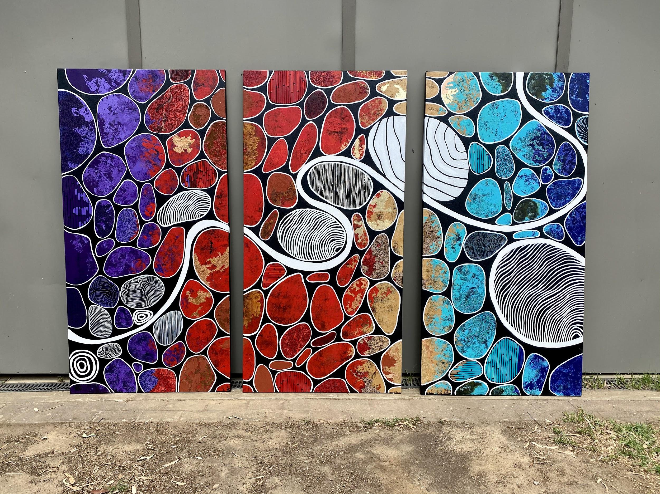

Agency | Belonging | Growth

The Artwork Narrative;
This triptych entitled Shared Journey; Own Path is a reflection of the dedication of the SACE Board to making outcomes and strategies for Aboriginal and Torres Strait Islander students a priority. Aboriginal and Torres Strait Islander student success depends on educational frameworks that place value on Aboriginal ways of knowing and being.

This artwork is the culmination of the great work undertaken by the SACE Board in their most recent Reconciliation Action Plan. It is the result of a relationship that was built over many weeks, in an effort to truly understand the narrative that I was asked to depict.

Shared Journey; Own Path takes three of the core values that best speak to the aims of the SACE Board with regard to Aboriginal and Torres Strait Islander student success, taken from our many conversations. These core values are Agency; Belonging and Growth. Together these core values form a collective that reflect the student journey for Aboriginal Students towards their SACE. The line that meanders across the triptych represents this student journey. Essentially, I have used the imagery of pebbles or rocks in a creek-bed to represent the students themselves; and water trickling through and between them as the student journey. The palette for the works reflects the diversity of the South Australian Aboriginal and Torres Strait Islander Student population; their histories and cultures. The diversity of their landscapes. I often use palette as a vessel to speak to aspects of landscape and by extension, those that live in, on and within them. In this work, we start with the deep inky purples that are informed by the night sky - a night sky that holds much of the wisdom that our collective cultures are underpinned by. This moves into softer purples that speak to smoke as a vessel for storytelling and cleansing. This transitions into reds and ochres that speak to the red deserts of Central and Outback South Australia. This gives way into warm sands, cool teals and deep blues that speak to The High Country with it's rainfall and cold winters, as well as the South Australian coastline with its mix of sandy beaches and shallow gulfs and rugged cliffs.

The first piece that speaks to agency, references the importance for Aboriginal and Torres Strait Islander students to receive recognition within the SACE framework for Cultural learning and learning on Country. This is referenced by the patterns within the white ‘highlighted’ pebbles - patterns I took from the natural world to reference growth; be it physical, spiritual, emotional or growth through learning. In this environment; cultural learning is celebrated and valued, and can co-exist with western academic success.

The second piece speaks to Belonging; with the pebbles here representing an environment where Aboriginal and Torres Strait Islander students feel a sense of inclusion. Here, the designs in the pebbles represent continued growth, but also the honouring of old wisdom through the same imagery of the growth rings of trees. The bold straight lines represent the fostering of an environment Indigenous perspectives are valued by educators and peers alike. Here these ‘highlighted’ pebbles are bigger, bolder and nestled into the journey line as to further illustrate this notion of belonging and inclusion. We should not accept a framework where Indigenous students are simply passengers in an arduous western education that they cannot see themselves in. In order to thrive, they must first belong.

The final piece illustrates growth. Aboriginal and Torres Strait Islander students that are empowered and feel they and their culture is an asset to their education; for whom the system acknowledges and celebrates Aboriginal ways of knowing and being, are far better equipped to shape their own future. To grow and to thrive. This is represented by the large bold pebbles; for whom this foundation stands them in good stead to become lifelong learners. Who do not simply ‘survive’ the process, but use it as a springboard for further learning in all facets of their lives.

These concepts are deeply entwined. But it is through this powerful combination that we make change and empower our young people to become the best they can be. To be powerful learners and cultural leaders.

The coloured other ‘pebbles’ in the creek are detailed. They are rich in texture and movement, which represent the complexities of life for Aboriginal students. Some include sand, which represents Connection to Country. Some include rust and verdigris (a type of green oxidation), which represent the enduring of Aboriginal and Torres Strait Islander people and culture - it represents the many tens of thousands of years of culture that we have kept alive. Some include copper and gold leaf which represent the immense value in Country as a concept - ironically not monetary or mineral wealth, but spiritual wealth. Some of the other patterns of lines, growth rings and dots, all refer to Country and Landscape - telling the story of the landscape we can see with our eyes; but more importantly, the Landscape we can feel with our spirits.

Shared Journey; Own Path is a work one can get lost in. There is much detail to take in, and upon each viewing, one might see something different. And so it is with the journeys themselves; there are always so many facets to a young Aboriginal student, indeed any students’ life path. There are many lenses through which we can understand them. This work is a celebration of this journey in whatever form it takes.

