STAGE 2 BIOLOGY
ASSESSMENT TYPE 1: Investigations Folio
Practical Investigation: Factors affecting enzyme activity

This is a completion practical with the method provided by the teacher and interpreted by the student.
Abstract
Fresh liver, ground liver, boiled liver, fresh potato and ground potato were put in different test tubes and hydrogen peroxide was poured on to them. This was to test the effects of temperature, surface area and cell type on the enzyme, catalase. The results showed that animal cells produce more catalase than plant cells, the larger the surface area the more catalase activity took place and if the tissue was boiled then less catalase activity took place, which supported all three hypotheses.
Introduction
Enzymes catalyse chemical reactions taking place inside and outside cells and are protein molecules. Catalysts are used inside human cells and many other cells to speed up the rate of chemical reactions. They usually do this by bringing the two reactants together to combine and react. Humans are constantly having chemical reactions occur inside their bodies so it is very efficient to have catalysts such as enzymes, because enzymes can carry out thousands of reactions, within the body, every second.
Application
Use of biological terms with some general effectiveness.
Enzymes are very sensitive in that the slightest change in temperature, pH, ion concentration and specific inhibitors can alter their three dimensional shape and therefore denature the enzyme.
A very common enzyme in many plants and animals is an enzyme called catalase which helps catalyse the breakdown of hydrogen peroxide within the body. Hydrogen peroxide is a toxic substance inside cells which reacts with other molecules and disturbs cell action.
Catalase
Hydrogen Peroxide Water + Oxygen
The rate of the reaction can be estimated by bubbles of oxygen that are produced.
In this practical the effects of change in temperature, surface area and cell type on the activity of an enzyme, catalase, will be investigated. The three hypotheses tested are:
Analysis and Evaluation
Makes simple predictions, with some relevance.

- Animal cells have more catalase than plant cells.
- The higher the temperature the less catalase activity.
- The larger the surface area the more catalase activity.
The constant variables will be the amount of material used, the concentration and the amount of hydrogen peroxide added.
The dependent variable will be the height of the oxygen bubbles.
Application Attempts to use some biological terms that may be appropriate.
The independent variables will be the temperature, the surface area and the type of cell.
If the results show that the fresh liver and ground liver have a higher rate of bubbles than the fresh potato and the ground potato, than it will support hypothesis number one. If the fresh cube of liver produces a higher rate of bubbles than the boiled cube of liver then hypothesis number two would be supported. If the cube of fresh liver and a cube of fresh potato produce less oxygen bubbles than the grounded liver and potato then hypothesis number three will also be supported, because the reason that the potato and liver were grounded was to increase the surface area. The potato was also grounded with sand this was to increase the surface area and break the membrane of the cells to let the catalase out. However, if all or any of these results were vice-versa or if they were the same, they would not support the hypotheses.

Materials and Method
6 test tubes
7 r.g of sand
1 cm cube of fresh liver
2 r.g of ground liver
1 cube of boiled liver
1 cm cube of fresh potato
2 r.g of ground potato
Hydrogen peroxide
Test tube holder
Small tongs
Ruler
Detergent

- Using the small tongs place each of the above materials of potato and liver in separate test tubes. Label the test tubes.
- Also place the sand in a separate test tube.
- Once all the test tubes are placed in the test tube holder, then put in one drop of detergent then pour 2cm of hydrogen peroxide.
- Place a ruler beside the test tube and measure the height of bubbles produced inside the test tube. Record the measurement.
- Repeat this for each test tube.

Data Presentation
Application Attempts to use biological terms that may be appropriate.
Plant Cells vs Animal Cells
[Teacher confirms accuracy of results at the end of the series of tests prior to clean up.]
Investigation Results are displayed in a table using generally appropriate formats with some errors but generally effective.
Test tube | Reaction height
B – fresh liver | 75 mm
E – fresh potato | 2mm
C – ground liver | 85 mm
F – ground potato | 10 mm
Plant Cells vs Animal Cells

Plant Cells vs Animal Cells
As shown in the above table and graph (Plant Cells vs Animal Cells) the fresh liver and the ground liver produced more bubbles than the fresh and ground potato.
Analysis and Evaluation Analyses data and their connections with concepts, to formulate generally appropriate conclusions.

With the fresh liver producing 75 mm and the ground liver producing 85 mm, the animal cells produced more catalase than the plant cells.
The Effects of Temperature
Test tube | Reaction height
B – fresh liver | 75 mm
D – boiled liver | 2mm

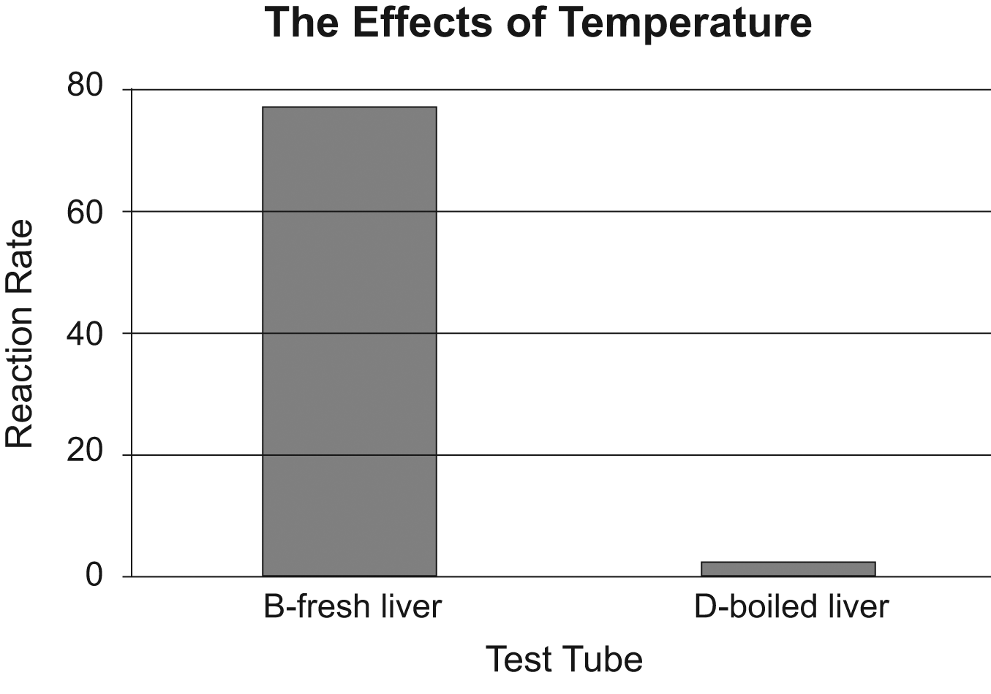
The Effects of Temperature
The table and graph above, labelled The Effects of Temperature, shows that the fresh liver produced a higher rate of bubbles, with 75 mm, whereas the boiled liver only produced 2 mm of bubbles.

The Effects of Surface Area
Test tube | Reaction height
B – fresh liver | 75 mm
C – ground liver | 85 mm
E – fresh potato | 2mm
F – ground potato | 10 mm

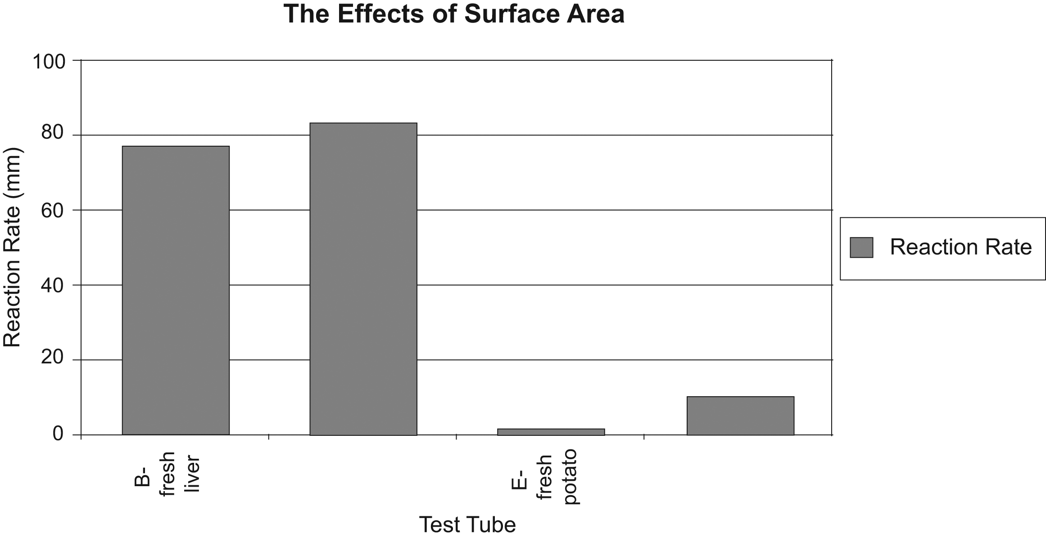
Analysis and Evaluation Attempts to extract meaning from data but has incorrectly identified systematic error.
The Effects of Surface Area
The effects of surface area are shown in the table and graph above, The Effects of Surface Area. This table and graph shows that the grounded products in both the animal and plant cells produced more bubbles than the fresh products. With the grounded liver producing 85 mm and the grounded potato producing 10mm compared to the fresh liver producing 75 mm and the fresh potato producing 2 mm.
Discussion
Random errors occur in all experiments and measurements. A random error in this experiment was that a ruler was used against the test tubes to measure the height of bubbles and therefore each test tube may have been measured slightly different according to the person holding the ruler and checking the measurements. Systematic errors may also occur but are introduced by faulty instruments, calibration errors etc.
Analysis and Evaluation Contributes to the evidence needed to demonstrate the ability to evaluate some procedures. For example identifies the role of sample size and identifies that improvements may be made.
A systematic error that may have occurred in this experiment was the measuring of the height of bubbles my have not been as accurate as it could have because when the hydrogen peroxide was added to the test tubes they was measured immediately, however if the test tubes were not measure immediately then the reactions would still be occurring during that time and bubbles would still be being produced therefore a systematic error may have occurred.
The sample size in this experiment was only a sample size of one. It is important, however, to increase the sample size in any experiment in order to be able to compare and analyse the data obtained more closely with a wider range of results. If the sample size was larger an average could be worked out and the results would be more accurate. If the class results were to be compared and analysed together, the sample size would be increase and an average could be obtained which would assist the results to be more accurate.
The strengths of this experiment were that the same chemical (hydrogen peroxide) was used for each and every test tube and we also used the same amount of material in each test tube, the pH was also kept constant. This is important because it will help with the accuracy of the results gained. There were also some weaknesses in the experiment that could have altered the outcome slightly. These weaknesses were that sometimes, after the hydrogen peroxide was poured into the test tube, it was not immediately measured therefore some test tubes had longer time to produce bubbles. By pouring the hydrogen peroxide in one at a time in each test tube and holding the ruler up against the test tube that the hydrogen peroxide was being poured into and taking an immediate reading, this weakness was overcome.
Analysis and Evaluation Evaluates some procedures that are generally appropriate.
Conclusion
Analysis and Evaluation Analyses data and their connections with concepts, to formulate generally appropriate conclusions.
The findings of this experiment have supported the three hypothesis that

- Animal cells produce more catalase than plant cells,
- The higher the temperature the less catalase produced and
- The larger the surface area the more catalase produced.
This experiment was carried out in order to show the effects of changes in temperature, surface area and cell type on the activity of the enzyme catalase. As seen in the results table (Plant Cells vs Animal Cells) the fresh liver and the ground liver produced more bubbles than the fresh and ground potato. With the fresh liver producing 75 mm and the ground liver producing 85 mm, the animal cells produced more catalase than the plant cells, this supports that animal cells produce more catalase than plant cells.
Application
In conjunction with teacher observation, the review contributes to the evidence to show the application of generally constructive collaborative work skills.
Also, the table and graph above, labelled The Effects of Temperature, shows that the fresh liver produced a higher rate of bubbles, with 75 mm, whereas the boiled liver only produced 1 mm of bubbles. This supports the hypothesis that the higher the temperature the less catalase produced with in a cell.

The third hypothesis was also supported in that the results showed in the table and graph above, The Effects of Surface Area, that the grounded products in both the animal and plant cells produced more bubbles than the fresh products. With the grounded liver producing 85 mm and the grounded potato producing 10mm compared to the fresh liver producing 75 mm and the fresh potato producing 2 mm. Therefore, the larger the surface area the more catalase produced.
Investigation
Teacher observation in addition to this safety assessment is used to assess this specific feature.
Review

I thought I worked ok in the group. I tried to pull my weight and even managed to make one suggestion which seemed to be agreed upon by all my group members. I didn’t learn anything new about being in a team, as we seemed to work ok most of the time.
Safety Assessment
Overall Hazard Assessment

LOW MEDIUM HIGH

Possible Hazard | Suggested Safe Operating Procedures
Cutting yourself | Use the knife safely. Do not cut another student.
Hydrogen peroxide | Is corrosive and can burn the skin. Dangerous if ingested. Use with gloves. Wear safety glasses and apron.
Liver and potato | Could contain germs that could cause disease. Wear gloves. Do not consume.
Broken glass | Do not pick up broken glass
Boiling | Could cause a burn. Take precautions to prevent burn.

Additional Comments:
This provides evidence contributes to an overall assessment of the:
- use appropriate biological terms and conventions (Analysis and Evaluation).
- data which is displayed in a number of tables and graphs with some errors but generally accurately and effectively (Investigation).
- practical report format to communicate knowledge and understanding of biology with some general effectiveness (Knowledge and Understanding).

Evidence from this investigation contributes to an overall assessment for the Investigations Folio of the:
- use of appropriate biological terms and conventions (Application).
- communication of knowledge and understanding of biology in different contexts, using different formats (Knowledge and Understanding).

Performance standards for Stage 2 Biology
 | Investigation | Analysis and Evaluation | Application | Knowledge and Understanding
A | Designs logical, coherent, and detailed biological investigations.  Critically and logically selects and consistently and appropriately acknowledges information about biology and issues in biology from a range of sources.  Manipulates apparatus and technological tools carefully and highly effectively to implement well-organised safe and ethical investigation procedures.  Obtains, records, and displays findings of investigations using appropriate conventions and formats accurately and highly effectively. | Critically and systematically analyses data and their connections with concepts, to formulate logical and perceptive conclusions and make relevant predictions.  Critically and logically evaluates procedures and suggests a range of appropriate improvements. | Applies biological concepts and evidence from investigations to suggest solutions to complex problems in new and familiar contexts.  Uses appropriate biological terms, conventions, formulae, and equations highly effectively.  Demonstrates initiative in applying constructive and focused individual and collaborative work skills. | Consistently demonstrates a deep and broad knowledge and understanding of a range of biological concepts.  Uses knowledge of biology perceptively and logically to understand and explain social or environmental issues.  Uses a variety of formats to communicate knowledge and understanding of biology coherently and highly effectively.
B | Designs well-considered and clear biological investigations.  Logically selects and appropriately acknowledges information about biology and issues in biology from different sources.  Manipulates apparatus and technological tools carefully and mostly effectively to implement organised safe and ethical investigation procedures.  Obtains, records, and displays findings of investigations using appropriate conventions and formats mostly accurately and effectively. | Clearly and logically analyses data and their connections with concepts, to formulate consistent conclusions and make mostly relevant predictions.  Logically evaluates procedures and suggests some appropriate improvements. | Applies biological concepts and evidence from investigations to suggest solutions to problems in new and familiar contexts.  Uses appropriate biological terms, conventions, formulae, and equations effectively.  Applies mostly constructive and focused individual and collaborative work skills. | Demonstrates some depth and breadth of knowledge and understanding of a range of biological concepts.  Uses knowledge of biology logically to understand and explain social or environmental issues.  Uses a variety of formats to communicate knowledge and understanding of biology coherently and effectively.
C | Designs considered and generally clear biological investigations.  Selects with some focus, and mostly appropriately acknowledges, information about biology and issues in biology from different sources.  Manipulates apparatus and technological tools generally carefully and effectively to implement safe and ethical investigation procedures.  Obtains, records, and displays findings of investigations using generally appropriate conventions and formats with some errors but generally accurately and effectively. | Analyses data and their connections with concepts, to formulate generally appropriate conclusions and make simple predictions, with some relevance.  Evaluates some procedures in biology and suggests some improvements that are generally appropriate. | Applies biological concepts and evidence from investigations to suggest some solutions to basic problems in new or familiar contexts.  Uses generally appropriate biological terms, conventions, formulae, and equations with some general effectiveness.  Applies generally constructive individual and collaborative work skills. | Demonstrates knowledge and understanding of a general range of biological concepts.  Uses knowledge of biology with some logic to understand and explain one or more social or environmental issues.  Applies different formats to communicate knowledge and understanding of biology with some general effectiveness.
D | Prepares the outline of one or more biological investigations.  Selects and may partly acknowledge one or more sources of information about biology or an issue in biology.  Uses apparatus and technological tools with inconsistent care and effectiveness and attempts to implement safe and ethical investigation procedures.  Obtains, records, and displays findings of investigations using conventions and formats inconsistently, with occasional accuracy and effectiveness. | Describes basic connections between some data and concepts, and attempts to formulate a conclusion and make a simple prediction that may be relevant.  For some procedures, identifies improvements that may be made. | Applies some evidence to describe some basic problems and identify one or more simple solutions, in familiar contexts.  Attempts to use some biological terms, conventions, formulae, and equations that may be appropriate.  Attempts individual work inconsistently, and contributes superficially to aspects of collaborative work. | Demonstrates some basic knowledge and partial understanding of biological concepts.  Identifies and explains some biological information that is relevant to one or more social or environmental issues.  Communicates basic information to others using one or more formats.
E | Identifies a simple procedure for a biological investigation.  Identifies a source of information about biology or an issue in biology.  Attempts to use apparatus and technological tools with limited effectiveness or attention to safe or ethical investigation procedures.  Attempts to record and display some descriptive information about an investigation, with limited accuracy or effectiveness. | Attempts to connect data with concepts, formulate a conclusion, and make a prediction.  Acknowledges the need for improvements in one or more procedures. | Identifies a basic problem and attempts to identify a solution in a familiar context.  Uses some biological terms or formulae.  Shows emerging skills in individual and collaborative work. | Demonstrates some limited recognition and awareness of biological concepts.  Shows an emerging understanding that some biological information is relevant to social or environmental issues.  Attempts to communicate information about biology.

