Stage 2 Agricultural Production

Assessment Type 2: Applications

Lamb Production

SACE ID _____________________ NAME___________________________

In this task you will be required to:

- obtain, record, represent, analyse, and interpret the results of agriculture investigations
- analyse evidence to formulate and justify conclusions
- develop and apply knowledge and understanding of agricultural concepts, skills, and practices in new and familiar contexts

Lamb markets are very good at the moment. However, farmers need to understand the requirements of these markets and how best to meet these requirements to get the best return from their sheep. They should also be able to assess their lambs so that they can determine the value of the animals and be in a position of strength when negotiating prices or contracts.

In this task you will be required to accurately weigh lambs, fat score them, calculate carcase weights and use this and other market information to determine the value of the animals. You will also be required to answer questions about the strategies that farmers can use to maximise their returns form lambs.

Performance Standards for Stage 2 Agricultural Production
- | Investigation, Analysis, and Evaluation | Knowledge and Application
A | Critically deconstructs a problem and designs a logical, coherent, and detailed agricultural investigation.  Obtains records, and represents data, using appropriate conventions and formats accurately and highly effectively.  Systematically analyses and interprets data and evidence to formulate logical conclusions with detailed justification.  Critically and logically evaluates procedures and their effects on data. | Demonstrates deep and broad knowledge and understanding of a range of agricultural concepts.  Applies agricultural concepts, skills, and practices highly effectively in new and familiar contexts.  Critically explores and understands in depth the interaction between agricultural science and society.  Communicates knowledge and understanding of agriculture coherently with highly effective use of appropriate terms, conventions and representations
B | Logically deconstructs a problem and designs a well-considered and clear agricultural investigation.  Obtains, records, and represents data, using appropriate conventions and formats mostly accurately and effectively.  Logically analyses and interprets data and evidence to formulate suitable conclusions with reasonable justification.  Logically evaluates procedures and their effects on data. | Demonstrates some depth and breadth of knowledge and understanding of a range of agricultural concepts.  Applies agricultural concepts, skills, and practices mostly effectively in new and familiar contexts.  Logically explores and understands in some depth the interaction between agricultural science and society.  Communicates knowledge and understanding of agriculture mostly coherently with effective use of appropriate terms, conventions, and representations.
C | Deconstructs a problem and designs a considered and generally clear agricultural investigation.  Obtains, records, and represents data, using generally appropriate conventions and formats with some errors but generally accurately and effectively.  Undertakes some analysis and interpretation of data and evidence to formulate generally appropriate conclusions with some justification.  Evaluates procedures and some of their effects on data. | Demonstrates knowledge and understanding of a general range of agricultural concepts.  Applies agricultural concepts, skills, and practices generally effectively in new or familiar contexts.  Explores and understands aspects of the interaction between agricultural science and society.  Communicates knowledge and understanding of agriculture generally effectively using some appropriate terms, conventions, and representations.
D | Prepares a basic deconstruction of a problem and an outline of an agricultural investigation.  Obtains, records, and represents data, using conventions and formats inconsistently, with occasional accuracy and effectiveness.  Describes data and undertakes some basic interpretation a basic conclusion.  Attempts to evaluate procedures or suggest an effect on data. | Demonstrates some basic knowledge and partial understanding of agricultural concepts.  Applies some agricultural concepts, skills, and practices in familiar contexts.  Partially explores and recognises aspects of the interaction between agricultural science and society.  Communicates basic information about agriculture, using some appropriate terms, conventions, and/or representations.
E | Attempts a simple deconstruction of a problem and a procedure for an agricultural investigation.  Attempts to record and represent some data, with limited accuracy or effectiveness.  Attempts to describe results and/or interpret data to formulate a basic conclusion.  Acknowledges that procedures affect data. | Demonstrates some limited recognition and awareness of agricultural concepts.  Attempts to apply agricultural concepts, skills, and/or practices in familiar contexts.  Attempts to explore and identify an aspect of the interaction between agricultural science and society.  Attempts to communicate information about agriculture.

Practical Skills Assessment

 | E - D | C - B | A
Preparation for practical activity | Student rarely arrives with appropriate clothing and footwear. Student rarely arrives having understood the background knowledge. Student rarely arrives with appropriate attitude to work. | Student usually arrives with appropriate clothing and footwear. Student usually arrives having understood the background knowledge. Student usually arrives with appropriate attitude to work. | Student always arrives with appropriate clothing and footwear. Student always arrives having understood the background knowledge. Student always arrives with appropriate attitude to work.
Student considers Occupational Health and Welfare | Student is rarely aware of potential hazards and works to prevent them. Student rarely works in safe manner. Student is rarely aware of animal welfare requirements | Student is usually aware of potential hazards and works to prevent them. Student usually works in safe manner. Student is usually aware of animal welfare requirements | Student is always aware of potential hazards and works to prevent them. Student always works in safe manner. Student is always aware of animal welfare requirements.
Obtaining Data | Student rarely correctly sets up and calibrates weighing equipment. Student rarely records correct tag number and weight. Student rarely maintains records in appropriate format. | Student usually correctly sets up and calibrates weighing equipment. Student usually records correct tag number and weight. Student usually maintains records in appropriate format. | Student always correctly sets up and calibrates weighing equipment. Student always records correct tag number and weight. Student always maintains records in appropriate format.
Application | Student rarely weighs sheep accurately. Student rarely correctly determines fat score of sheep. Student rarely determines correct dressing percentage of animals. | Student usually weighs sheep accurately. Student usually correctly determines fat score of sheep. Student usually determines correct dressing percentage of animals. | Student always weighs sheep accurately. Student always correctly determines fat score of sheep. Student always determines correct dressing percentage of animals.

The Task:
You will be required to assess 3 lambs for sale. This will include weighing them, fat scoring, determining dressing % and dressed weight.

Use the information in the following tables to determine the value of each lamb.

Category  Carcase weight (kg) |  | Fat-score | Average carcase weight price (c/kg)
0 – 12  12.1 – 16  16.1 – 18  18.1 – 20  20.1 – 22  22.1 – 24  24.1 – 26  26.1 – 30  >30 |  | 1 – 3  2 – 4  2 – 4  2 – 4  2 – 4  2 – 4  3 – 5  3 – 5  3 - 5 | 675  622  653  652  643  647  648  622  610

Skin Value
Wool Length | Value
50mm + | $14.00
25 – 50mm | $9.00
12 – 25mm | $7.00
6 – 12mm | $4.00

- Construct and complete a table to show the information that you have measured, determined and calculated for your three lambs.

- Use the market report supplied to calculate the value of each of the lambs, showing your calculations and add this information to your table.

- Use figure 1 to determine which market would best suit each of the lambs.

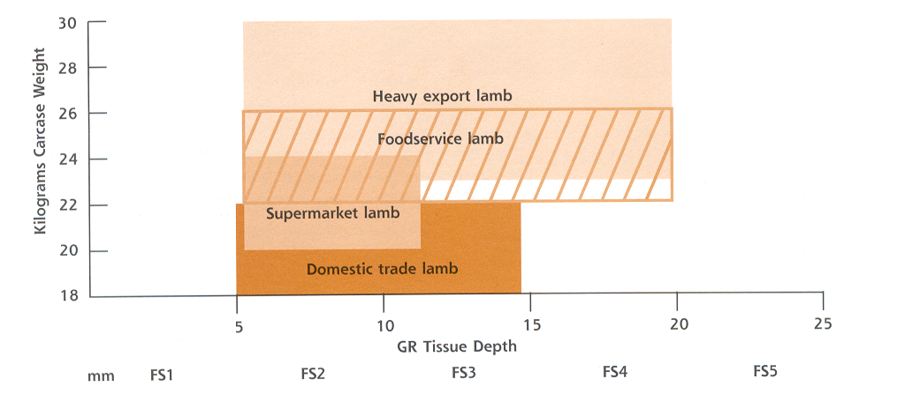

____________________________________________________________________________________________________________________________________________________________________________________________________________________________________________________________________________________________________________________________________________________________________________________________________________________________________________________________________________________________________________________________________________________________________________________________________________________________________________________________________________________________________________________________________________________________________________________________________________________________________________________________________________________________________________________

Questions.

- You decide to sell the lambs over the hooks. The abattoir has the following price grid.

 | Fat Score
Carcase weight (kg) | 1 | 2 | 3 | 4 | 5
18.1-20 | 6.20 | 6.20 | 6.20 | 6.20 | 6.20
20.1 – 22 | 6.20 | 6.20 | 6.20 | 6.20 | 6.20
22.1-24 | 6.20 | 6.50 | 6.50 | 6.50 | 6.20
24.1-26 | 6.20 | 6.50 | 6.50 | 6.50 | 6.20
26.1-28 | 6.20 | 6.50 | 6.50 | 6.50 | 6.20
28.1-30 | 6.20 | 6.50 | 6.50 | 6.50 | 6.20
30 + | 6.20 | 6.20 | 6.20 | 6.20 | 6.20

a) Use the information above to calculate the price for each of the lambs above.
________________________________________________________________________________________________________________________________________________________________________________________________________________________________________________________________________________________________________________________________________________________________________________________________________________________________________________________________________________________________________________________________________________________________

b) Explain whether you would sell any of your 3 lambs via this method rather than through the market.
________________________________________________________________________________________________________________________________________________________________________________________________________________________________________________________________________________________________________________________________________________________________________________________________________________________________________________________________________________________________________________________________________________________________

c) Give a possible explanation why the prices for some categories of lamb are higher over the hooks while others are lower than those quoted in the market report.
____________________________________________________________________________________________________________________________________________________________________________________________________________________________________________________________________________________________________________________________________________________________________________________________________________________________________________________________________________________________________________________________________________________________________________________________________________________________________________________________________________________________________________________________________________________________________________

d) Give at least 2 advantages and one disadvantage of using over-the-hooks to sell the lambs compared to selling through the saleyard.
______________________________________________________________________________________________________________________________________________________________________________________________________________________________________________________________________________________________________________________________________________________________________________________________________________________________________________________________________________________________________________________________________________________________________________________________________________________________________________________________________________________________________________________________________________________________________________________________________________________________________________________________________________________________________________________________________________________________________________________________________________
e) Complete the National Vendor Declaration (NVD) form (attached) by using the following information and information available from the Export Slaughter Intervals and Withholding Period http://apvma.gov.au/node/26536

Ima Farmer owns a property on Secondary Rd, Outer Wallop, SA. His Property Identification Code is XA456987 and raises his sheep under the LambCare quality assurance program and his license number is 432678. His phone number is 09 12349876 and his fax number is 09 1234 9877. He has decided to sell a mob of lambs today, making the most of the good prices available at the time. The mob includes 250 lambs that were born on his property in early winter 2013 and another 100 lambs that he bought from Western Australia 4 months ago, that were born at about the same time as his. The Property Identification Code for the property he bought them from is WX 345982. All of the lambs were shorn in December 2017. 5 weeks ago, on the 23rd February, Ima treated these lambs with Coopers Paramax-F Broad Spectrum Anti-Helminthic and Flukicide for Sheep. Other than this they have not been treated with any other chemicals and have only been grazed on pastures that have not been sprayed with any chemicals. He put the lambs into a yard last night with no feed or water at 6pm. The truck picked them up at 7.30 am this morning, the 11th April 2018.
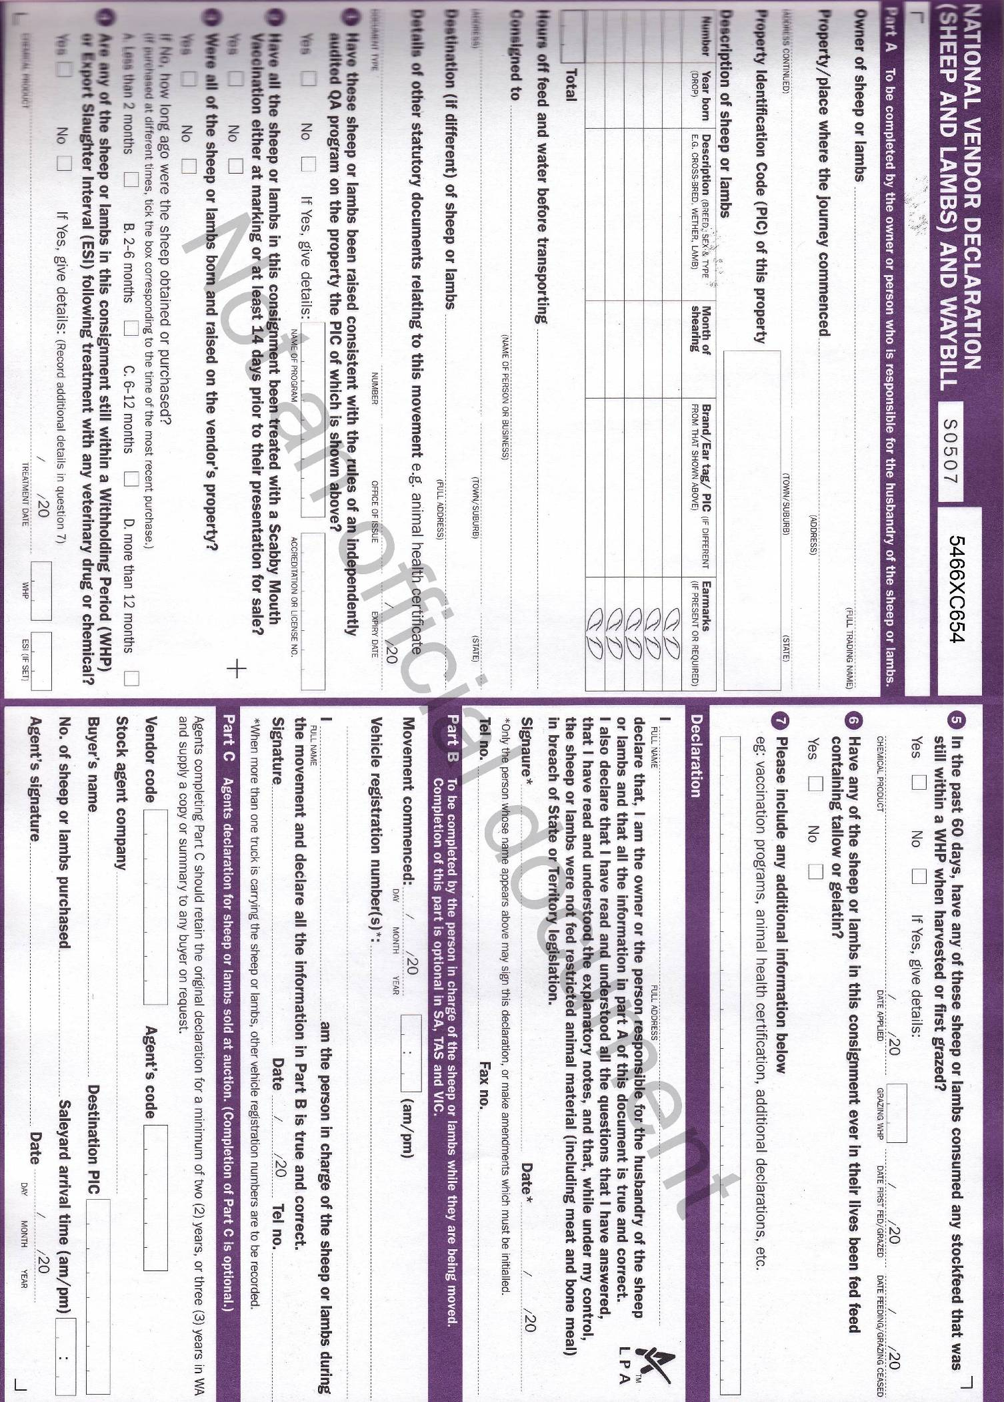
- For each of the three animals that you have assessed make a recommendation, with an explanation, about what should happen to each of them. For example should they be sold straight away, shorn and sold, kept for awhile etc.
_________________________________________________________________________________________________________________________________________________________________________________________________________________________________________________________________________________________________________________________________________________________________________________________________________________________________________________________________________________________________________________________________________________________________________________________________________________________________________________________________________________________________________________________________________________________________________________________________________________________________________________________________________________________________________________________________________________________________________________________________________________________________________________________________________________________________________________________________________________________________________________________________________________________________
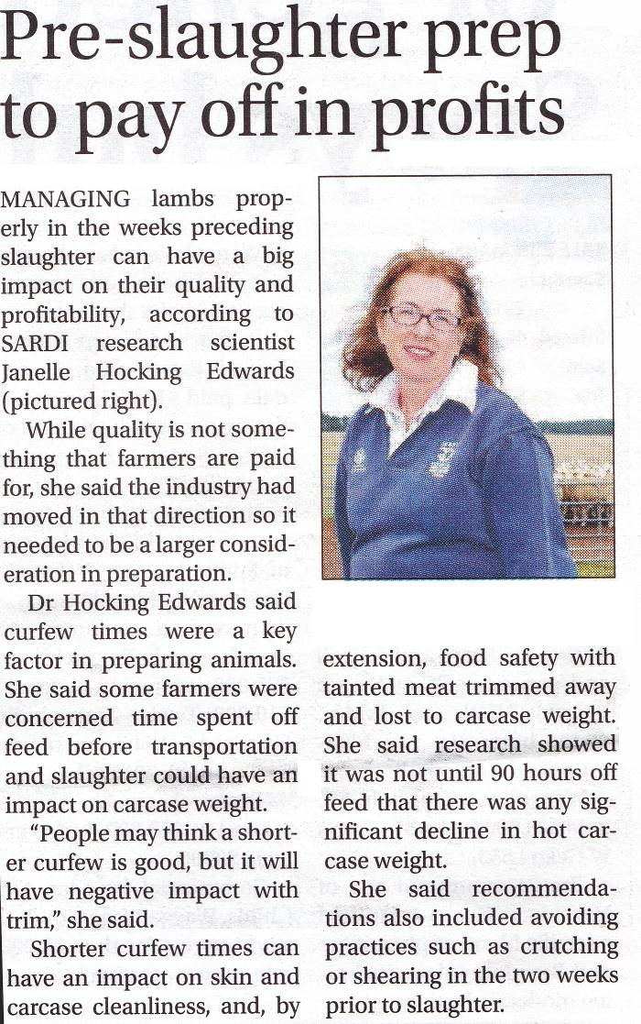
- Read this article from the “Stock Journal” on 27th April 2017 and answer the questions that follow.

- Explain why it is important to put lambs on a curfew before sending them to market. ____________________________________________________________________________________________________________________________________________________________________________________________________________________________________________________________________________________________________________________________________________________________________________________________________________________________________________________________________________________________________________________________________________________________________________________________________________________________________________________________________________________________________________________________________________________________________________________________________________________________________________________________________________________________________________

- Explain why it is unlikely that a longer curfew will reduce the carcase weight of sheep before slaughter.
_______________________________________________________________________________________________________________________________________________________________________________________________________________________________________________________________________________________________________________________________________________________________________________________________________________________________________________________________________________________________________________________________________________________________________________________________________

- Explain why a shorter curfew, or no curfew at all may ultimately reduce the final carcase weight.
_______________________________________________________________________________________________________________________________________________________________________________________________________________________________________________________________________________________________________________________________________________________________________________________________________________________________________________________________________________________________________________________________________________________________________________________________________

- What is the optimum length of time for sheep to be on curfew prior to slaughter?
_________________________________________________________________________

- It is recommended that sheep are “keyhole” crutched a few days before being sent to market. How is this crutching different from standard crutching? Why is it used? What are the implications of not crutching the sheep before sale?
_____________________________________________________________________________________________________________________________________________________________________________________________________________________________________________________________________________________________________________________________________________________________________________________________________________________________________________________________________________________________________________________________________________________________________________________________________________________________________________________________________________________________________________________________________________________________________________________________________________________________________________________________________________________________________________________________________________________________________________________

- What is the recommended length of wool on sheep that are to be sold for meat? Why is length ideal? What are the implications for having shorter or longer wool than this?
____________________________________________________________________________________________________________________________________________________________________________________________________________________________________________________________________________________________________________________________________________________________________________________________________________________________________________________________________________________________________________________________________________________________________________________________________________________________________________________________________________________________________________________________________________________________________

- The level of glycogen stored in the muscles of lambs before slaughter is a major factor in determining the eating quality of the meat produced.

  - Briefly explain how the level of glycogen affects eating quality.
_________________________________________________________________________________________________________________________________________________________________________________________________________________________________________________________________________________________________________________________________________________________________________________________________________________________________________________________________________________________________________________________________________________________________________________________________________________________________________________________________________________________________________________________________________________________

  - Describe the steps that the farmer can take to maximise the glycogen levels in the lambs before they are slaughtered.
__________________________________________________________________________________________________________________________________________________________________________________________________________________________________________________________________________________________________________________________________________________________________________________________________________________________________________________________________________________________________________________________________________________________________________________________________________________________________________________________________________________________________________________________________________________________

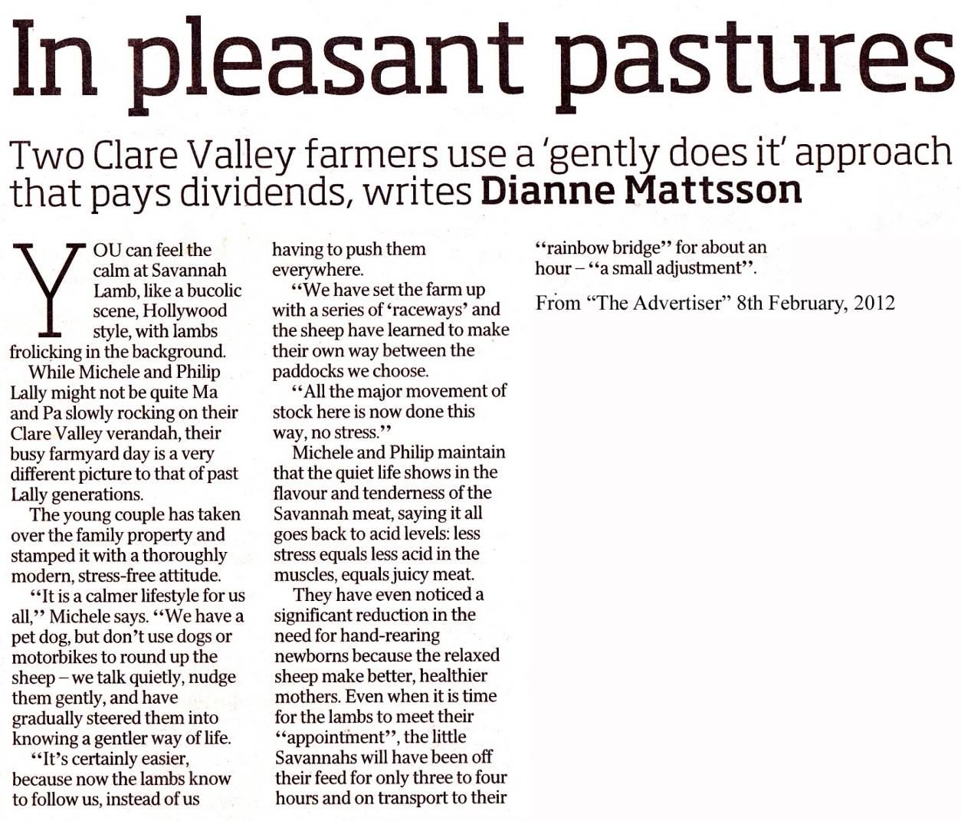

Read the above article and answer the following questions.

- The owners of Savannah Meat state that “less stress equals less acid in the muscles, equals juicy meat”. Is that statement correct? Explain why or why not.
________________________________________________________________________________________________________________________________________________________________________________________________________________________________________________________________________________________________________________________________________________________________________________________________________________________________________________________________________________________________________________________________________________________________________

- Are the owners right in saying that less stress can lead to more tender meat? Explain your answer.
______________________________________________________________________________________________________________________________________________________________________________________________________________________________________________________________________________________________________________________________________________________________________________________________________________________________________________________________________________________________________________________________________________________________________________________________________________________________________________________________________________________________________________________________________________________________________________________________________________________

- Rewrite the paragraph relating to tenderness and stress in a way that reflects what you have learned about tenderness in meat.
_____________________________________________________________________________________________________________________________________________________________________________________________________________________________________________________________________________________________________________________________________________________________________________________________________________________________________________________________________________________________________________________________________________________________________________________________________________________________________________________________________________________________________________________________________________________________________________________________________________________________________________________________________________________________________

