STAGE 1 MATHEMATICS

PROGRAM 2 – SEMESTER 2 (PRE-SPECIALIST MATHEMATICS)
This program is for a cohort of students intending to continue to Specialist Mathematics at Stage 2. The following program describes the second semester of learning.
Topic 10: Further Trigonometry, Topic 11: Matrices, and Topic 12: Real and Complex Numbers
ASSESSMENT
Assessment for one semester (10 credits):
- at least 2 SATs
- at least one investigation
- each Assessment Type has weighting of at least 20%
- total of four tasks for assessment
NOTES
- Schools may have a different week breakdown per term/semester.
- Not all schools will have a semester examination.
- Excursions, sports days, extra-curricular activities are not specified.
- The investigation opportunities are a guide for ideas.
TOPIC TIME DURATION
Further Trigonometry – 5 weeks
Matrices – 5 weeks
Real and Complex Numbers– 6 weeks

Term 3  Week | Topic | Content | Assessment
Topic 10: Further Trigonometry
(5 weeks)
1 | Subtopic 10.1  Further Trigonometric Functions  (Assumes Topic 3: Trigonometry has been covered before this topic) | Explore the effects of A, B, C and D in the general formula 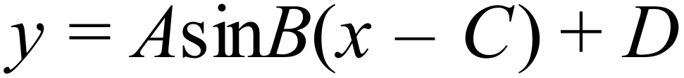 compared to 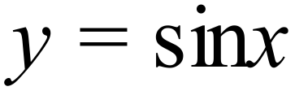 and extend to cosine and tangent functions.  Sketch graphs with and without technology.
2 | Subtopic 10.1  Further Trigonometric Functions | Sketch graphs with and without technology (continued).  Solve trigonometric equations graphically and with technology.
3 | Subtopic 10.2  Trigonometric Identities | Use the unit circle, compare graphs and use addition and subtraction formulae to deduce identities.
4 | Subtopic 10.2  Trigonometric Identities | Use identities algebraically to establish relationships.  Derive $A \sin{x}+B\cos{x}=k\sin\left(x+a\right)$ and find expressions for $k, \cos{α }and\sin{α}$.
5 | Subtopic 10.2  Trigonometric Identities | Sketch graphs and of the reciprocal trigonometric functions.  Revision. | SAT 1: Further Trigonometry  Part 1 – no calculators  Part 2 – calculators permitted

Topic 11: Matrices
(5 weeks)
6 | Subtopic 11.1  Matrix Arithmetic | Order of matrices.  Addition, subtraction and scalar multiplication.  Matrix multiplication
7 | Subtopic 11.1  Matrix Arithmetic | Identity matrix.  Inverse of square matrices, concept of singular matrices.
8 | Subtopic 11.1  Matrix Arithmetic | Find the inverse of 2x2 matrices.  Solve AX=B or XA=B when the inverse exists.
9 | Subtopic 11.2  Transformations in the Plane | Ordered pairs as column or row matrices.  Translations; dilations, rotations, reflections.
10 | Subtopic 11.2  Transformations in the Plane | Inverses of linear transformations.  Application of encrypting codes and decrypting.  Revision | SAT 2: Matrices  INVESTIGATION  Hills cipher using 2x2 matrices and modulo 26
Term 4
Week
Topic 12: Real and Complex Numbers
(6 weeks)
1 | Subtopic 12.1  The Number Line | Rational and Irrational numbers.  Prove some simple results.  Interval notation.
2 | Subtopic 12.2  Introduction to Mathematical Induction | Ladder/Dominoes example.  Initial statement, inductive step.
3 | Subtopic 12.2  Introduction to Mathematical Induction | Initial statement, inductive step.  Examples – with reference to Topic 7: Arithmetic and Geometric Sequences and Series
4 | Subtopic 12.3  Complex Numbers | Introducing 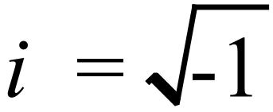 and reasons for its use.  Complex numbers: real and imaginary parts.  Conjugates, addition, subtraction, multiplication and use 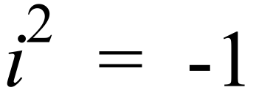 , division.
5 | Subtopic 12.4  The Complex (Argand) Plane | 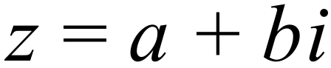 as (a, b) or [a, b].  Use vector addition in the complex plane.  Conjugate of and modulus 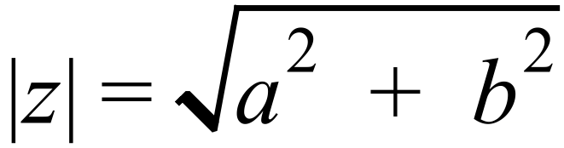 .
6 | Subtopic 12.5  Roots of Equations | Factorise quadratics into linear factors; use of quadratic formula involving i.
7 |  |  | SAT 3: Real and Complex Numbers  Part 1 – no calculators  Part 2 – calculators permitted
8 |  | EXAMINATION REVISION
9 |  | YEAR 11 EXAMS
Some other Investigation opportunities may include the use of quadratic iterations.

