Stage 1 Physics Practical Design Investigation: Motion on an incline

Purpose: To investigate the effect of the slope of an incline on the acceleration of an object down the incline.

Hypothesis: The greater the slope of the incline, the larger the acceleration of an object down the incline.

Independent Variables: Angle of incline
Dependent Variable: Acceleration of object
Controlled factors:
- Mass of object. The same cart will be used to roll down the slope each time.
- Length/surface of track. The same track will be used each time.
- Time of trial. The motion sensor will record the cart’s movements for the entire length of the track (start to finish).

Apparatus:
- Track
- Trolley
- Ultrasonic motion sensor
- Blocks of different heights
- Ruler
Investigation
Demonstrates ability to design a logical, coherent, and detailed plan for a physics investigation by providing relevant, accurate and detailed information in each section of the report on this page.

Procedure:
Cart
Motion Sensor -

Ramp
Block -
θ

1. Set up apparatus as shown in diagram, choosing the first angle of incline using different blocks.
2. Measure the base length and height to the bottom of the ramp.
3. Plug in motion sensor to computer and start DataStudio.
4. Place the cart at the top of the ramp.
5. Begin the first run on DataStudio and release the cart.
6. Stop the cart once it has travelled down the ramp, careful not to stop it too early (allow it a full run).
7. Stop the run on DataStudio.
8. Repeat steps 1-7 using 4 different heights for the ramp.
9. Using the measurements, calculate the angle of incline and sin angle of incline for each trial.
10. Using the DataStudio results, calculate the rate of acceleration for each trial.
Data:
Investigation
Demonstrates skills in accurately and effectively obtaining, recording, and displaying data from an investigation using appropriate conventions and format e.g. diagram shows the variables, graph is clearly labelled.
Trial 1 Diagram

Height = 18.6 cm

θ

Base =113.5 cm

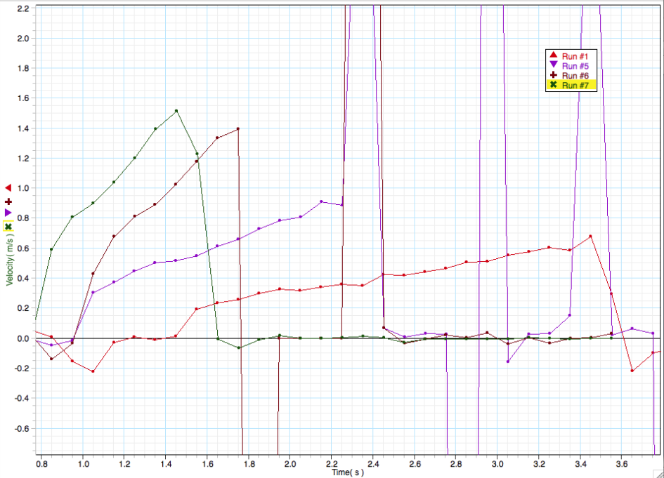
Trial 1

Trial 2

Trial 3

Trial 4

(1.25, 1.2)

(1.35, 1.4)

(1.65, 1.35)

(1.35, 0.9)

(1.05, 0.3)

(1.25, 0.45)

(1.55, 0.2)

(1.85, 0.3)

Data Analysis:
Knowledge and Understanding
Shows some depth and breadth of knowledge and understanding of the physics concepts related to the effect of slope on acceleration by providing formulae to use in data analysis.

The angle of incline of the slope is determined by using the following formula:

θ = tan⁻¹ (height/base)

For each trial, data points were selected from the graph then used to determine the change in velocity. The acceleration is calculated using the following formula:

Acceleration (slope) = [(y₂-y₁) / (x₂-x₁)]

Acceleration: Trial 1
Using points – (1.25, 1.2) and (1.35, 1.4)
Slope = 1.4-1.2/1.35-1.25
= 0.2/0.1
= 2 m/s/s
Analysis and Evaluation
Demonstrates thorough analytical skills by documenting connections between data obtained and acceleration rates for each trial and in a summary table.
Acceleration: Trial 2
Using points – (1.35, 0.9) and (1.65, 1.35)
Slope = 1.35-0.9/1.65-1.35
= 0.45/0.3
= 1.5 m/s/s

Acceleration: Trial 3
Using points – (1.05, 0.3) and (1.25, 0.45)
Slope = 0.45-0.3/1.25-1.05
= 0.15/0.2
= 0.75 m/s/s

Acceleration: Trial 4
Using points – (1.55, 0.2) and (1.85, 0.3)
Slope = 0.3-0.2/1.85-1.55
= 0.1/0.3
= 0.33 m/s/s

Summary of calculations

 | Base  (cm) | Height  (cm) | Angle of Incline  (θº) | Sinθ | Acceleration  (m s⁻²⁾
Trial 1 | 113.5 | 18.6 | 9.31 | 0.16 | 2
Trial 2 | 115 | 14.8 | 7.33 | 0.13 | 1.5
Trial 3 | 118.5 | 6.7 | 3.24 | 0.06 | 0.75
Trial 4 | 113.5 | 3.7 | 1.87 | 0.03 | 0.33

- Graph of acceleration (vertical axis) vs sin (angle of incline) (horizontal axis)

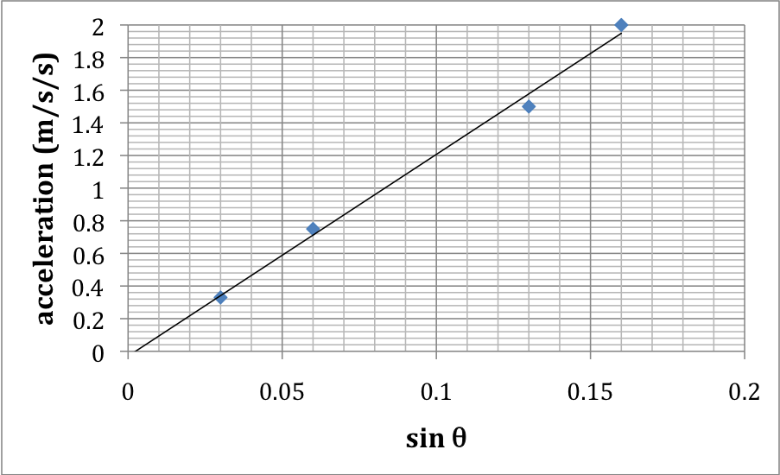
Investigation
Further demonstration of skills in accurately and effectively recording, and displaying data from an investigation using appropriate conventions and format i.e. graph includes a title, axes are clearly labelled and appropriate units are used.

- Explanation of results using Physics concepts.

Newton’s second law states that the acceleration of an object is directly proportional to the net force acting upon it, using the formula: F = m x a. The force acting upon our cart in this experiment was gravitational force. When the slope of the incline is steeper, there is a greater component of the gravitational force acting upon the cart, causing to it accelerate at a higher rate. When graphed, the acceleration vs. sine (angle of incline) showed that the values had a linear relationship. The acceleration of an object down an incline is directly proportional to the sine of the angle of incline as the relationship is linear and passes through the origin.
Knowledge and Understanding
Shows some depth and breadth of knowledge and understanding of physics concepts related to acceleration of an object.
Analysis and Evaluation
Demonstrates ability to use information from data analysis in the previous paragraph to formulate a logical and relevant conclusion.
  - Conclusion:
Based on the data collected in this investigation, the hypothesis is supported. That is, a larger angle of incline results in a higher rate of acceleration for an object travelling down the incline.

  - Evaluation:

- Identify any unexpected results and suggest a reason for them.
Our results followed the expected trend and there was only a little scatter around the line of best fit. Our third trial was not entirely precise and this could have been due to random error on our part – we may have incorrectly measured or recorded the base length or height of the ramp, or it may have been that our controlled variables were not kept constant. The cart may not have travelled in a straight line. Another possible source of error was in the selection of data points from the graph used to calculate the acceleration. These points were chosen as representative of the rate at which the velocity was changing. Given that the data shows variations, this is a possible source of error. Despite this, our results were logical and expected.
Analysis and Evaluation
Shows ability to logically evaluate procedures (by identifying possible sources of error), and suggest a range of appropriate improvements (three relevant suggestions are given).

- Suggest improvements to the experiment.
Our experiment could be improved by testing each angle of incline more than once. We only had one result for each angle of incline, but if we had more if would reduce the effect of random errors on our overall results.

We could also have chosen different sets of points on the graphs and taken an average acceleration for each trail. This may also have helped to reduce the effect of random error.

It may also be a good idea to pool data with other groups, but this would only work if all groups measured the same angles using the same track and cart.

Additional comments
In this task, the student has used appropriate physics terms, conventions, formulae, and equations highly effectively e.g. formula for acceleration, use of units, equation F = m x a.
During the lesson, the teacher has noted:
- Careful and highly effective manipulation of apparatus to implement well-organised, safe, and ethical investigation procedures (Investigation)
- Initiative in applying constructive and focused approaches to individual and collaborative work. (Application)
More than one assessment task would need to be considered to assess a student’s ability to:
- consistently demonstrate a deep and broad knowledge and understanding of a range of physics concepts. (Knowledge and Understanding).
- systematically analyse data and their connections with concepts to formulate logical and perceptive conclusions (Analysis and Evaluation).
- use appropriate scientific terms, conventions, formulae, and equations highly effectively (Application).

Stage 1 Physics PERFORMANCE STANDARDS FOR ASSESSMENT: INVESTIGATIONS FOLIO – PRACTICAL 1

 | Investigation | Analysis and Evaluation | Application | Knowledge and Understanding
A | Designs a logical, coherent, and detailed physics investigation.  Critically and logically selects and consistently and appropriately acknowledges information about physics and issues in physics from a range of sources.  Manipulates apparatus and technological tools carefully and highly effectively to implement well-organised safe and ethical investigation procedures.  Obtains, records, and displays findings of investigations using appropriate conventions and formats accurately and highly effectively. | Systematically analyses data and their connections with concepts to formulate logical and perceptive conclusions and make relevant predictions.  Logically evaluates procedures and suggests a range of appropriate improvements. | Applies physics concepts and evidence from investigations to suggest solutions to complex problems in new and familiar contexts.  Uses appropriate physics terms, conventions, formulae, and equations highly effectively.  Demonstrates initiative in applying constructive and focused individual and collaborative work skills. | Consistently demonstrates a deep and broad knowledge and understanding of a range of physics concepts.  Uses knowledge of physics perceptively and logically to understand and explain contemporary issues and applications.  Uses a variety of formats to communicate knowledge and understanding of physics coherently and highly effectively.
B | Designs a well-considered and clear physics investigation.  Logically selects and appropriately acknowledges information about physics and issues in physics from different sources.  Manipulates apparatus and technological tools carefully and mostly effectively to implement organised safe and ethical investigation procedures.  Obtains, records, and displays findings of investigations using appropriate conventions and formats mostly accurately and effectively. | Logically analyses data and their connections with concepts to formulate consistent conclusions and mostly relevant predictions.  Evaluates procedures and suggests some appropriate improvements. | Applies physics concepts and evidence from investigations to suggest solutions to problems in new and familiar contexts.  Uses appropriate physics terms, conventions, formulae, and equations effectively.  Applies mostly constructive and focused individual and collaborative work skills. | Demonstrates some depth and breadth of knowledge and understanding of a range of physics concepts.  Uses knowledge of physics logically to understand and explain contemporary issues and applications.  Uses a variety of formats to communicate knowledge and understanding of physics coherently and effectively.
C | Designs a considered and generally clear physics investigation.  Selects with some focus, and mostly appropriately acknowledges, information about physics and issues in physics from different sources.  Manipulates apparatus and technological tools generally carefully and effectively to implement safe and ethical investigation procedures.  Obtains, records, and displays findings of investigations using generally appropriate conventions and formats with some errors but generally accurately and effectively. | Analyses data and their connections with concepts to formulate generally appropriate conclusions and make simple predictions with some relevance.  Evaluates some procedures in biology and suggests some improvements that are generally appropriate. | Applies physics concepts and evidence from investigations to suggest some solutions to basic problems in new or familiar contexts.  Uses generally appropriate physics terms, conventions, formulae, and equations with some general effectiveness.  Applies generally constructive individual and collaborative work skills. | Demonstrates knowledge and understanding of a general range of physics concepts.  Uses knowledge of physics with some logic to understand and explain one or more contemporary issues and applications.  Uses different formats to communicate knowledge and understanding of physics with some general effectiveness.

 | Investigation | Analysis and Evaluation | Application | Knowledge and Understanding
D | Prepares the outline of a physics investigation.  Selects and may partly acknowledge one or more sources of information about physics or an issue in physics.  Uses apparatus and technological tools with inconsistent care and effectiveness and attempts to implement safe and ethical investigation procedures.  Obtains, records, and displays findings of investigations using conventions and formats inconsistently, with occasional accuracy and effectiveness. | Describes basic connections between some data and concepts and attempts to formulate a conclusion and make a simple prediction that may be relevant.  For some procedures, identifies improvements that may be made. | Applies some evidence to describe some basic problems and identify one or more simple solutions, in familiar contexts.  Attempts to use some physics terms, conventions, formulae, and equations that may be appropriate.  Attempts individual work inconsistently, and contributes superficially to aspects of collaborative work. | Demonstrates some basic knowledge and partial understanding of physics concepts.  Identifies and explains some physics information that is relevant to one or more contemporary issues and / or applications.  Communicates basic information to others using one or more formats.
E | Identifies a simple procedure for a physics investigation.  Identifies a source of information about physics or an issue in physics.  Attempts to use apparatus and technological tools with limited effectiveness or attention to safe or ethical investigation procedures.  Attempts to record and display some descriptive information about an investigation, with limited accuracy or effectiveness. | Attempts to connect data with concepts, formulate a conclusion and make a prediction.  Acknowledges the need for improvements in one or more procedures. | Identifies a basic problem and attempts to identify a solution in a familiar context.  Uses some physics terms or formulae.  Shows emerging skills in individual and collaborative work. | Demonstrates some limited recognition and awareness of physics concepts.  Shows an emerging understanding that some physics information is relevant to contemporary issues or applications.  Attempts to communicate information about physics.

