The Eclipse of Ballet: The Romantic Era
Stage 2 Dance Theory
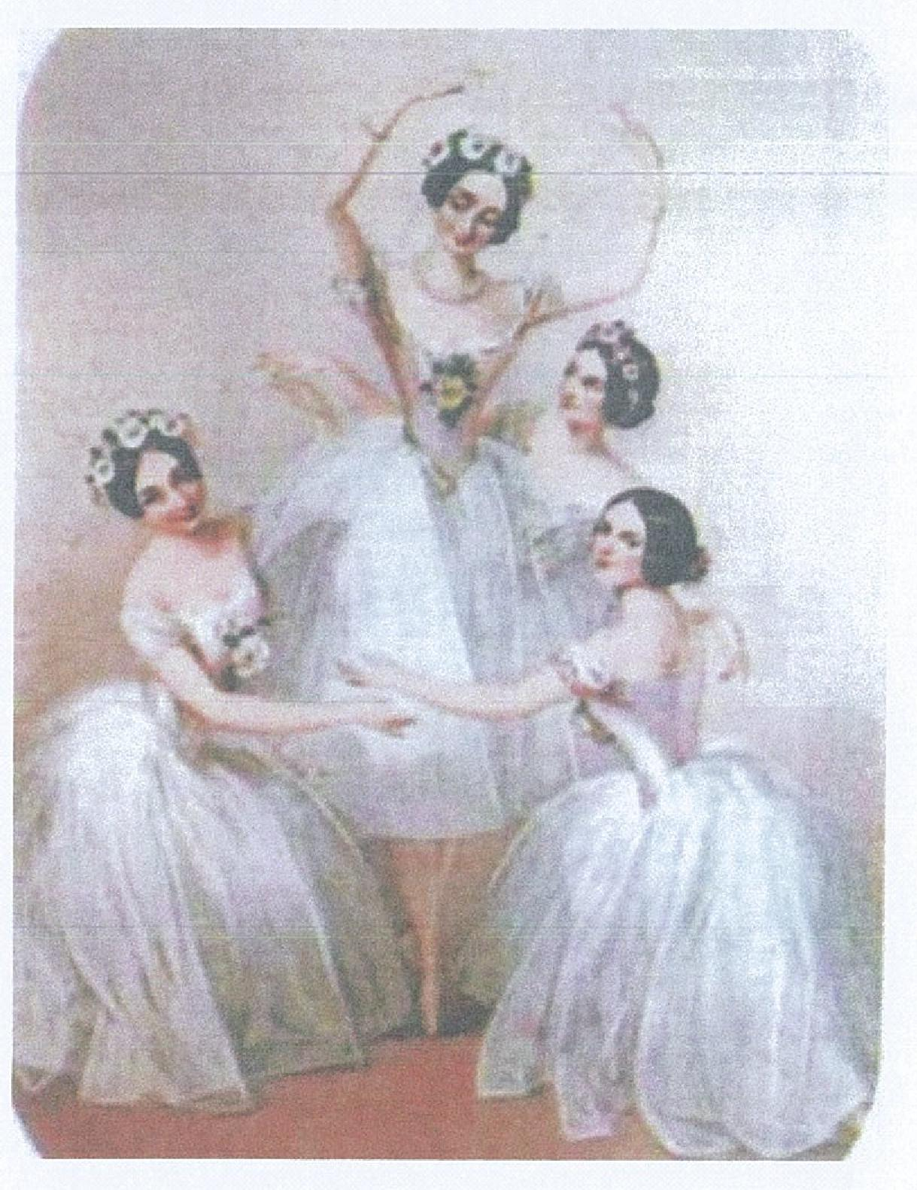
Historical Perspectives Essay
The Romantic Era
Between 1830 and 1850 classical dance has evolved significantly from its early years in French aristocratic court life, but no other period in its history created such monumental change as the Romantic Era. Despite the brevity of this period, it created radical change and helped form ballet into what it is today. Its impact can be seen in simple changes to costuming and theatrical innovations, which made a significant and substantial impression on how the public perceived dance. These technological advances revolutionised the theatre going experience. Iconic themes that were generated by the likes of Marie Taglioni brought depth and emotion to what were previously one-dimensional storylines, along with the development of how the roles of men and women in dance went against the conformation of society. These factors helped shape the mid 1800s into what is now considered to be the most influential and prominent era in the development of classical dance.
Presentation and Communication
Use of highly developed language and terminology relevant to the dance context. E.g. brevity, theatrical innovations, iconic themes, one-dimensional storylines, conformation of society.
Knowledge and Understanding
Indepth understanding of the Romantic Era demonstrated by reference to other related artforms followed by more detailed reference to dance specifically.
The Romantic Era, as it later became known, was thus named due to the influence of romanticism throughout Europe in the 1800s. Reflected also in the art, music and lifestyle of that time, these years became known as Romantic due to the popularity of such a lifestyle. In relation to dance, it was not so much a transition from one type of classical dance to another, but more major developmental phase that helped ballet emerge as a completely different art form. One of the most significant developments was the introduction of new theatrical innovations that revolutionised the experience for both dancers and audience members alike. Prior to the Romantic Era, theatres were lit only by houselights, which would remain at full capacity during the entire performance. When gas lighting was invented and implemented in the theatrical setting, it became a major feature. During a performance, gas lighting took a more predominant role, whilst houselights were dimmed, creating a thoroughly ethereal effect. The slight flickering of the gaslights added a sense of 'eeriness' to the production and produced a feeling of being in an environment with 'supernatural insinuation'. The use of suspended gas jets helped create the illusion of flickering moonbeams. The combination of this and a darkened eerie atmosphere on stage is particularly indicative of the Romantic Era. Another innovation was the way the curtain was utilised. In previous decades, the curtain had remained raised for the entirety of the performance but in the 1800s it became the norm for the curtain to be lowered in between scenes. This allowed scenery to be re-arranged so that when the curtain was lifted again, the audience would be presented with an unexpected transformation. Lowering the curtain became a method of drawing the audience into the story line and becoming engaged in the performance. Possibly the most radical development was the introduction of fly wires which in turn created the basic ideology of the pointe shoe. In ballets that required spirits to transition across the stage with an almost 'ghost-like' fashion, the dancers were suspended above the stage on strong yet impossibly thin wires that were controlled away from the eye of the audience. Allowing the dancers to momentarily suspend in the air and create an illusion that they were 'balancing on the tips of their toes' formed the foundations of a phenomena that now features extensively in modern classical dance, thus highlighting the significance of the Romantic Era.
Presentation and Communication
Section on costumes is representative of sustained communication using depth of explanation, detail and use of examples.
Costumes have always been significant in the world of dance as it helps create a certain feel to the piece being performed and can accentuate the line of the dancer. The Romantic Era created more significant changes to costuming than any other time period. The ballets created in this historical era were full of passion and 'out of this world events', and it was important that costumes were altered to suit this change. Ballets such as `La Sylphide' required the female dancers to appear ethereal and weightless. The illusion of this airiness was created with the use of a tight, fitted bodice and a bell shaped skirt constructed from layers of material that complimented the line of the dancer yet billowed 'like a cloud' as she leapt around the stage. The tight bodice was crucial in displaying the slender physique of the dancers, whe eas the appropriately named 'romantic tutu' was designed to conceal rather than convey. Costumes were unique to each production. In the 'moonlight' phases of a ballet, the costumes were more simplistic, with well-crafted detailing and softer colours. In the happier sections of the piece (the peasants waltz in Giselle par example), the costumes were plainer, but with vibrant colours. The only areas of bare skin on display were the neck and shoulder area, and it was essential that the tutu was long enough to cover the ankle. In the 1800's, the ankle was considered the most sensual part of the female body. Creators of the ballet were concerned that if it were on display then the males of the audience would not be concentrating on the dancing itself. However the feet were shown, as the father of renowned ballerina Marie Taglioni wanted to display his daughter's intricate footwork and her ability to balance En Pointe. The introduction of the pointed shoe was a personification of the Romantic era, and its initiation is associated with this time period. The changes in costuming were indicative of the Romantic Era as they added to the mystery of the ethereal creatures that the ballets of the time depicted.

The Romantic Era can be described as a codified collection of ballets that follow similar key themes of betrayal, love and a spiritual connection between the living and dead, as well as the evolutionary development of the female dancer. Choreographers such as Filippo Taglioni, Jean Coralli and Jules Perrot wove these themes into their defining ballets of romanticism: Giselle, La Sylphide and La Bayadere. All of the great ballets of this time contained complicated love triangles, tragic deaths and meetings between spiritual beings and those contained within their human form. These themes were a reflection on society of the time. When the public were facing hardship, they looked to the theatre to distract them from the troubles plaguing their lives. As such, the ballets of the mid 1800's were created to entertain and evoke emotion within communities. ln the 19th century, men were seen to have the dominant role in society. This social hierarchy was disproves in the dance world with the arrival of the Romantic Era. Female dancers dominated the stage and engaged with the audience in a manner never before seen in the theatre. The development of the pointed shoe was a milestone in the development of classical dance that gave the female dancer a visual advantage over their male counterparts. Audiences were enthralled by the ability of the dancers to stand on the ends of their toes with effortless poise that created a supernatural feel to many works generated in this time. The influence of the 'modern' ballerina was steadily rising, fuelled more so by the phenomena of the pointed shoe. From that stage, the pointe shoe became associated with women and female dancers outgrew their 'gender competition', creating what is classified as the Romantic Ballerina.
Analysis and Evaluation
Description of ballets and the common themes indicative of the period with analysis of how the dance works were relevant for the historical period.
Between 1830 and 1850, more changes were made to classical dance than in any other time period. Despite this period being short in duration, these changes have helped ballet become the respected art form of the 21st century. The significance of the Romantic Era can be gauged by multiple factors, including the changes made to costume and the theatre such as the invention of gas lighting, the introduction of the pointe shoe and the significantly more modern 'romantic tutu'. The numerous themes that were expressed through the works became associated with the era, along with the development of the roles of men and women, which were reversed in a manner never before seen in 19th century society.
Analysis and Evaluation
Concluding paragraph highlights the various factors that were collectively responsible for defining the Romantic Era in dance.

Historical Perspectives Essay
The Romantic Era
References:
The Australian Ballet (2010) The History of Romantic Ballet. Accessed: 10th July 2011 URL: http://www.australianballet.com.auieducation/about ballet/history of ballet/history of b allet romantic ballet
Analysis and Evaluation
Detailed bibliography demonstrates indepth research.
Dancers guide (2010) Ballet History: The Romantic Era. Accessed: 10th July 2011 URL: http://library.thinkouestorg/C0126184/english/musicballet.htm
Garafola, L (1997). Rethinking the sylph: new perspectives on the Romantic ballet. 2nd ed. United Kingdom: Wesleyan University Press. p. 89 -103.
InfoPlease Encyclopedia (2009) The Romantic Period and Ballet's Eclipse. Accessed: 9th July 2011 URL: http://www.infoplease.com/ce6/ent/A0856825.html
Lee, C (2002). Ballet in western culture: a history of its origins and evolution. 3rd ed. New York: Routledge Publishing House. p. 56 - 92.
Metropolitan Museum of Art (2011) The' Ballet. Accessed: 8th July 2011 URL: http://www.metmuseum.org/toah/hd/balt/hd balt.htm
Minden, E. G. (2005). The Romantic Era, An Eclipse in Ballet. In: The Ballet Companion: A Dancer's Guide to the Technique, Traditions and Joys of Ballet. . 2nd ed. London: Random House Publishing. p. 178 – 183
Performance Standards for Stage 2 Dance
- | Knowledge and Understanding | Practical Application | Presentation and Communication | Analysis and Evaluation
A | In-depth knowledge and understanding of the dance technique of a specific genre.  In-depth knowledge and understanding of the work of dance artists locally, nationally, or globally.  In-depth knowledge and understanding of the aesthetic qualities in technique, choreography, and/or performance. | Highly proficient and sustained application of technical skills and knowledge demonstrated, using safe dance practice.  Broad, varied, and thorough exploration, selection, and refinement of ideas.  Highly proficient and sustained demonstration of the dynamic contrasts and musicality within the principles of a specific dance genre.  Highly productive, independent, and collaborative performance or production skills. | Productive use of an extensive variety of appropriate skills to communicate sensitively and expressively and to engage an audience through practitioners’ on-stage or off-stage roles.  Coherent and sustained communication of original and innovative choreographic intention.  Highly developed use of language and terminology relevant to the dance context.  Sophisticated, coherent, and sustained communication, to exchange well-informed ideas and opinions. | In-depth research into, and analysis and interpretation of, historical and contemporary dance works, practice, and issues in context, using a variety of sources.  A purposeful evaluation of the relationships that interconnect in the process of staging dance.  Critical review of and reflection on dance, and perceptive evaluation of dance processes.  Perceptive analysis and in-depth understanding of dance as a creative form.
B | Detailed knowledge and understanding of the dance technique of a specific genre.  Some depth in knowledge and understanding of the work of dance artists locally, nationally, or globally.  Well-informed knowledge and understanding of the aesthetic qualities in technique, choreography, and/or performance. | Proficient technical skills and knowledge demonstrated consistently, using safe dance practice.  Thorough exploration, selection, and refinement of ideas.  Proficient demonstration of the dynamic contrasts and musicality within the principles of a specific dance genre.  Mostly productive, independent, and collaborative performance or production skills. | Mostly productive use of a variety of skills to communicate expressively and to engage an audience through practitioners’ on-stage or off-stage roles.  Clear communication of the original choreographic intention with some innovation.  Capable use of language and terminology relevant to the dance context.  Consistent and clear communication, to exchange informed ideas and opinions. | Thorough research into, and analysis and interpretation of, historical and contemporary dance works, practice, and issues in context, using several different sources.  A thoughtful evaluation of the relationships that interconnect in the process of staging dance.  Critical review of and reflection on dance, and well-considered evaluation of dance processes.  Well-considered analysis and some depth in understanding of dance as a creative art form.
C | Appropriate knowledge and understanding of the dance technique of a specific genre.  Considered knowledge of the work of dance artists locally, nationally, or globally.  Appropriate knowledge and understanding of the aesthetic qualities in technique, choreography, and/or performance. | Generally competent application of technical skills and knowledge, using safe dance practice.  Appropriate exploration, selection, and refinement of ideas.  Generally competent demonstration of the dynamic contrasts and musicality within the principles of a specific dance genre.  Generally competent, independent, and collaborative performance or production skills. | Competent use of appropriate skills to communicate with some expression and to engage an audience through practitioners’ on-stage or off-stage roles.  Competent communication of an original choreographic intention, with elements of innovation.  Competent use of language and terminology relevant to the dance context.  Appropriate and generally clear communication to exchange ideas and opinions. | Competent research into, and analysis and interpretation of, historical and contemporary dance works, practice, and issues in context, using different sources.  Considered evaluation of the relationships that interconnect in the process of staging dance.  Critical review of and reflection on dance, and considered evaluation of some dance processes.  Considered analysis and understanding of dance as a creative art form.
D | Some identification and understanding of the dance technique of a specific genre.  Some awareness of the work of dance artists locally, nationally, or globally.  Some knowledge and understanding of the aesthetic qualities in technique, choreography, and/or performance. | Basic technical skills and knowledge, with some understanding of how to apply safe dance practice.  Some exploration, selection, and refinement of ideas.  Basic demonstration of the dynamic contrasts and musicality within the principles of a specific dance genre.  Some independent and collaborative performance or production skills. | Some skills in communicating to an audience, with some engagement, through practitioners’ on-stage or off-stage roles.  Some communication of aspects of choreographic intention.  Basic use of language and terminology with some relevance to the dance context.  Attempted communication to exchange ideas and opinions. | Some research into, and description of, one or more historical and contemporary dance works, practices, or issues, using more than one source.  Some consideration of the relationships that interconnect in the process of staging dance.  Superficial review of and reflection on dance, and some description of dance processes.  Description of dance as a creative art form.
E | Awareness of some basic dance technique of a specific genre.  Emerging awareness of the work of dance artists locally, nationally, or globally.  Emerging awareness of the aesthetic qualities in technique, choreography, and/or performance. | Emerging technical skills, with limited awareness of safe dance practice.  Attempted exploration, selection, and refinement of ideas.  Emerging demonstration of the dynamic contrasts and musicality within the principles of a specific dance genre.  Some attempt to work independently or collaboratively in performance or production. | Emerging skills when attempting communication of an idea to an audience.  Attempted communication of an aspect of choreographic intention.  Attempted use of some language or terminology with limited relevance to the dance context.  Emerging skills in communication of ideas or opinions. | Attempted search for information on historical or contemporary issues or practice, using at least one source.  Emerging recognition that relationships interconnect in the process of staging dance.  Identification of an element of dance or dance processes.  Identification and brief description of dance as a creative art form.

