Stage 2 Biology

Assessment Type 2: Skills and Applications Tasks

Cells Test

Purpose

This task allows you to demonstrate your knowledge and understanding of the concepts of biology at a cellular level.

Description of the assessment

This test assesses:

* knowledge and understanding of concepts of cells and their function.
* knowledge and understanding of transport and movement of molecules into and out of cells
* knowledge and understanding of the principles of cellular evolution including cell culturing and altering cellular metabolism.
* application of concepts to the solving of problems in familiar and new contexts
* communication of knowledge and understanding of the concepts of cells in different formats.

Assessment conditions

* Time allowance: 100 minutes

|  |  |  |
| --- | --- | --- |
| ***Learning Requirements*** | ***Assessment Design Criteria*** | ***Capabilities*** |
| 1. identify and formulate questions, hypotheses, concepts, and purposes that guide biological investigations  2. design and conduct individual and collaborative biological investigations  3. manipulate apparatus and use technological tools and numeracy skills to obtain, represent, analyse, interpret, and evaluate data and observations from biological investigations  4. select and critically evaluate biological evidence from different sources and present informed conclusions and personal views on social, ethical, and environmental issues  5. communicate their knowledge and understanding of biological concepts using appropriate biological terms and conventions  6. demonstrate and apply biological knowledge and understanding of concepts and interrelationships to a range of contexts and problems, including by presenting alternative explanations. | Investigation  The specific features are as follows:  I1 Design of biological investigations.  I2 Selection and acknowledgment of information about biology and issues in biology from different sources.  I3 Manipulation of apparatus and technological tools to implement safe and ethical investigation procedures.  I4 The obtaining, recording, and display of findings of investigations using appropriate conventions and formats.  Analysis and Evaluation  The specific features are as follows:  AE1 Analysis and evaluation of connections between data, concepts, and issues in biology.  AE2 Evaluation of procedures, with suggestions for improvement.  Application  The specific features are as follows:  A1 Application of biological concepts and evidence from investigations to solve problems in new and familiar contexts.  A2 Use of appropriate biological terms, conventions, formulae, and equations.  A3 Demonstration of skills in individual and collaborative work.  Knowledge and Understanding  The specific features are as follows:  KU1 Demonstration of knowledge and understanding of biological concepts.  KU2 Use of knowledge of biology to understand and explain social or environmental issues.  KU3 Communication of knowledge and understanding of biology in different formats. | **Communication**  Citizenship  Personal Development  Work  Learning |

Performance Standards for Stage 2 Biology

|  | Investigation | Analysis and Evaluation | Application | Knowledge and Understanding |
| --- | --- | --- | --- | --- |
| A | Designs logical, coherent, and detailed biological investigations.  Critically and logically selects and consistently and appropriately acknowledges information about biology and issues in biology from a range of sources.  Manipulates apparatus and technological tools carefully and highly effectively to implement well-organised safe and ethical investigation procedures.  Obtains, records, and displays findings of investigations using appropriate conventions and formats accurately and highly effectively. | Critically and systematically analyses data and their connections with concepts, to formulate logical and perceptive conclusions and make relevant predictions.  Critically and logically evaluates procedures and suggests a range of appropriate improvements. | Applies biological concepts and evidence from investigations to suggest solutions to complex problems in new and familiar contexts.  Uses appropriate biological terms, conventions, formulae, and equations highly effectively.  Demonstrates initiative in applying constructive and focused individual and collaborative work skills. | Consistently demonstrates a deep and broad knowledge and understanding of a range of biological concepts.  Uses knowledge of biology perceptively and logically to understand and explain social or environmental issues.  Uses a variety of formats to communicate knowledge and understanding of biology coherently and highly effectively. |
| B | Designs well-considered and clear biological investigations.  Logically selects and appropriately acknowledges information about biology and issues in biology from different sources.  Manipulates apparatus and technological tools carefully and mostly effectively to implement organised safe and ethical investigation procedures.  Obtains, records, and displays findings of investigations using appropriate conventions and formats mostly accurately and effectively. | Clearly and logically analyses data and their connections with concepts, to formulate consistent conclusions and make mostly relevant predictions.  Logically evaluates procedures and suggests some appropriate improvements. | Applies biological concepts and evidence from investigations to suggest solutions to problems in new and familiar contexts.  Uses appropriate biological terms, conventions, formulae, and equations effectively.  Applies mostly constructive and focused individual and collaborative work skills. | Demonstrates some depth and breadth of knowledge and understanding of a range of biological concepts.  Uses knowledge of biology logically to understand and explain social or environmental issues.  Uses a variety of formats to communicate knowledge and understanding of biology coherently and effectively. |
| C | Designs considered and generally clear biological investigations.  Selects with some focus, and mostly appropriately acknowledges, information about biology and issues in biology from different sources.  Manipulates apparatus and technological tools generally carefully and effectively to implement safe and ethical investigation procedures.  Obtains, records, and displays findings of investigations using generally appropriate conventions and formats with some errors but generally accurately and effectively. | Analyses data and their connections with concepts, to formulate generally appropriate conclusions and make simple predictions, with some relevance.  Evaluates some procedures in biology and suggests some improvements that are generally appropriate. | Applies biological concepts and evidence from investigations to suggest some solutions to basic problems in new or familiar contexts.  Uses generally appropriate biological terms, conventions, formulae, and equations with some general effectiveness.  Applies generally constructive individual and collaborative work skills. | Demonstrates knowledge and understanding of a general range of biological concepts.  Uses knowledge of biology with some logic to understand and explain one or more social or environmental issues.  Applies different formats to communicate knowledge and understanding of biology with some general effectiveness. |
| D | Prepares the outline of one or more biological investigations.  Selects and may partly acknowledge one or more sources of information about biology or an issue in biology.  Uses apparatus and technological tools with inconsistent care and effectiveness and attempts to implement safe and ethical investigation procedures.  Obtains, records, and displays findings of investigations using conventions and formats inconsistently, with occasional accuracy and effectiveness. | Describes basic connections between some data and concepts, and attempts to formulate a conclusion and make a simple prediction that may be relevant.  For some procedures, identifies improvements that may be made. | Applies some evidence to describe some basic problems and identify one or more simple solutions, in familiar contexts.  Attempts to use some biological terms, conventions, formulae, and equations that may be appropriate.  Attempts individual work inconsistently, and contributes superficially to aspects of collaborative work. | Demonstrates some basic knowledge and partial understanding of biological concepts.  Identifies and explains some biological information that is relevant to one or more social or environmental issues.  Communicates basic information to others using one or more formats. |
| E | Identifies a simple procedure for a biological investigation.  Identifies a source of information about biology or an issue in biology.  Attempts to use apparatus and technological tools with limited effectiveness or attention to safe or ethical investigation procedures.  Attempts to record and display some descriptive information about an investigation, with limited accuracy or effectiveness. | Attempts to connect data with concepts, formulate a conclusion, and make a prediction.  Acknowledges the need for improvements in one or more procedures. | Identifies a basic problem and attempts to identify a solution in a familiar context.  Uses some biological terms or formulae.  Shows emerging skills in individual and collaborative work. | Demonstrates some limited recognition and awareness of biological concepts.  Shows an emerging understanding that some biological information is relevant to social or environmental issues.  Attempts to communicate information about biology. |

CELLS TEST

SECTION A: MULTIPLE CHOICE

*Answer all questions in this section*

Tests generally begin with straight forward questions assessing **Knowledge and Understanding** which most students should be able to answer correctly.

*Each multiple choice is worth two marks.*

1. Which statement about chloroplasts is FALSE?

J. They are organelles with a double membrane.

K. They contain their own genetic information and ribosomes.

L. They are found in eukaryotic and prokaryotic cells.

M. They contain ATP.

2. Many single celled organisms, such as Amoeba, feed by a process in which the cell membrane engulfs solid food particles to form a **food vacuole**. This process is called

J. endocytosis.

K. active transport.

L. exocytosis.

M. osmosis.

3. Which one of the following statements correctly describes the function of the cell membrane?

J. The cell membrane strengthens the cell and gives it shape.

K. The cell membrane selectively permits materials to pass into and out of the cell.

L. The cell membrane contains a phospholipid bilayer embedded with proteins.

M. The cell membrane is composed of cellulose.

1. Refer to the following electron micrograph which shows an organelle from a cell in a multicellular organism.

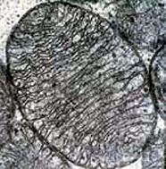

approx1 µm

Source: U.S. Dept. of Health and Human Services/National Institutes of Health

The organelle is the site of

J. starch formation.

K. photosynthesis.

L. ATP synthesis.

M. glycogen storage.

1. In a sample of human blood, the average diameter of the red blood cells was found to be 8.0 micrometres. A student placed equal volumes of this blood in each of three solutions of unknown concentration. After 10 minutes the student determined the average diameter of the cells in each solution, with the following results.

|  |  |
| --- | --- |
| Solution | Average diameter in cells |
| I | 8.8 micrometres |
| II | 7.3 micrometres |
| III | 8.1 micrometres |

It would **not** be reasonable to conclude that

J. solution I was more dilute than blood plasma.

K. there had been net movement of water out of the cells in solution II.

L. if the cells had been placed in a solution more concentrated than solution II, the cells would probably have burst.

M. the concentration of solutes in solution III was similar to the concentration of solutes in the cells.

6. Which one of the following combinations correctly identifies a cellular structure, its function, and the type of cell in which it is found?

|  |  |  |  |
| --- | --- | --- | --- |
|  | **Cellular structure** | **Function** | **Type of cell in which it is found** |
| J. | circular loop of DNA | contains information for the synthesis of proteins | eukaryotic |
| K. | ribosome | the site of protein synthesis | prokaryotic |
| L. | linear DNA | contains information for the synthesis of mRNA molecules | prokaryotic |
| M. | endoplasmic reticulum | the site for the packaging and secretion of proteins | eukaryotic |

7. Refer to the following diagrams, which show three identical plant cells that had been left to stand for 5 minutes in sugar solutions of different concentrations. The solution inside the three cells initially had the same concentration as sugar

solution 2. 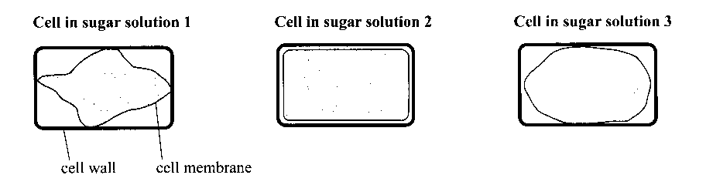

It would be reasonable to conclude that

J. the solution inside the cells initially was more concentrated than sugar solution 1.

K. the solution inside the cells initially was more concentrated than sugar solution 3.

L. sugar solution 1 was more concentrated than sugar solution 3.

M. sugar solution 1 was less concentrated than sugar solution 2.

8. Refer to the following diagram, which shows the concentration of sodium ions inside three sections along a kidney and in a cell next to each section of the tubule:

Questions such as this are more challenging because they require students to connect two or more ideas and carry out some problem solving. Correctly answering the question provides evidence of **Application** at an A level.

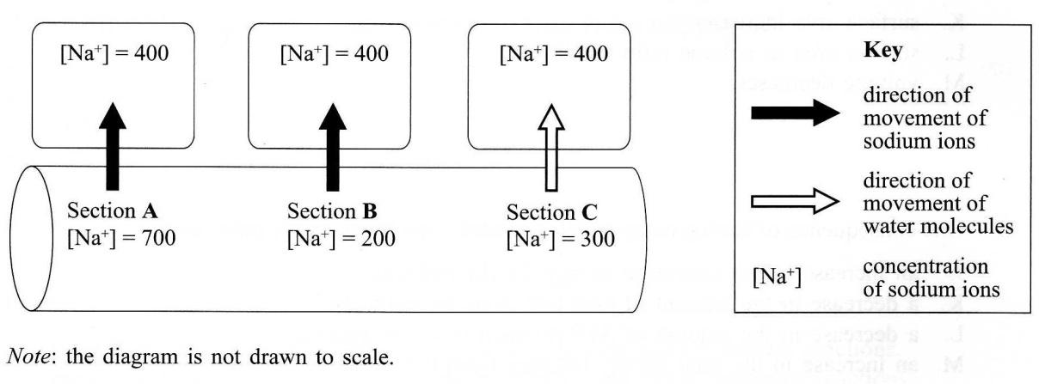

Which one of the following combinations correctly matches the processes that result in the net movement of

* sodium ions *out of* section **A**
* sodium ions *out of* section **B**
* water molecules *out of* section **C**?

|  |  |  |  |
| --- | --- | --- | --- |
|  | **Process that results in the net movement of:** | | |
|  | **Sodium ions out of section A** | **Sodium ions out of section B** | **Water molecules out of section C** |
| J. | Diffusion | Active transport | Osmosis |
| K. | Active transport | Diffusion | Osmosis |
| L. | Diffusion | Active transport | Active transport |
| M. | Active transport | Diffusion | Active transport |

9. Refer to the diagram below in which the cubes represent living cells. Cell A, Tissue B and Tissue C all have the same volume.

**Cell A**

**Tissue B**

**Tissue C**

Which one of the following statements is correct?

J. In distilled water tissue B would gain water at a faster rate than cell A.

K. In distilled water the cells in tissue C would shrink at a faster rate than

cell A.

L. In a concentrated salt solution tissue C would gain water at a faster rate than cell A.

M. In a concentrated salt solution tissue C would lose water more slowly than tissue B.

10. Which one of the following sequences of cell structures correctly describes the pathway that leads to the production, transport, and secretion of the protein thyroxine by thyroid gland cells?

J. Nucleus ribosomes endoplasmic reticulum Golgi body cell membrane

K. Nucleus ribosomes vesicle endoplasmic reticulum cell membrane

L. Ribosomes mitochondria Golgi body vesicle cell membrane

M. Ribosomes endoplasmic reticulum nucleus Golgi body cell membrane

11. Which one of the following combinations correctly matches components of eukaryotic and prokaryotic cells with components of eukaryotic but not prokaryotic cells?

|  |  |  |
| --- | --- | --- |
|  | **Components of eukaryotic *and* prokaryotic cells** | **Components of eukaryotic *but not* prokaryotic cells** |
| J | Mitochondria | Cell membrane |
| K | Cell membrane | DNA |
| L | Cell membrane | Mitochondria |
| M | DNA | Cell membrane |

12. One consequence of having small regulated steps in an energy pathway is

J. an increase in the activation energy for the pathway.

K. a decrease in the amount of heat lost from the pathway.

L. a decrease in the amount of ATP released from the pathway.

M. an increase in the total energy released from the pathway.

13. Refer to the following diagrams, which show a process in which molecules move through a cell membrane.

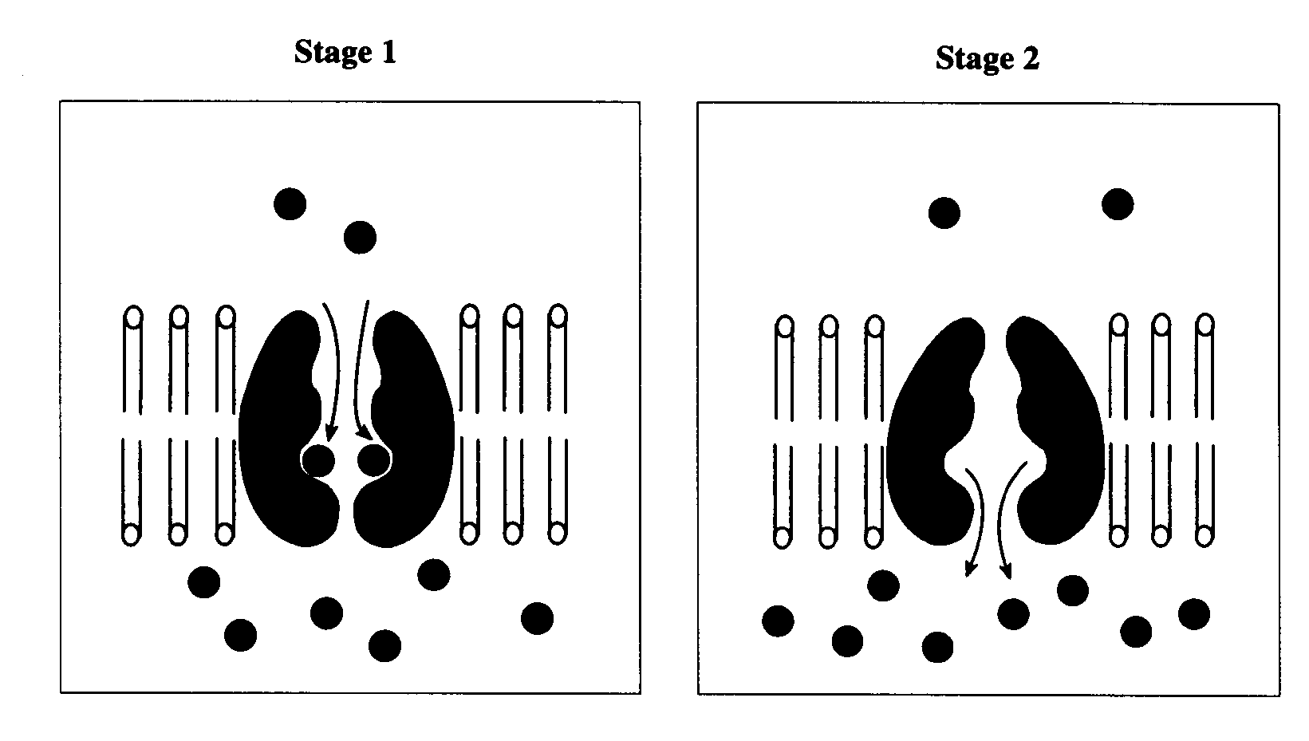

Questions such as this allow students the opportunity to demonstrate their **Application** of appropriate biological terminology.

The process show in the diagram is

J. active transport.

K. diffusion.

L. osmosis.

M. phagocytosis.

14. *Refer to the following diagrams, which show the appearance of cells from a plant tissue. Cells* **A***,* **B***, and* **C** *are undergoing various stages of mitosis. Cells* **D** *and* **E** *are daughter cells formed immediately after cell division.*

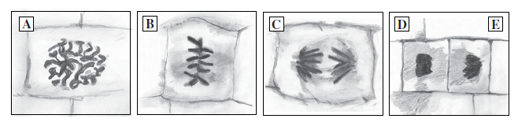

Questions such as this are more challenging because they require students to connect two or more ideas and carry out some problem solving. Correctly answering the question provides evidence of **Knowledge and Understanding** at an A level.

The plant tissue had been grown in a culture medium containing radioactive DNA nucleotides. The level of radioactivity in each cell was measured and the results are shown in the table below:

|  |  |
| --- | --- |
| **Cell in diagram** | **Level of radioactivity**  **(arbitrary units)** |
| A | 102 |
| B | 100 |
| C | 52 |
| D | 51 |

Cells with the same amount of DNA have approximately the same level of radioactivity.

For which cell was the level of radioactivity ***incorrectly*** measured?

J. **A**.

K. **B**.

L. **C**.

M. **D**.

15. Which one of the following statements about cell culture is ***incorrect***?

J. The temperature of the culture is critical because it affects the rate of chemical reactions in the cells.

K. A cell culture can be used to produce genetically identical human cancer cells.

L. A gene of interest can be transferred into a bacterium by cell culture.

M. Sterile conditions are needed in a cell culture to prevent the growth of unwanted microorganisms.

Questions such as this which requires the selection of an *incorrect* alternativeare generally more demanding than those requiring the selection of a correct alternative.

16. Which one of the following statements about binary fission ***is incorrect?***

J. Genetically identical daughter cells are produced.

K. Each daughter cell contains some of the DNA from the parent cell.

L. The cytoskeleton separates chromosomes into the daughter cells.

M. DNA replication occurs before binary fission.

17. Refer to the following graph, which shows changes in energy during the progress of a synthesis reaction, **X, Y** and **Z** indicate stages in the progress of the synthesis reaction.

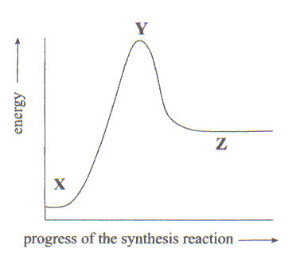

Questions such as this allow students to demonstrate their A**pplication** of evidence from investigations to solve problems in new and familiar contexts.

Which one of the following statements about this ***synthesis*** reaction is correct?

J. Between **Y** and **Z** an input of energy is required**.**

K. Between **Y** and **Z** energy is released as chemical bonds form.

L. Between **X** and **Y** energy is released as chemical bonds break.

M. Between **X** and **Z** there is an overall release of energy.

18. In eukaryotic cells the conversion of ADP and phosphate into ATP occurs

J. only in the mitochondria, and requires energy.

K. only in the cytoplasm, and releases energy.

L. in both the mitochondria and the cytoplasm, and requires energy.

M. in both the mitochondria and the cytoplasm, and requires energy.

19. Refer to the following diagram, which shows four stages in a cellular process.

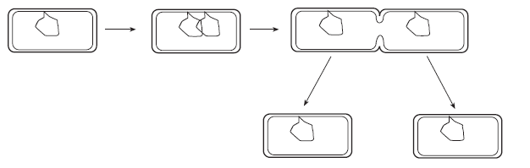

The cellular process shown in the diagram above is

J. binary fission in a prokaryotic cell.

K. binary fission in a eukaryotic cell.

L. mitosis in a prokaryotic cell.

M. mitosis in a eukaryotic cell.

20. Refer to the following diagram, which represents stages in the cell cycle.

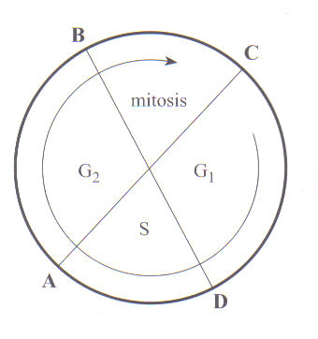

Questions such as this allow students to demonstrate their **Application** of biological concepts to solve problems in new and familiar contexts.

Which one of the following statements is correct?

J. To prevent mitosis from taking place, a block would occur in a chemical reaction in a stage from **C** to **B**.

K. DNA synthesis would occur in the stage from **A** to **B**.

L. Ribosomes will be particularly active in the stage from **B** to **C**.

M. All cells resulting from mitosis will continue to pass through the stages from **C** to **D**, **D** to **A**, to **B**, and **B** to **C** again.

**SECTION B: SHORT ANSWER QUESTIONS**

21. Eukaryotic cells evolved about 1.5 billion years ago in an environment that is thought to have been very different from today’s environment.

a) State one piece of evidence to support this hypothesis that prokaryotic cells probably existed before eukaryotic cells.

____________

2 marks

b) State and explain one piece of evidence to support the hypothesis that the evolution of eukaryotic cells probably involved endosymbiotic events.

Questions beginning with different words such as ‘State ….’ and ‘Explain ….’ provide students with opportunities to provide evidence of their knowledge and understanding of biological concepts at different levels against the performance standards.

4 marks

22. Explain how mutations caused by carcinogens can induce cancer.

4 marks

23. Refer to the following diagram, which shows the structure of a cell.

Note:

The mark scheme used in this test for the short answer questions follows the pattern that is used for marking the external examination.

Two marks are allocated for one well-expressed piece of information. Questions that require an explanation are worth four marks.

Therefore, in order to obtain full marks, students need to supply two relevant and connected pieces of information.

In addition, where the answer to a question requires a biological term that is used in the subject outline, students are expected to spell it correctly to be awarded full marks.

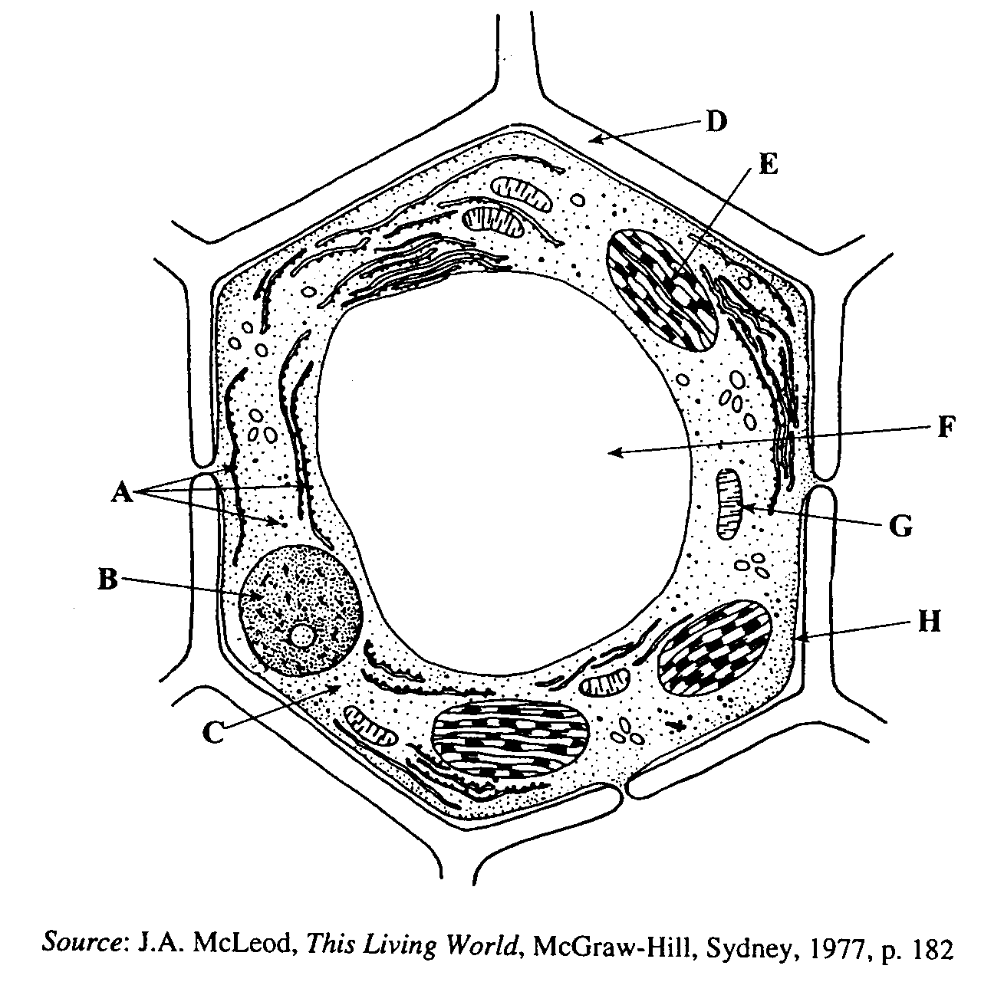

*Source:* J.A. McLeod, *This Living World*, McGraw-Hill, Sydney, 1977, p. 182

1. State one piece of evidence that indicates that the cell shown above is an eukaryotic cell.

2 marks

1. Which letter indicates where aerobic respiration occurs? 2 marks
2. Complete the following table by writing the name of the structures labelled B and H and the function or purpose of that structure.

|  |  |  |
| --- | --- | --- |
| **Structure** | **Name of structure** | **Function or purpose** |
| B |  |  |
| H |  |  |

4 marks

24. Refer to the following diagram, which shows the structure of part of the cell membrane of a bacterium.

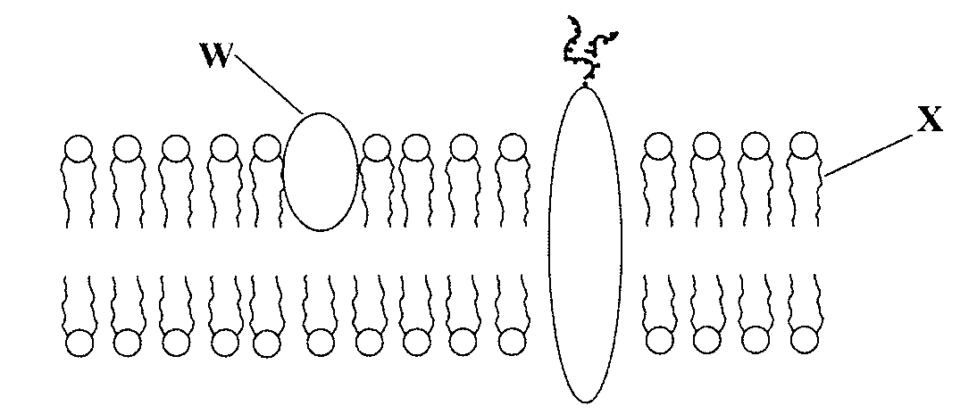

1. Name the molecules represented by W and X.

W:

X: 2 marks

(b) The recent appearance of bacteria that are resistant to a wide range of antibiotics has led to increased research into new types of antibiotic. One of these types of antibiotic comprises a hollow, cylindrical protein, which becomes incorporated in the cell membrane of bacteria, as shown below.

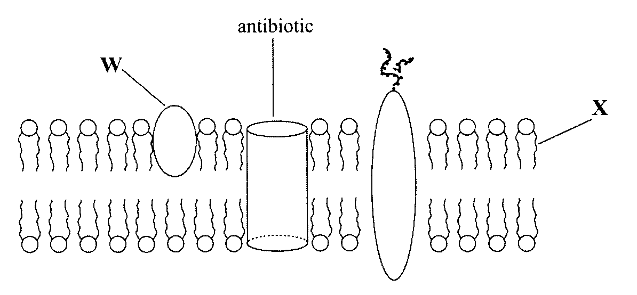

Explain how the incorporation of a hollow, cylindrical protein in the cell membrane could affect a bacterial cell.

4 marks

25. Refer to the following diagram, which shows some of the events in the cell cycle of eukaryotic cells.

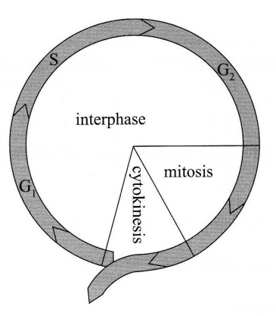

1. Compare the amount of DNA in a cell at G2 with the amount of DNA in a cell at G1.

2 marks

1. Compare the genetic composition of the daughter cells produced by mitotic cell division with the genetic composition of the parent cell.

2 marks

1. State ***one*** function of the cytoskeleton during mitotic cell division.

2 marks

(d) Researchers think that cells from elderly people may not respond to growth hormones as effectively as cells from a baby.

Explain one possible reason for this, based on the structure of the cell membrane.

4 marks

26. Refer to the following diagrams, which show two successive stages, **I** and **II**,in the division of a cell.

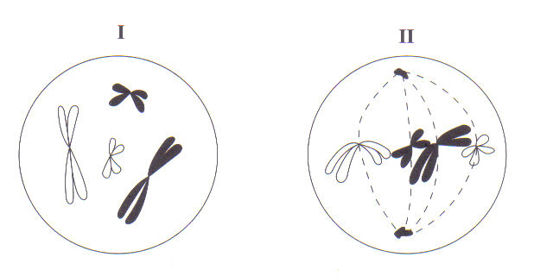

1. Draw the chromosomes as they would appear next (in stage **III** of the division of this cell).

4 marks

Questions such as this allow students to provide evidence of communication in a different format.

1. State one piece of evidence from the diagrams above to indicate that this is a eukaryotic cell.

2 marks

1. State two energy-using processes that occur during cell division.

(i) Process 1: ___________________________________________ 2 marks

(ii) Process 2: ___________________________________________ 2 marks

**SECTION C:** **Extended Response**

Note:

This test does not contain questions that will provide evidence of learning against the Assessment Design Criterion *Investigation.* This criterion must be addressed in at least one Skills and Applications Task. Questions relating to the recording and display of findings of investigations using appropriate conventions and formats (*I4*) would be suitable.

**Content: 12 Marks Communication: 3 Marks**

*Credit will be given for clear, well-expressed answers that are well organised and relevant to the questions.*

27. Cell cultures have been widely used in studies of the growth and development of cells and the regulation of cell division.

Describe

* the regulation of cell division;
* a method that is used for culturing cells;
* two contemporary examples of the use of cell cultures.

An Extended Response Question provides students with the opportunity to display their depth of knowledge of biological concepts as well as demonstrate their written communication skills.

It provides evidence of **Knowledge and Understanding** of biological concepts, communication in the extended response format, and the **Application** of appropriate biological terms and conventions.

**Note** - The following is an excerpt from the Chief Assessor’s report:

An extended-response question is marked out of 15, with 12 marks being allocated for content (each well-made point is worth 2 marks) and 3 marks for communication. This question has three content parts, with each part being marked out of 4.

In awarding a communication mark, the following factors are taken into account:

* Is the response at least half a page in length and is it structured in the form of sentences and paragraphs?
* Does the response use correct grammar and spelling?
* Does the response clearly explain concepts using relevant and concise biological language?

Students should be able to fully answer an extended-response question in about one page of writing. It is unnecessary for students to re-write the question or to provide an introduction to their response. Both of these practices are time-wasting, receive no credit, and may even result in a reduction in the communication mark.