Procedure for Oral Examinations conducted through Zoom

Contents
Minimum Technical requirements 2
Background Information 3
On the day of the oral examination 4
Conduct of the oral examination 7

SUMMARY OF ORAL CONNECTION PROCESS
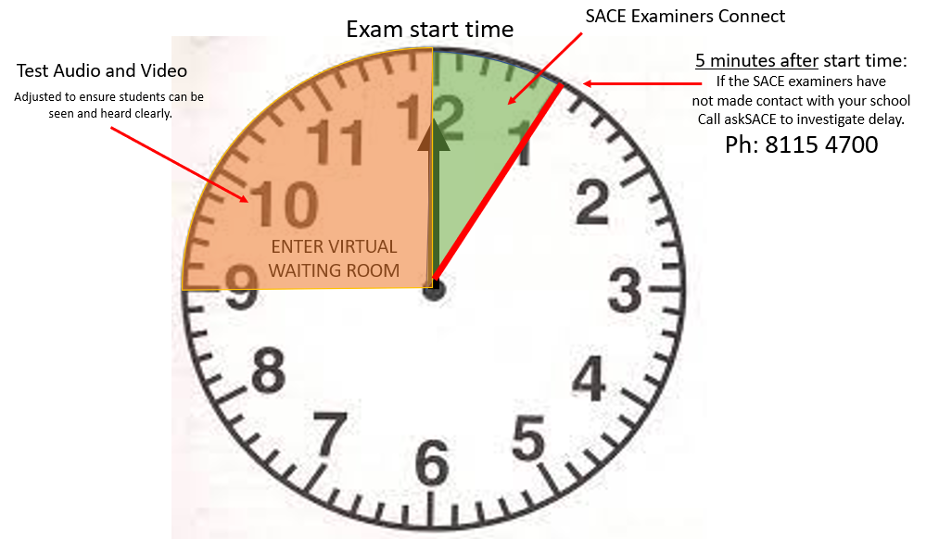

Minimum Technical requirements
In order to ensure the best video and sound quality for connection the SACE Board of SA recommend the examination venue have access to:-

Minimum requirements
Device | Desktop or Laptop
Operating Systems | Windows or Mac
Internet browsers | • Windows: IE 11+, Edge 12+, Firefox 27+, Chrome 30+  • Mac: Safari 7+, Firefox 27+, Chrome 30+  • Linux: Firefox 27+, Chrome 30+  Any one of the above browsers can be used.
Security | Up to date anti-virus protection
System Requirements | - An internet connection – broadband wired or wireless (3G or 4G/LTE)  - Speakers and a microphone – built-in or USB plug-in or wireless Bluetooth  - A webcam or HD webcam - built-in or USB plug-in

Background Information
  - Each student studying a language will be examined at their contact school (examination venue) at a time that SACE will advise. Please ensure that all language students know their correct oral examination venue.
  - The SACE board will publish an examination timetable outlining the start and finish times for each examination for a specific language at each contact school.
  - Following publication of this timetable the SACE Board will send a spreadsheet to each contact school outlining the individual times, dates and ZOOM examination room URL link.
  - Students should aim to arrive at the examination area at their contact school 15 to 20 minutes before the scheduled time of their individual oral examination.
  - Schools should access the Zoom examination room URL at least 15 minutes prior to the scheduled start time of their first student’s examination.
  - Each students examination should take approximately 15 minutes.
  - Once connected to the ZOOM examination room, schools will access a virtual waiting area until the designated start time to allow the school opportunity to ensure that the audio and video are working correctly.
  - At the designated start time of the first student’s examination the SACE examiners will admit the invigilator to the allocated ZOOM examination room.
  - Where there are several students that are being examined the SACE Board will remain connected to the same Zoom examination room URL and schools will not need to disconnect or reconnect in between each student.
  - Where there are several students that are being examined, each student will be examined in alphabetical order, by surname.
  - In the event that there are 2 or more examinations for a school on the same day and time then schools must ensure that they have adequate spaces set aside for students of one or more languages to be examined simultaneously. Note: The ZOOM examination room URL meeting request can be forwarded to any individual invigilator or member of staff at the school to access the examination.
  - As there may be several different examination room URLs required on a particular day for a school, please ensure that the correct ZOOM examination room link is used for the correct examination

On the day of the oral examination
  - Each examination venue must ensure that there is:
    - A staff member available to supervise all students on arrival
    - A designated waiting area(s) available near the examination room(s)
    - A designated examination room(s)
    - A designated invigilator (see point 4)
  - Office staff should be made aware of the location of the examination and waiting rooms so they can direct students to the examination area if necessary.
  - Mobile phones and other electronic devices must be switched off and not accessed in the waiting area or examination area.
  - The examination venue needs to ensure that there is an appropriate invigilator(s) who can provide technical assistance to the student if the need arises. The invigilator requirements are identified below:
    - The invigilator cannot be a teacher of the language or familiar with the language being examined.
    - Must be familiar with the use of ZOOM.
    - There must be at least one invigilator in the examination room throughout the examination period and while any student is in the room. An invigilator may be relieved from time to time, provided that there is always at least one invigilator in the room.
  - Before the start of the first examination, the school should click the ZOOM URL examination room link allocated to the examination room. If there are multiple students being examined your school will remain connected to this link until the last student for that room has completed their oral examination. Please verify upon connection that your school is connected to the correct ZOOM examination room. Please see example below:-
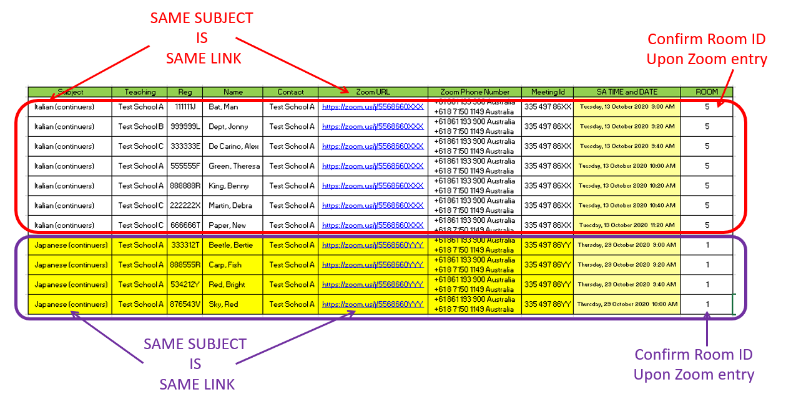
  - You will NOT need to download ZOOM on the computer. When you click the URL attached to your schedule, ZOOM will open in your browser. Click on the link ‘Join from your browser’ (NOTE: you need to click launch meeting or download and run zoom first to see this option). Please ensure your internet browser is up to date as you will access online oral examination through the browser version of this software. We recommend that you do not use the application version of ZOOM as this may be out of date.
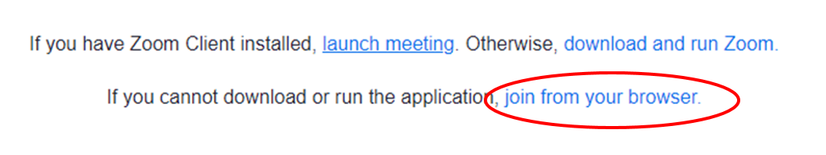
  - Enter your school name and the language that your students are studying in the ‘Your Name’ field, and tick ‘I’m not a robot’ and follow the directions on screen. Please note that the name of the school and language must be updated each time you enter the online oral examination meeting request. An example of the naming convention is shown below:-
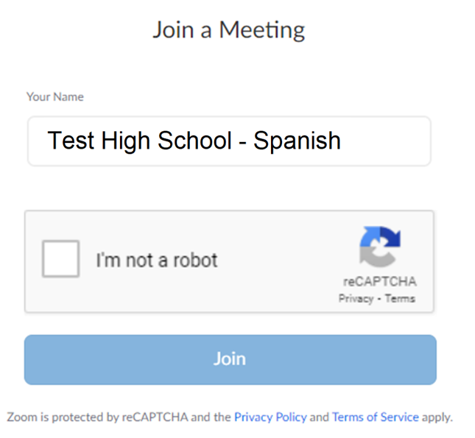
  - Your school will be able to test the video and audio connection before the first examination commences.
  - Your school will now enter a virtual waiting room until the SACE examiners are ready for the first student’s examination to commence.
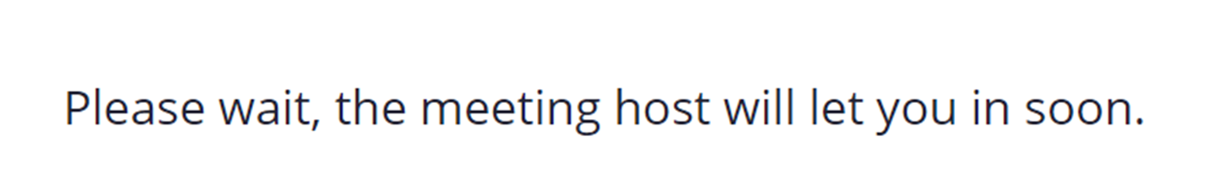
  - If the SACE examiners do not make contact within 5 minutes of the designated first students start time, please contact askSACE on 8115 4700.
Please refer to the table below as a visual representation of this admission process. For student with a start time of 12.00 pm
Oral Published Time (example) | Action
24 October YEAR - 11:45:00 AM | School connects to the ZOOM URL provided in the timetable. Enter the virtual waiting room for the allocated examination room. Make sure your volume and camera are adjusted suitably for an online oral examination.
24 October YEAR - 12:00:00 PM | Planned start time*  The SACE examiners will connect to your school.  * Please wait patiently for the examiners to connect with your school as the start time could be delayed by up to 5 minutes.
24 October YEAR - 12:05:00 PM | If connection to the examiners has not occurred after 5 minutes, then please contact askSACE on 8115 4700 to investigate delays.

  - Once the school has connected to the SACE examiners, the invigilator should ensure that the audio/video devices are selected and that they can see and hear the SACE examiners. The SACE examiners will provide guidance to the invigilator in adjusting the position of the laptop, microphone, and camera to ensure the examiners can hear and see the student being examined.
  - If there is an issue with communication, each ZOOM meeting has a phone number attached. Please use the phone number and meeting ID provided in order to proceed with the oral examination if communication with the SACE examiners is unable to be established online. A ‘speaker phone’ or conference telephone may be preferable, if one is available.
  - Schools who are unable to access the ZOOM meeting URL directly will need to dial the phone number provided and enter the relevant meeting ID and the # key.
  - If there are any issues with either of these two connection methods, please contact askSACE on 8115 4700.
  - Once contact has been made with the school the examiners will instruct the invigilator to collect the first student from the waiting area and accompany them into the examination room.

Conduct of the oral examination

  - Mobile phones and other electronic devices must not be brought into the examination room.
  - The invigilator brings the nominated student into the examination room and assists them to adjust the equipment to meet the individual student’s requirements.
  - Once the set-up is to the student’s satisfaction the examiners will commence the examination. The invigilator must remain in the examination room throughout the examination to provide technical support if the student requires this.
  - Schools are to ensure that students know their student registration number before entry into the examination room. At the start of the examination, students are asked to confirm their student registration number with the examiners.
  - For languages at background speakers and continuers levels, the students’ In-depth study overview should be emailed to the SACE board before the end of Term 3. The examiners will be provided with hard copies of these forms to refer to during the examination.
  - Students are NOT permitted to bring a hard copy of their IDS outline into the examination room. Other written materials, notes and cue cards are also NOT permitted in the examination room.
  - Students are permitted to bring objects such as photographs, pictures, and maps. Student annotations are not permitted on photographs, pictures, etc. The only writing permitted on maps and charts will be labels or headings. All student materials they wish to use in their online oral examination should be emailed to the SACE board before the end of Term 3. These materials should be clearly labelled with the students registration number, subject and allocated time this material will be provided to the examiners.
  - Students are not permitted to use the computer to present any prepared electronic information to the examiners.
  - The oral examinations will NOT be videoed however, an audio recording of each examination will be taken for quality assurance purposes.
  - Once students have completed their examination, they must leave the examination area. The examination venue must ensure that students who have completed the examination must not have access to the waiting room or have contact with those still waiting to be examined.
  - If there are multiple students being examined the ZOOM examination room link will remain open, the invigilator must remain in the examination room and wait for instructions from the SACE examiners.
  - When the SACE examiners are ready to continue with the next examination, the examiners will instruct the invigilator to collect the next student and follow steps 1 to 8 in this process until all students have been examined.
  - If a student cannot be present for the scheduled examination because of medical reasons or other extenuating circumstances, then the student must submit an application for special provisions via their school. Applications on the grounds of medical reasons must be supported by detailed medical evidence sought on the day of the examination. Catch up oral examinations are not available.
  - When the last student for a school has been examined, the SACE examiners will advise the invigilator to end the zoom meeting.

