It’s not only music that can influence the creative process for a composition…
You may find some of these ideas helpful to get your composition/s off to a flying 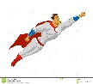start.

- Find a picture of a superhero and an evil villain. Keep it alongside you when composing or writing out ideas.

- Create a list of adjectives that sum up the personality traits of your super hero and evil villain.

- Create a list of phrases that depict your super hero and evil villain. Could these phrases influence rhythms for your compositions?

i.e “Up, Up and Away!” could be interpreted as

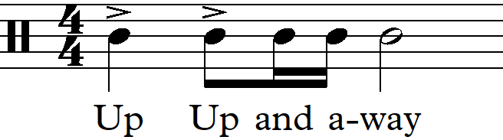

- Listen to the compositions of others who composed musical works for heroes and villains.
i.e.
  - John Williams
  - Danny Elfman
  - Hans Zimmer
  - _________________________
  - _________________________
  - _________________________

