Stage 2 ancient studies
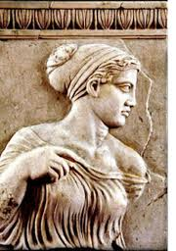
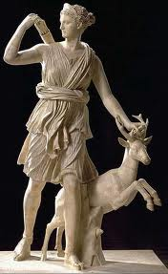
Assessment Type 1: Skills and Applications
Topic 7: Literature – drama and poetry
Antigone and Hippolytus

Choose one of the following tasks:
- Whilst Sophocles’ Antigone and Euripides’ Hippolytus present the audience with the notion that the gods are the ultimate power on earth, they have very different views on the nature of the gods and the way man and the gods might interact. Compare and contrast the handling of the gods by these two playwrights.

- “Sophocles’ Antigone and Euripides Phaedra are victims both to external powers and situations not of their making yet they are equally driven to their deaths by their own actions. “ Discuss this statement.

Assessment design criteria and evidence:
KU 1: Knowledge and understanding of selected texts, ideas, individuals, groups, institutions, practices events and artefacts of the ancient world

To fulfil these criteria to a high level you need to demonstrate:
- a sophisticated understanding of selected texts, ideas, institutions and practices
- Knowledge of multiple concepts
- Ability to give rich detail
- Focus on ideas with narrative as support rather than narrative retelling
- Discussion which explores the playwrights’ ideas within the social construct and values of their time
- Deep insights highlighted at the end of paragraphs and drawn in the concluding section
RA 1: Research into and analysis of primary and secondary sources and perspectives primary and secondary sources including literary texts
To fulfil this criteria to a high level you need to demonstrate:
- Understanding of the text as a whole but also a commanding use of the specifics of the text and an ability to link parts of the text together.
- Reading, and synthesis of scholarly views on Antigone and Hippolytus and the concerns of Sophocles and Euripides.

A1: Synthesis of evidence and appropriate acknowledgement of sources
A2: communication of ideas and arguments using subject specific terminology
To fulfil these criteria to a high level you need to demonstrate:
- Specific and constant addressing of the task/question.
- Use of tragic and cultural terminology in such a way as to make meaning clear to the reader
- A persuasive line of argument that leads the reader logically, through distinct points, to deep insights on the issue in question
- Prose that is clear and precise
    - Well-structured and progresses logically
    - Signposted with, as appropriate for the form:
        - Introduction
        - Topic sentences
        - Linking sentences
        - Apt use of example from the text
        - Conclusion

- Quotes integrated into sentences of discussion
- A bibliography

Due dates:
- Draft: Monday Week Two, Term Three
- Final: Monday Week 4

