Stage 2 Child Studies
Assessment Type 1: Practical Activity
Student Evidence

Complete this pro forma to document your Practical Activity using dot points and/or photos with captions. You are encouraged to use this evidence to also display your ability to show initiative and creativity.

Practical Application | Student Responses
Implementation of safe management practices (PA1) | -When making my special needs toy I made sure that when cutting out the magnets I did not create any sharp edges that would hurt the user.  - After I bought the miniature whiteboard I made sure that I secured the penholder on the top as I didn’t want it to fall off and be a choking hazard to the user.  - When using scissors to cut out the various facial parts I made sure that I was handling them correctly.  - When choosing which facial parts to use for my toy I made sure that I was choosing parts that were not too small that they would become a choking hazard.
Organise and manage time (PA2) | - Once I had decided on what toy I was going to make I drew out a planning sheet of what I wanted my toy to look like and the materials that I would need.  - I made sure that I used my class time wisely to make sure that I had enough time to complete each component of the investigation.  - I made sure that I had set goals on when I wanted different components of the task to be completed, to make sure I wasn’t spending all my time on one area of the investigation.  - I made sure that I had selected the items needed to make my toy before I started constructing, to make sure that I had all the materials to complete the toy.
Organise and manage techniques (PA1) | - To make my toy I used magnet sheets to use to stick my faces on.  -I also used the computer and the printer to pick and print out my cartoon facial parts.  - When cutting out the pictures on the magnets I made sure that I rounded off the edges so they were not a hazard to the child.
Organise and manage resources (PA2) | -The materials I used to make my toy were magnet sheets, paper and a miniature whiteboard.  -I chose to purchase a miniature whiteboard, as it was the correct size for my chosen special need, as a child with Cerebral Palsy could play with the whiteboard on their lap if they were in a wheelchair.  - When placing the face print outs on the magnet sheet I made sure that I was trying to fit as many printouts on the sheet as possible to save money on buying extra sheets.  - The containers I have chosen are easy to access the different facial parts and are colourful and fun.
Generate and maintain quality control (PA1) | - To make sure that my toy was looking appealing to my target audience I made sure that the facial parts I chose were a mixed variety of gender and look.  - I made sure that when choosing a whiteboard to use for my toy that it was a boys colour as I am targeting a 6 year old boy with Cerebral Palsy.  - When cutting out my face magnets I made sure that I had precise and detailed cutting to make the toy look like a professional toy that could be bought in a shop.  - When labeling each container I made sure that I made each containers label on the computer to generate a quality product.
Select and apply appropriate technology to prepare learning activities for children (PA3) | - I used the computer and the internet to choose and print out my selected facial parts.  - I also used the internet for the research as I used it to find important information about the development stages of children with Cerebral Palsy.  - I used scissors as my technology to cut out all the magnet face parts.  - I looked in a catalogue for primary school teachers at the start of the investigation to find inspiration and ideas of what toy was suitable to make for a 6 year old boy with Cerebral Palsy.
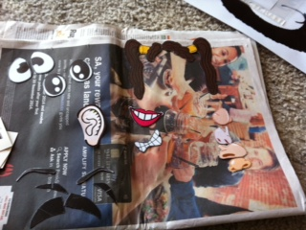
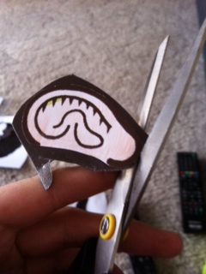
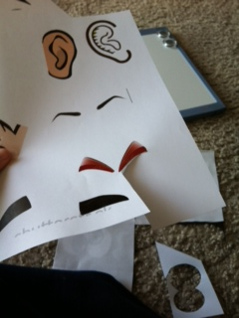
Photographic evidence of learning (Describe the learning depicted in the photo/s.)
Figure 2 shows PA2 as it is showing evidence that I was using magnet sheets as part of my materials list. This also shows PA1 as I am making sure that my cutting is rounding off the edges so that the toy is not harmful to the user.
Figure 1 shows PA1 as it shows how I was being safe when cutting out my face parts. I am also showing PA1 by maintain quality control as I was making sure that my cutting was precise and accurate.
Figure 3
Figure 2
Figure 1

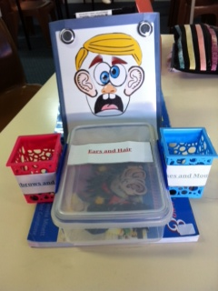
Figure 4 shows the final product of my toy. I am showing PA1 as this shows the quality of my product.
Figure 4
Figure 3 shows some of the different facial parts I chose for my toy. This picture is showing PA1 as it shows the mix of facial parts I chose, showing that they were not one sided. It also shows PA2 as it proves that I used magnet sheets and the computer to print out my selected facial parts.

