Stage 2 Physics - Program 2: Assessment Type 2
Science Inquiry Skills and Paragraph Answers

PHYSICS

### insert date ###

Summative Test Material: One question booklet with formula sheet
Approved dictionaries and calculators may be used
Instructions to students
1. You will have 5 minutes to read the paper. You must not write in your question booklets or use a calculator during this reading time but you may make notes on the scribbling paper provided.
2. The allocation of marks are given below each question, however, your final grade is determined by the performance standards given. The total number of marks and time allowed is given as:
Total 38 marks - 40 minutes
4. The formula sheet is provided for use during the test.
5. Marks may be deducted if you do not clearly show all steps in the solution of problems or if you do not define additional symbols. You should use diagrams where appropriate in your answers.
6. Use only black or blue pens for all work other than graphs and diagrams, for which you may use a sharp dark pencil.

Stage 2 Physics Performance Standards
- | Investigation, Analysis and Evaluation | Knowledge and Application
A | Critically deconstructs a problem and designs a logical, coherent, and detailed physics investigation.  Obtains, records, and represents data, using appropriate conventions and formats accurately and highly effectively.  Systematically analyses and interprets data and evidence to formulate logical conclusions with detailed justification.  Critically and logically evaluates procedures and their effect on data. | Demonstrates deep and broad knowledge and understanding of a range of physics concepts.  Applies physics concepts highly effectively in new and familiar contexts.  Critically explores and understands in depth the interaction between science and society.  Communicates knowledge and understanding of physics coherently, with highly effective use of appropriate terms, conventions, and representations.
B | Logically deconstructs a problem and designs a well-considered and clear physics investigation.  Obtains, records, and represents data, using appropriate conventions and formats mostly accurately and effectively.  Logically analyses and interprets data and evidence to formulate suitable conclusions with reasonable justification.  Logically evaluates procedures and their effect on data. | Demonstrates some depth and breadth of knowledge and understanding of a range of physics concepts.  Applies physics concepts mostly effectively in new and familiar contexts.  Logically explores and understands in some depth the interaction between science and society.  Communicates knowledge and understanding of physics mostly coherently, with effective use of appropriate terms, conventions, and representations.
C | Deconstructs a problem and designs a considered and generally clear physics investigation.  Obtains, records, and represents data, using generally appropriate conventions and formats with some errors but generally accurately and effectively.  Undertakes some analysis and interpretation of data and evidence to formulate generally appropriate conclusions with some justification.  Evaluates procedures and some of their effect on data. | Demonstrates knowledge and understanding of a general range of physics concepts.  Applies physics concepts generally effectively in new or familiar contexts.  Explores and understands aspects of the interaction between science and society.  Communicates knowledge and understanding of physics generally effectively, using some appropriate terms, conventions, and representations.
D | Prepares a basic deconstruction of a problem and an outline of a physics investigation.  Obtains, records, and represents data, using conventions and formats inconsistently, with occasional accuracy and effectiveness.  Describes data and undertakes some basic interpretation to formulate a basic conclusion.  Attempts to evaluate procedures or suggest an effect on data. | Demonstrates some basic knowledge and partial understanding of physics concepts.  Applies some physics concepts in familiar contexts.  Partially explores and recognises aspects of the interaction between science and society.  Communicates basic physics information, using some appropriate terms, conventions, and/or representations.
E | Attempts a simple deconstruction of a problem and a procedure for a physics investigation.  Attempts to record and represent some data, with limited accuracy or effectiveness.  Attempts to describe results and/or interpret data to formulate a basic conclusion.  Acknowledges that procedures affect data. | Demonstrates limited recognition and awareness of physics concepts.  Attempts to apply physics concepts in familiar contexts.  Attempts to explore and identify an aspect of the interaction between science and society.  Attempts to communicate information about physics.

- A student undertook an experiment to determine the drag coefficient of a paper coffee filter.
The filter was dropped from a fixed height, and its terminal speed, v_{t}, was determined using a stopwatch. The mass was then altered by adding small pieces of plasticine, and the terminal speed recorded again. The experiment was repeated three times.
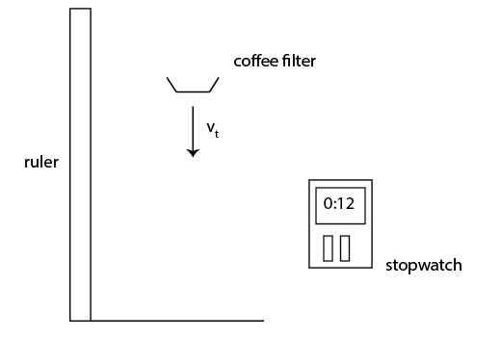
- Explain which is the dependent variable in this experiment.
___________________________________________________________________________
___________________________________________________________________________
___________________________________________________________________________
___________________________________________________________________ (2 marks)

Their results are shown in the table below:
Mass (g) | Trial 1 v_{t} (ms⁻¹) | Trial 2 v_{t} (ms⁻¹) | Trial 3 v_{t} (ms⁻¹) | Average v_{t} (ms⁻¹)
0.95 | 0.85 | 0.89 | 0.86 | 0.87
1.90 | 1.25 | 1.30 | 1.28 | 1.28
2.83 | 1.50 | 1.56 | 1.54 | 1.53
3.79 | 1.78 | 1.80 | 1.73 | 1.77
4.74 | 1.90 | 1.95 | 1.85 | 1.90

- Explain why repeating an experiment increases accuracy.
___________________________________________________________________________
___________________________________________________________________________
___________________________________________________________________________
___________________________________________________________________ (2 marks)
The student then graphed against m.

- Sketch a line of best fit on the graph above. Calculate its gradient.
___________________________________________________________________________
___________________________________________________________________________
___________________________________________________________________________
___________________________________________________________________ (3 marks)
- Explain if there is any evidence of systematic errors on the graph above.
___________________________________________________________________________
___________________________________________________________________________
___________________________________________________________________________
___________________________________________________________________ (2 marks)
The terminal speed of an object is given by:
Where m is the mass, g is the acceleration due to gravity, C_{d} is the drag coefficient and ρ is the density of the medium.
In this experiment, the acceleration due to gravity is 9.81 ms⁻², the cross sectional area was 0.0175m² and the density of air is 1.225 kgm⁻³.
- Determine the drag coefficient of the coffee filter.
___________________________________________________________________________
___________________________________________________________________________
___________________________________________________________________________
___________________________________________________________________ (2 marks)
- Two students are attempting to determine the magnetic field strength around a solenoid using a current balance apparatus. As a current flows through the balance, a force due to the magnetic field, F_{B}, pushes the balance inside the solenoid downwards.
At the open end of the solenoid, the balance is pushed upwards. This is balanced by the force due to gravity, F_{G}, as mass is added to the balance at the open end.
When the balance is level, . The students manipulate the current through the balance and record the mass required to balance.
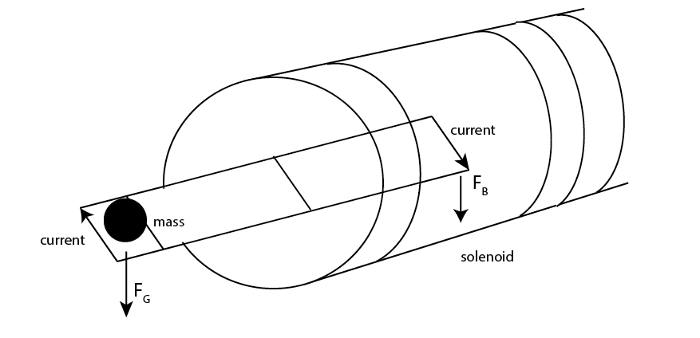
- State and explain whether the current through the solenoid is flowing clockwise or anticlockwise.
___________________________________________________________________________
___________________________________________________________________________
___________________________________________________________________________
___________________________________________________________________ (2 marks)
Two students, Marayam and Timothy obtain the following results:
Current (A) | Mass (g)
0.02 | 0.011
0.04 | 0.023
0.06 | 0.032
0.08 | 0.041
0.10 | 0.053
Current (A) | Mass (g)
0.015 | 0.0168
0.042 | 0.0471
0.055 | 0.0617
0.083 | 0.0932
0.14 | 0.157
Marayam Timothy

- Explain which of the two students has the more precise data.
___________________________________________________________________________
___________________________________________________________________________
___________________________________________________________________________
___________________________________________________________________ (2 marks)

- Show that the current balance is level when the mass is given by, where B is the magnetic field strength of the solenoid, I is the current through the current balance, g is the acceleration due to gravity and Δl is the width of the current balance.
___________________________________________________________________________
___________________________________________________________________________
___________________________________________________________________________
___________________________________________________________________ (3 marks)
Timothy’s results are displayed in the graph below:

- Calculate the gradient of the line of best fit.
___________________________________________________________________________
___________________________________________________________________________
___________________________________________________________________________
___________________________________________________________________ (3 marks)

- Use your answer to (d) to calculate the magnetic field strength of the solenoid. The width of the current balance is 0.025 m and the acceleration due to gravity is 9.81 ms⁻².
___________________________________________________________________________
___________________________________________________________________________
___________________________________________________________________________
___________________________________________________________________ (3 marks)

Marayam found that her results gave the magnetic field strength of the solenoid as 0.20 T.
An electronic device used to measure the magnetic field strength directly gave a value of 0.28T.

- Explain which student had the more accurate data.
___________________________________________________________________________
___________________________________________________________________________
___________________________________________________________________________
___________________________________________________________________ (2 marks)

- Cyclotrons are used to produce radioisotopes that are used for medical applications. The South Australian Health and Medical Research Institute (SAHMRI) has a cyclotron which produces radioisotopes for use in identifying and treating cancer.

- Describe the nature and direction the magnetic field needed to deflect ions into a circular path into the dees of a cyclotron (6 marks)
___________________________________________________________________________
___________________________________________________________________________
___________________________________________________________________________
___________________________________________________________________________
___________________________________________________________________________
___________________________________________________________________________
___________________________________________________________________________
___________________________________________________________________________
___________________________________________________________________________
___________________________________________________________________________
___________________________________________________________________________
___________________________________________________________________________
___________________________________________________________________________
___________________________________________________________________________
___________________________________________________________________________
___________________________________________________________________________
___________________________________________________________________________
___________________________________________________________________________
- Discuss the importance of being able to generate radioisotopes in Adelaide instead of having radioisotopes transported from interstate. (6 marks)
___________________________________________________________________________
___________________________________________________________________________
___________________________________________________________________________
___________________________________________________________________________
___________________________________________________________________________
___________________________________________________________________________
___________________________________________________________________________
___________________________________________________________________________
___________________________________________________________________________
___________________________________________________________________________
___________________________________________________________________________
___________________________________________________________________________
___________________________________________________________________________
___________________________________________________________________________
___________________________________________________________________________
___________________________________________________________________________
___________________________________________________________________________
___________________________________________________________________________
___________________________________________________________________________
___________________________________________________________________________
___________________________________________________________________________
___________________________________________________________________________
___________________________________________________________________________
___________________________________________________________________________
___________________________________________________________________________
___________________________________________________________________________
___________________________________________________________________________
___________________________________________________________________________

